STDCOM ( Stec Development Operational Methods) Grade Operator Entry

Overview
This can be used as an app, or as a part of a larger python package, for operators to enter grades previously setup by the builder.

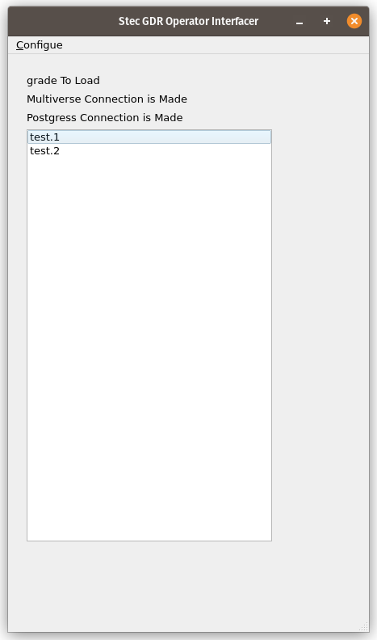

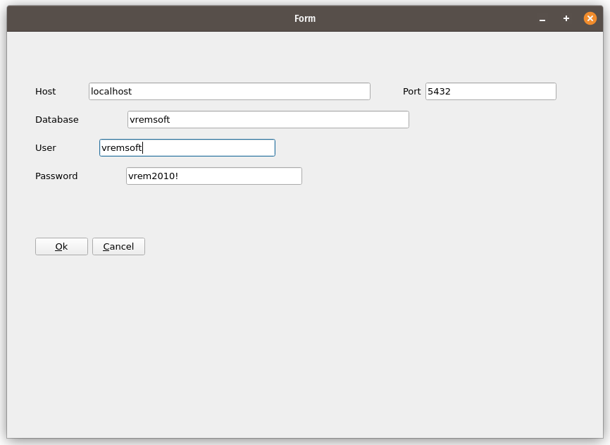

Postgres Setup

Multiverse Setup to NextStep Plugin

