Study Population Demographics
Age Distribution
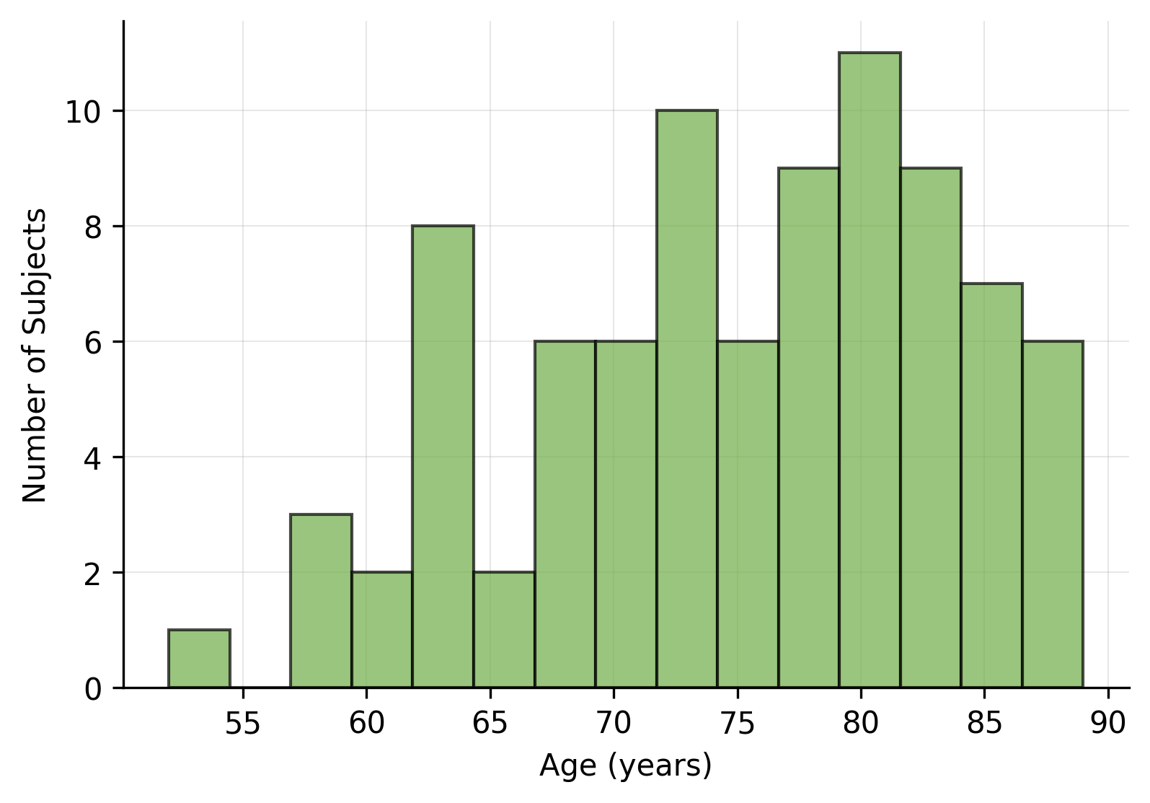
Analysis population: All randomized subjects (N=254)
Source: ADSL dataset

