Provenance location-based authentication of cloud

Phornsawan Roemsri
Computer Science
Texas Tech University
Texas, United State
phornsawan.roemsri@ttu.edu

Abstract—Cloud computing is booming technology, whereas it has a lot of problems; security, availability, performance, and so the list continued. The security problem is a big concern for cloud computing. Authentication of the user is an important thing in this issue. There are many ways to do authentication for the user in the cloud. One of them is so old and basic; password-based authentication which still has used today in cloud computing, and the bad guy can access an account of other people very easily as they have a password. Some works in this field apply provenance to authentication, but they still have lots more to work on. In this paper, we propose a new algorithm that applies provenance with authentication too, but it focuses on the application which masses with the location. We generate the database and dataset and simulate the system. We evaluate the algorithm by using the use case. Therefore, future research has to be focusing on implement this algorithm to the application of the cloud.
Keywords—provenance, authentication, location-based, cloud computing

Introduction
In the current world, cloud computing is the simplest computing method accessible to company organizations online. It covers many services for company organizations such as computing, storage, application hosting, software development platforms, servers, and software through the internet, referred to as cloud computing. As many people use it, the challenge to track malicious activities and security violations in the cloud environment is required.
In cloud computing today, They use the provenance that provided through the linking of log data, which are generated through the execution of software on the given physical, virtual, or application resource, and audit data, which are created for the sole purpose of provenance assurance[7]. A plus of this, provenance is information about entities, activities, and people involved in producing a piece of data or thing, which can be used to form assessments about its quality, reliability, or trustworthiness[1].
Furthermore, the security issue has a big concern in cloud computing due to its nature of virtualization, elasticity, scalability, and ubiquity of the data[5]; authentication of the user is an important factor because it guarantees that the communicating entity is the one claimed. Many methods are being used to authenticate users in the cloud computing environment. Single Sign-On (SSO), password-based authentication, as well as biometric authentication, are the main methods being used today[4]. Unfortunately, enterprises still prefer to use password-based authentication mechanisms because the other methods are used to make it more convenient for users. However, other people can succeed in login into all associated applications of the other one because they have a password. The reason is the system verification use only using the authentication factor—password[10].
Password-based authentication is still widely used and will survive in the future if it is improved in usability, security, and convenience aspects. So, we want to do a password-based authentication based on a different premise—strengthening authentication follow the Provenance Based Model and Prototype to Strengthen Authentication by Rajidi Satish, Chandra Reddy, and Srinivas Reddy Gopu[10]. They come up with an idea to confirm the users’ identity utilizing authentication provenance. But we found that they use a few attributes and make some use case that has the same input but different output. So, in this paper, we will try to improve this weakness by adding more another attribute—location.
The remainder of this paper is organized as follows: In Section II, we briefly discuss the background and basic concepts of Cloud computing, Provenance, and Authentication. In Section III, we discuss the Provenance Based Model and Prototype to Strengthen Authentication by Rajidi Satish, Chandra Reddy, and Srinivas Reddy Gopu. Meanwhile, we summary this work. In Section IV, we discuss the Provenance location-based authentication of Cloud. Finally, we evaluate the paper in Section V.

Related Work

Cloud computing
The National Institute of Standards and Technology (NIST) defined the cloud computing as a model for enabling ubiquitous, convenient, on-demand network access to a shared pool of configurable computing resources (e.g., networks, servers, storage, applications, and services) that can be rapidly provisioned and released with minimal management effort or service provider interaction. This cloud model is composed of five essential characteristics, three service models, and four deployment models[4-5, 9].

Essential Characteristics

On-demand self-service: A consumer can unilaterally provision computing capabilities, such as server time and network storage, as needed automatically without requiring human interaction with each service provider.

Broad network access: Capabilities are available over the network and accessed through standard mechanisms that promote use by heterogeneous thin or thick client platforms

Resource pooling: The provider’s computing resources are pooled to serve multiple consumers using a multi-tenant model, with different physical and virtual resources dynamically assigned and reassigned according to consumer demand.

Rapid elasticity: Capabilities can be elastically provisioned and released, in some cases automatically, to scale rapidly outward and inward commensurate with demand. To the consumer, the capabilities available for provisioning often appear to be unlimited and can be appropriated in any quantity at any time.

Measured service: Cloud systems automatically control and optimize resource use by leveraging a metering capability1 at some level of abstraction appropriate to the type of service. Resource usage can be monitored, controlled, and reported, providing transparency for both the provider and consumer of the utilized service.

Service Model

Software as a Service (SaaS): It is the topmost layer which provides to the consumer is to use the provider’s applications running on a cloud infrastructure. The applications are accessible from various client devices through either a thin client interface, such as a web browser (e.g., web-based email), or a program interface. The consumer does not manage or control the underlying cloud infrastructure including network, servers, operating systems, storage, or even individual application capabilities, with the possible exception of limited user specific application configuration settings.

Platform as a Service(PaaS): It is the second layer which provides to the consumer is to deploy onto the cloud infrastructure consumer-created or acquired applications created using programming languages, libraries, services, and tools supported by the provider. The consumer does not manage or control the underlying cloud infrastructure including network, servers, operating systems, or storage, but has control over the deployed applications and possibly configuration settings for the application-hosting environment.

Infrastructure as a Service (IaaS): It is the bottommost layer that provides to the consumer is to provision processing, storage, networks, and other fundamental computing resources where the consumer is able to deploy and run arbitrary software, which can include operating systems and applications. The consumer does not manage or control the underlying cloud infrastructure but has control over operating systems, storage, and deployed applications; and possibly limited control of select networking components. The consumer does not manage or control the underlying cloud infrastructure but has control over operating systems, storage, and deployed applications; and possibly limited control of select networking components (e.g., host firewalls).

Development Model

Public cloud: The cloud infrastructure is provisioned for open use by the general public.

Private cloud: The cloud infrastructure is provisioned for exclusive use by a single organization comprising multiple consumers

Community cloud: The cloud infrastructure is provisioned for exclusive use by a specific community of consumers from organizations that have shared concerns.

Hybrid cloud: The cloud infrastructure is a composition of two or more distinct cloud infrastructures (private, community, or public) that remain unique entities, but are bound together by standardized or proprietary technology that enables data and application portability.

Provenance
Provenance is the place of origin or earliest known history of something. Works in this area are almost talking about data and apply it with other fields. One of them applies provenance with privacy due to scientific workflows that use provenance to recording information that often contains private or confidential data[3]. The others apply provenance with blockchain for the two main reasons; There are tamper-proof and transparency of data. For the blockchain field, they also present their model for the cloud environment and use their model for supply-chain[9] and cloud storage applications[8].
Only this group of provenance did differently from other papers; they apply provenance to authentication. They create the provenance based authentication model, and prototype to strengthen password-based authentication of a system; They apply provenance data model with authentication by creating a policy model and use it to control authentication. Then, they develop a prototype and evaluate it by using the detection mechanism[10].

Authentication
Authentication is the process or action of proving or showing something to be true, genuine, or valid. In terms of computer, authentication is the process or action of verifying the identity of a user or process. In the current world, there are many kinds of authentication. Some of them using a biometrics base, for instance, use fingerprints, retinal or iris scans, voice recognition, and face detection. Biometrics-based authentication is still evolving and has accuracy issues[2, 12]. Another one using a location base, one of this group use location-based authentication with an application of industrial IoT. This system uses ambient information, which changes continuously and required to collect it in real-time from multipoint. So, this method depends on network performance[11]. Moreover, another one of this group used for verifying the authentication of transmitting messages, but it difficult because the location of vehicles is changing[6].
The last one, they do different they using password-based and apply the provenance to authentication by creating the policy. This model can detect anomalous user logins, but the availability of all required attributes are critical[10].

Provenance Based Model and Prototype to Strengthen Authentication
From this paper, they use the provenance data model[1] to apply with authentication. The core of the provenance data model is entity, activity, and agent.
- An entity is a physical, digital, conceptual, or another kind of thing with some fixed aspects; entities may be real or imaginary.
- An activity is something that occurs over a period of time and acts upon or with entities; it may include consuming, processing, transforming, modifying, relocating, using, or generating entities.
- An agent is something that bears some form of responsibility for an activity taking place, for the existence of an entity, or for another agent's activity.
They apply this model to authentication and create policy.
Agent: user
Activity: login and browse
Entity: application
The set of authentication requests includes username, MAC address, location, time, date.
The set of authentication decisions includes allow, allow with condition, and deny.
We can analyze their policy with this algorithm I. This algorithm focuses on the MAC address, and the location of the user will have the same data with the database.

Algorithm I: Provenance Based Authentication Model
input : ar is a set of authentication request such that
ar = username, MAC address, location, time, date
 | output : authentication decisions
1 | if check_location(ar) and check_MAC_address(ar) do
2 | return "Allow"
3 | end else if not check_location(ar) and check_MAC_address(ar) do
4 | return "Allow"
5 | end else if not check_location(ar) and not check_MAC_address(ar) and check_system(ar) do
6 | return "Allow"
7 | end else if check_location(ar) and not check_MAC_address(ar) and not check_system(ar) do
8 | if check_origin_system_available(ar) do
9 | return "Deny"
10 | end else do
11 | return "Allow"
12 | end
13 | end else do
14 | return "Deny"
15 | end

From the table I, we can observe that this evaluation has a different result with the same input; case No.2 and No.3.
- Use Case Evaluation Results
Use case No | Attributes |  |  | Anomaly | Result
Use case No | Location | MAC address | System | Anomaly | Result
1 | û | û | û | Yes | Detected—response “Deny”
2 | ü | û | û | Yes | Detected—response “Deny”
3 | ü | û | û | No | Response “Allow”
4 | ü | ü | ü | Yes | Undetected—response “Allow”
5 | ü / û | û | û | Yes | Detected—response “Deny”
6 | ü | ü | ü | No | Response “Allow”
ü Match with database.
û Not match with database

Provenance Location-Based Authentication Of Cloud Model
We propose a new algorithm to cope with provenance location-based authentication in the cloud, illustrated in Algorithm II and Figure I.
And the same as Provenance Based Authentication Model.
Agent: user
Activity: login and browse
Entity: application
But the set of authentication requests includes username, MAC address, type of device(portable or non-portable), location, time, date.
And the set of authentication decisions includes allow, allow with condition, and deny.
After the system checks the credential of the user, if it corrects, the system will sent authentication requests to the Provenance Location-Based Authentication Of Cloud Model (Algorithm II). This algorithm focuses on four attributes; location of the user, MAC address, type of device(portable or non-portable), and location of the device. Besides, if the device is portable, the system will check the location of the user and the MAC address. But if the device is non-portable, the system will check all attributes.
Algorithm II: Provenance Location-Based Authentication
input : ar is a set of authentication request such that
ar = username, MAC address, type of device(portable or non-portable), location, time, date
 | output : authentication decisions
1 | if check_user_location(ar) do
2 | if check_model(ar) do
3 | if device_can_carry(ar) do
4 | if check_MAC_address(ar) and check_MAC_address_exists(ar) do
5 | return "Allow"
6 | end else if check_MAC_address_exists(ar) do
7 | return "Allow with conditions"
8 | end else do
9 | return "Deny"
10 | end
11 | end else do
12 | if check_MAC_address(ar) and check_MAC_address_exists(ar) do
13 | if check_device_location(ar) and check_device_location_exists(ar) do
14 | return "Allow"
15 | end else if check_device_location_exists(ar) do
16 | return "Allow with conditions"
17 | end else do
18 | return "Deny"
19 | end
20 | end else if check_MAC_address_exists(ar) and check_device_location_exists(ar) do
21 | return "Allow with conditions"
22 | end else do
23 | return "Deny"
24 | end
25 | end
26 | end else do
27 | return "Deny"
28 | end
29 | end else do
30 | return "Deny"
31 | end

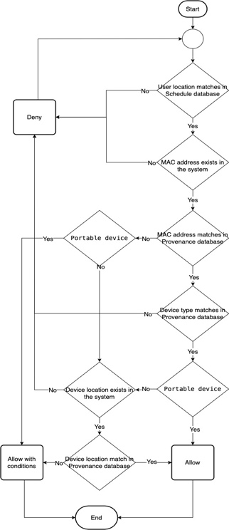
Figure I: Provenance location-based authentication model.
At first, I simulation the company by generating the database and coding this algorithm by using python. Then, generate random data of authentication requests. This data set has exactly 27 unique rows because the attributes have a dependency. As shown in figure II. There are seven attributes:
- The type of device: Portable or Non-portable.
- Is the type of device match with data in the system? : True or False
- Is the User Location match in the system? : True or False
- Is the Mac Address exists in the system? : True or False
- Is the Mac Address match with data in the system? : True or False
- Is the Device location exists in the system? : True or False
- Is the Device location match with data in the system? : True or False

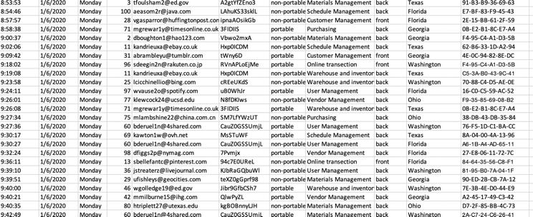
Figure II: Provenance location-based authentication model.
After I feed this dataset to this algorithm, it can work correctly. As shown in figure III.
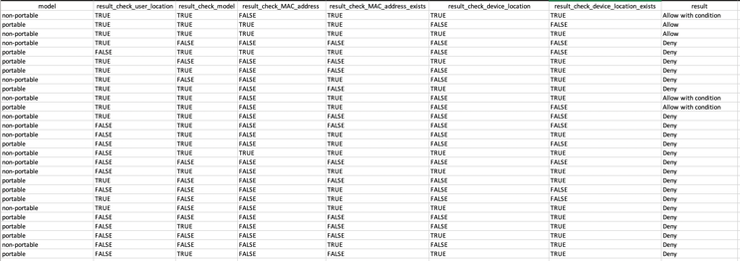
Figure II: Provenance location-based authentication model.

Evaluation

Use case summary
- Use case 1 - Someone outside the company, name Eve, tries to log in an application by using Alice's credentials. In this case, we assume that Eve attempts to log in to the application in a different location, so that's mean this address does not match the data in the Provenance database. Then, Eve can not log in to an application.
- Use case 2 - Alice buys a new laptop and tries to use this to log in to her application at her office. In this case, Alice can not log in to her application by using her laptop because it isn't the company's laptop, and there is not data of this laptop in the company's database.
- Use case 3 - Alice can not use her laptop because her laptop is broke, and the supporter gives her a temporary laptop for working at the workplace the same as the schedule. In this case, Alice can log in to her application with conditions; one-time password (OTP).
- Use case 4 - Alice uses a desktop, which provides by the company working at the workplace, the same as the schedule. In this case, Alice can log in to her application.
- Use case 5 - Alice uses another desktop that never uses it before, which provides by the company at the same place as scheduled. In this case, Alice can log in to her application with conditions; one-time password (OTP).

Evaluation result
- Use Case Evaluation Results
Use case No | Attributes |  |  |  |  | Result
Use case No | Type | User Location | MAC address | MAC address already exists | Device Location | Result
1 | – | û | – | – | – | Deny
2 | Portable | ü | û | û | – | Deny
3 | Portable | ü | û | ü | – | Allow with condition
4 | Non-Portable | ü | ü | ü | ü | Allow
5 | Non-Portable | ü | û | ü | ü | Allow with condition
ü Match with database.
û Not match with database.
– Not matter.

Conclusions, Limitation and Future work
In this paper, we present the new algorithm, provenance location-based authentication of cloud model, simulate the system and evaluated it with use case scenarios, and provided its limitations and challenges. As we proposed the new algorithm, provenance location-based authentication of cloud model, it can be used for other types of authentications also. Our evaluation shows that it can work correctly for the different use cases. For the limitation, this system depends on the availability of requests to collect data of the user: the location. Our recommendations for future research are: focusing on implement this algorithm to the application of the cloud.

References

- Belhajjame, K., R. B’Far, J. Cheney, S. Coppens, S. Cresswell, Y. Gil, P. Groth, G. Klyne, T. Lebo and J. McCusker (2013). Prov-dm: The prov data model. W3C Recommendation.
- Datta, P., S. Bhardwaj, S. Panda, S. Tanwar and S. Badotra (2020). Survey of Security and Privacy Issues on Biometric System. In Handbook of Computer Networks and Cyber Security, Springer, pp. 763-776.
- Davidson, S., S. Khanna, S. Roy, J. Stoyanovich, V. Tannen and Y. Chen (2011). On provenance and privacy. In Proceedings of the 14th International Conference on Database Theory, pp. 3-10.
- Farooq, H. (2017). A review on cloud computing security using authentication techniques. In International Journal of Advanced Research in Computer Science, 8(2).
- Karajeh, H., M. Maqableh and R. Masa’deh (2016). Privacy and Security Issues of Cloud Computing Environment. In Proceedings of the 23rd IBIMA Conference Vision 2020, pp. 1-15.
- Kawamoto, Y., H. Nishiyama, N. Kato, Y. Shimizu, A. Takahara and T. Jiang (2015). Effectively collecting data for the location-based authentication in Internet of Things. IEEE Systems Journal, 11(3): 1403-1411.
- Khandelwal, M. and H. Saini (2019). Review on Security Challenges of Cloud Computing. In International Conference on Advancements in Computing & Management (ICACM-2019).
- Liang, X., S. Shetty, D. Tosh, C. Kamhoua, K. Kwiat and L. Njilla (2017). Provchain: A blockchain-based data provenance architecture in cloud environment with enhanced privacy and availability. In 2017 17th IEEE/ACM International Symposium on Cluster, Cloud and Grid Computing (CCGRID), pp. 468-477, IEEE.
- Mell, P. and T. Grance (2011). The NIST definition of cloud computing.
- Reddy, R. and S. R. Gopu (2019). PRAN: A Provenance Based Model and Prototype to Strengthen Authentication. In Workshops of the International Conference on Advanced Information Networking and Applications, pp. 139-150 , Springer.
- Ren, K., Z. Qin and Z. Ba (2019). Toward Hardware-Rooted Smartphone Authentication. In IEEE Wireless Communications, 26(1): 114-119.
- Tosh, D., S. Shetty, X. Liang, C. Kamhoua and L. Njilla (2019). Data Provenance in the Cloud: A Blockchain-Based Approach. In IEEE Consumer Electronics Magazine, 8(4): 38-44.
- Whaiduzzaman, M., M. Sookhak, A. Gani and R. Buyya (2014). A survey on vehicular cloud computing. In Journal of Network and Computer applications, 40: 325-344.

