**Networking on VPC**

VPC is a virtual private cloud.

**How can we manage the router traffic?**

VPC is a logical Separation of a network test, pre-prod env. So same way here you can isolate the traffic with help of VPC.

**Public:** Which is connect to **IGW** directly, here there is no restriction of internet any instance you launch in this VPC will have a public IP and access the internet through IGW, here **in bound** and **out bound traffic** is passed with public IP.

**Private:** This is connected to NAT (Network Address translation which converts private IP address to public IP to get the internet so the private is not exposed to internet?

**Protected:** No internet Access any EC2 instances launched under this VPC will not have internet access

We can deploy Web server in public.

Application in Private

Database in protected.

We usually provide internet access to database server.

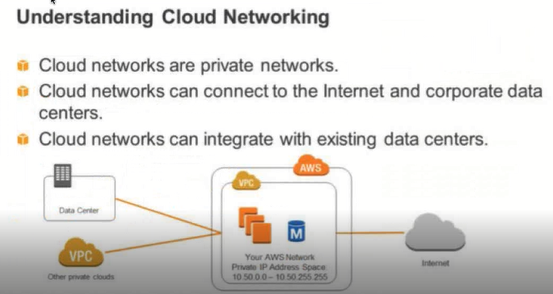

VPC is an isolated portion of AWS.

**Subnets:** It is the actual place where the EC2 instances get the IP address.

In VPC we have the **subnets**.

Usually, we launch Ec2 instance under a subnet.

**CIDR block is:** Nothing but how do we receive an IP Address.

To receive from 10.0.0 .0 to 10.255.255.255

10.0.0/16/17 (In order to receive like this, it is called as CIDR block)

CIDR: Cashless inter domain Routing.

Amazon supports either IPv4 or Ipv6.

Once VPC is created you can create a Subnet.

Subnet usually helpful; to slice of the IP address.

Subnet has the range of IP Address change.

Subnet is the actual place where you get the IP address for an EC2 instance.

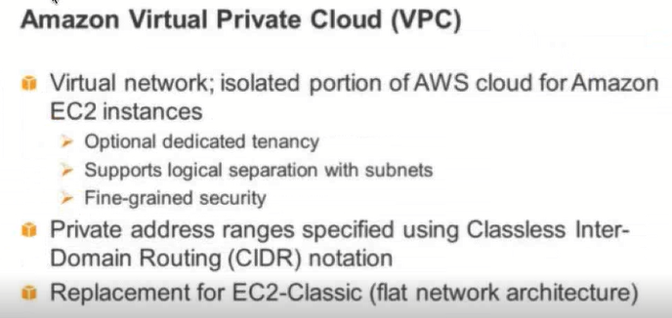

Without a VPC an Ec2 instance cannot be launched.

So, by default there is a VPC always.

In Ec2 instance we must mention where this VPC belongs to.

If not, we will not be able to launch an Ec2 instances.

**What is the actual use of VPC?**

On every account Amazon has a default VPC created it is called as Default VPC and it is connected to internet gateway (IGW), VPC, subnet, routing table.

In case we want a custom VPC then we will create a new VPC.

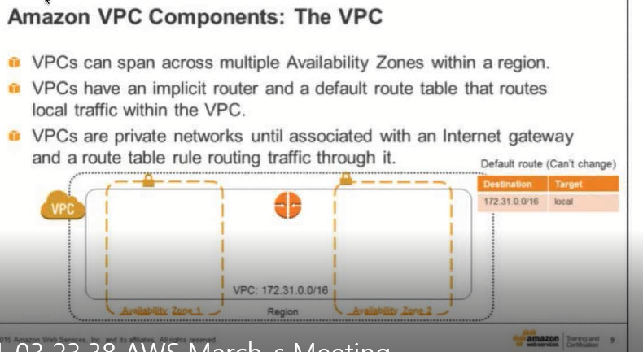

If at all we want a secure network or want to provide a security, then it is called a VPC.

------------------------------------------------------------------------------------

Every IP on this range will have internet access.

We need to give the subnet association, and then create a routing table.