# [How do I update Ubuntu using terminal command line](https://www.cyberciti.biz/faq/upgrade-update-ubuntu-using-terminal/)

# How do I update Ubuntu using terminal?

1. Open the terminal application
2. For remote server use the ssh command to login. For example:**ssh user@server-name**
3. Fetch update software list by running the **sudo apt-get update** command
4. Update Ubuntu software by running the **sudo apt-get upgrade** command
5. Finally, reboot the Ubuntu box by running the **sudo reboot** command.

Let us see all commands in details with examples.

**How do I upgrade Ubuntu using terminal?**

You need to use either [apt command](https://www.cyberciti.biz/faq/ubuntu-lts-debian-linux-apt-command-examples/?utm_source=Linux_Unix_Command&utm_medium=faq&utm_campaign=nixcmd) or [apt-get command](https://www.cyberciti.biz/tips/linux-debian-package-management-cheat-sheet.html?utm_source=Linux_Unix_Command&utm_medium=faq&utm_campaign=nixcmd). The apt command provides a high-level command line interface for the package management system. One can install new packages, update packages, remove/delete packages and performer other [sysadmin duties](https://www.cyberciti.biz/faq/what-is-the-role-of-the-system-administrator/) for package management using apt.

### How to sync the package index files from their sources via Internet

First, open the terminal application. Then run the following command:  
$ sudo apt-get update  
OR  
$ sudo apt update

### How to install the newest versions of all installed packages on Ubuntu

Next, execute the following command to apply package updates and patches:  
$ sudo apt-get upgrade  
OR  
$ sudo apt upgrade  
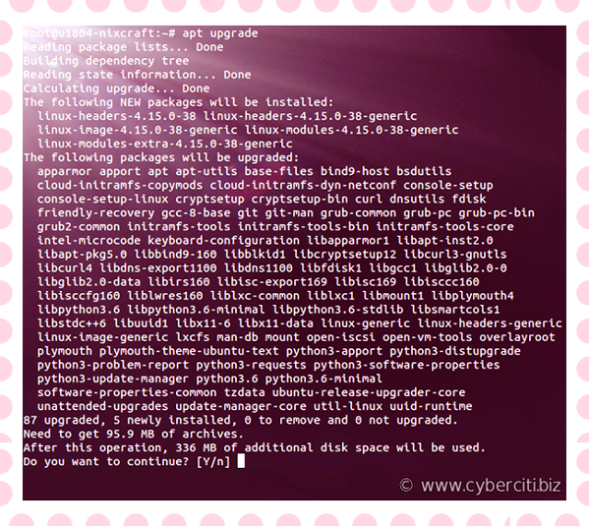  
Sometimes a new Linux kernel is installed to fix security bugs at the kernel level. Hence, you may need to reboot the Ubuntu [Linux server if kernel was updated](https://www.cyberciti.biz/faq/howto-reboot-linux/). Issue the following command for your cloud server or desktop:  
$ sudo reboot

### How to update already installed package named nginx

Want to upgrade existing packages to fix security or other issues? No problem. The syntax is as follows:  
$ sudo apt install PackageNameHere  
Alternatively, you can use the following syntax too:  
$ sudo apt-get install PackageNameHere  
Now, let us upgrade nginx package:  
$ sudo apt install nginx  
If nginx package is already installed it will try to update to latest version:

Reading package lists... Done

Building dependency tree

Reading state information... Done

nginx is already the newest version (1.10.3-0ubuntu0.16.04.2).

0 upgraded, 0 newly installed, 0 to remove and 0 not upgraded.

## Conclusion

You learned how to update or upgrade Ubuntu Linux using terminal-based session. The [apt command](https://www.cyberciti.biz/faq/ubuntu-lts-debian-linux-apt-command-examples/?utm_source=Linux_Unix_Command&utm_medium=faq&utm_campaign=nixcmd) or [apt-get command](https://www.cyberciti.biz/tips/linux-debian-package-management-cheat-sheet.html?utm_source=Linux_Unix_Command&utm_medium=faq&utm_campaign=nixcmd) have many more options. Therefore, I suggest that you consult the following manul pages using the [help command](https://bash.cyberciti.biz/guide/Help_command?utm_source=Linux_Unix_Command&utm_medium=faq&utm_campaign=nixcmd) or [man command](https://bash.cyberciti.biz/guide/Man_command?utm_source=Linux_Unix_Command&utm_medium=faq&utm_campaign=nixcmd):  
$ man apt  
$ man apt-get  
$ apt --help