Pyr0-Piezo MCU Update Procedure
Tools and components:
- Pyr0-Piezo Unit
- USB-UART bridge ~or~ Pyr0-Piezo Program Interface Board
- ICSP Programmer or ArduinoISP
- Soldering Iron
- Wire
- 10K resistor
- 100pF – 0.1uF Capacitor (ceramic is preferred)
- Arduino IDE (optional)
- avrdude
- MCUDude's MiniCore
- Pyr0-Piezo git project
Links:
Arduino IDE: https://www.arduino.cc/en/main/software
avrdude: https://download.savannah.gnu.org/releases/avrdude/
Pyr0-Piezo GitHib: https://github.com/pyr0ball/pyr0piezo
Hookup:
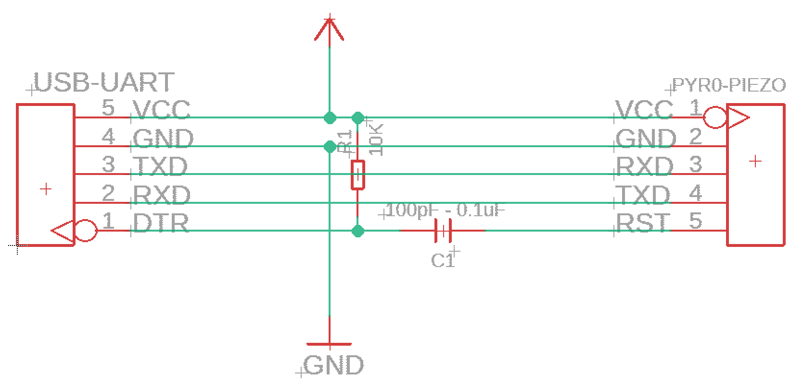
In order for serial (UART) programming to work, a capacitor must be placed in line between the Pyr0-Piezo RST pin, and the UART's DTR pin, and a 10k pullup resistor between DTR and +5v. ICSP programming requires no extra passive components. TXD/RXD pairs are inverted between sender and receiver
Programming With Arduino IDE
- Download and install the Arduino IDE, clone or download the Pyr0-Piezo project (git clone is recommended to ensure updates are pulled) to a folder of your choosing.
- Open firmware/AVR-Source/ and open the firmware ino file related to the board you're updating.
- Install MCUDude's MiniCore
  - Open File > Preferences, and add the MiniCore json to the “Additional Board Manager URL's” Field: https://mcudude.github.io/MiniCore/package_MCUdude_MiniCore_index.json
  - Click on Tools > Board > Boards Manager, use the search box to find “MiniCore”, and click the “install” button
- Choose the MCU used in your sensor
  - Click on Tools > Board > Select Atmega88 for Rev.1.x.x boards, Atmega328 for Rev.2+ boards. All other settings will be the same
  - Under Tools, set the following:
    - Bootloader: Yes
    - Clock: 8Mhz Internal
    - BOD: anything 2.7v or lower
    - Compiler LTO: Disabled
    - Variant: *8P/PA
- Set the programmer type to Programmer: AVRISP mkII
- Choose the COM port of your USB-UART bridge
- Make any adjustments to the top section of variables
- Click on “upload”
- Done!

Programming with avrdude
- Download avrdude (or find avrdude installed along with ArduinoIDE: Arduino/hardware/tools/avr/bin) and extract it to a folder of your choosing.
- Copy the firmware for your board out of /firmware/Compiled-Firmware/*.hex to the folder where you extracted avrdude
- run the following command, replacing the m88p with m328p if using a Rev.2+, and COM4 with the serial port of your USB-UART bridge
./avrdude.exe -c avrisp2 -p m88p -b19200 -PCOM4 -U flash:w:<firmware.filename>.hex -v
