Project Synopsis
Semester: 7th

1. Project Title: DevSync – Global Open-Source Contribution Platform
2. Project Type: Software Development.

3. Project Overview/ Abstract:
DevSync is a global, recurring open-source contribution platform designed to make open-source software (OSS) participation more accessible, consistent, and community-driven for students and early-career developers. The platform aims to bridge the gap between learners, mentors, and organizations by providing year-round opportunities for real-world open-source collaboration.
Unlike traditional seasonal programs, DevSync operates as a continuous contribution ecosystem offering hands-on mentorship, project exposure, and structured participation across multiple technology stacks. It fosters global collaboration by connecting university students, tech communities, startups, and enterprises under a unified platform.
The system also enables organizations to engage with contributors for branding, hiring, and sponsorship opportunities, thereby creating a sustainable open-source ecosystem. The platform is designed to scale globally while remaining beginner-friendly, inclusive, and impactful.
4. Problem Statement:
Open-source contribution plays a vital role in skill development and industry readiness; however, existing OSS participation models face several challenges. Opportunities are often limited to seasonal programs, corporate engagement at the student level remains low, and most initiatives lack inclusivity and global continuity.
Students frequently struggle to find structured pathways, mentorship, and long-term engagement in open-source projects. Existing programs are either annual, region-specific, or limited in scope, making consistent contribution difficult. There is a need for a global, recurring, and accessible open-source platform that lowers entry barriers and encourages continuous collaboration.
DevSync addresses these challenges by providing a unified, recurring open-source contribution framework accessible to participants worldwide.

5. Objective:
- To design and develop a global, recurring open-source contribution platform.
- To provide structured and beginner-friendly pathways for OSS participation.
- To enable year-round mentorship and real-world project exposure.
- To facilitate collaboration between students, developers, mentors, and organizations.

- To support corporate and institutional partnerships for sustainable engagement.
- To promote inclusivity across regions, experience levels, and technology stacks.

6. Methodology:
The development and execution of DevSync follow a structured methodology:
- Platform Design:
User-centric design focusing on accessibility, scalability, and community engagement.
- Community & Contribution Model:
Recurring open-source contribution cycles with guided mentorship and project allocation.
- Mentorship Framework:
Hands-on guidance from experienced developers and maintainers to support contributors.
- Engagement Strategy:
Year-round activities including contribution events, challenges, workshops, and webinars.
- Collaboration Model:
Integration with organizations and institutions for sponsorship, branding, and hiring opportunities.

7. Flow Chart/DFD/ER Diagram:

- ER Diagram:

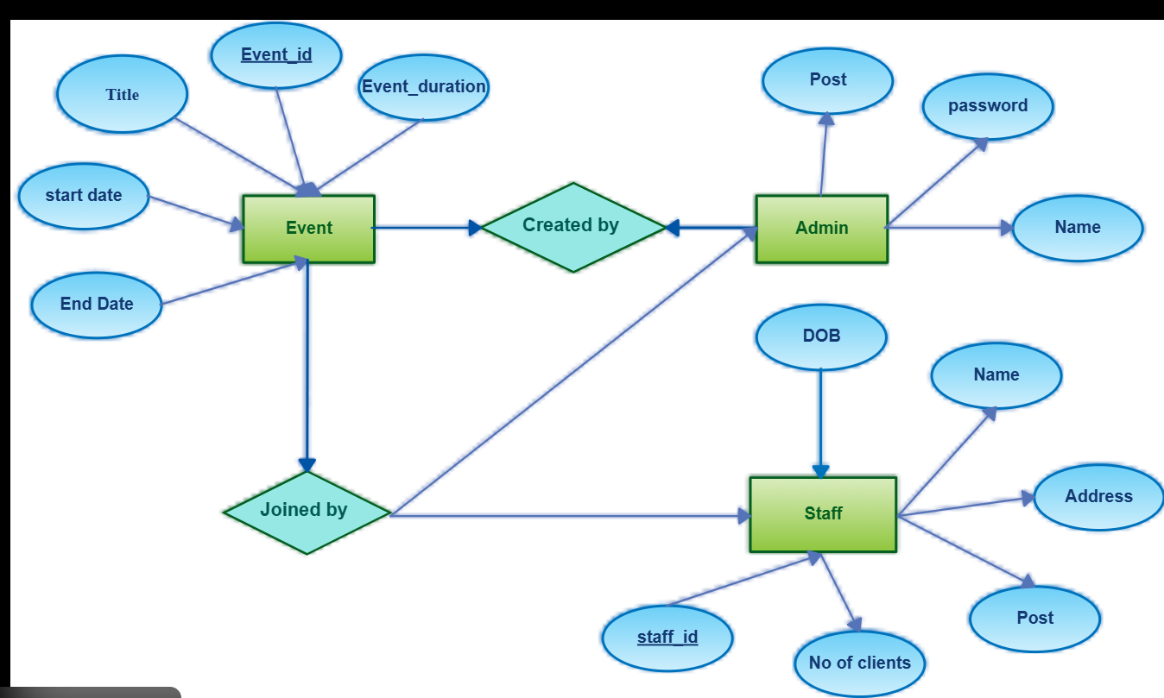

Fig1. ER Diagram

- Flowchart

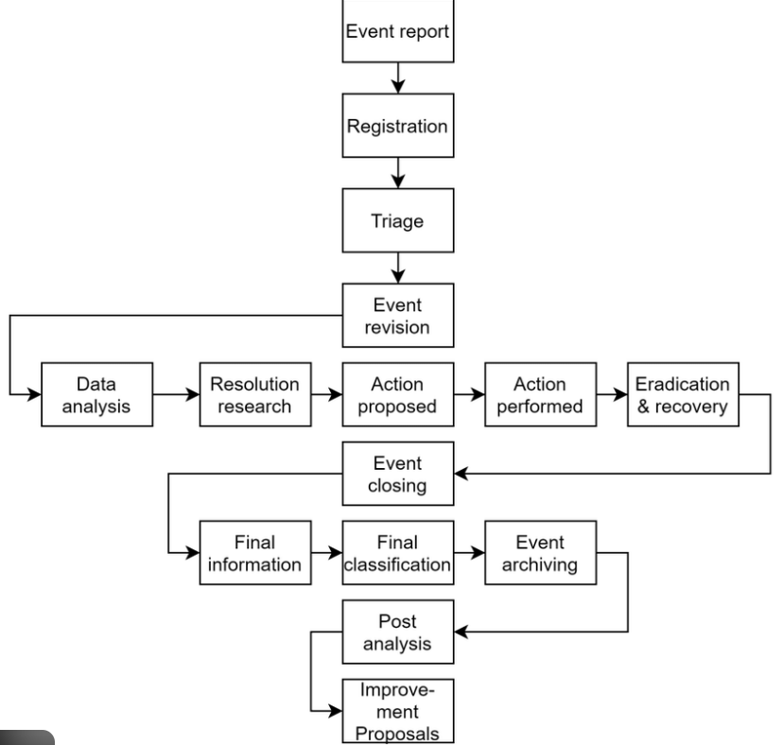

Fig2. Flowchart

8.Technical Details:
- Platform Type: Web-based application
- Core Features:
- Global recurring contribution events
- Mentor-guided open-source projects
- Beginner-friendly onboarding
- Gamification and rewards

9. Team Members:

SN | Name of Projectee | Enrollment | Univ.Roll No. | ERP | Contact no.
1 | YASHRAJ KUMAR | CB8320 | 301302222067 | 6602786 | 9416655502
2 | SAYAN KARMAKAR | CB8433 | 301302222124 | 6202000 | 7848948443
3 | ANSHIKA RAJ | CB8455 | 301302222143 | 6601893 | 7061960468
4 | RAVI | CB8398 | 301302222084 | 6601976 | 6203464933

Signature of Project Guide:  Prof. Jyoti Singh Kanwar | Signature of Project Coordinator:  Prof. Shweta Bandhekar
Head of Department
Dr. Tripti Sharma

