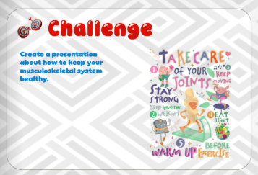

**📢 Assignment Alert! 🦴💪**

Hello, students! 🌟 Your next group assignment is all about **keeping our skeletal system healthy!** 🏃‍♂️🥦

🔹 **Task:** Each group will research and present **ways to keep our bones strong and healthy.**  
🔹 **Hints to guide you:**  
✅ Eat calcium-rich foods (milk, cheese, leafy greens).  
✅ Get vitamin D from sunlight and healthy foods.  
✅ Exercise regularly, especially weight-bearing activities.  
✅ Maintain good posture while sitting and standing.  
✅ Stay hydrated for strong joints.  
✅ Avoid smoking and too much caffeine.  
✅ Wear protective gear to prevent injuries.

📅 **Due Date:** [2/3/2025]  
💡 Be creative! You can present through posters, skits, or short presentations.

Let’s keep our bones strong and healthy together! 💪🦴✨