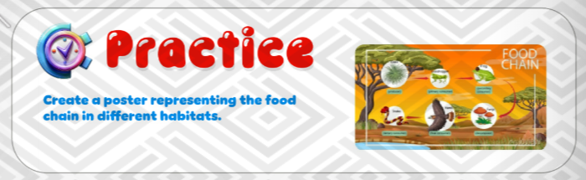

**📢 Assignment Alert! 🌿🔗**

Hello, young scientists! 🔬🌎

Your next task is to **create a poster for a food chain** that you will apply in your project! 🌱🦗🐦🐍

🔹 **Instructions:**  
✅ Choose a habitat (forest, ocean, desert, etc.).  
✅ Show the flow of energy from producers to consumers.  
✅ Use drawings, labels, and arrows to clearly represent the food chain.  
✅ Be creative and make it visually appealing!

📅 **Due Date:** [2/3/2025]

Let’s explore how living things depend on each other for survival! 🌍✨