**Person service REST API Documentation**

**How to build and run the application**

Once project has been checked out, go to the parent/root directory (person-management-service) and execute the below command and you can see the below output as mentioned in the screen shot.

**Command:** mvn clean install

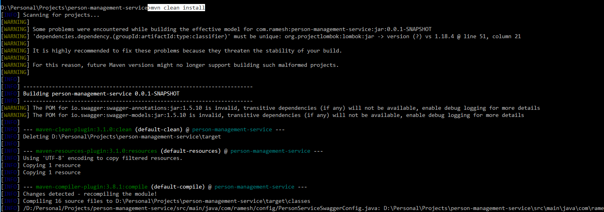

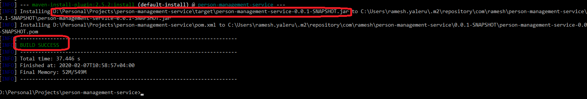

After build successfully, jar will be generated in the mentioned path (.\person-management-service\target)

**And go to that path and execute the below command to run the application**

**Command :** D:\Personal\Projects\person-management-service\target>**java -jar person-management-service-0.0.1-SNAPSHOT.jar**

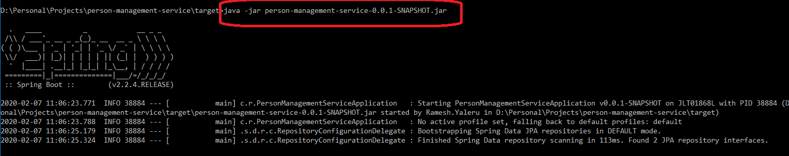

**HOW to test the application**

Once the application is up and running, the application can be tested two ways

1. POST man (POST man need to download)
2. Swagger API (no need to download)

**Swagger API Doc**

The swagger API doc can accessible with the below URL

<http://localhost:8080/swagger-ui.html#!/person-controller>

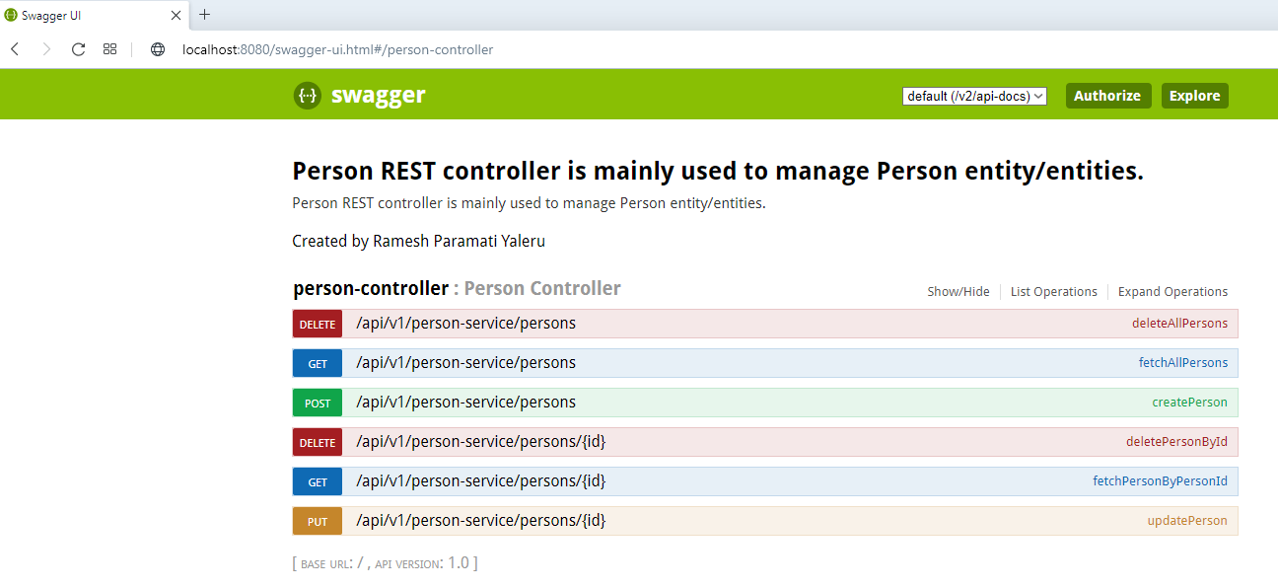

Enter JWT token here and click Authorize

**JWT Token :** **158a483339019a3b61eb7e2eae729fbc47360ee18381dfff9a77045d7f32f996**

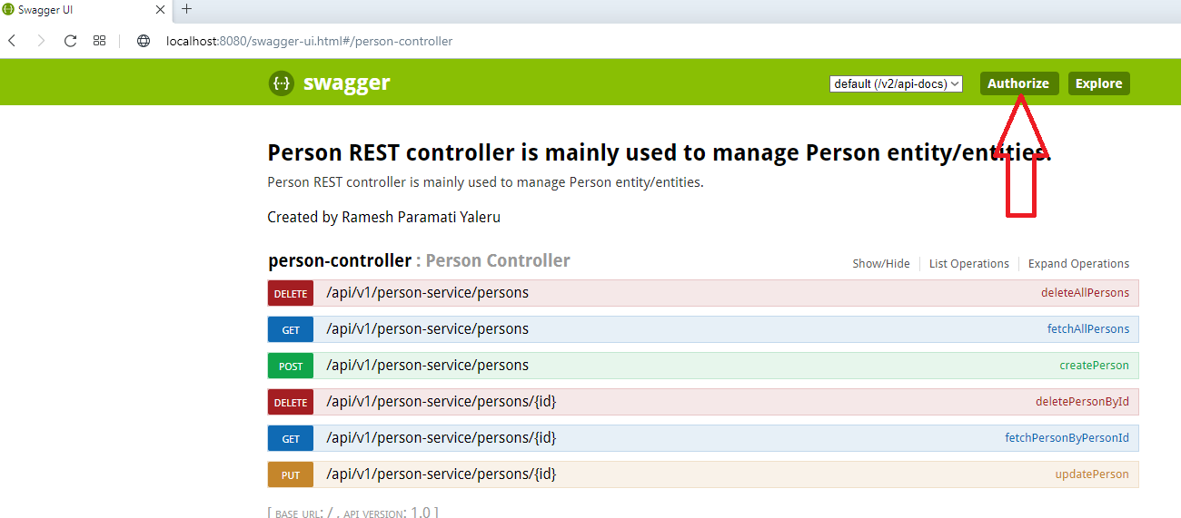

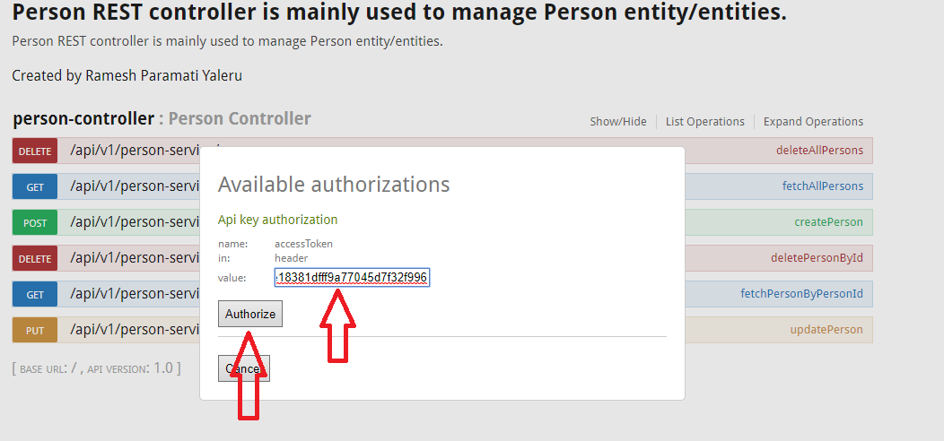

**How to test REST end points**

1. **Create a person**

Enter desired input and click “**try it out**”

Sample Input :

{

"person": [

{

"age": "30",

"favourite_colour": "blue",

"first_name": "ramesh",

"hobby": [

"cricket","football"

],

"last_name": "yaleru"

}

]

}

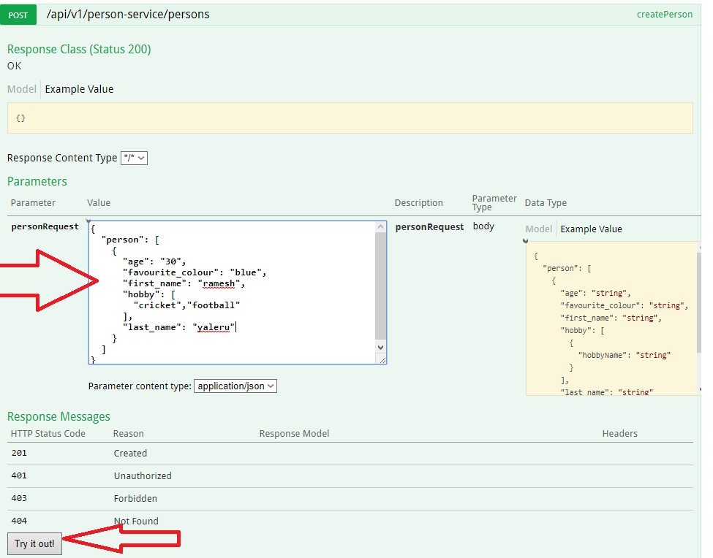

**And the output as below**

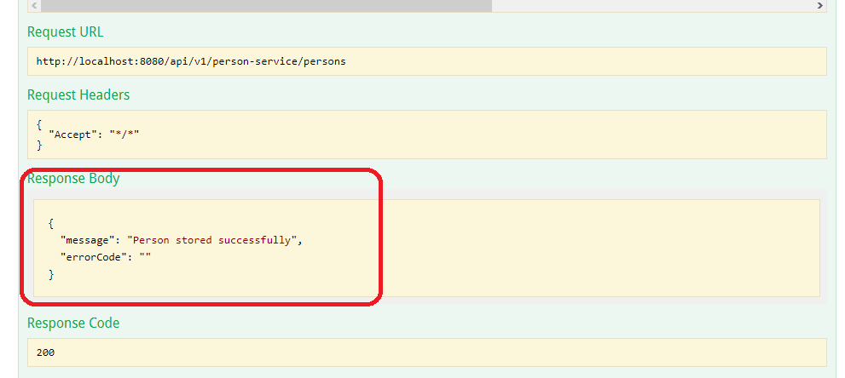

**Database**

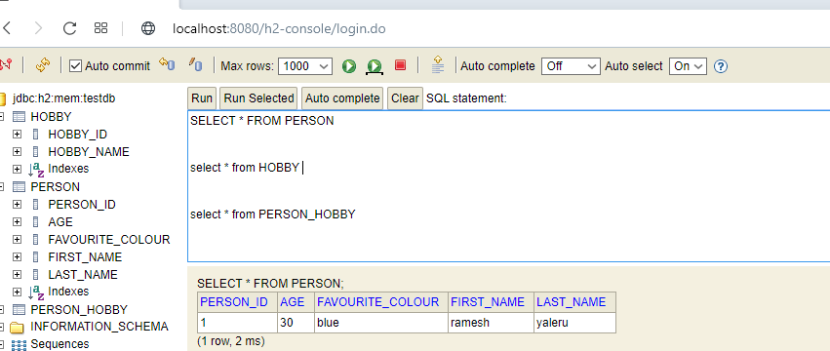

1. **Get ALL Person end point**

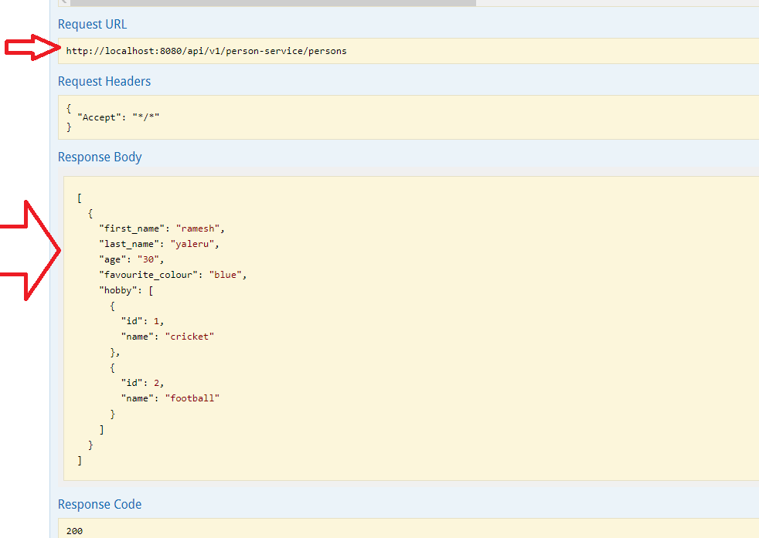

And similarly other endpoint can be tested.