**Application Architecture:**

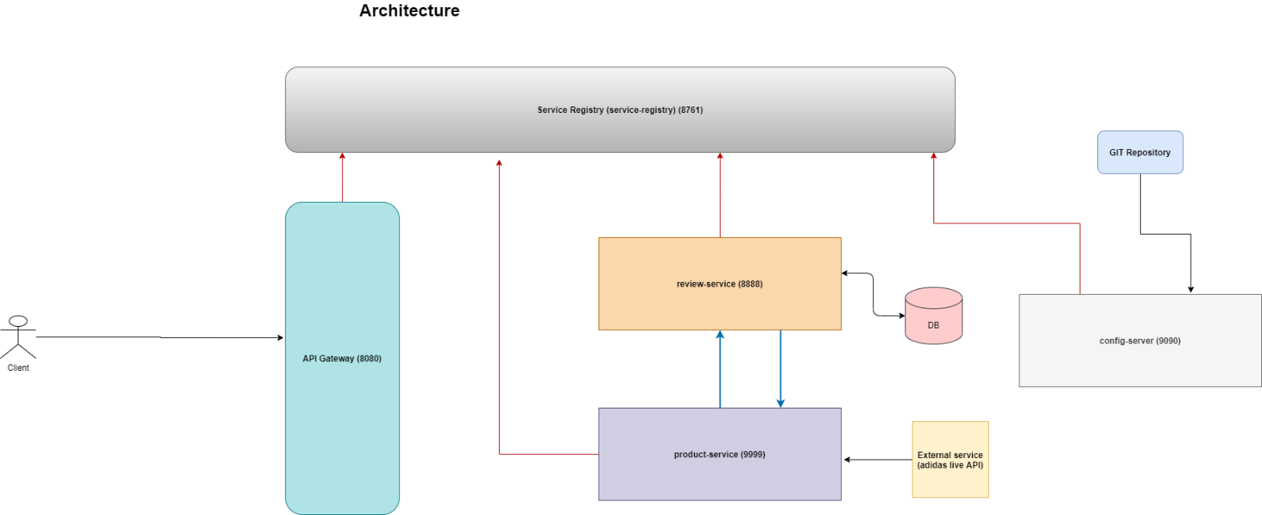

**Spring Cloud with Microservices:**

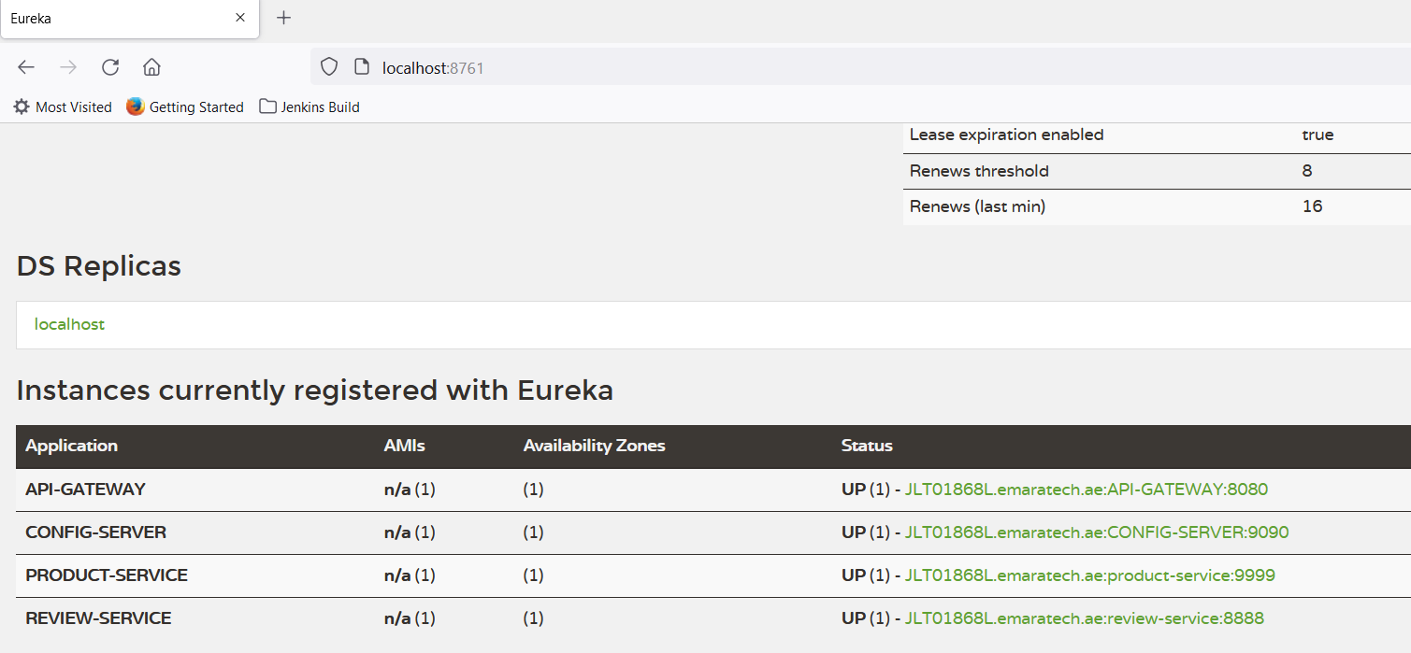

**REST Endpoints:**

**Create Resource:**

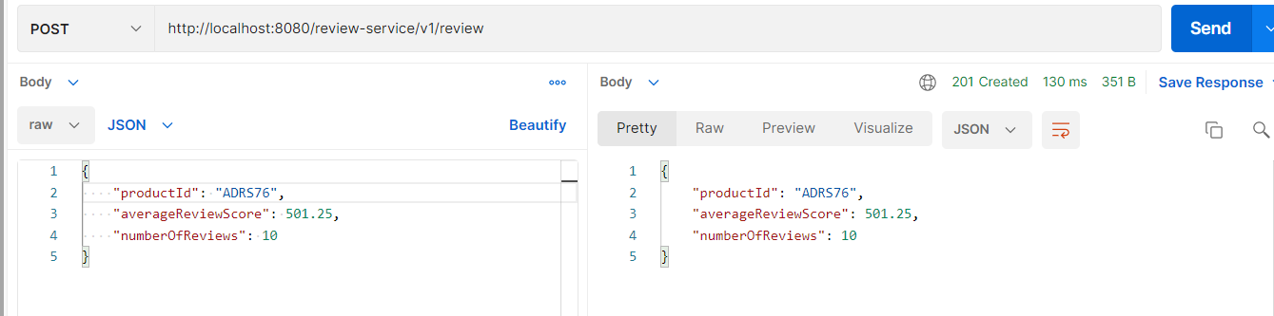

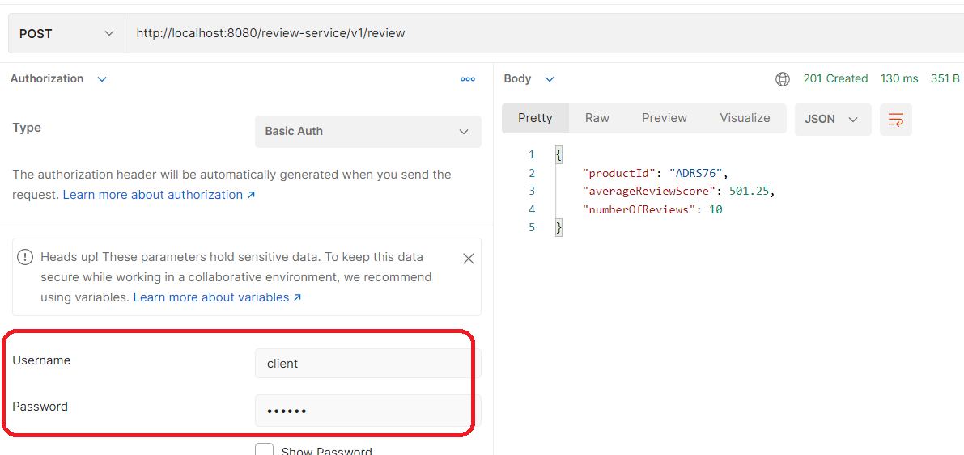

**Get Resource:**

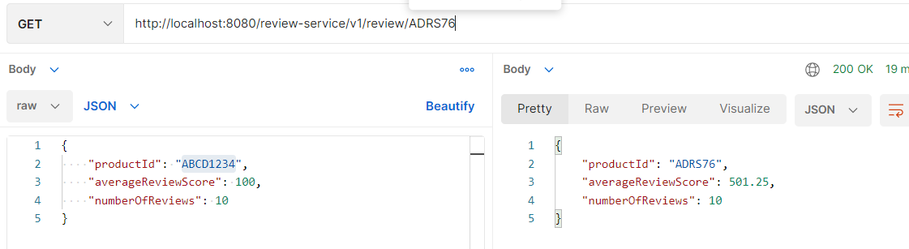

**Get Product resource:**

