Family leaders
These are teachers for the player and their peers. They have been hand-picked by Temesh for their unique skills and wisdom. The player may turn to them for advice and guidance during the course of the game.

Temesh Gildclaw
Done

Shana Bloodrunner
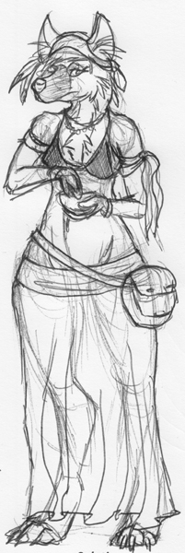
Role: Leader of the Bloodrunner family. Teacher of herbs, medicine and they ways of the beasts.
Personality: Calm, patient, open minded and well travelled. She will use violence when attacked but will tend towards disabling an opponent with minimal lasting damage.
Appearance: Mid 40s. She used to be an agile hunter and she did a lot of travelling when younger giving her a well toned form, but age is beginning to catch up with her and she accepts that. She wears light, simple clothing made from common materials. She wears a number of adornments too, all mostly made from natural materials (feathers, shells, small stones, etc).
Essentially some kind of tasteful blend of hippy and Goldenwolf... if that is at all possible.

Clarance Coppertail
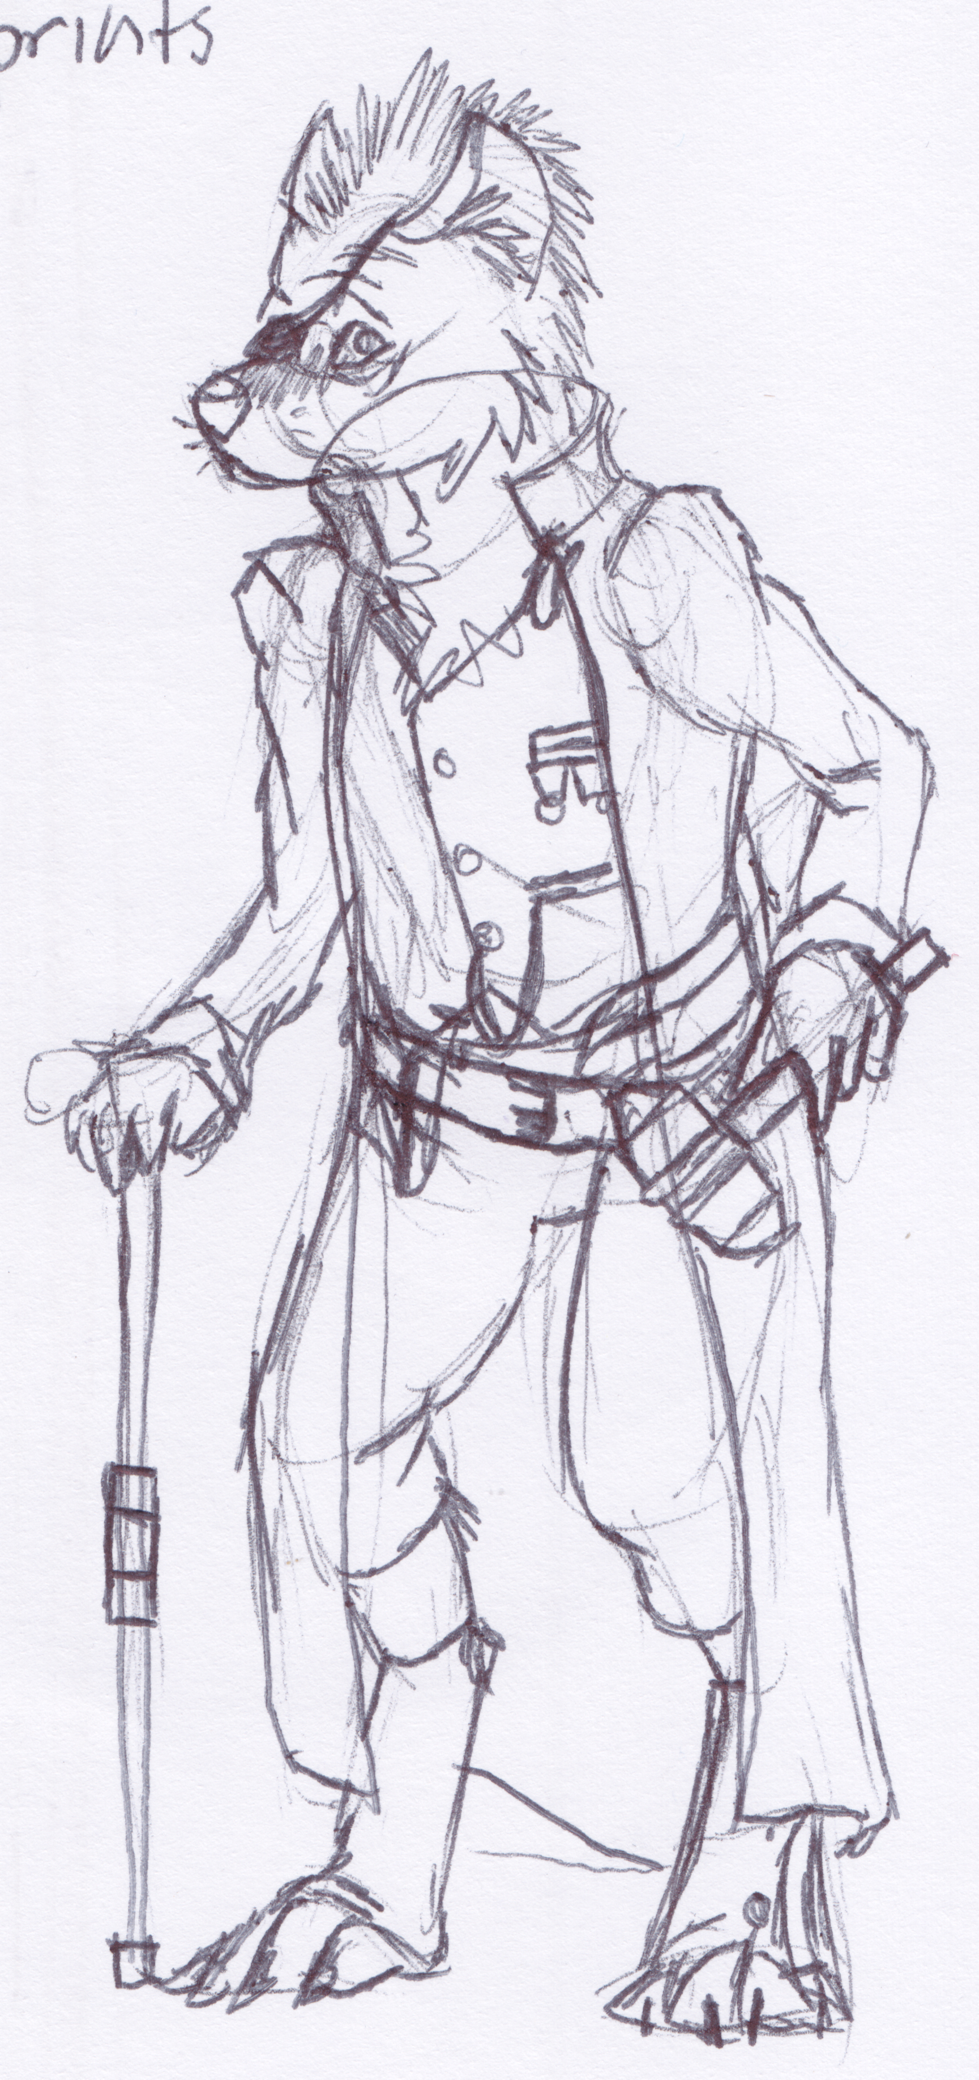
Role: Leader of the Coppertail family. Teacher of metalcraft, construction and all round tinkering. He's also the clans chief engineer.
Personality: Eccentric, easily distracted and endlessly fascinated with the unusual. He generally has a quite playful mood about most things. In a fight he will try to use the environment to his advantage to make up for his slightly runty stature.
Appearance: I am still very much undecided about if this guy is a relatively young fellow (techno wiz-kid) or old guy (steam engine worker, will talk your ear off about reciprocating pistons and pressure valves). I'm ok with whichever. But he was brought up by a human blacksmith and so keeps human styles in his dress, as well as his human- name. There are usually a half dozen or so gadgets and tools on his person at any one time (clockwork eye-glasses, spring loaded multi-spanners, etc).
A crude form of steampunk I guess.

Marrack Daggermaw
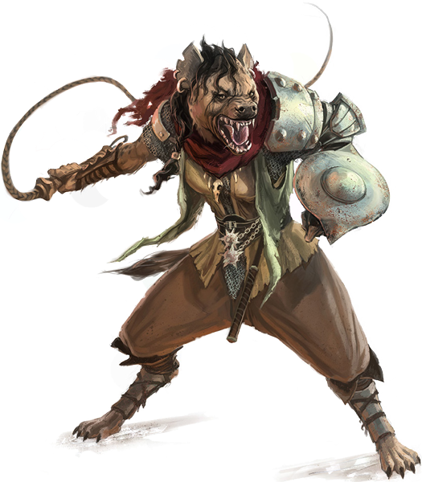
Role: Leader of the Daggermaw family and teacher of martial skills. She trains young gnolls to be warriors and keen scouts. She is also chief military strangest.
Personality: Rough and abrasive. She tends to be the most 'gnoll-like' of the characters. She has no tolerance for accepting weakness, but will get behind and support anyone wishing to improve themselves, no matter their starting point. In a fight she will gladly slaughter those that threaten her.
Appearance: Late 40s, same age as Temesh. Again, 'gnoll-like'. She is well built, hunched, scarred and will wear leather armour at all times. She always has at least two weapons on her, brutal ones such as axes or morning stars. She has a ragged cloak from the time she was employed in an experimental 'beast army' run by some rich Lord looking to cheaply conquer foreign lands. It didn't work, but Marrack found it fun.

Interacters
These are characters that will help or hinder the player in their quest for love. They each have an outfit for each family because they will join a different one to the player. They are potentially datable but difficult.

Ellie (Ally)
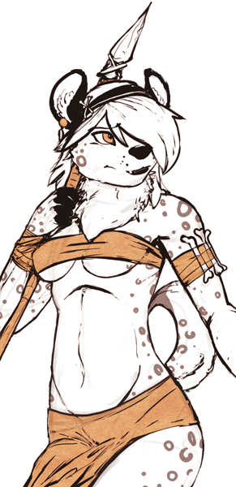
Role: Girl you grew up with. She serves to help give you advice on dating and can also supply information on the potential dates as well as what the Rival is up to.
Personality: Kindly but stern in the face of defeatism. She has a playful attitude but will not take shit from anyone talking down to her.
Appearance: Bright eyes. Tends towards the practical- but with a flowery touch.

Charrd (Rival)
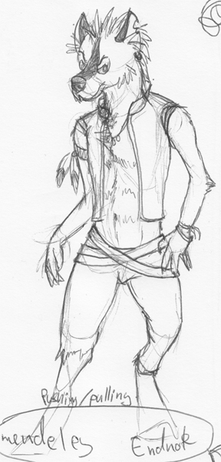
Role: Provides an obstacle to the players romantic pursuits.
Personality: Hot-blooded, always thinks he's right. An ass hole. He is secretly quite insecure and holds a low opinion of himself but tried to overcompensate publicly.
Appearance: Sinewy. He always tries to be showy with what he wears.

Datables
The four main gnolls the player can date.

Kacela (Hunter)
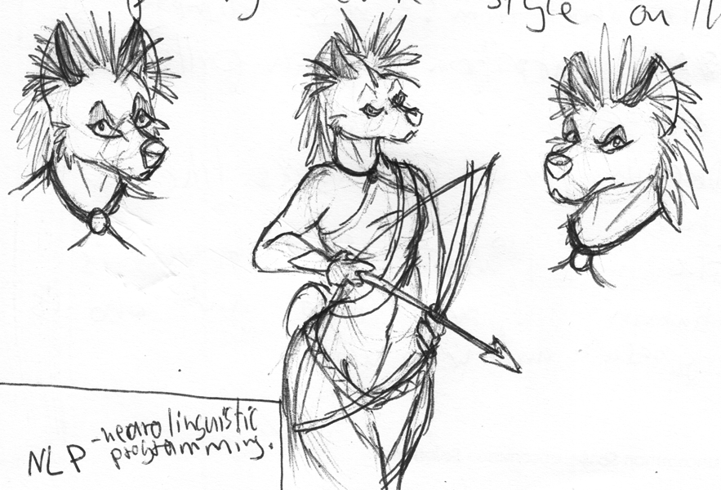
Role: She is a hunter in training.
Personality: Hot blooded and impatient. She tends to take things seriously but has a tender side under the spikiness. She has a real appreciation for the beauty of nature and a love of family and clan lore.
Appearance: About 19. Athletic build. Her clothing tends towards practical and minimal but with enough storage for hunting and survival equipment (knives, ointments, a water bottle, etc). Maybe some face or body paint based on old traditions of the clan.

Maria (Mechanic)
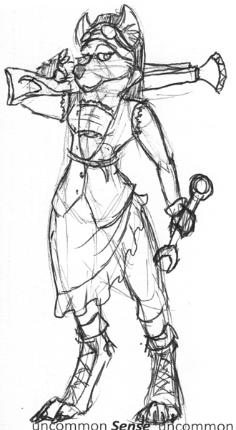
Role: Trainee mechanic.
Personality: All Coppertails are a bit weird and odd, Maria is no exception. Bright, bubbly and almost as easily distracted as Clarence. She is a bit oblivious in social situations, but can get really animated when talking about areas of interest for her.
Appearance: About 17-18. Unusually petite build for a gnoll female. She wears mismatched human clothing that is not incredibly practical or hard wearing- she just tends to grab things she likes the look of. She has long dreads that she ties back. Her fur is almost always scruffy.

Crasher (Fighter)
Not the final name, I need to find something not shit.
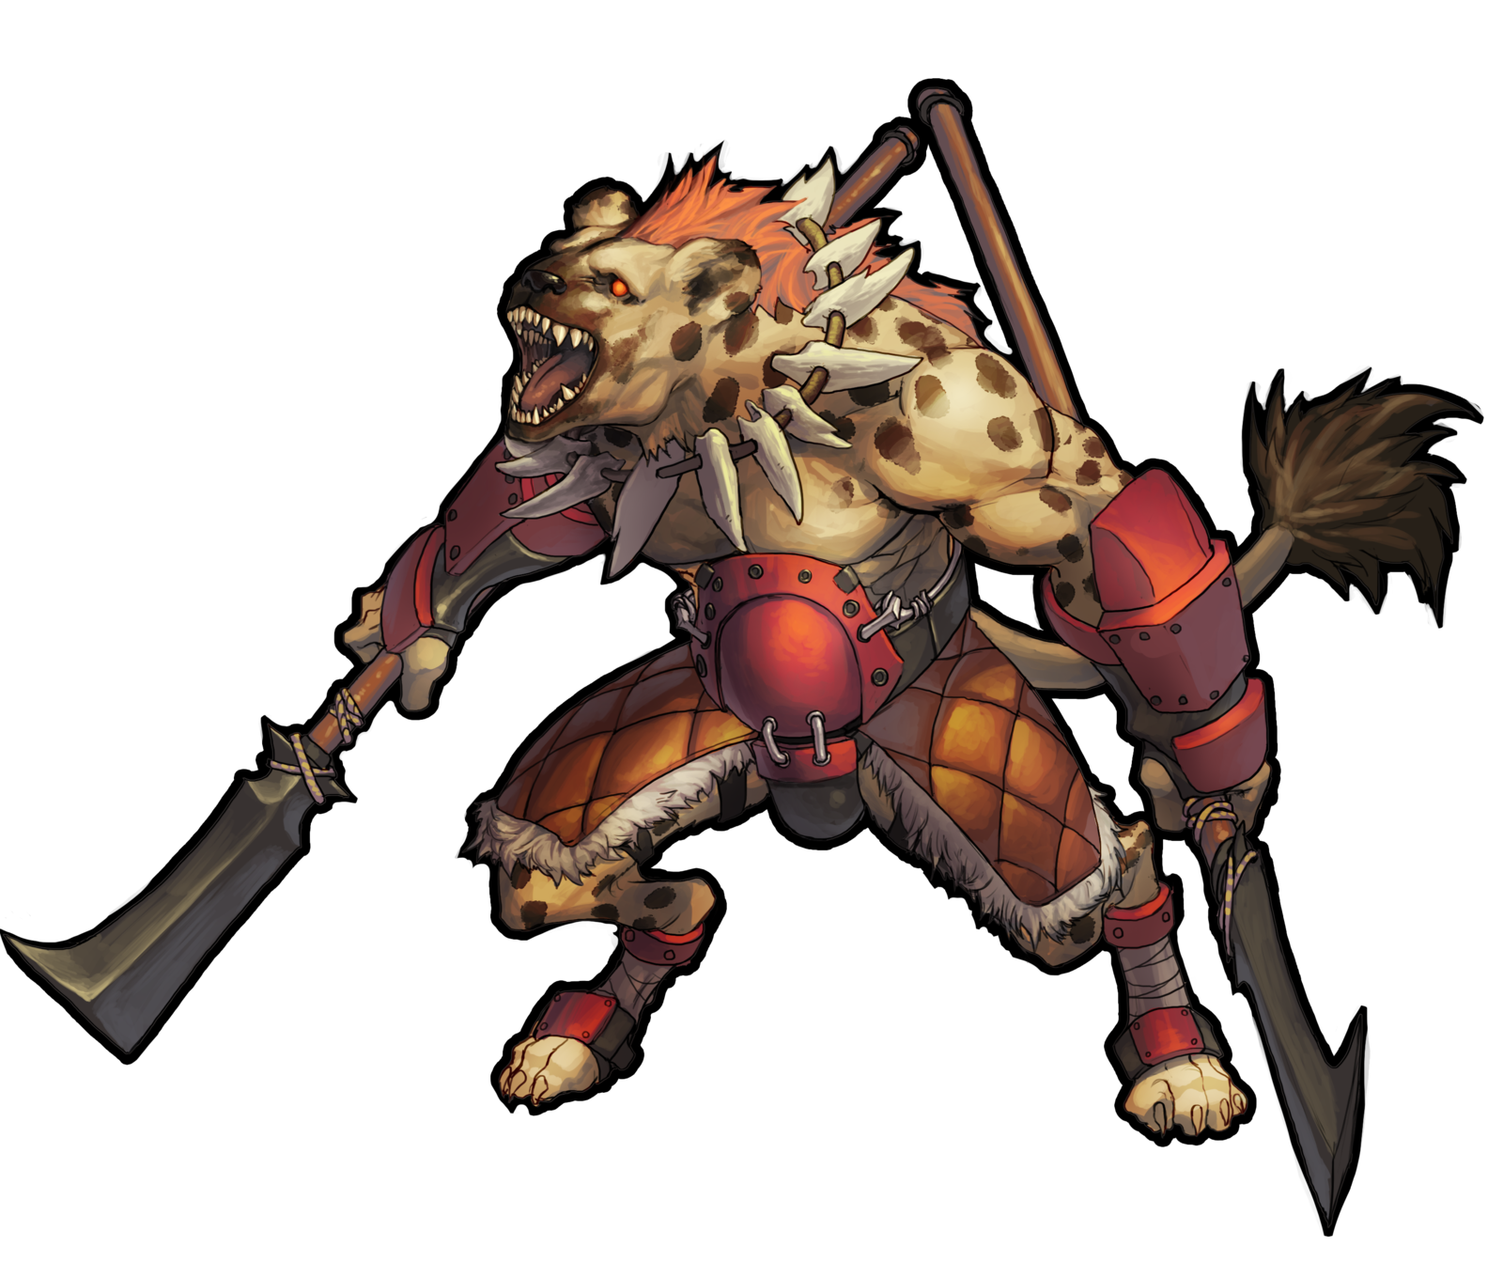
Role: Trainee warrior.
Personality: Rowdy and loud. He likes to challenge anyone to a fight if he can and will resort to fists if any form of conflict arises. He has a sensitive side though and a talent for painting. Could have been a Coppertail but was convinced that the Daggermaws needed his strength more than the Coppertails needed his art.
Appearance: 19-ish. Brutish and barrel-chested. He tends to like his muscles to show. He has acquired a number of scars already in his young life.

Denmar (Trader)
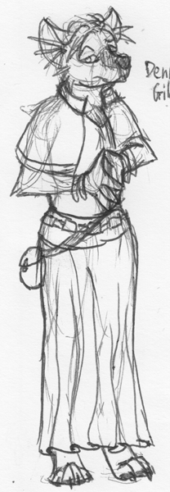
Role: Trainee trader
Personality: He tries to come across as well-read and confident but with an unfortunate lacking in expertise so that he will quickly get out of his depth and become nervous.
Appearance: 18 or there about. Slick and well dressed, he has a slender build. He has a slightly exotic cast to his features and faint stripes in his fur suggesting that there is some striped hyena gnoll blood in him.

