WTFPOS
Per-Location Setup Topology
Prepared by: Arturo Jose T. Magno | Client: WTF! Corporation (Christopher Samonte, CEO)
Last updated: March 11, 2026
Each location runs one Mini PC as the SvelteKit Node server — the single source of truth for that branch. All other devices (cashier tablet, kitchen screens) are thin clients: Android tablets running Chrome browser, pointed at the mini PC over local WiFi. No data replication, no sync — every device reads and writes to the same server.

Internet is NOT required for daily operations. Internet is only needed for: owner cross-branch dashboard and cloud backup (Phase 2).

Alta Citta — Tagbilaran (tag)
Location: Alta Citta Mall, Tagbilaran City, 6300 Bohol
Type: Retail — full POS + Kitchen + Stock | Tables: 20 dining tables
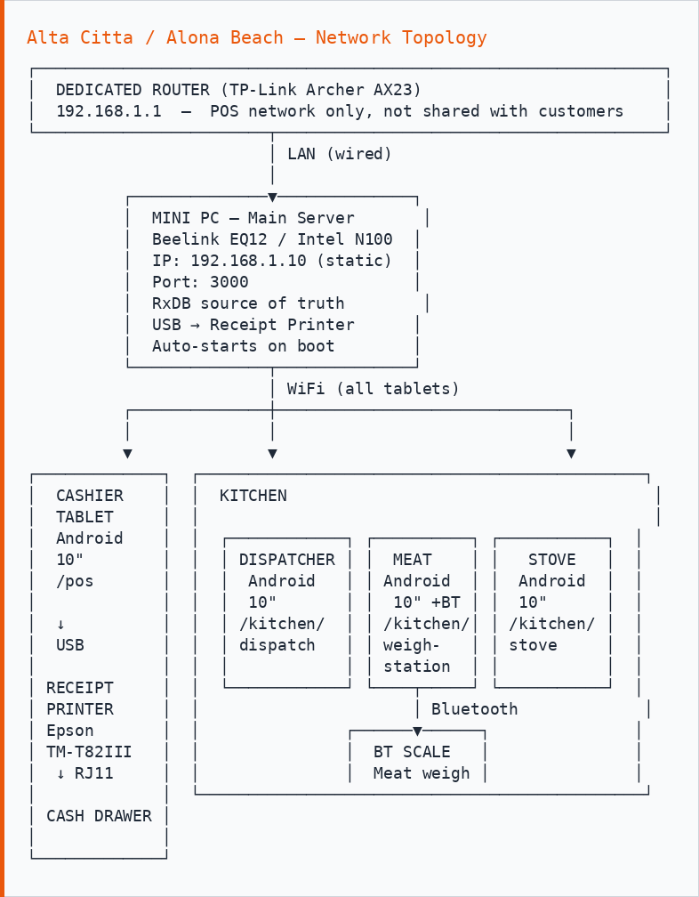

Device Roles
Device | Route | Role
Cashier tablet | /pos | Order taking, payments, checkout
Dispatcher tablet | /kitchen/dispatch | Expo — oversees all stations, sides queue
Meat station tablet | /kitchen/weigh-station | Meat weighing via Bluetooth scale
Stove tablet | /kitchen/stove | Dishes and drinks queue
Mini PC | — | Server, RxDB, print server, cash drawer trigger

Network
Device | Connection | IP
Router | — | 192.168.1.1
Mini PC | LAN cable (wired) | 192.168.1.10 (static)
All tablets | WiFi | 192.168.1.x (DHCP)

Print Flow
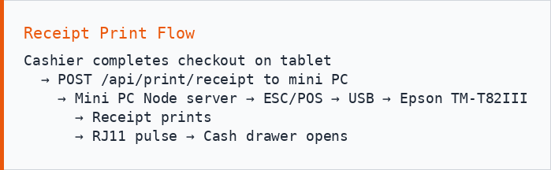

Alona Beach — Panglao (pgl)
Location: Panglao Circumferential Road, Alona Beach Rd, Tawala, Panglao, 6300 Bohol
Type: Retail — full POS + Kitchen + Stock | Tables: 20 dining tables
Identical setup to Alta Citta. Same device roles, same network layout, same print flow.

If IP addressing changes between branches, update the static IP assignment on the mini PC and the router’s DHCP reservation table.

Tagbilaran Central Warehouse (wh-tag)
Location: Tagbilaran City, 6300 Bohol
Type: Warehouse — inventory only (no POS, no kitchen)
Access: Stock receiving, deliveries, transfers to branches
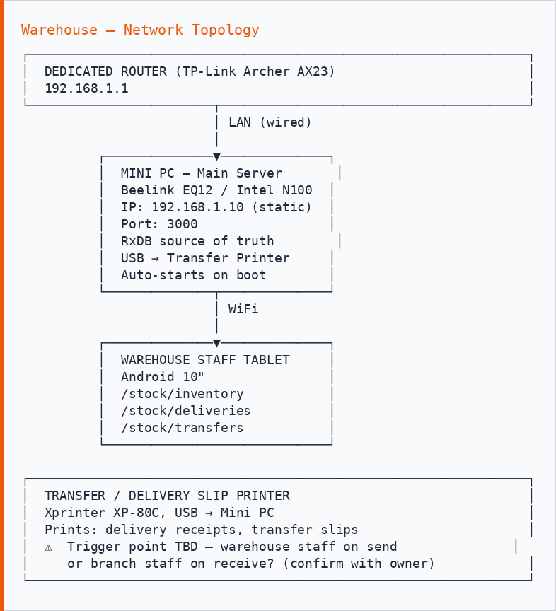

Device Roles
Device | Route | Role
Warehouse tablet | /stock/* | Receive deliveries, initiate transfers, stock counts
Mini PC | — | Server, RxDB, print server for transfer slips

What the Warehouse Does NOT Have
- No POS (/pos route hidden for wh-tag location)
- No kitchen screens
- No cash drawer
- No floor plan

Cross-Branch Owner View
The owner’s device (any browser, any location) can see both branches via the SSE aggregate — reads live order data from both Tag and Pgl servers simultaneously. Internet connection required.
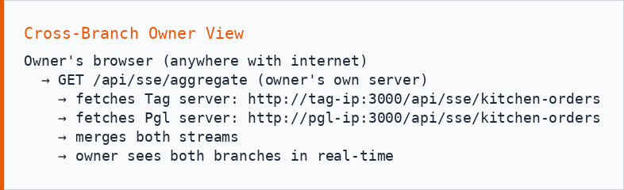

Phase 2 replaces SSE with Ably pub/sub channels for more reliable cross-branch real-time sync.

