Remote Monitoring and Control using GSM-SMS

Peter John
Student
Dept of Instrumentation Technology, VTU
Bangalore, Karnataka India
pyros2097@gmail.com

Abstract—Remote Monitoring, Control is one of the most important criteria for maximizing production and process plant availability. Wireless media has been undergoing a rapid innovation process in search for a reliable, simple and business-viable technology for fast, easy and inexpensive diagnosis of faults in industries. There has been much interest in remote monitoring and control in the field of the Industrial automation. There is a great deal of benefits for industries to adopt the wireless communication to control systems. The dominant mobile phone network in the world today is GSM. With the use of GSM SMS technology it becomes easier to monitor and control from far distance which makes it more reliable and efficient. The cost is also cheaper since most of the GSM towers are already made by service providers over large areas and can be readily accessed by the GSM modem for communicating wireless over long ranges.
Keywords-ARM Cortex-M4 (MK20DX128), GSM, SMS, Humidity Sensor(STH75), Temperature Sensor(LM35dz), Teensy3

INTRODUCTION
Remote Monitoring, Control and intelligent maintenance is one of the most important criteria for maximizing production and process plant availability. Wireless media has been undergoing a rapid innovation process in search for a reliable, simple and business-viable technology for fast, easy and inexpensive diagnosis of faults in industries. Today, growth is coming from global expansion and services. A new surge of growth will come through new technology, production at the lowest cost for global distribution, and fast time-to-market.
GSM (Global System for Mobile Communication) is widely used for mobile communication and is available where there is a mobile network coverage. It is a digital mobile communication network, which developed, rapidly in recent years. This network has coverage in most urban areas and offer support for the SMS that allows users to communicate with each other by sending short text messages to each other.
GSM offers a wide range remote monitoring and control applications. Many people use SMS(Short Messaging Service) provided by GSM service provides to send messages and receive messages. The SMS can be used as a way of communication protocol to monitor and control a process. Using SMS we can monitor the process variables of a Control System and also allow remote control of the System.
The use of mobile phones or handsets has grown exponentially over the years. As the number of mobile phone users increased, the technology and infrastructure supporting the handsets have also evolved to cope with the traffic created by the number of users.
The Field Operator can have access to the system which is in any remote location and has network coverage. The operator can use his mobile phone to send a message containing different commands to the system by using its mobile number which instruct the system on what operation to perform when it receives the message. This will allow the field operator to query all the process variables he wants to know and also control them.
Example : There are many pumps which fill water into overhead tanks spread across a wide region which has network coverage. We can connect our system to these pumps. The operator now can check out which pump is running and what is the level of water and also find out if there is any problem so that he can send maintenance engineers to the location. This makes the operator's life easy because he doesn’t need to visit every location and check if every pump is working.
In High Power Systems like the Inverters used in GSM Towers the temperature of the system has to be continuously monitored, if in case it exceeds the set point our system can be used to send a message to alert the field operator that the system has reached the critical point and needs to be checked for maintenance.
Measurement and control of temperature has significant appliance in industry, science, healthcare, agriculture and controlling technological processes. This proposed system monitors the temperature from and remote location and whenever the temperature crosses the set point it will send an SMS to the concerned operator via GSM Network.
Currently the common conditions of use of SCADA systems only allow for control and supervision to take place when the operator and the plant being observed are in the same general vicinity. It led to the emergence of the wireless remote monitoring and control systems. There has also been much interest in wireless communication in industrial sector for uses in automation as well as to increase the safety and security standards. There is a great deal of benefits for industries to adopt the wireless communication to control systems.
Recently, there has been much interest in remote monitoring and control in the field of the Industrial automation. This is the main objective and focus of the present work. The primary aim of this project is to propose the concept of Development of a Low-Cost GSM-SMS Based Temperature Remote Monitoring and Control system for Industrial Applications using the combination of a ARM Controller (MK20DX128) and a GSM communications module linked by a serial communications port. Using this temperature could be efficiently recorded from the remote location and whenever it crosses the set limit, the ARM processor will send an SMS alert to a concerned authority mobile phone. The concerned authority(s) can control the system through the mobile phone by sending commands to the System.

FUNCTIONAL BLOCK DIAGRAM AND DESCRIPTION
All the major subsystem blocks are shown with their interconnections to each module .The block diagram consists of Temperature Sensor (LM35) ,Humidity Sensor (SHT75), ARM Controller (MK20DX128) , GSM MODEM (SIM300), Controlling device Solid State Relay . In this application, the system was set up to monitor and control the temperature and ensures that it was within safe operating limits. The detailed descriptions of the blocks used in the system are explained below,
Figure 1. Function Block Diagram

ARM Cortex-M4 (MK20DX128)
The MK20DX128VFT5 is a 32-Bit Microcontroller with 16 KB RAM,128 KB Flash and available in QFN-32 package. It is a lowest power Kinetis ARM Cortex-M4 device with high feature integration in a small form factor, making them ideal for space and cost-constrained applications. Over 200 hardware and software compatible ARM Cortex-M4 MCUs with DSP + low-power, connectivity, communications, HMI and security features. Exceptional integration with fast 16-bit ADCs, DACs, PGAs and more. Powerful, cost-effective signal conversion, conditioning and controlFast, low-power 90nm Thin-Film Storage Flash.

GSM Module
GSM modem is a wireless modem that works with GSM networks. A wireless modem behaves like a Hayes compatible dial-up modem. The main difference between a standard Hayes modem and a GSM modem is that a hayes modem sends and receives data through a fixed telephone line while a GSM modem sends and receives data through radio waves.Like a GSM mobile phone, a GSM modem requires a SIM card from a wireless carrier in order to operate.GSM modems support an extended set of AT commands. These extended AT commands are defined in the GSM standards.
SIM300 is a Tri-band GSM/GPRS engine that works on frequencies EGSM 900 MHz, DCS 1800 MHz and PCS1900 MHz. SIM300 provides GPRS multi-slot class 10 capability and support the GPRS coding schemes CS-1, CS-2, CS-3 and CS-4.With a tiny configuration of 40mm x 33mm x 2.85 mm , SIM300 can fit almost all the space requirement in your application, such as Smart phone, PDA phone and other mobile device. The physical interface to the mobile application is made through a 60 pins board-to-board connector, which provides all hardware interfaces between the module and customers‟ boards. The SIM300 is designed with power saving technique, the current consumption to as low as 2.5mA in SLEEP mode. The SIM300 is integrated with the TCP/IP protocol，Extended TCP/IP AT commands are developed for customers to use the TCP/IP protocol easily, which is very useful for those data transfer applications.

Sensors
1. Temperature Sensor (LM35)
The LM35 is a high precision temperature sensor. It has a analog output, which is linearly proportional to the surrounding temperature. Just hook it up to a ADC pin on your micro-controller to get temperature readings. The LM35 series are precision integrated-circuit temperature sensors, whose output voltage is linearly proportional to the Celsius (Centigrade) temperature. The LM35 thus has an advantage over linear temperature sensors calibrated in ° Kelvin, as the user is not required to subtract a large constant voltage from its output to obtain convenient Centigrade scaling. The LM35 does not require any external calibration or trimming to provide typical accuracies of ±¼°C at room temperature and ±¾°C over a full -55 to +150°C temperature range. Low cost is assured by trimming and calibration at the wafer level. The LM35's low output impedance, linear output, and precise inherent calibration make interfacing to readout or control circuitry especially easy. It can be used with single power supplies, or with plus and minus supplies. As it draws only 60 µA from its supply, it has very low self-heating, less than 0.1°C in still air. The LM35 is rated to operate over a -55° to +150°C temperature range, while the LM35C is rated for a -40° to +110°C range (-10° with improved accuracy). The LM35 series is available packaged in hermetic TO-46 transistor packages, while the LM35C, LM35CA, and LM35D are also available in the plastic TO-92 transistor package. The LM35D is also available in an 8-lead surface mount small outline package and a plastic TO-220 package.

2. Humidity Sensor ( SHT75)
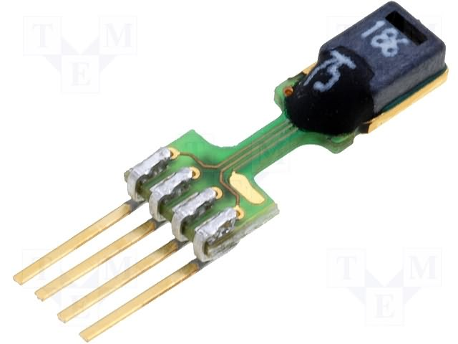
SHT7x is Sensirion’s family of relative humidity and temperature sensors with pins. The sensors integrate sensor elements plus signal processing in compact format and provide a fully calibrated digital output. A unique capacitive sensor element is used for measuring relative humidity while temperature is measured by a band-gap sensor. The applied CMOSens® technology guarantees excellent reliability and long term stability. Both sensors are seamlessly coupled to a 14bit analog to digital converter and a serial interface circuit. This results in superior signal quality, a fast response time and insensitivity to external disturbances.

D. Controlling Device
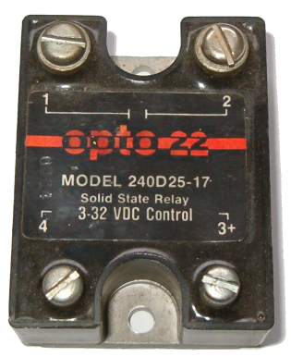
A solid-state relay (SSR) is an electronic switching device in which a small control signal controls a larger load current or voltage. It consists of a sensor which responds to an appropriate input (control signal), a solid-state electronic switching device which switches power to the load circuitry, and some coupling mechanism to enable the control signal to activate this switch without mechanical parts. The relay may be designed to switch either AC or DC to the load. It serves the same function as an electromechanical relay, but has no moving parts. Many SSR's use optical coupling. The control voltage energizes an LED which illuminates and switches on a photo-sensitive diode (photo-voltaic); the diode current turns on a back-to-back thyristor, silicon controlled rectifier, or MOSFET to switch the load. The optical coupling allows the control circuit to be electrically isolated from the load.

E. Mobile Phone
This device is used for sending and receiving SMS's by the operator. He can manually type the instruction commands to the system as a text message and send it. I've developed an GUI application for android phones, which makes it easier for the operator as he no longer needs to type the message manually. The application does it automatically, all he needs to do is learn to use the mobile application. The application contains different text fields and buttons which are used to display the different parameters of the system. By the pushing the buttons the operator can send instruction commands directly to the system.

HARDWARE IMPLEMENTATION AND DESCRIPTION
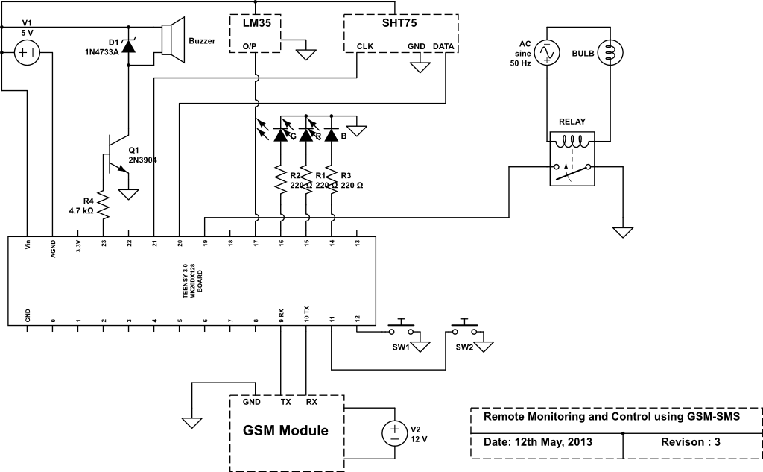
Figure 2. Schematic of System
The schematic of the entire system is shown in Figure 2. The Temperature Sensor measures the temperature and gives a proportional linear output voltage. This voltage is measured by the 10-bit ADC of the ARM Cortex-M4 micro-controller. The humidity Sensor measures the relative humidity and converts it to a digital binary format which can be accessed by the micro-controller through the data pin using 2-wire interface. The Buzzer is used as an alarm if temperature reaches above set point. There are 3 LED's , Red indicates error in communication, Blue indicates network connectivity, Green indicates communication working. There are also 2 buttons which are used for testing the message sending features. The first button when pressed sends the temperature value to the operator and the second button when pressed sends the relative humidity value to the operator. A Solid State Relay is used to control the temperature bu turning on/off the light bulb which is used as the heating element.

SOFTWARE DEVELOPMENT

Figure 3. Flowchart of System
The System starts and initializes the GPIO Ports first. Only the GPIO that is used by the circuit is initialized, such as Digital Input/Output pins, ADC, Serial Ports, buzzer, leds, bulb. The GSM module is then initialized so that effective communication can take place. The Temperature Sensor's ADC is initialized and all timers related to it also. The Humidity Sensors communication protocol 2-wire is initialized.
The humidity is measured. Then the temperature is measured. If the mode is automatic, the automatic control of the temperature is done. If mode is manual then the temperature can be controlled manually by the operator via SMS.
In Automatic Mode the temperature value is compared with the setpoint and if it exceeds the limit, then the system sends a message with the temperature value to the Operator and turns off the bulb which is used as a heating element. In this mode the operator can also set the temperature setpoint value to a new value by sending an SMS “SET integervalue” to the system.
In Manual Mode the heating element Bulb can be manually turned off and on. The operator can send “OFF” or “ON” message to the system mobile no, if he wants to manually turn off and on the bulb.
In both the modes the operator can also monitor the variables of the system by querying. The querying is done by sending SMS. If the operator sends the SMS “TEMP” to the system it replies by sending a SMS with the temperature value. If the operator sends the SMS “HUM” to the system it replies by sending a SMS with the Humidity value.

TESTING AND RESULT
System Testing | Test Case - 8
Name | Remote Monitoring and Control using GSM-SMS
Description | To Test whether SMS can be used to Monitor and Control the Temperature Control System
Expected Result | 1.)SMS - “TEMP” is Sent Then SMS - “Temperature : 35.00c” is returned  2.)SMS - “HUM” is Sent Then SMS - “Humidity : 55.20% RH” is returned  3.)SMS - “ON” is Sent Then  Bulb is turned on and SMS - “Bulb is on” is returned  4.)SMS - “OFF” is Sent Then  Bulb is turned off and SMS - “Bulb is off” is returned  5.)SMS - “SET 35” is Sent Then  setpoint is set to 35.00c and SMS - “Setpoint: 35.000000” is returned  6.)SMS - “AUTO” is Sent Then Automatic mode is set and SMS - “Automatic mode is set” is returned  7.)SMS - “MAN” is Sent Then Manual mode is set and SMS - “Manual mode is set” is returned
Actual Result | As Expected

Humidity  (% RH) | Temperature (°C) | Temperature  Setpoint (°C) | Mode | Received Message Content | Acknowledgment Message Content | Bulb Status
58.20 | 35.28 | 40.00 | MAN | ON | Bulb Turned on | ON
60.20 | 38.98 | 40.00 | MAN | OFF | Bulb Turned off | OFF
61.20 | 39.28 | 40.00 | AUTO | AUTO | Automatic mode set | ON
60.30 | 39.68 | 40.00 | AUTO | OFF | Please Change mode | ON
59.50 | 40.98 | 40.00 | AUTO | - | Temperature: 40.28c | OFF
60.80 | 41.28 | 40.00 | AUTO | SET 45 | Setpoint : 45.00 | OFF
62.00 | 40.98 | 45.00 | AUTO | MAN | Manual mode set | OFF
61.10 | 40.28 | 45.00 | MAN | TEMP | Temperature: 40.28c | OFF
59.20 | 39.25 | 45.00 | MAN | HUM | Temperature: 61.50% | OFF

SNAPSHOTS
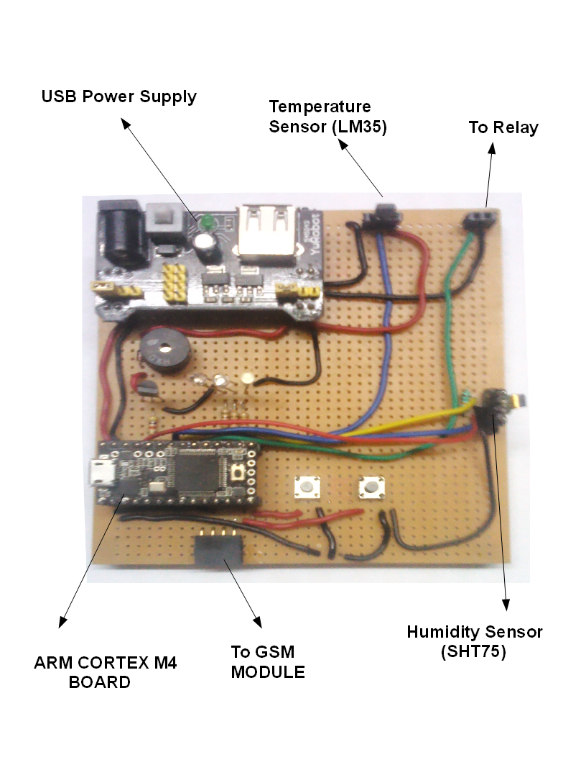
Figure 4. Development Board
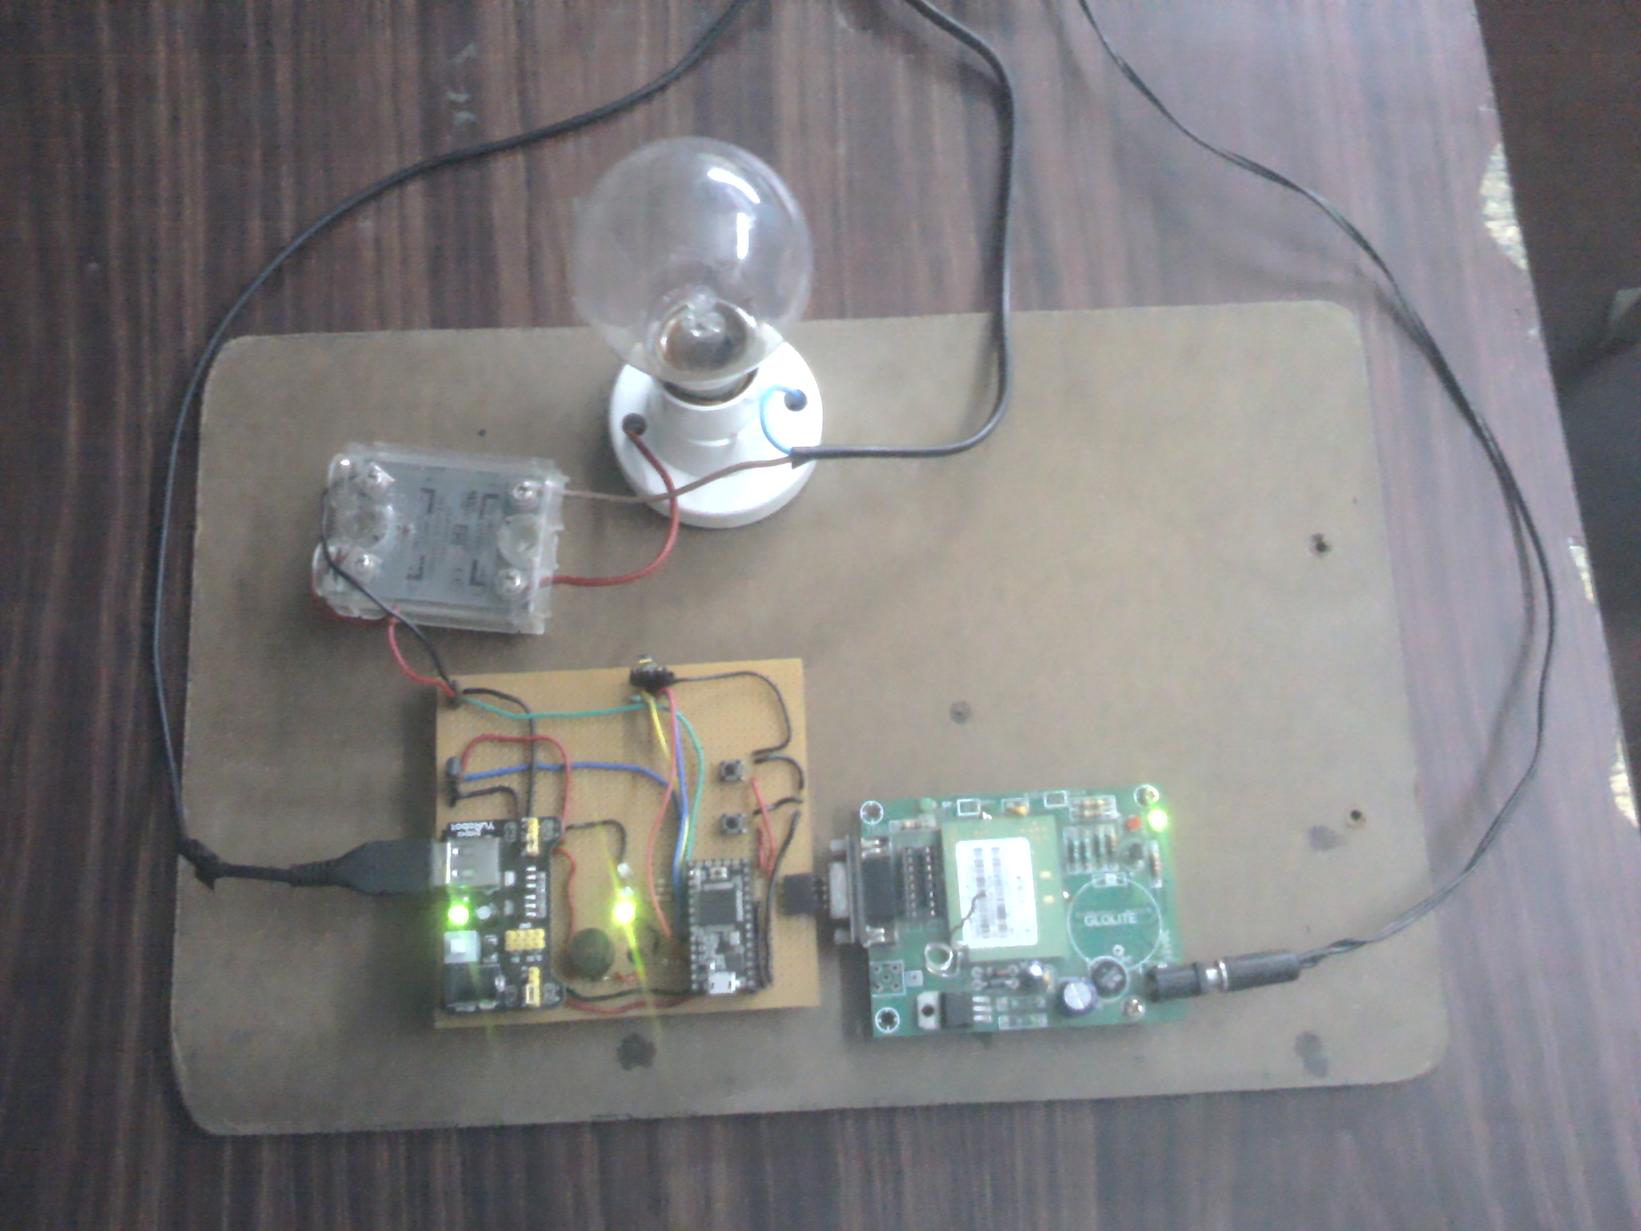
Figure 4. Development System

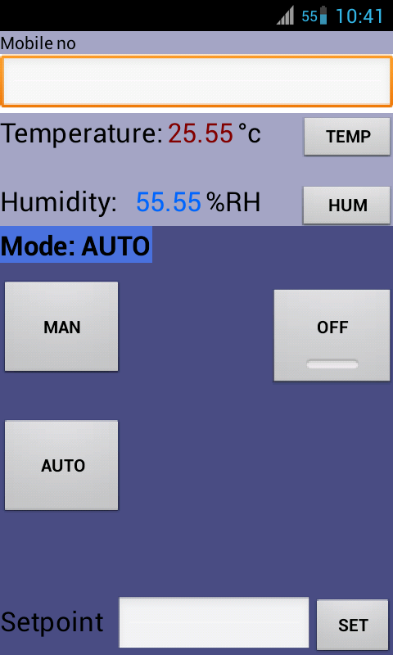

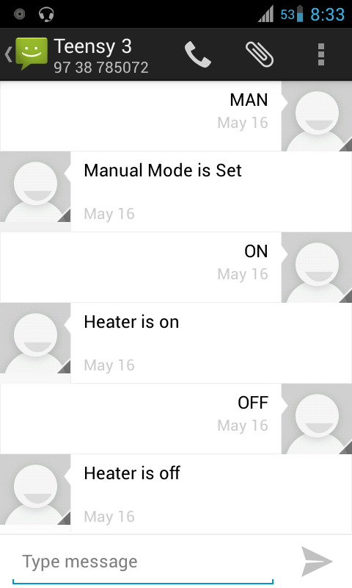
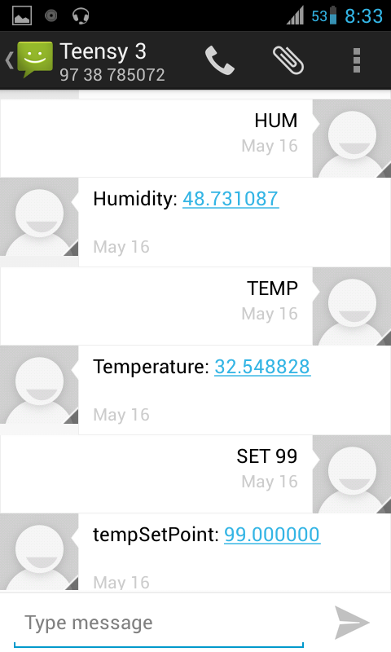
Figure 5. Android Application

VII. CONCLUSION
We have shown through our project that with the use of GSM module we can overcome the drawbacks of traditional wired SCADA systems which are used over long distances. Remote monitoring through long ranges by GSM allows Field Operators to easily manage the Plants which cannot be accessible by road easily. It allows the plant to become redundant because if any error occurs the plant will automatically notify the operator for repair and maintenance.
This system can be further improved by using GPRS packets for Real time Monitoring and Control which will allow complex process variables to be controlled by the operators remotely. This will allow any device which has connection to the internet to monitor and control the system through TCP/IP Protocol.
By creating mobile and desktop applications which can provide a Graphical User Interface (GUI) to the field operators, it bescomes easier to monitor and control the process variables and many instruments and devices can be easily controlled without the operator needing to type a text message for each function or instruction to the micro-controller.
Wi-Fi technology has been increasing considerably nowadays. Using Wi-Fi we can enhance the data rate at which the variables are transferred and Real Time Monitoring and Control is possible.

REFERENCES
- Robert Lafore, Object-Oriented Programming in C++, 4th ed, Pearson Education,, 2002
- Steve Furber, ARM System-on-Chip Architecture, 3rd ed, Addison-Wesley Longman Publishing Co., 2000
- Dr.B.Ramamurthy, S.Bhargavi and Dr.R.ShashiKumar, “Development of a Low-Cost GSM SMS Based Humidity Remote Monitoring and Control system for Industrial Applications”, (IJACSA) International Journal of Advanced Computer Science, Vol. 1, No. 4, October 2010
- Susmita Ghose and Dr.R.ShashiKumar, “Design and Development of Microcontroller Based SMS Gateway for GSM Mobile”, (IJAEST) International journal of advanced engineering sciences and technologies vol no. 2, issue no. 1, 090 – 098
- Arduino Open Source Hardware - http://arduino.cc/en/
- GSM - http://ewh.ieee.org/r10/bombay/news5/GSM.htm
- SIM300 Manual - http://www.simcom.us

