PARASH PHUYEL
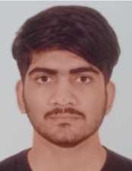
Address: Kanepokhari- 07
Phone: 9862026565
Email Address: parashphuyal809@gmail.com
Web Address: https://parashphuyel.com.np

OBJECTIVE:
Dedicated and compassionate paramedic aiming to utilize my clinical expertise to deliver high-quality medical care and contribute to saving lives in emergency situations.

SKILLS:
- Clinical Skills: Patient assessment, counseling, and treatment
➢ Triage, patient stabilization, and trauma management.
- History taking, physical examination, and medication.
- Communication Skills
- Problem Solving

EDUCATION:
- Koshi Health Institute, Biratnagar o PCL in General Medicine
- Coursework: Anatomy, Physiology, Pharmacology, Clinical Skills Training
- Shree Janakalyan Secondary School, Kanepokhari
o SEE

CLINICAL EXPERIENCE:
- Koshi Hospital (6 months in clinical practice) (as in OJT/internship) Key responsibility:
  - Observe and analyze patient handling, diagnosing, treating.
  - Taking vital signs, History of patient, Medications, Counseling and Examinations for the diagnosis.
  - Observe the major and minor surgery and assist surgeon, other staffs.

