Haokun (Daniel) Xu

ECE 4385

HW 2

NAND
- I included NAND because Dr. Bhuva talked about including all building blocks of the layout in class today (10/5).
Schematic
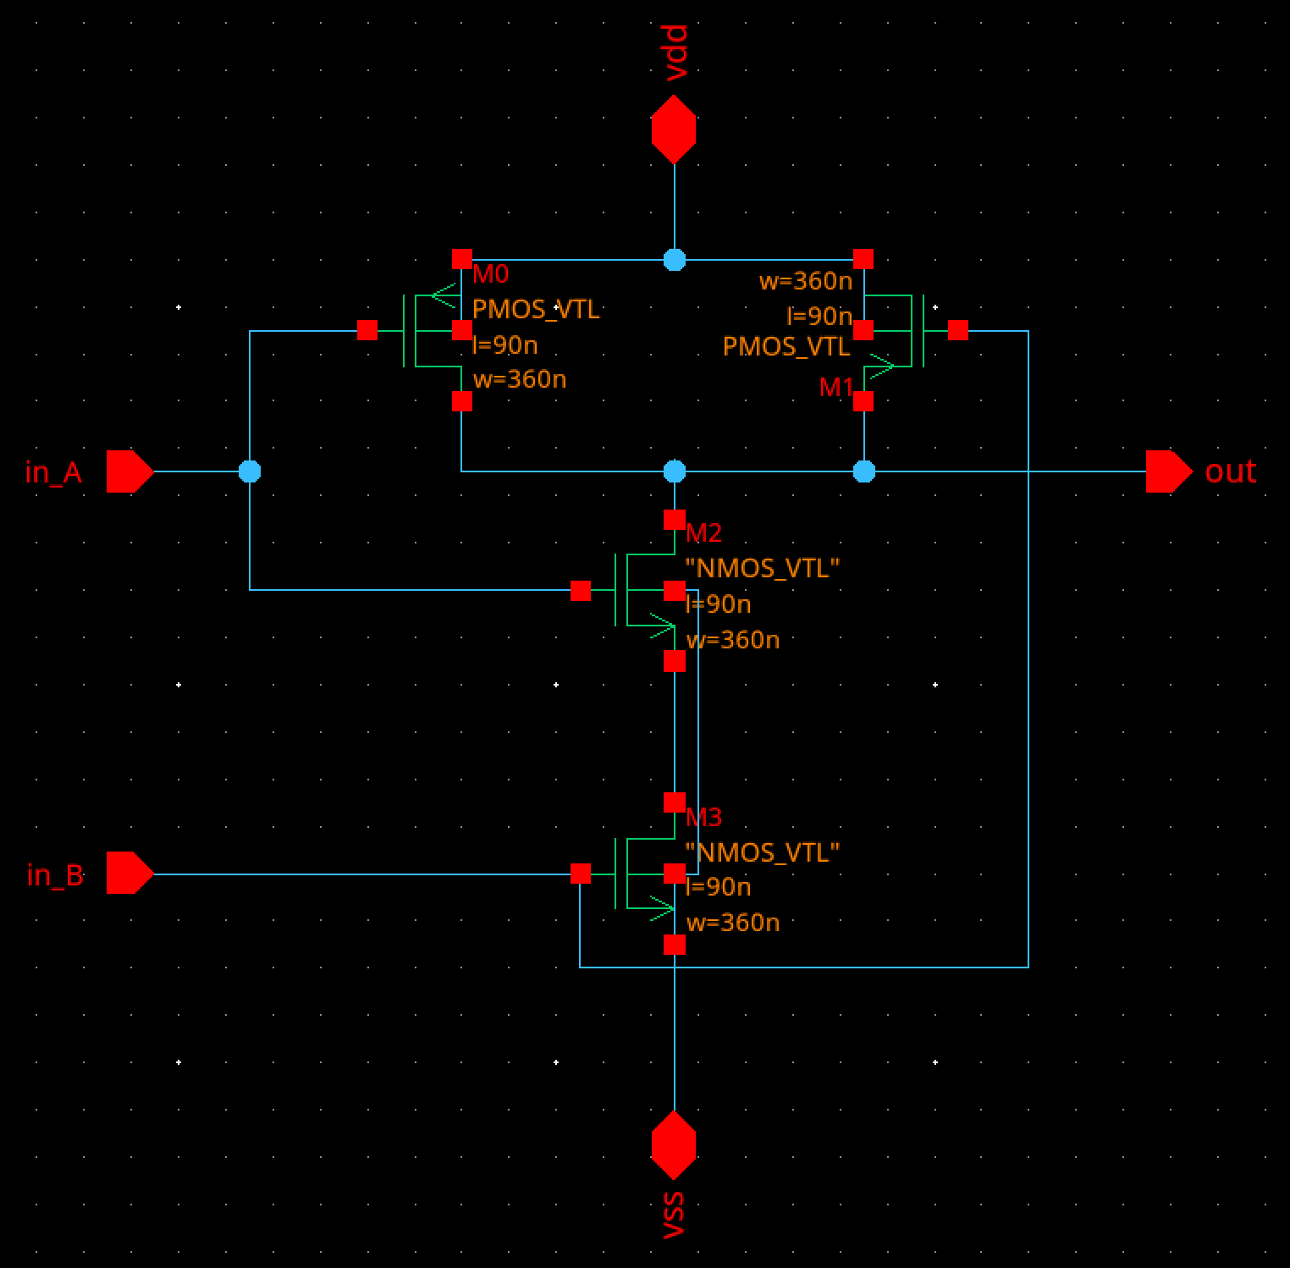

Symbol/Simulation Setup
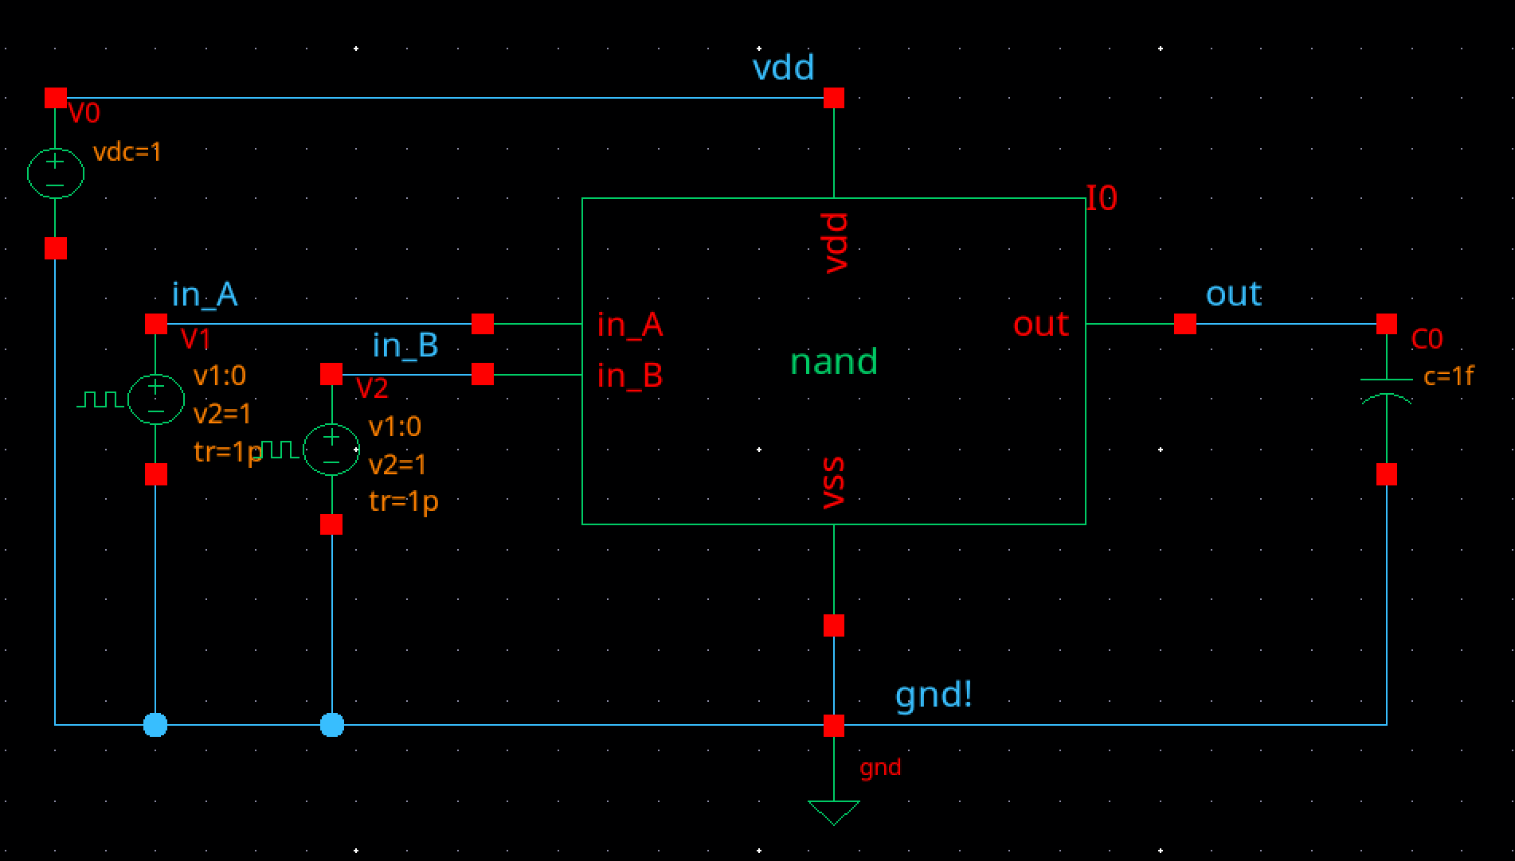
Simulation Results
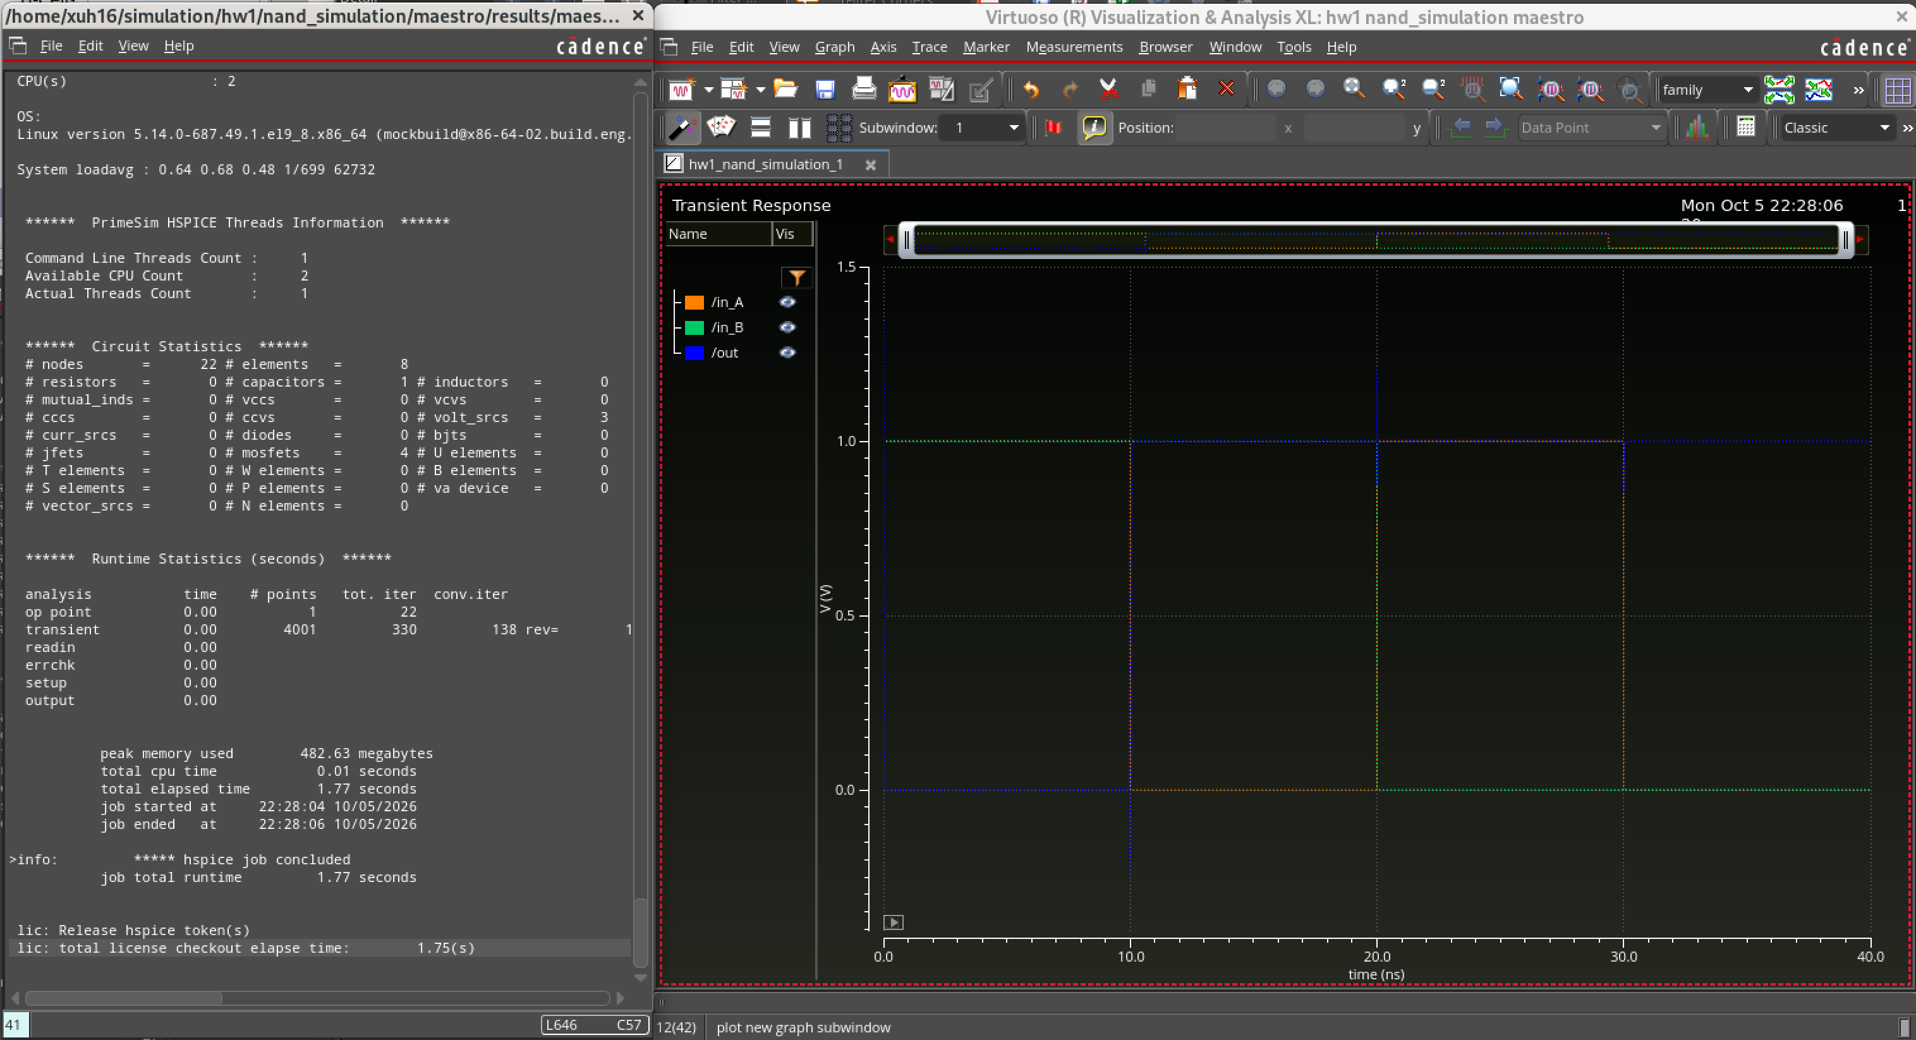

Layout
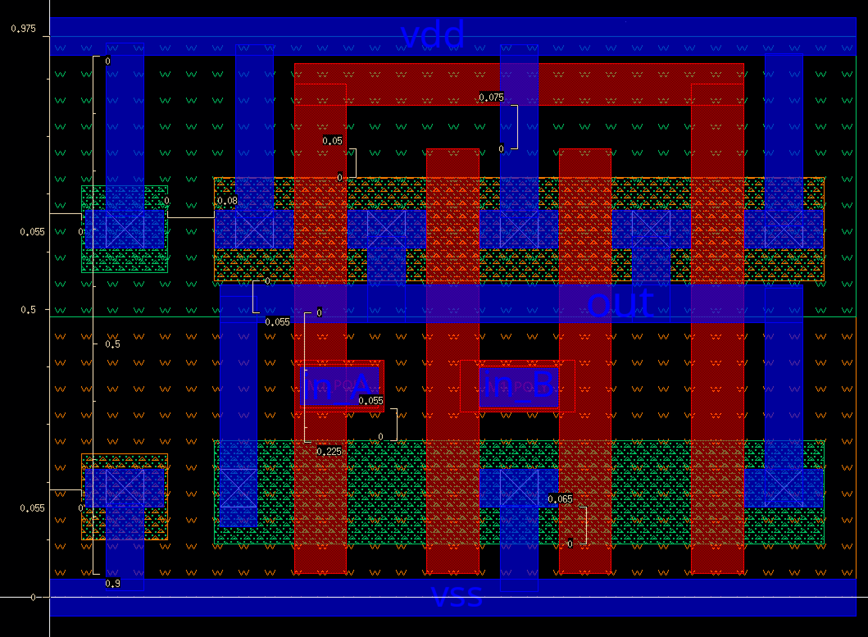
DRC
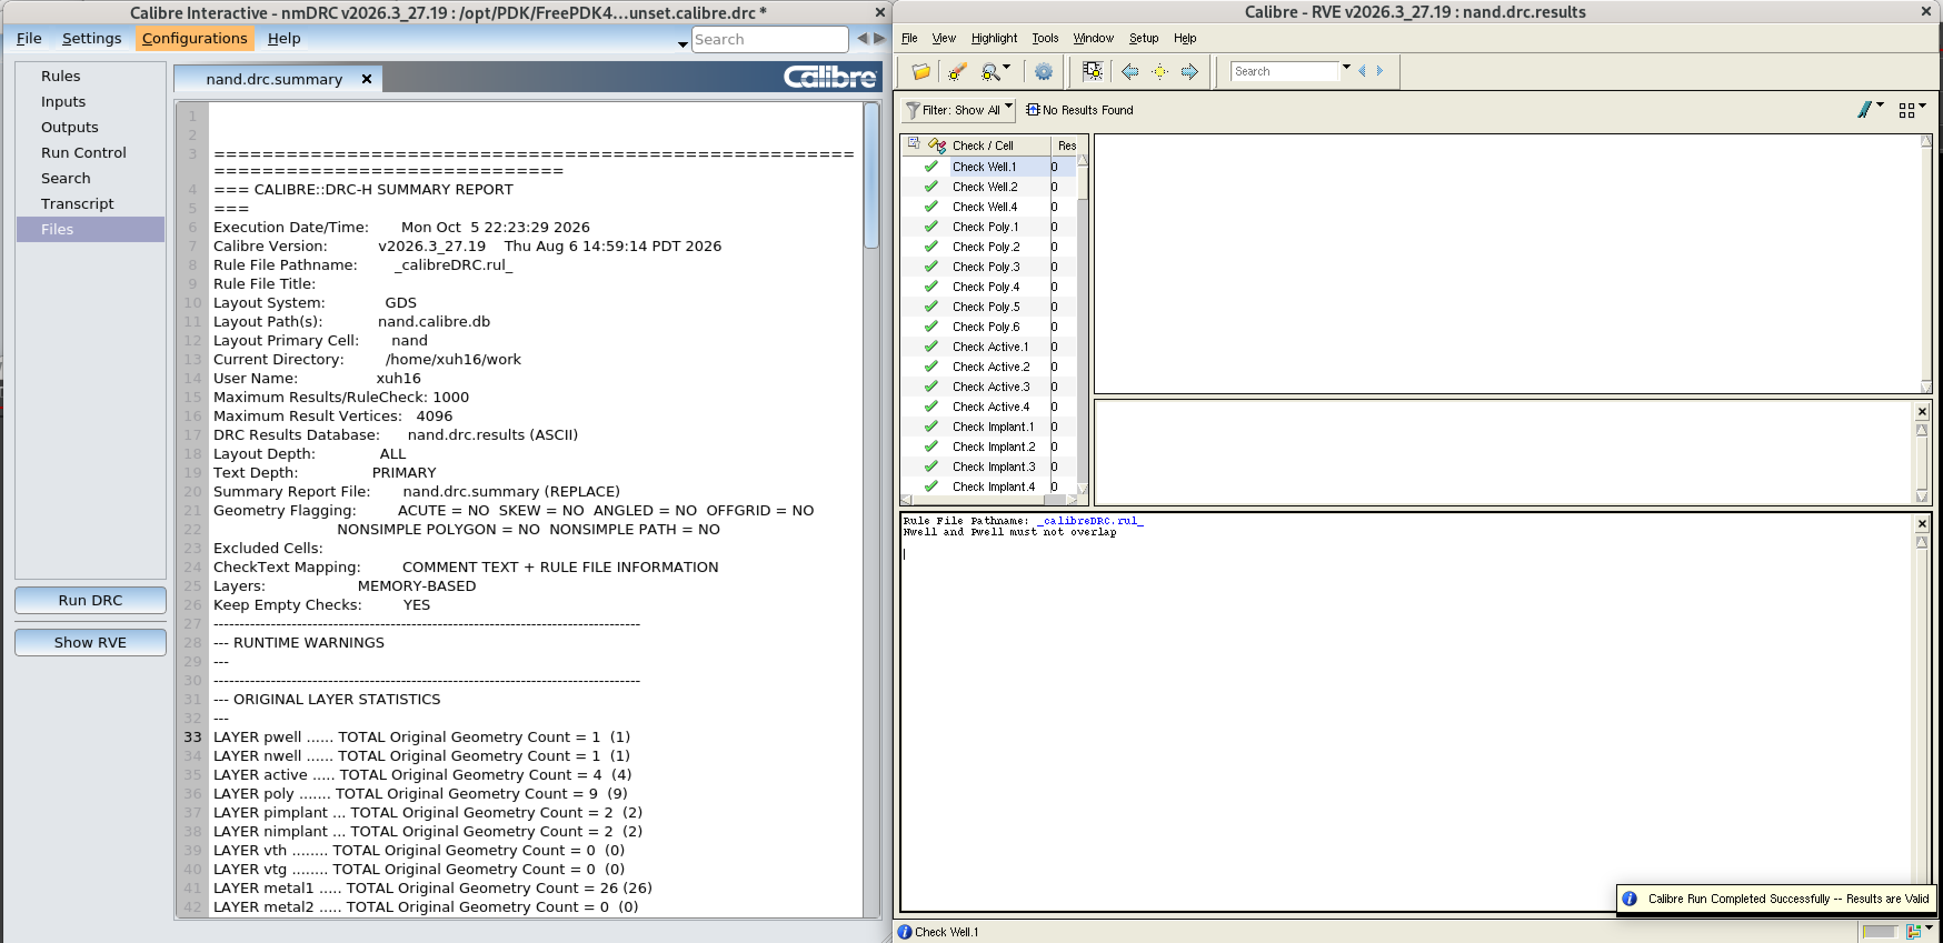
LVS
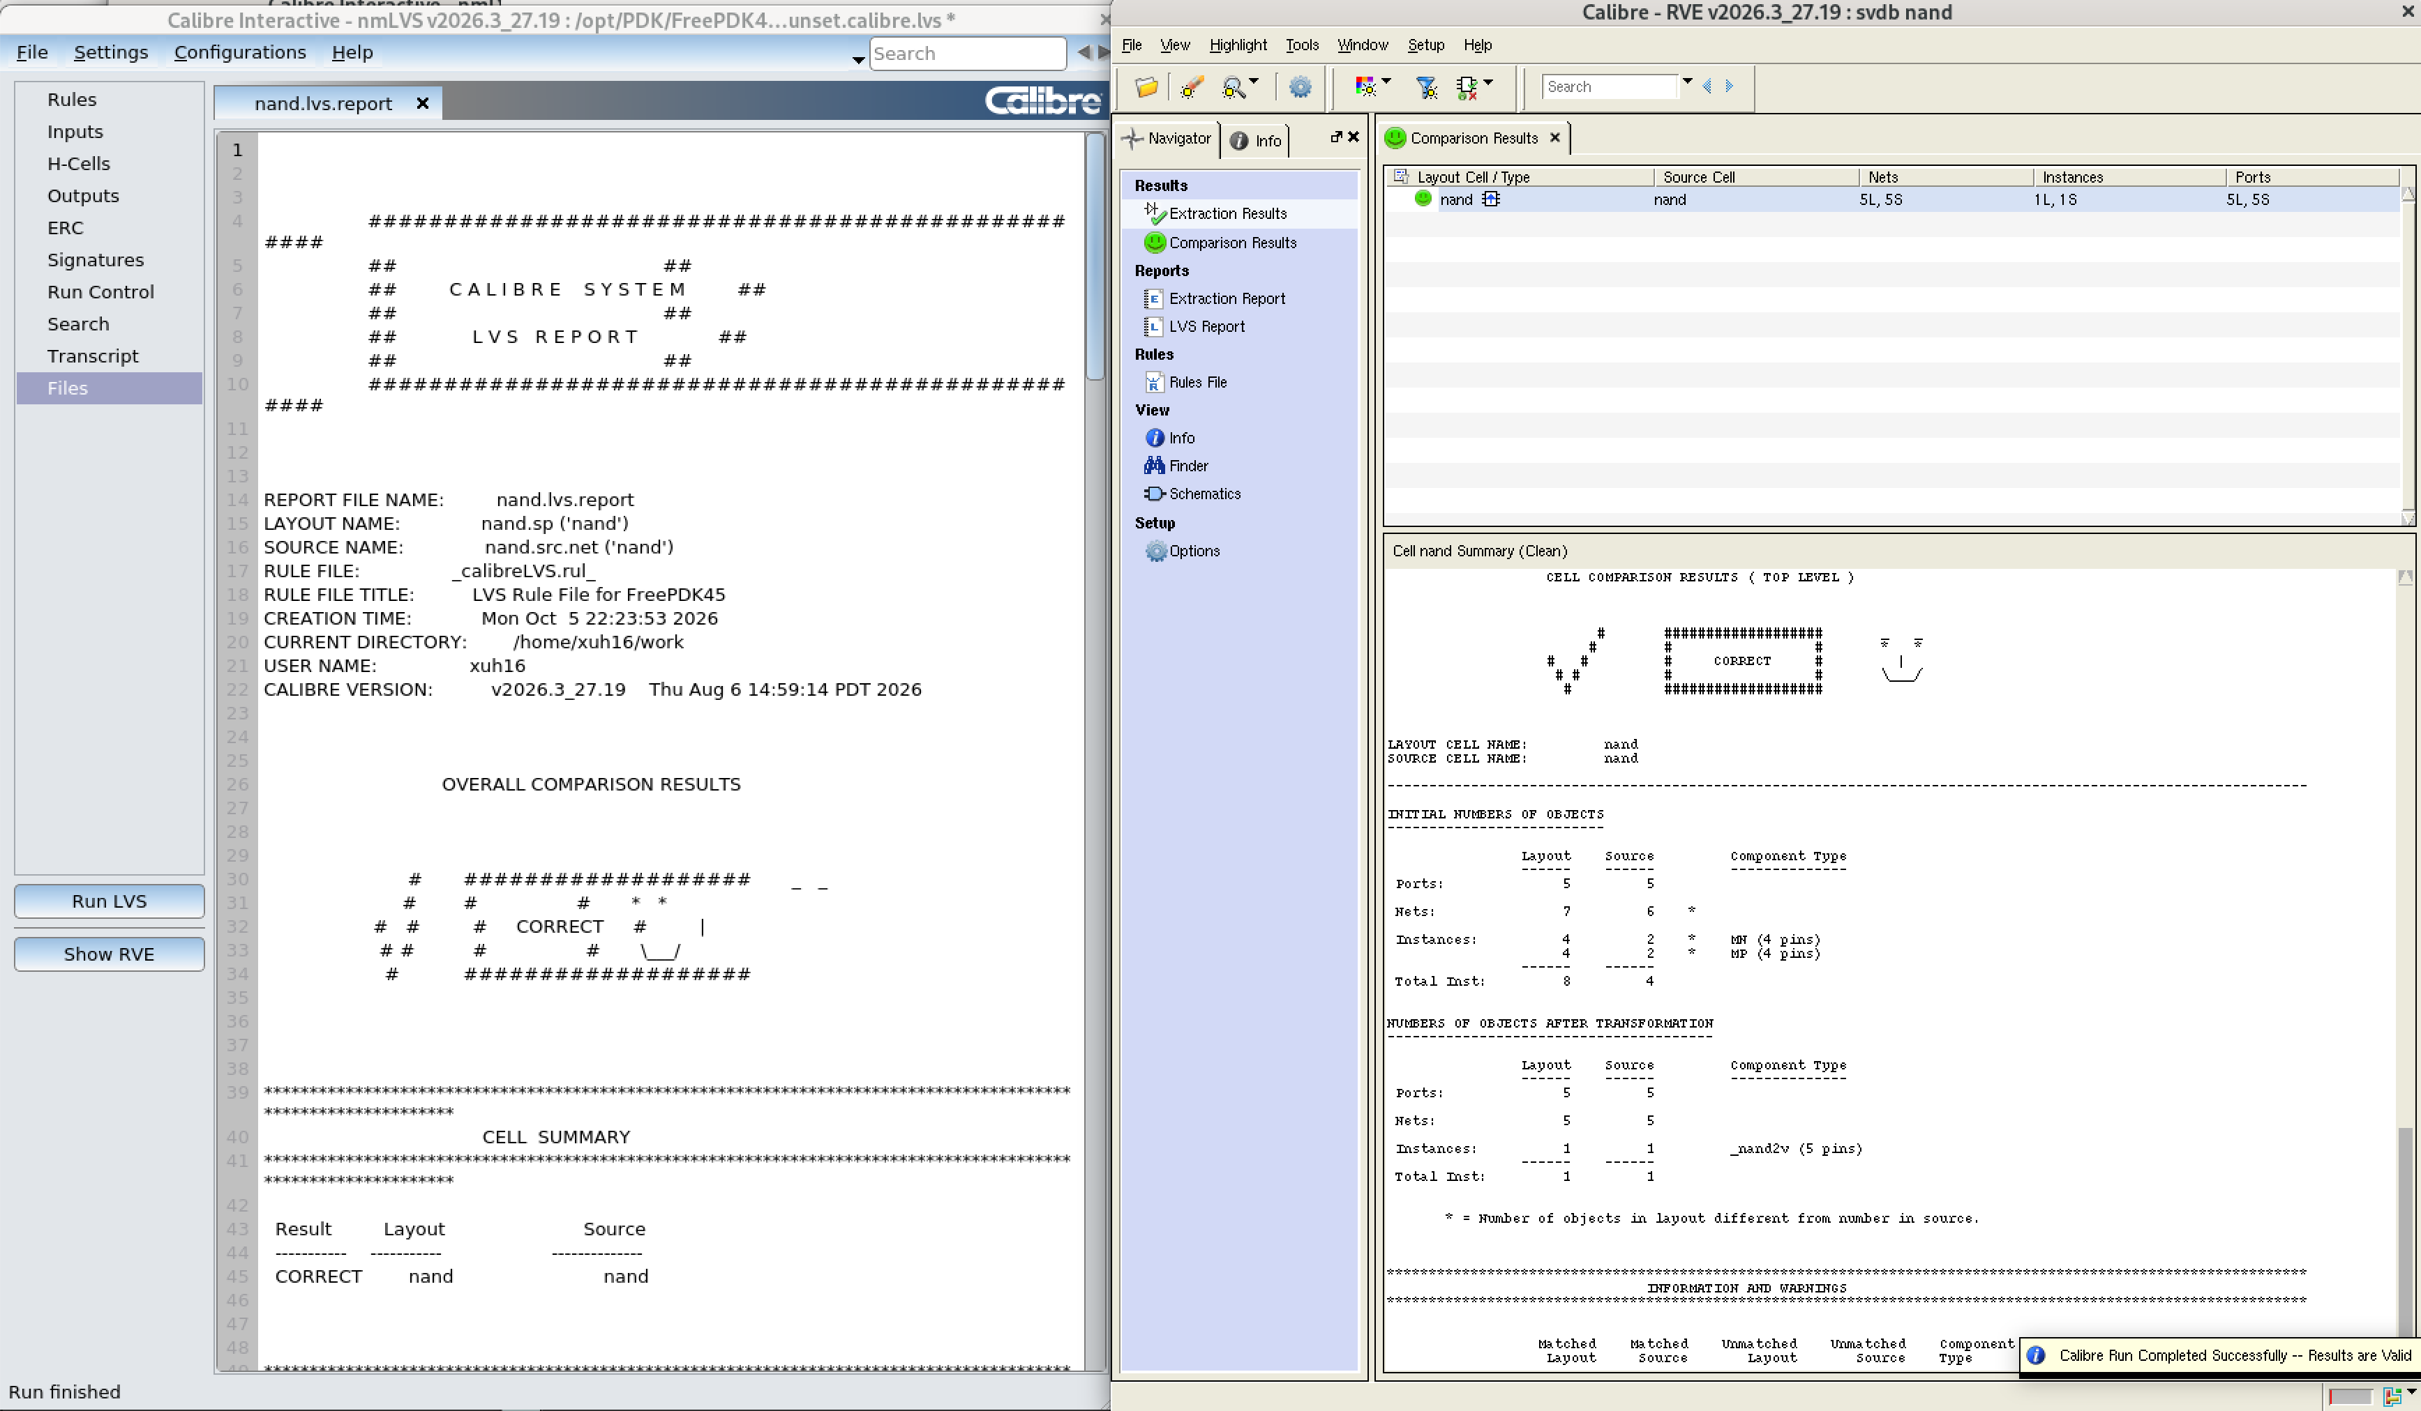

Half Adder
Schematic
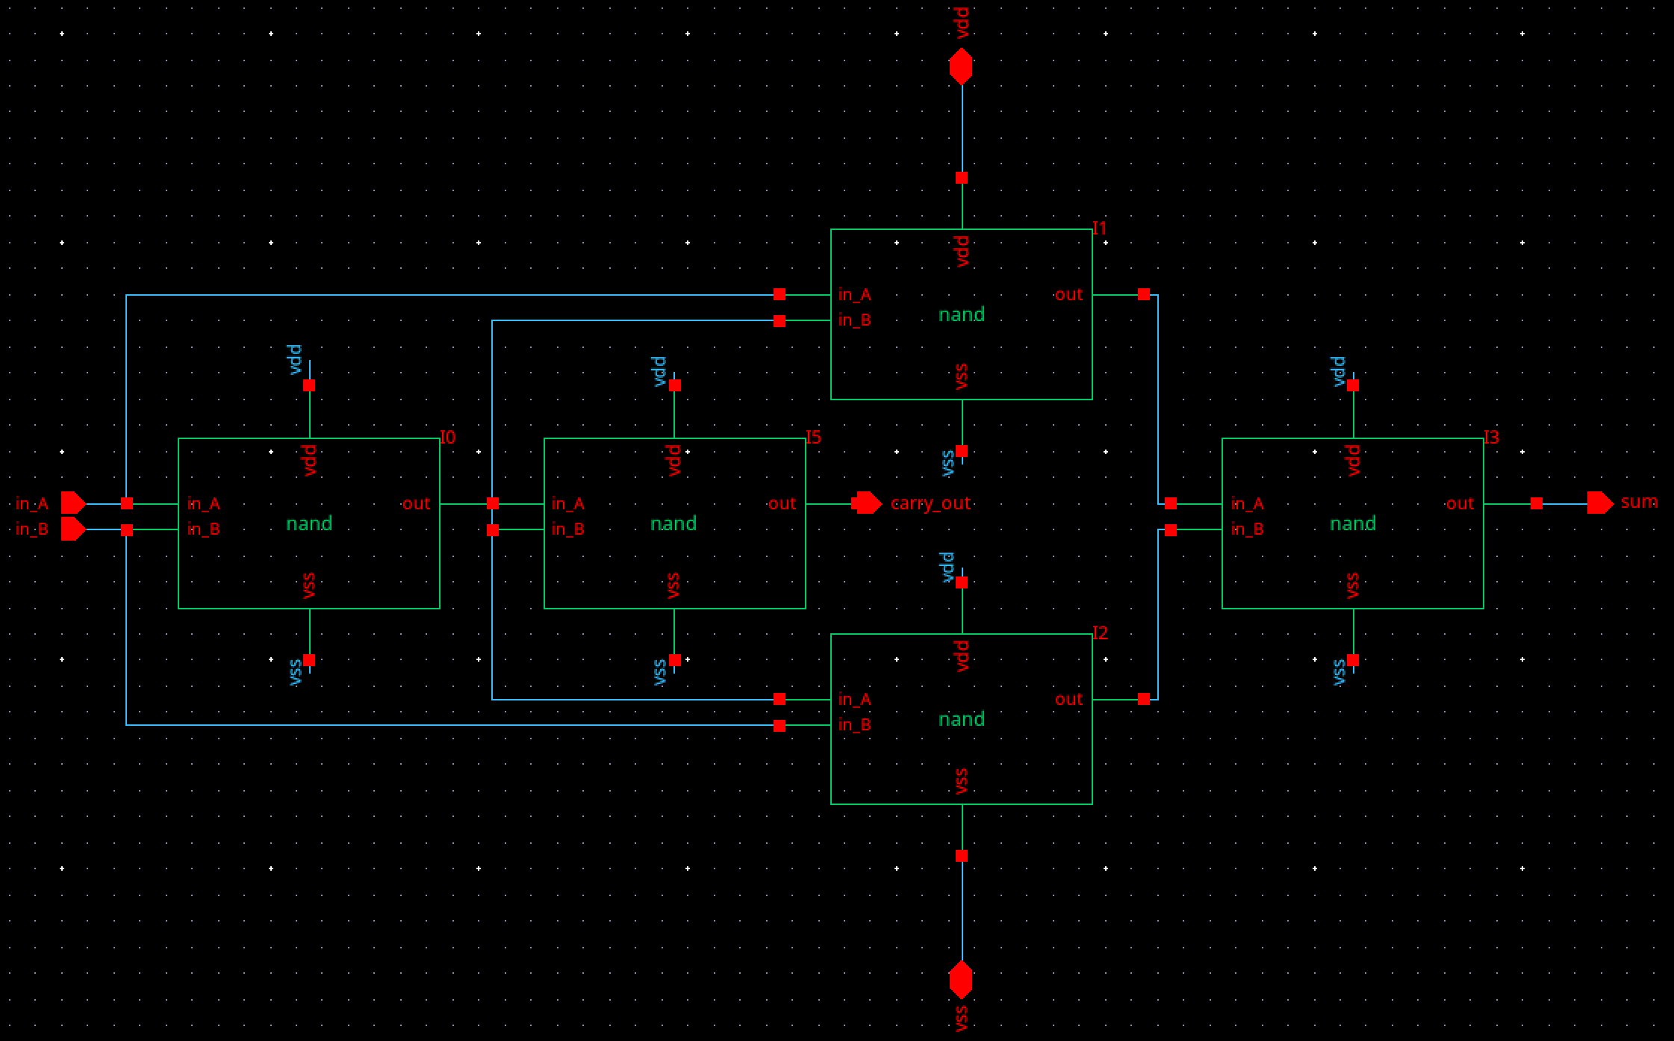
Symbol/Simulation Setup
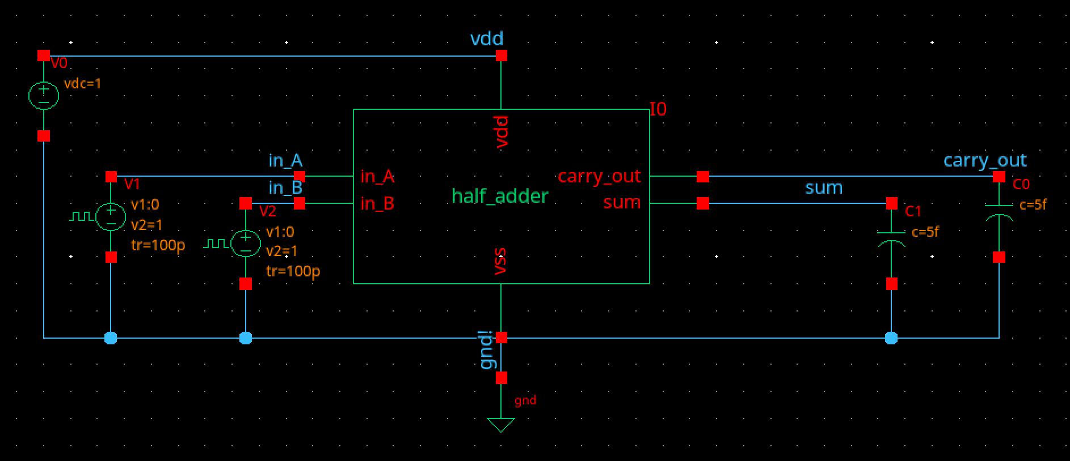

Simulation Results
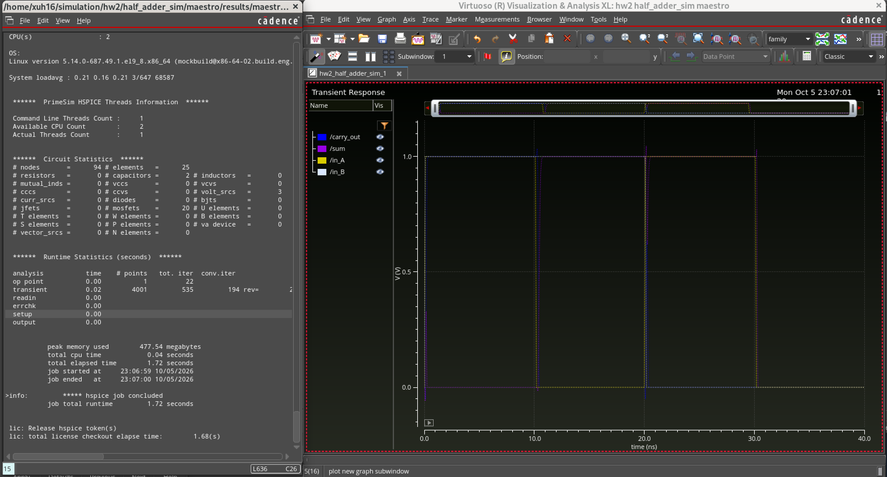
Layout
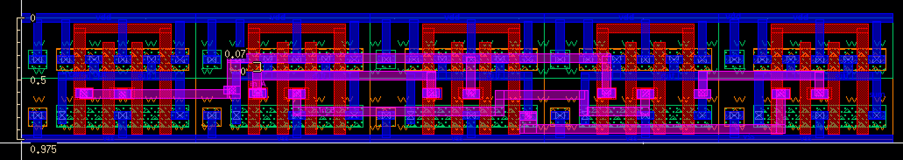

DRC
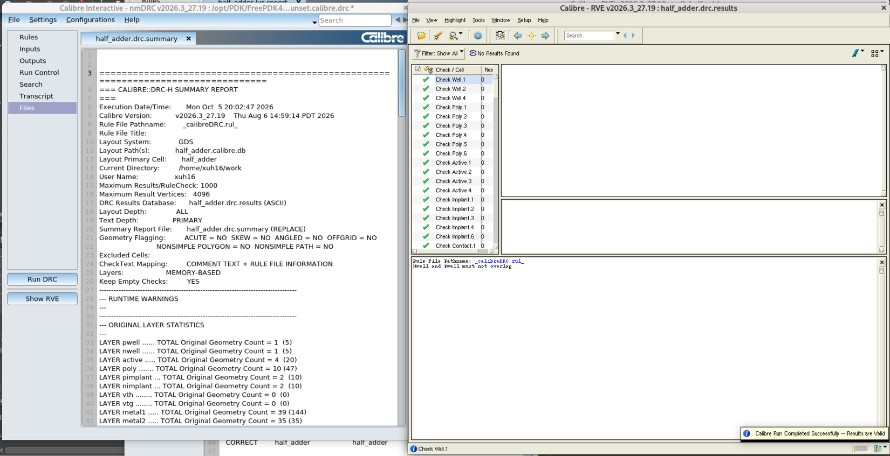
LVS
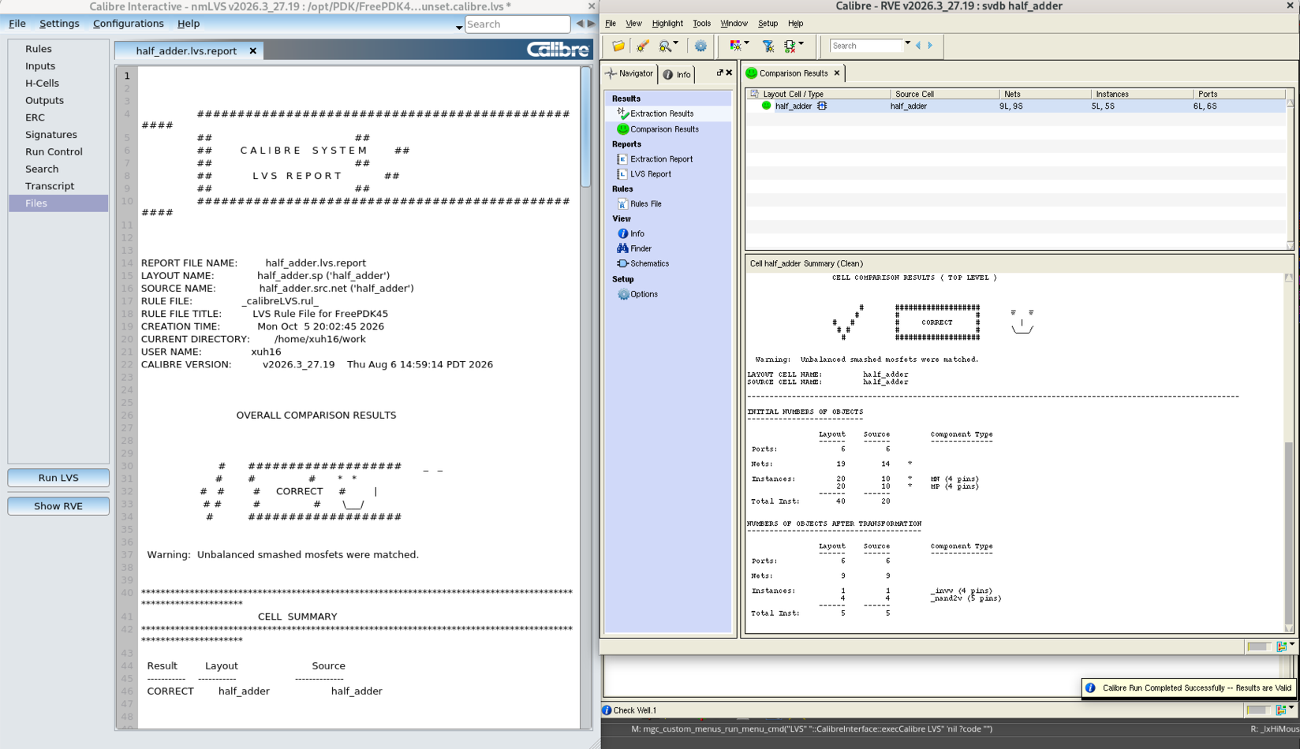

Full Adder
Schematic
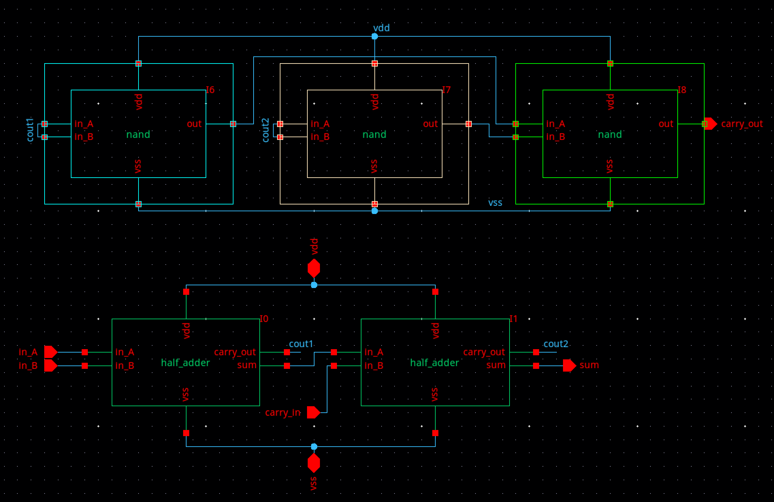
Symbol/Simulation Setup
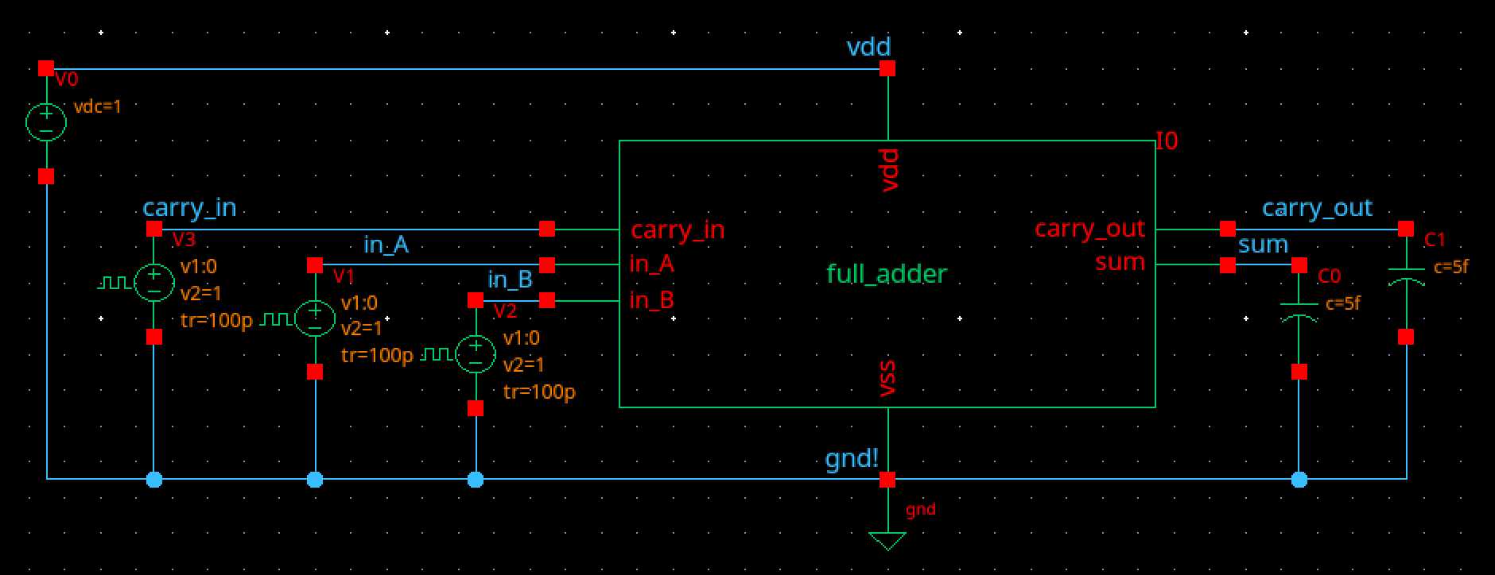

Simulation Results
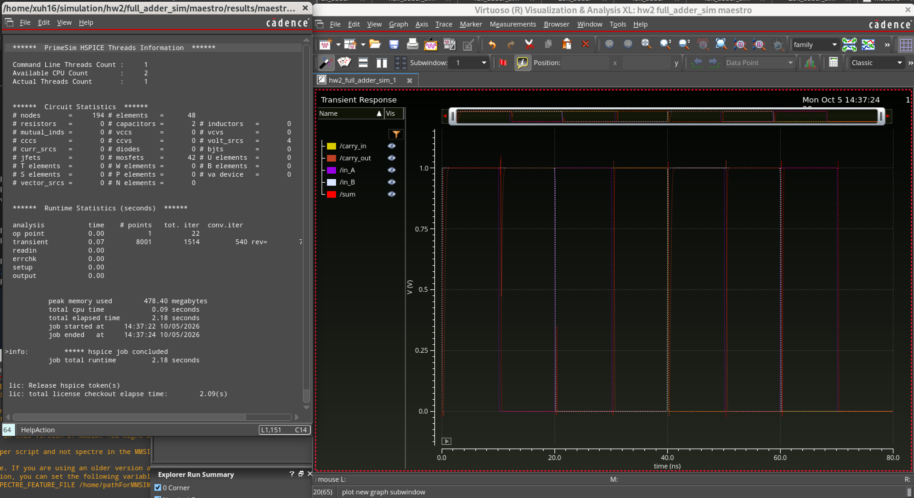
Layout
DRC
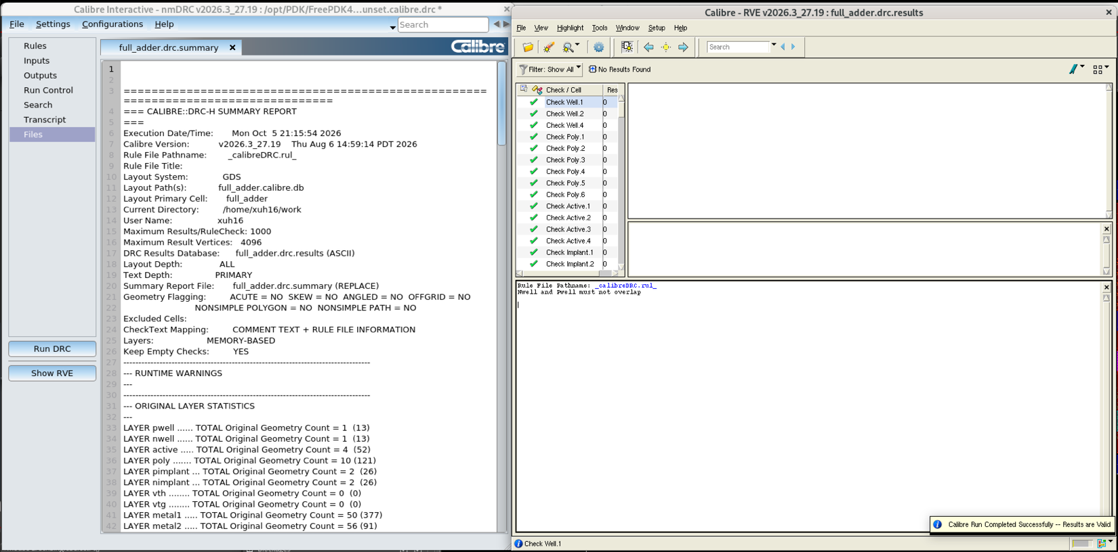
LVS
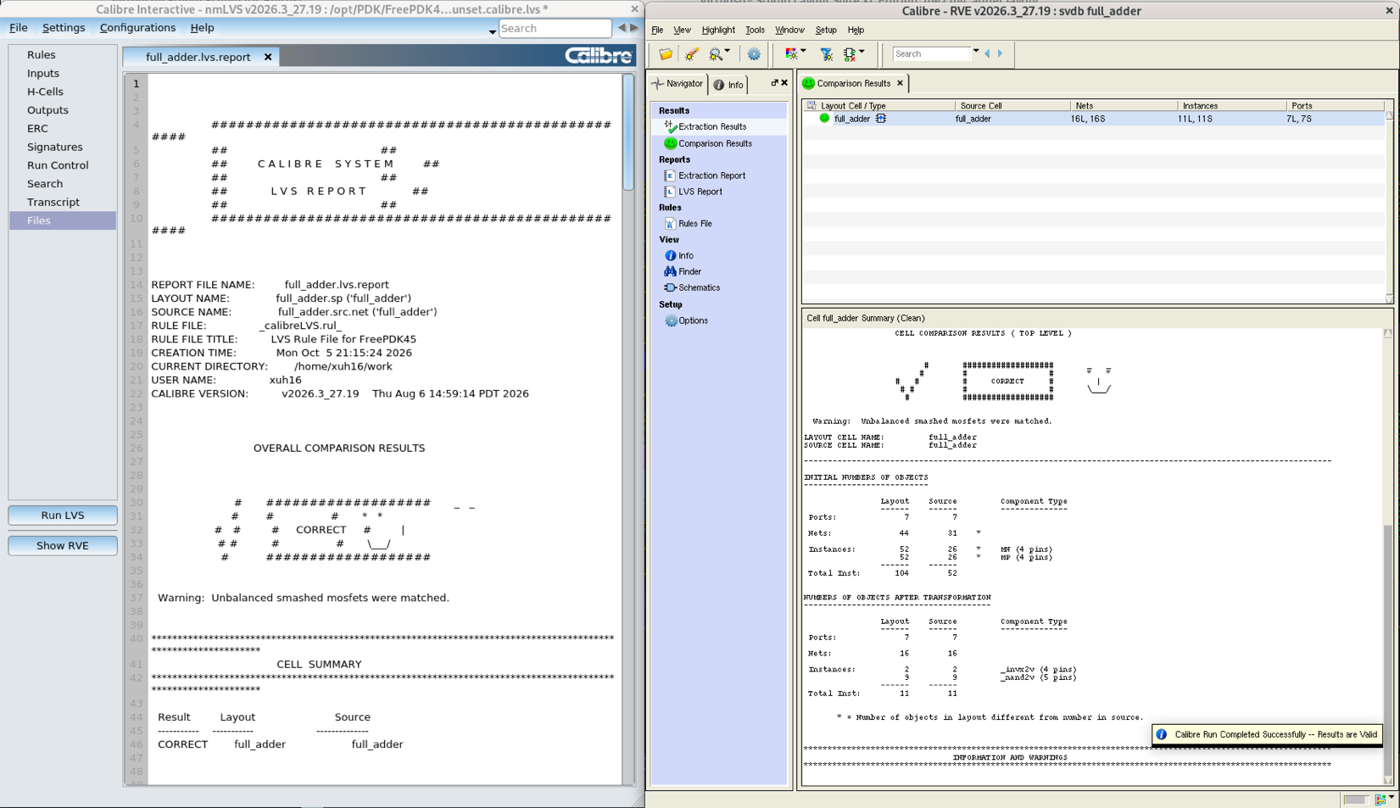

2-Bit Adder
Schematic
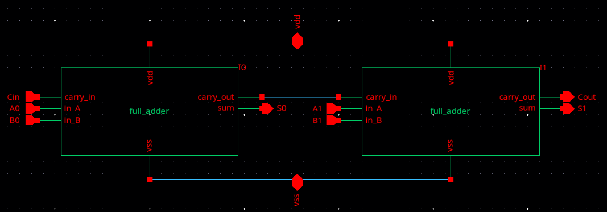
Symbol/Simulation Setup
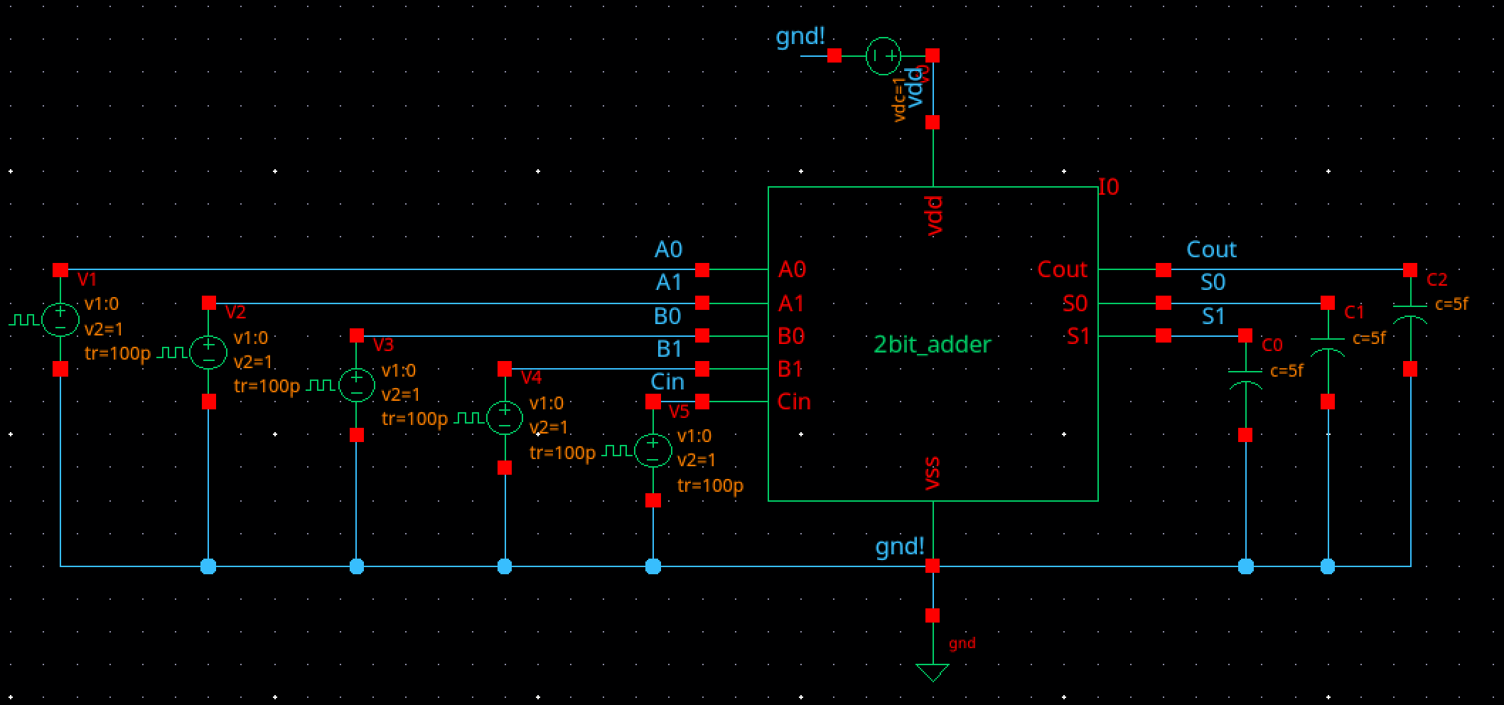

Simulation Results
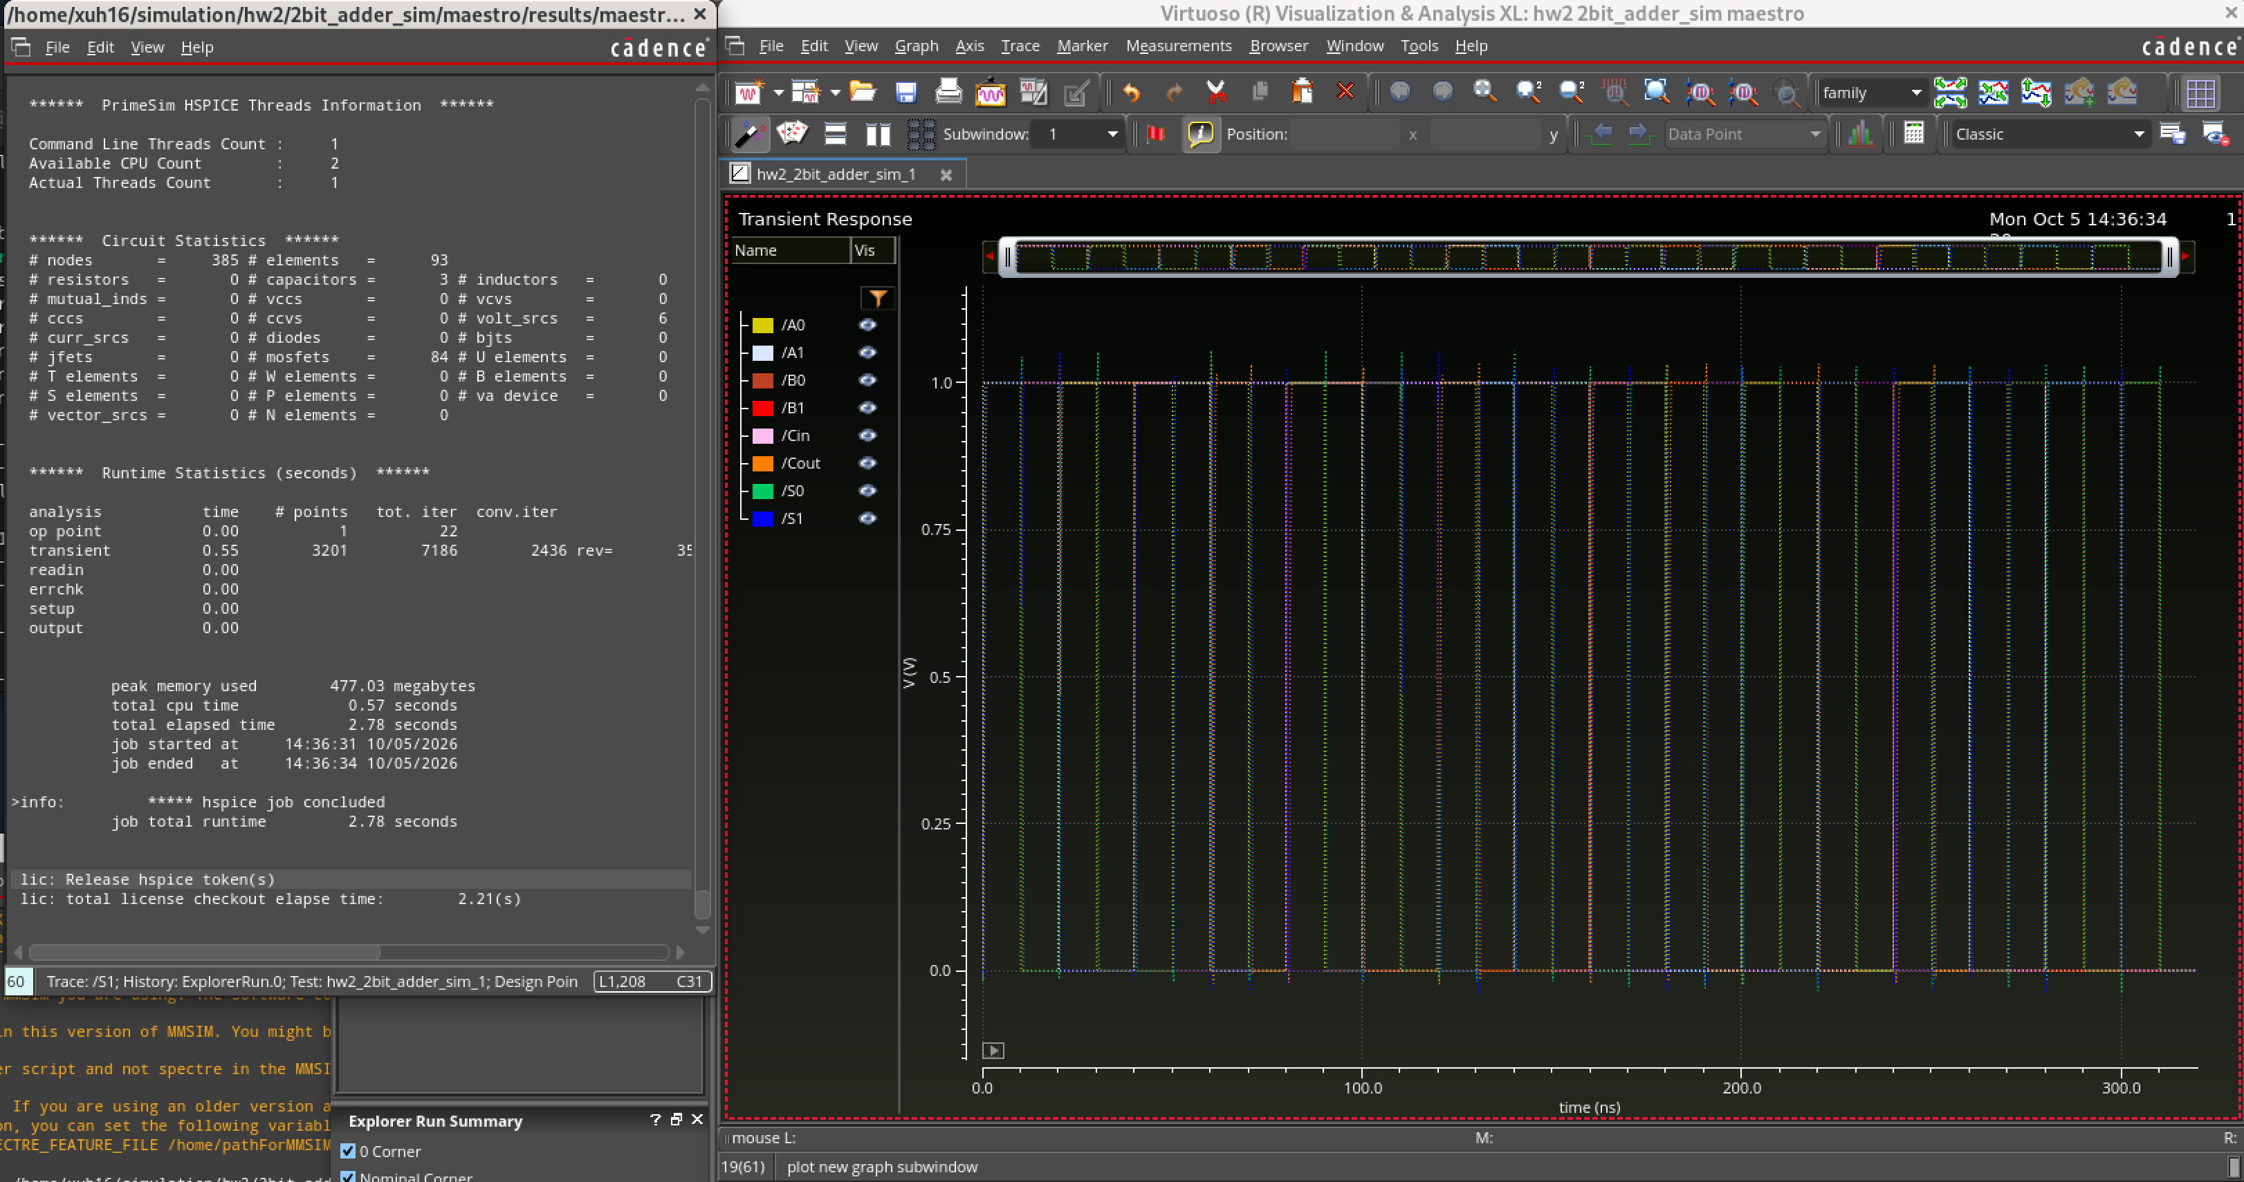
Layout
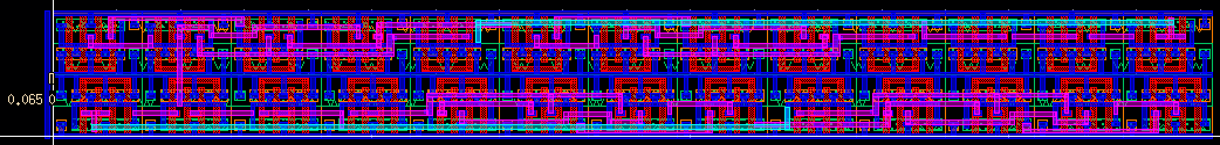
DRC
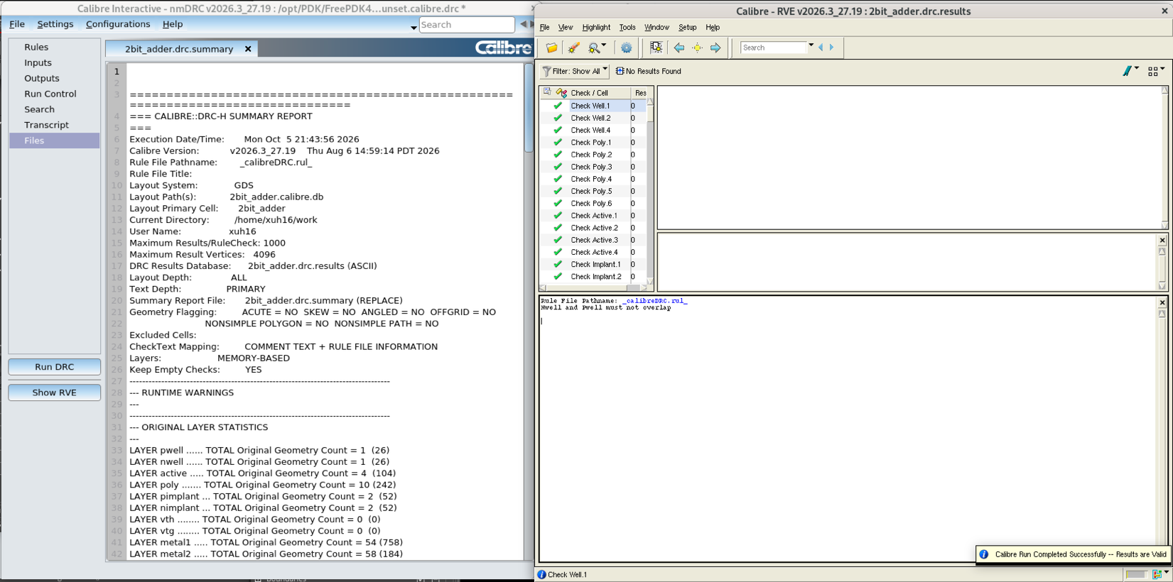
LVS
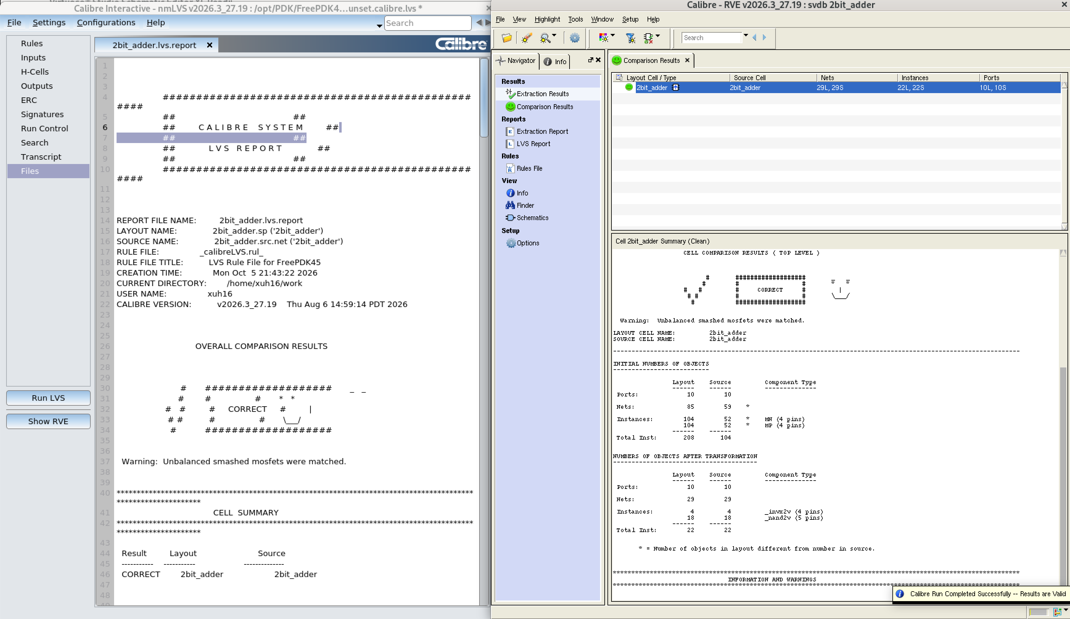

4-Bit Adder
Schematic
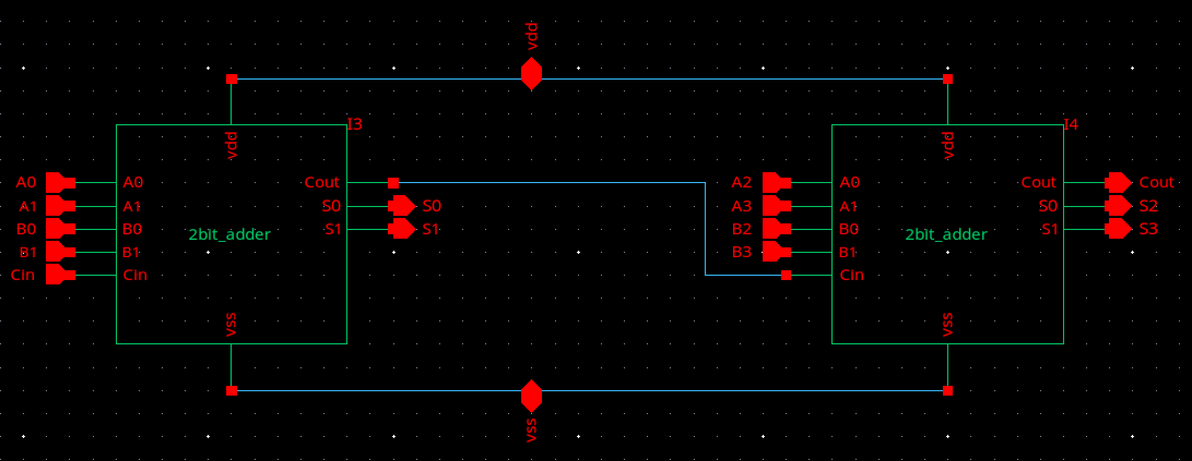
Symbol/Simulation Setup
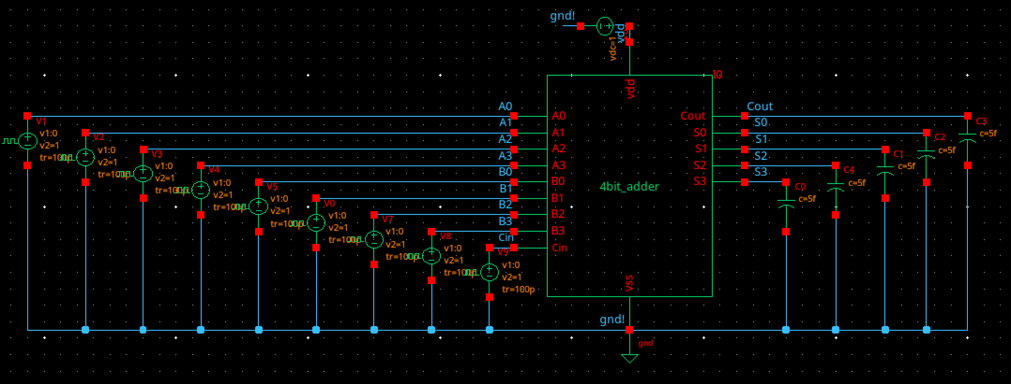

Simulation Results
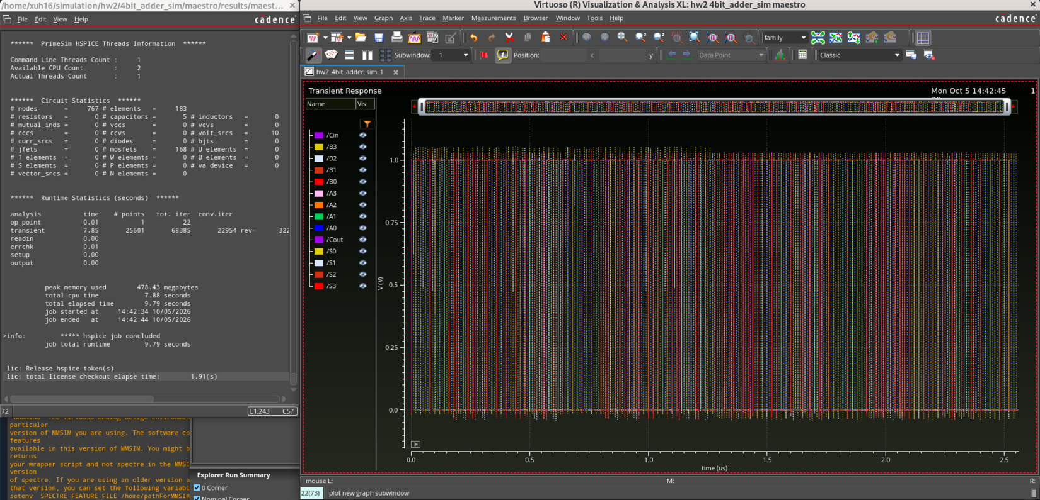
Layout
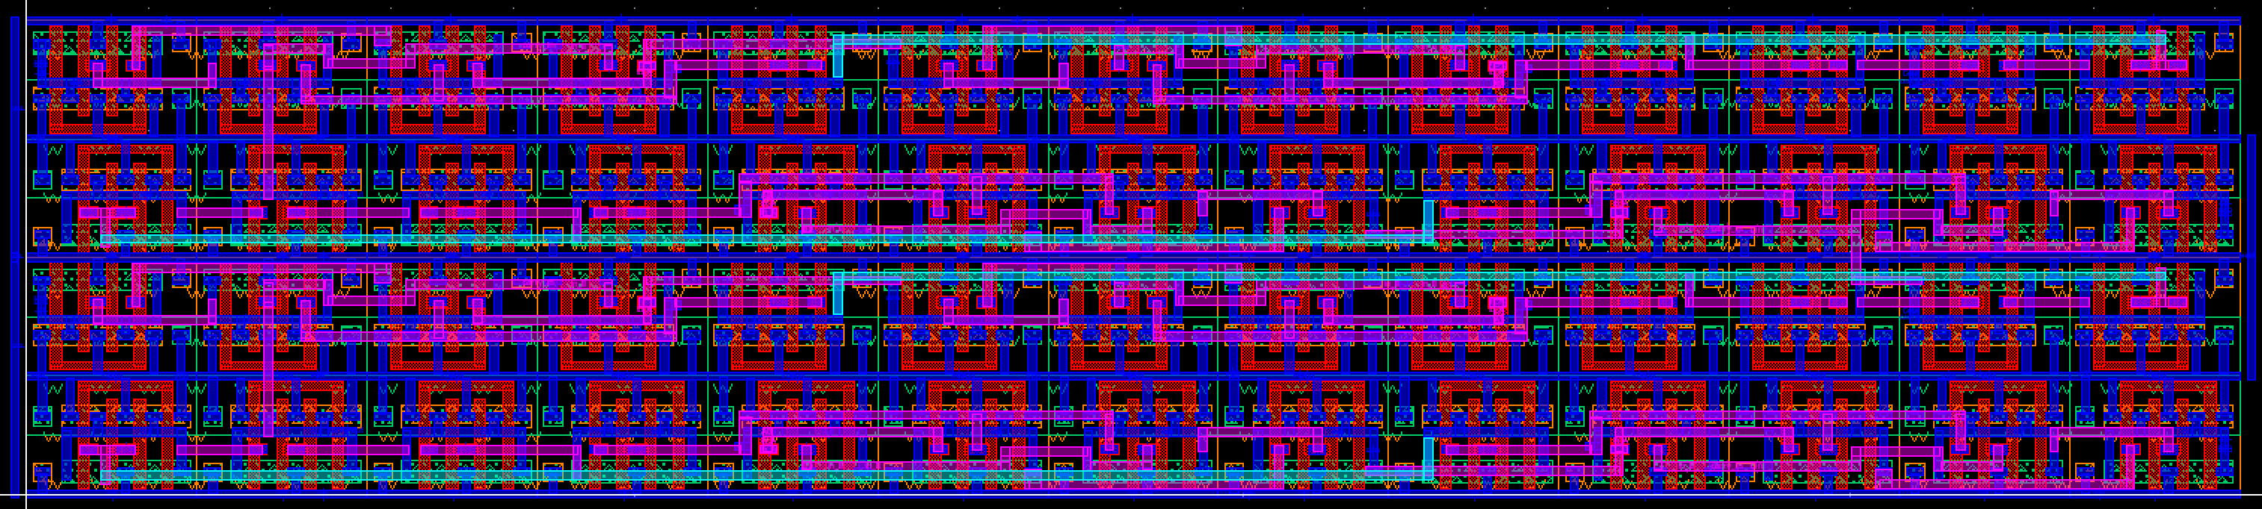

DRC
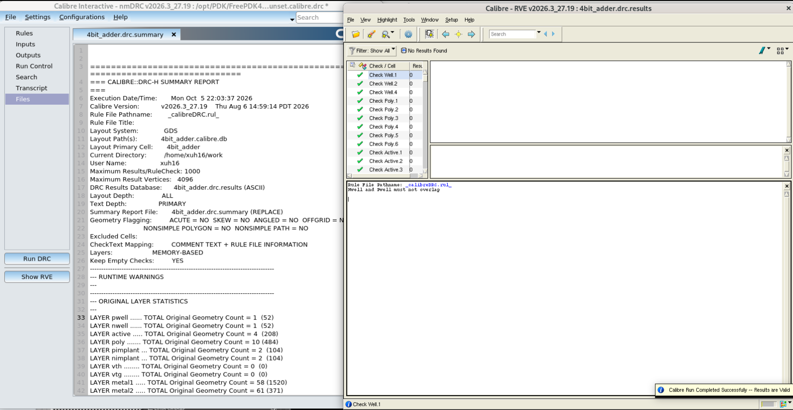

LVS

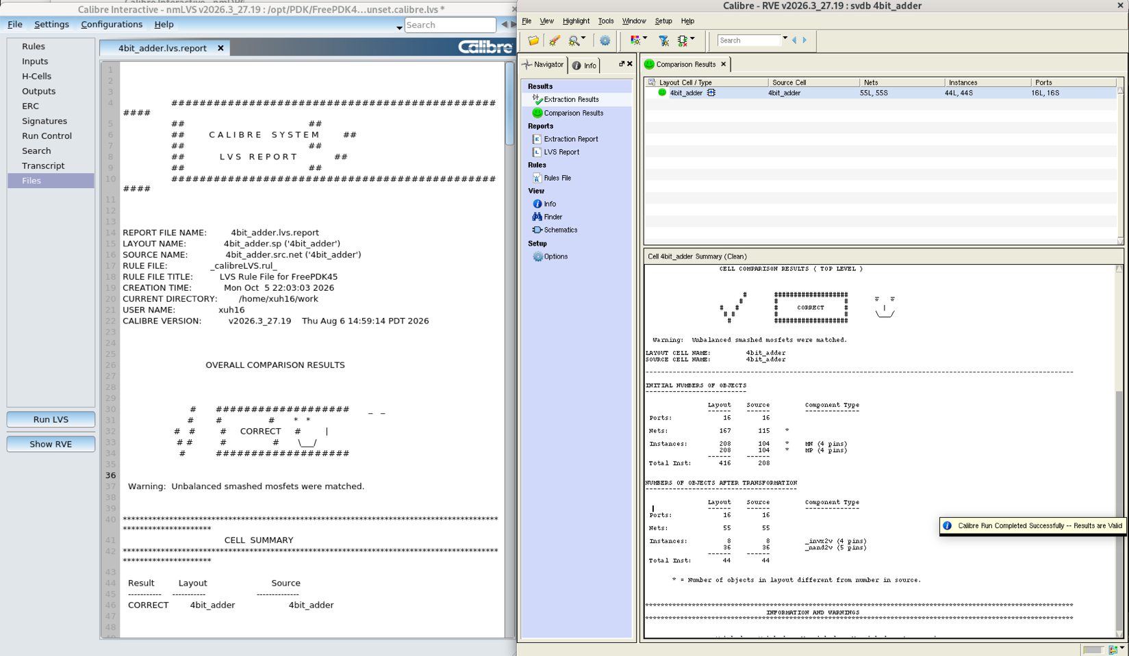

4-Bit Adder Critical Path Analysis
To test the critical path propagation delays, I set up two more simulations. One was the “best case,” where A=0000, B=0000, and Cin changes from 0 to 1. This is the best case because the carry does not have to propagate, and only S0 updates. One was the “worst case,” where A=1111, B=0000, and Cin changes from 0 to 1. This is the worst case because the carry has to ripple through all four full adders. The worst case resulted in a propagation delay 5x that of the best case (1ns vs 0.2ns). Results are shown below.

Best case setup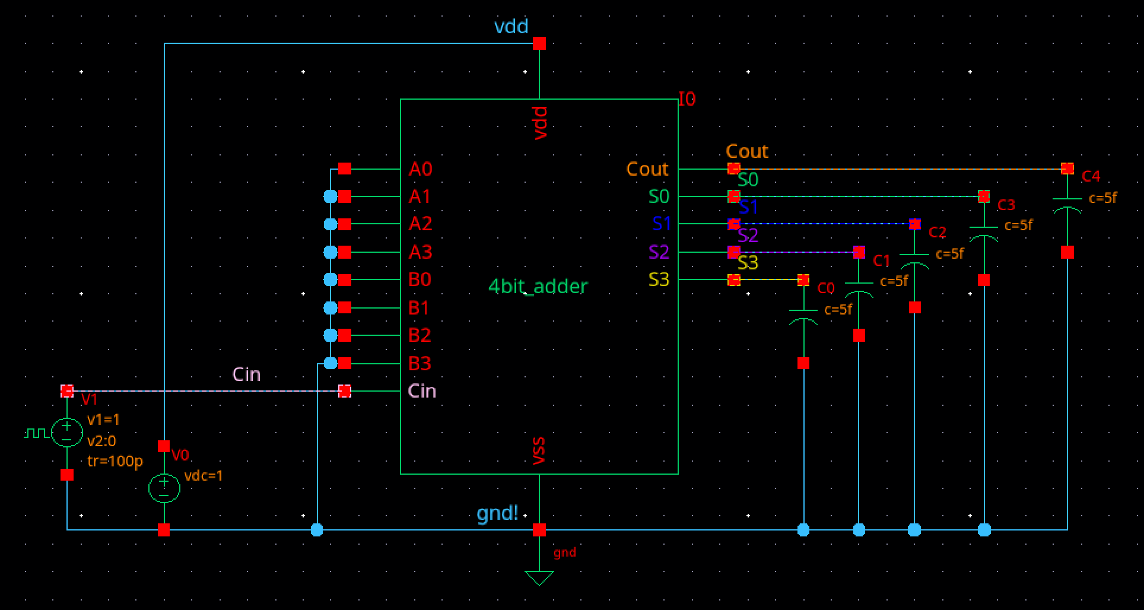
Best case results
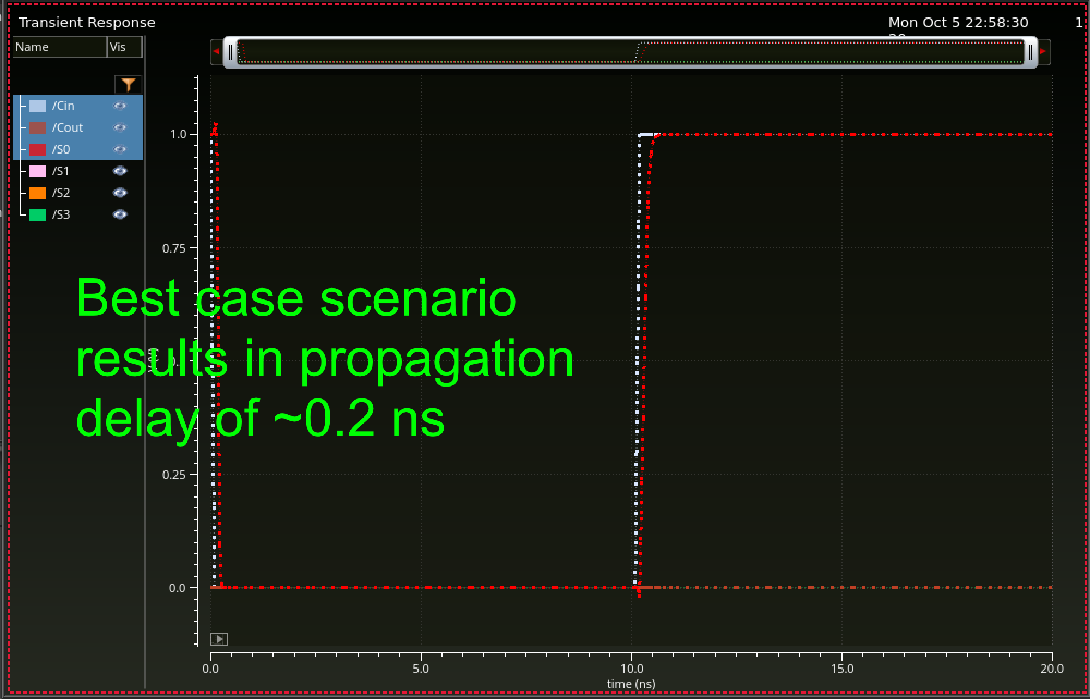
Worst case setup
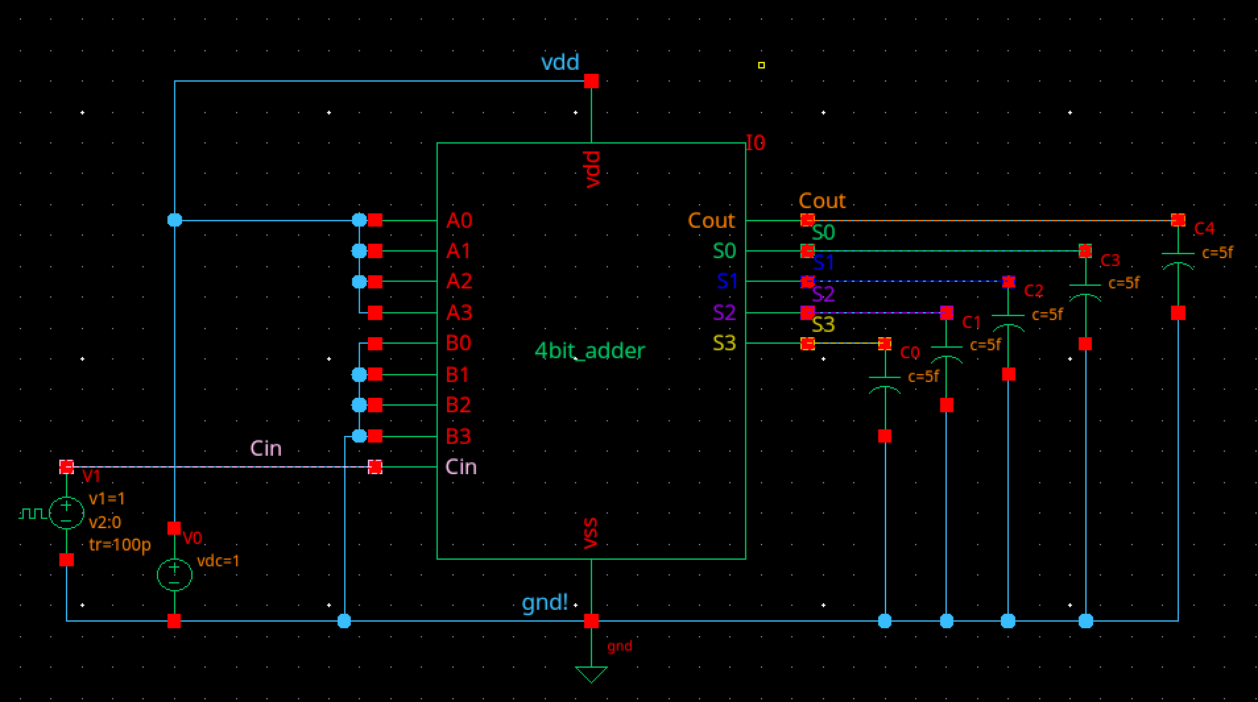
Worst case results
