Predictive CI/CD Reliability
Predicting Workflow Failures from Pre-Build Metadata
Course No.: S1-26_SSWTZG628T
Course Title: Dissertation
Dissertation Done By:
Student Name: Bhagyashri Kiran Bhat
BITS ID: 2022wc15160
Degree Program: MTech - Integrated Software Systems - WIPRO TECHNOLOGIES (WASE)
Research Area: Machine Learning
Dissertation carried out at: Wipro Technologies, Pune


BIRLA INSTITUTE OF TECHNOLOGY AND SCIENCE, PILANI
VIDYA VIHAR, PILANI, RAJASTHAN - 333031
Work Integrated Learning Programmes (WILP) Division
October 2026

Contents
1. Broad Area of Work 3
2. Background 3
3. Objectives 4
4. Scope of Work 4
5. Plan of Work 5
6. Literature References 5
7. Particulars of the Supervisor and Examiner 6
8. Remarks of the Supervisor 7

1. Broad Area of Work
Continuous Integration and Continuous Delivery (CI/CD) pipelines are a core part of modern software engineering, and predicting their outcomes is a growing research area in machine learning for software engineering. This project predicts whether a CI workflow run will fail, using only information available before the run starts. It covers the following application areas:
- Software engineering analytics: To study CI workflow histories, commits and repository metadata from public projects
- Supervised machine learning: To predict workflow failure with Logistic Regression, Random Forest and gradient boosting, against strong baselines
- Temporal data engineering: To build leakage-safe historical features that never use information from after the prediction time
- Evaluation and MLOps: To evaluate on future builds and unseen repositories, calibrate risk scores and deliver an inspectable service

2. Background
Teams that practice CI trigger automated build and test workflows on every commit. When a workflow fails, developers wait longer for feedback, compute resources are consumed and work is blocked until the cause is found (Hilton et al., 2016). If the risk of failure could be estimated before a workflow runs, reviewers and pipeline owners could direct attention to the riskiest runs first. This is relevant to any organization that depends on automated pipelines for delivery, where late detected failures slow releases and increase cost.
Earlier studies have predicted CI build outcomes with machine learning (Hassan and Wang, 2017; Ni and Li, 2017; Saidani et al., 2020). However, results are often hard to trust. Random train/test splits mix past and future builds, some features are only known after a build starts, and models are rarely compared with a simple baseline such as each repository’s own historical failure rate. Failures also have many causes (code regressions, flaky tests, infrastructure and configuration problems), so a prediction is not a statement about code quality.
This project addresses these gaps by fixing its evaluation rules before testing: a go/no-go data audit, a strict prediction-time definition, time-based and unseen-repository holdouts, and an acceptance criterion measured against the historical-rate baseline and the best possible ranking, with confidence intervals.

3. Objectives
The objectives of my project are as follows:
Audit a public CI dataset (outcome labels, timestamps, identifiers, feature availability) and apply a written go/no-go gate before any modelling.
Define a prediction contract and build a leakage-safe feature pipeline in which every run uses only information available at its prediction time, verified by automated tests.
Compare a dummy baseline, Logistic Regression, Random Forest and HistGradientBoosting with a smoothed historical repository failure-rate baseline, using Average Precision and recall at a 10% alert budget.
Evaluate generalization on future builds and on repositories unseen in training, with calibration, feature-group ablation and error analysis.
Deliver a FastAPI service and a two-page Streamlit dashboard for inspecting historical builds, together with a model card that states the limitations.

4. Scope of Work
The student will independently carry out the dataset audit, feature engineering, model development, evaluation, and the prediction service and dashboard. The target is workflow-level failure (success versus failure) predicted from pre-build metadata, with repository history reconstructed only from runs that had already finished.
Out of scope: live integration with GitHub, identifying the cause of a failure or labelling code as defective, automatic build cancellation, deep-learning models, CatBoost/LightGBM, and free-form what-if predictions.
Success is judged against a criterion fixed in advance: recall at the 10% alert budget of at least 0.20 and compared with the historical-rate baseline using repository-clustered bootstrap confidence intervals. A missed target will be reported honestly as a finding.

5. Plan of Work
Phases | Start Date-End Date | Work to be done
Data Audit & Go/No-Go | 02 Nov 2026 – 08 Nov 2026 | Dataset selection, data dictionary, label and timestamp audit, baseline feasibility, go/no-go decision
EDA & Feature Engineering | 09 Nov 2026 – 22 Nov 2026 | EDA, target definition, frozen data splits, leakage-safe features with automated tests
Modelling & Tuning | 23 Nov 2026 – 06 Dec 2026 | Baselines, Logistic Regression, Random Forest, gradient boosting, tuning, class-weight and buffer decisions
Evaluation | 07 Dec 2026 – 20 Dec 2026 | Calibration, thresholds, single final test run, temporal and unseen-repository evaluation
Analysis & Model Card | 21 Dec 2026 – 27 Dec 2027 | Feature-group ablation, error analysis, feature importance, model card
Application Development | 28 Dec 2027 – 14 Jan 2027 | FastAPI service, two-page dashboard, Docker packaging and automated CI
Dissertation Review | 15 Jan 2027 – 20 Jan 2027 | Contingency buffer; submit Dissertation to Supervisor & Additional Examiner for review and feedback
Submission | 21 Jan 2027 – 30 Jan 2027 | Final review and submission of Dissertation

6. Literature References
The state of the art is the base for any successful research project. The current project draws on literature about CI build-outcome prediction, flaky tests, probability calibration and evaluation on imbalanced data. The following are referred works from the preliminary literature review.
- M. Beller, G. Gousios, and A. Zaidman. TravisTorrent: Synthesizing Travis CI and GitHub for full-stack research on continuous integration. In Proceedings of the 14th International Conference on Mining Software Repositories (MSR 2017), pages 447–450. IEEE, 2017.
- F. Hassan and X. Wang. Change-aware build prediction model for stall avoidance in continuous integration. In Proceedings of the 11th ACM/IEEE International Symposium on Empirical Software Engineering and Measurement (ESEM 2017), pages 157–162. IEEE, 2017.
- M. Hilton, T. Tunnell, K. Huang, D. Marinov, and D. Dig. Usage, costs, and benefits of continuous integration in open-source projects. In Proceedings of the 31st IEEE/ACM International Conference on Automated Software Engineering (ASE 2016), pages 426–437. ACM, 2016.
- Q. Luo, F. Hariri, L. Eloussi, and D. Marinov. An empirical analysis of flaky tests. In Proceedings of the 22nd ACM SIGSOFT International Symposium on Foundations of Software Engineering (FSE 2014), pages 643–653. ACM, 2014.
- M. Mitchell et al. Model cards for model reporting. In Proceedings of the Conference on Fairness, Accountability, and Transparency (FAT* 2019), pages 220–229. ACM, 2019.
- Z. Ni and B. Li. Cost-effective build outcome prediction using cascaded classifiers. In Proceedings of the 14th International Conference on Mining Software Repositories (MSR 2017). IEEE, 2017.
- A. Niculescu-Mizil and R. Caruana. Predicting good probabilities with supervised learning. In Proceedings of the 22nd International Conference on Machine Learning (ICML 2005), pages 625–632. ACM, 2005.
- F. Pedregosa et al. Scikit-learn: Machine learning in Python. Journal of Machine Learning Research, 12:2825–2830, 2011.
- I. Saidani, A. Ouni, M. Chouchen, and M. W. Mkaouer. Predicting continuous integration build failures using evolutionary search. Information and Software Technology, 128:106392, 2020.
- T. Saito and M. Rehmsmeier. The precision-recall plot is more informative than the ROC plot when evaluating binary classifiers on imbalanced datasets. PLoS ONE, 10(3):e0118432, 2015.

7. Particulars of the Supervisor and Examiner
Particular | Supervisor | Additional Examiner
Name | Apurva Deshpande | Ram Panchal
Qualification | BE | MCA
Designation | Software Test Engineer | Software Consultant
Employing Organization and Location | Wipro Technologies, Pune | Wipro Technologies, Pune
Phone No.(with STD Code) | 8796143066 | 9112299931
Email Address | apurva.deshpande@wipro.com | ram.panchal@wipro.com

8. Remarks of the Supervisor
The proposed work, Predictive CI/CD Reliability: Predicting Workflow Failures from Pre-Build Metadata, addresses a practical problem in software delivery: failed CI workflows cost compute and delay feedback to developers. The topic suits a dissertation in machine learning for software engineering.
The objectives are clear and achievable within the semester. The proposal is careful about evaluation. It includes a data audit with a go/no-go decision before modelling, a strict rule on what information is available at prediction time, and features built so they don't leak later information. It tests on later builds and on repositories the model hasn't seen. The success criterion is fixed in advance and compared against each repository's historical failure rate. These choices avoid the most common weaknesses in earlier build-prediction studies.
The scope is realistic, and the plan correctly excludes finding the cause of a failure and connecting to GitHub live. The main risk is the data: a suitable public CI dataset with reliable timestamps and labels must be available. The planned audit addresses this. I recommend the student record the go/no-go decision and its reasoning in the dissertation.
The timeline is reasonable and includes a contingency buffer. I recommend that the outline be approved.

BIRLA INSTITUTE OF TECHNOLOGY AND SCIENCE, PILANI
Work Integrated Learning Programmes (WILP) Division
First Semester of Academic Year 2026-2027
(Insert Course No.) : Dissertation / Project / Project Work Outline
STUDENT ID No. | 2022wc15160
NAME OF THE STUDENT | Bhagyashri Kiran Bhat
STUDENT'S EMAIL ADDRESS | 2022wc15160@wilp.bits-pilani.ac.in
STUDENT’S EMPLOYING ORGANIZATION & LOCATION | Wipro Technologies, Pune
SUPERVISOR’S NAME | Apurva Deshpande
SUPERVISOR’S EMPLOYING ORGANIZATION & LOCATION | Wipro Technologies, Pune
SUPERVISOR’S EMAIL ADDRESS | apurva.deshpande@wipro.com
ADDITIONAL EXAMINER’S NAME | Ram Panchal
ADDITIONAL EXAMINER’S EMPLOYING ORGANIZATION & LOCATION | Wipro Technologies, Pune
ADDITIONAL EXAMINER’S EMAIL ADDRESS | ram.panchal@wipro.com
DISSERTATION / PROJECT / PROJECT WORK TITLE | Predictive CI/CD Reliability: Predicting Workflow Failures from Pre-Build Metadata

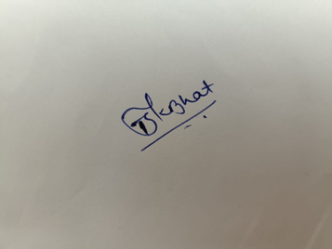 | 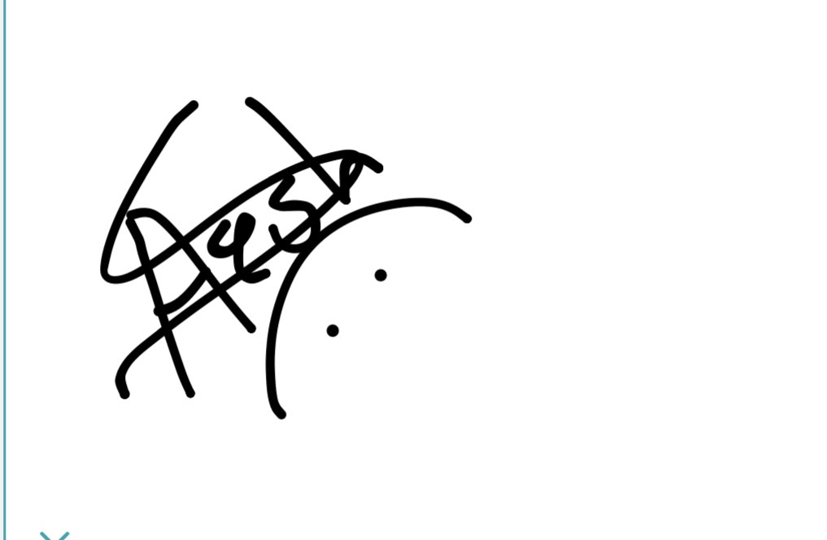 | 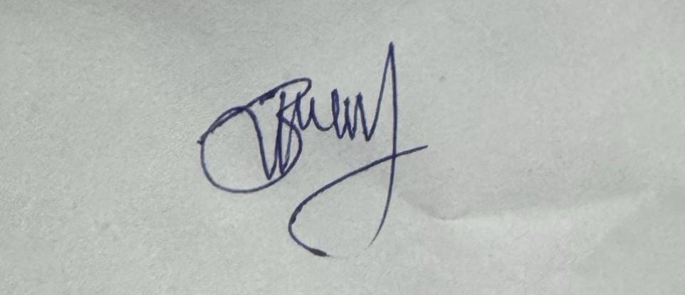
Signature of Student | Signature of Supervisor | Signature of Additional Examiner
Name:  Bhagyashri Pathak | Name:  Apurva Deshpande | Name:  Ram Panchal

