**Practical 8**

Q7 :Write NS2 program to connect nodes in a given network and send data traffic using FTP over TCP

Ans.

#——-Event scheduler object creation——–#

set ns [new Simulator]

#———-creating trace objects—————-#

set nt [open test2.tr w]

$ns trace-all $nt

#———-creating nam objects—————-#

set nf [open test2.nam w]

$ns namtrace-all $nf

#———-Setting color ID—————-#

$ns color 1 red

$ns color 2 yellow

$ns color 3 blue

#———- Creating Network—————-#

set n1 [$ns node]

set n2 [$ns node]

set n3 [$ns node]

#———- Creating Duplex Link—————-#

$ns duplex-link $n1 $n2 2Mb 50ms DropTail

$ns duplex-link $n2 $n3 2Mb 50ms DropTail

$ns duplex-link-op $n1 $n2 orient right

$ns duplex-link-op $n2 $n3 orient right

#————Labelling—————-#

$ns at 0.0 "$n1 label Server"

$ns at 0.0 "$n2 label Router"

$ns at 0.0 "$n3 label Client"

$ns at 0.0 "$n1 color blue"

$ns at 0.0 "$n3 color blue"

$n1 shape hexagon

$n3 shape hexagon

#————Data Transfer between Nodes—————-#

# Defining a transport agent for sending

set tcp [new Agent/TCP]

# Attaching transport agent to sender node

$ns attach-agent $n1 $tcp

# Defining a transport agent for receiving

set sink [new Agent/TCPSink]

# Attaching transport agent to receiver node

$ns attach-agent $n3 $sink

#Connecting sending and receiving transport agents

$ns connect $tcp $sink

#Defining Application instance

set ftp [new Application/FTP]

# Attaching transport agent to application agent

$ftp attach-agent $tcp

# Setting flow color

$tcp set fid_ 4

# data packet generation starting time

$ns at 1.0 "$ftp start"

# data packet generation ending time

$ns at 6.0 "$ftp stop"

#———finish procedure——–#

proc finish {} {

global ns nf nt

$ns flush-trace

close $nf

close $nt

puts "running nam…"

exec nam test2.nam &

exit 0

}

#Calling finish procedure

$ns at 10.0 "finish"

$ns run

**OUTPUT:**

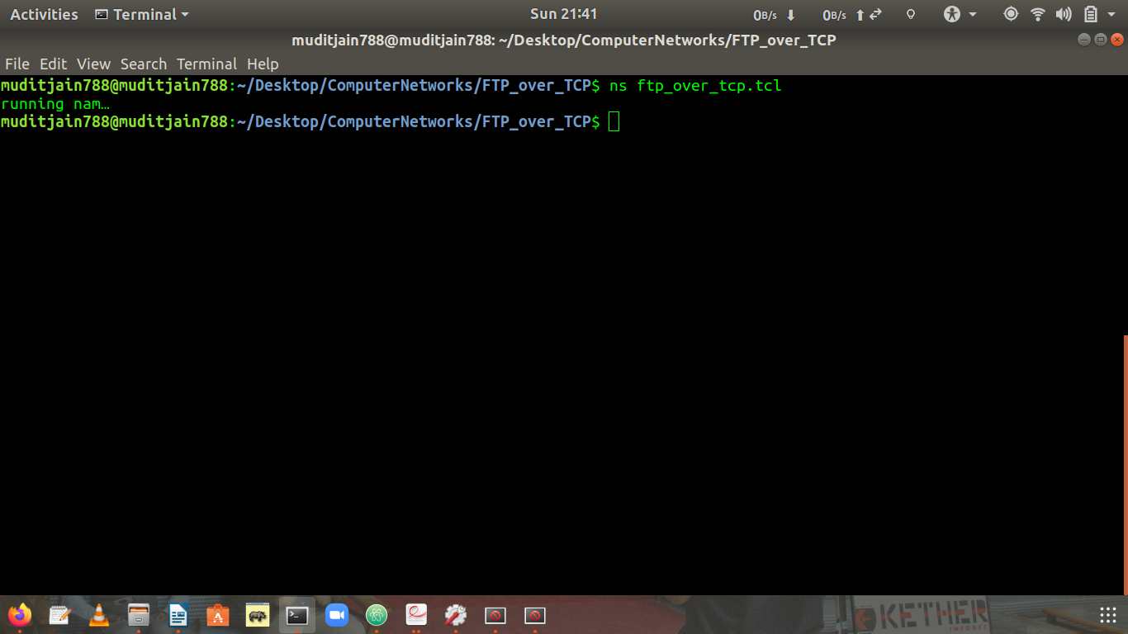

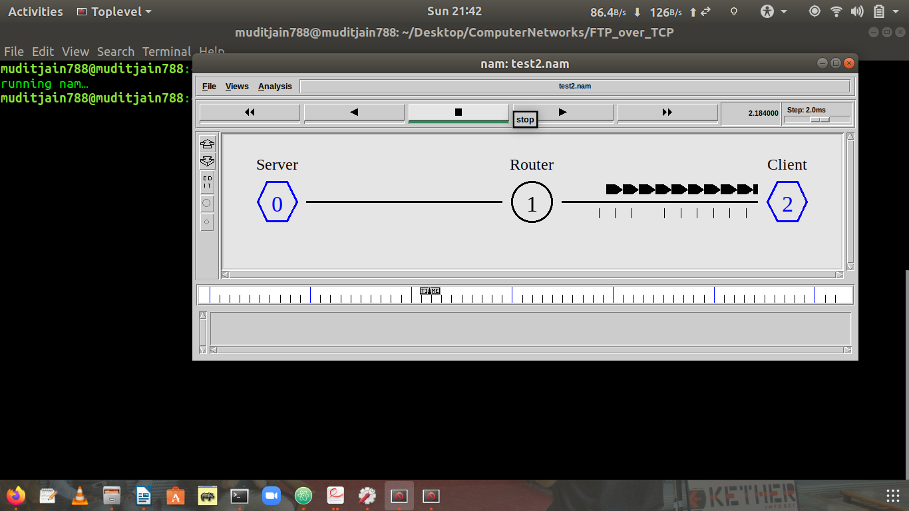

**Explaination**

Most of the statements in above ns2 program are commented for explaination of what it does .Now in theory part ,we know that nodes communicate using the communication model that consists of Transport Control Protocol (TCP) agent, TCPSink agent, and File Transfer Protocol (FTP) application in a wired network . The sender node in network is attached to the TCP agent while the receiver node is attached to the TCPSink agent. The connection between TCP agent and TCPSink agent is established using the keyword “connect”. Transport agent (TCP) and application (FTP) are connected using the keyword “attach-agent”. TCP agent sends data to TCPSink agent. On receiving the data packet, TCPSink agent sends the acknowledgement to the TCP agent that in turn processes the acknowledgements and adjusts the data transmission rate. The lost packets interpreted as a sign of congestion. The tcl script in sample5.tcl demonstrates the communication between the nodes using TCP protocol.