**Vallum Assignment**

**1.** **what is equity investing, and how would you define it ?**

**An equity investment is money that is invested in a company by purchasing shares of that company in the stock market. These shares are typically traded on a stock exchange. Ex. Suppose we take 1000 share of MRF so that 1000 qty of my share is that my equity in that company . Capital Gains: The increase in the value of the stock over time, allowing investors to sell the shares at a higher price than they were purchased. Dividends: Regular payments made by the company to its shareholders out of its profits.**

**Example of equity investing = Suppose you decide to invest in Tata Moters by purchasing 10 shares at 300 rup each and Your total investment would be 3000 rup , If the stock price increases to 500 per share, your investment would be worth 5000 rup , giving you a capital gain of 2000. Additionally.**

**2.** **can you explain the GARP style if investing ?**

**“GARP”—or “growth at a reasonable price”—stocks exhibit solid growth prospects as well as attractive valuations and a track record of sustained earnings growth. Here's what to know about this investment approach and where to potentially find opportunities currently. Advantages of GARP Investing Balanced Approach: By combining growth and value principles, GARP investing offers a balanced approach that can potentially reduce volatility and risk compared to pure growth investing Potential for Outperformance: GARP stocks often outperform during market conditions where neither high-growth nor deep value strategies are clearly**

**advantageous. Sustainable Growth: The focus on reasonable growth rates and valuations can lead to sustainable long-term returns.**

**3. When analyzing companies listed on BSE & NSE, how do you differentiate between GARP style opportunities, growth-only, and value-only companies?**

**A : On the similar lines of value investing, GARP strategy looks for stocks that have a low P/E ratio and low P/B ratio as compared to the industry average. So, the strategy focuses on selecting stocks that have good growth rates but at the same time are available at reasonable prices.**

**B:While GARP investing combines key tenets from growth investing and value investing, it also has some notable differences. Growth investors are often willing to pay for growth at any price, even if it's extreme, while GARP investors are only willing to pay a reasonable price for growth.**

**4.** **How comfortable are you with Python? Please provide details about your knowledge and practical application level?**

**I'm quite comfortable with Python. I have knowledge of core Python concepts like data types, control flow, functions, and modules, as well as libraries commonly used in data analysis and web scraping like Pandas, NumPy, BeautifulSoup, and Scrapy. I've**

**also been trained on various Python projects and have practical experience applying Python for data analysis, scripting, and automation tasks.**

* **I am showing some my python work as a example**

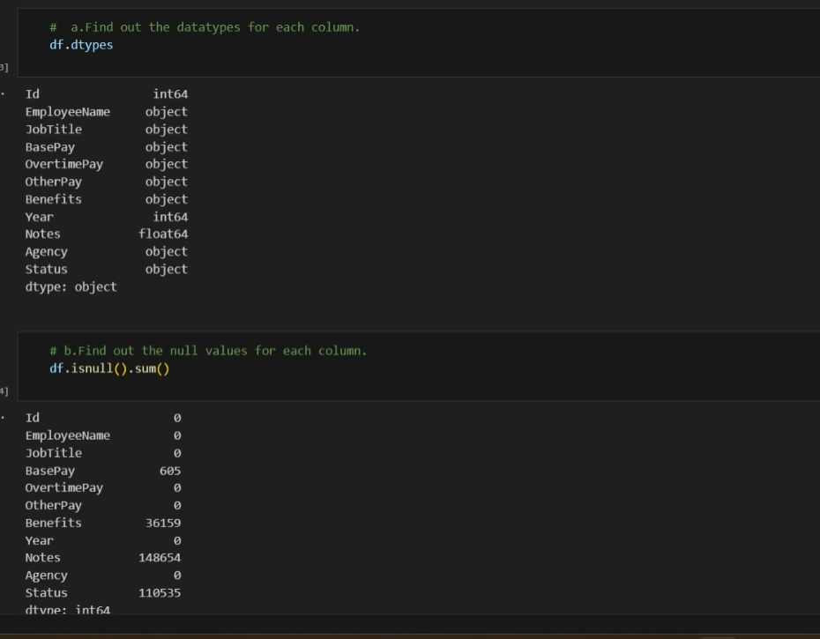

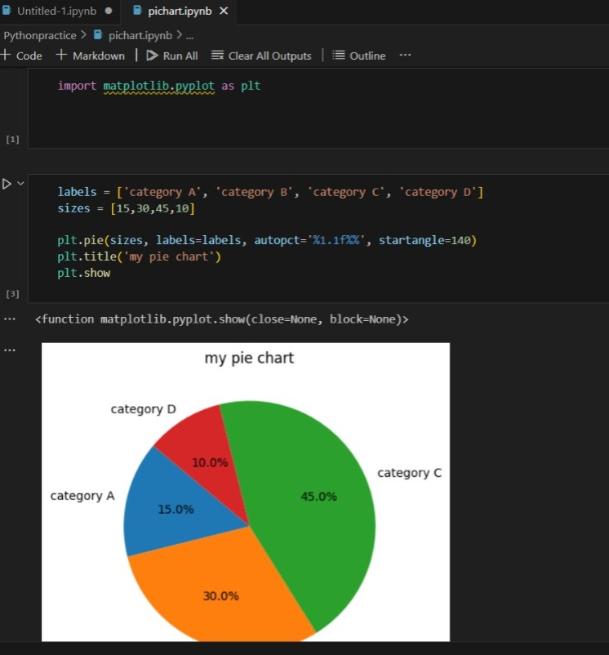

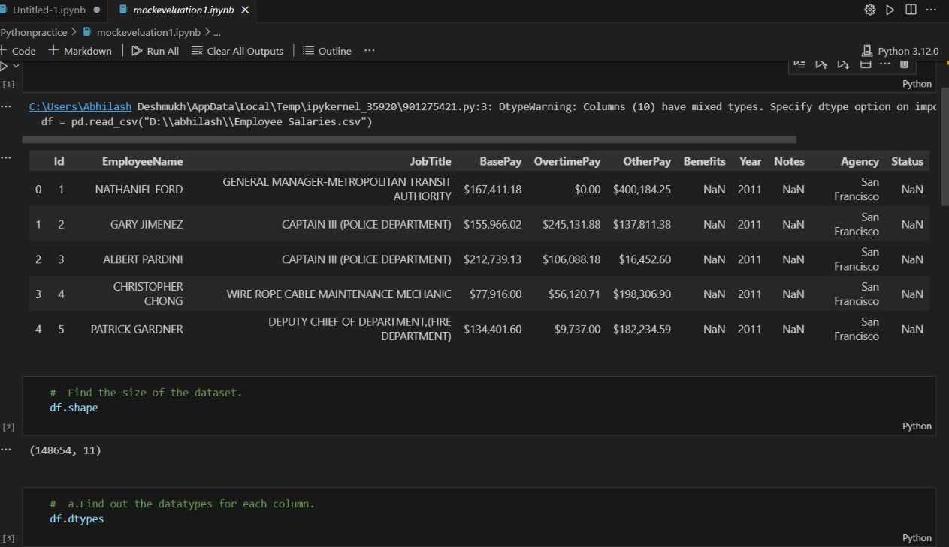

**5.** **Using Python, how would you determine if a company listed on BSE & NSE follows the GARP style, considering the available data for approximately 6000 companies?**

**To determine if a company follows the GARP style using Python, you would typically gather relevant financial data for the companies listed on BSE & NSE.**

**6.Based on your knowledge, what insights can you derive and showcase about the following stocks: SBIN, Adani Enterprises, HUL, Tata Steels, Moil?**

**1. State Bank of India (SBIN) Sector: Banking and Financial Services Market Position: SBI is India's largest public sector bank with a significant market share in deposits, loans, and overall banking services.**

**I am showing a SBIN stock market chart as performance in last 5 year.**

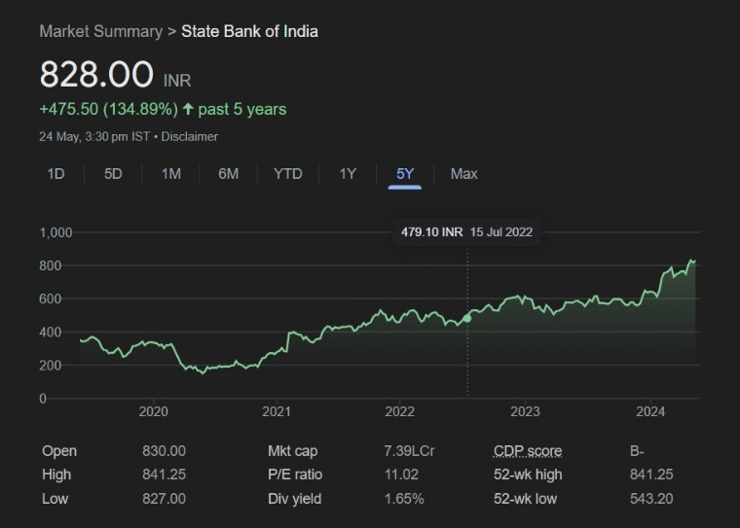

**2. Adani Enterprises Sector: Conglomerate (Diversified interests including ports, energy, and logistics) Market Position: A key player in several infrastructure sectors, particularly known for its rapid expansion in the renewable energy space.**

**Adani Enterprises stock market performance in last 5 year**

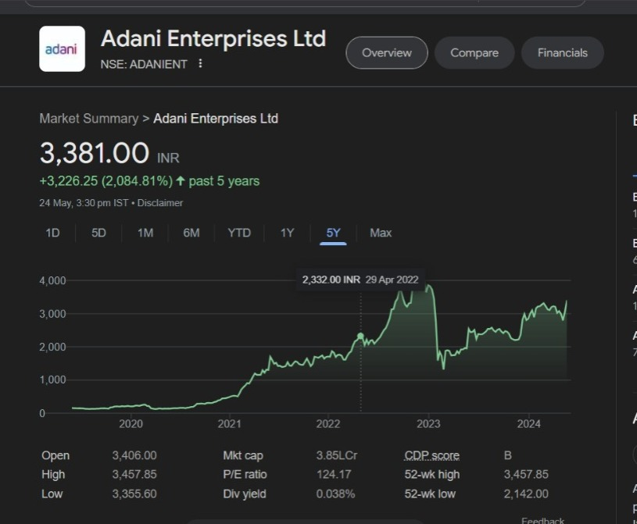

**3. Tata Steel Sector: Steel Manufacturing Market Position: One of the top steel producers globally, with a strong presence in both domestic and international markets.**

**Tata Steel stock market performance in last 5 year**

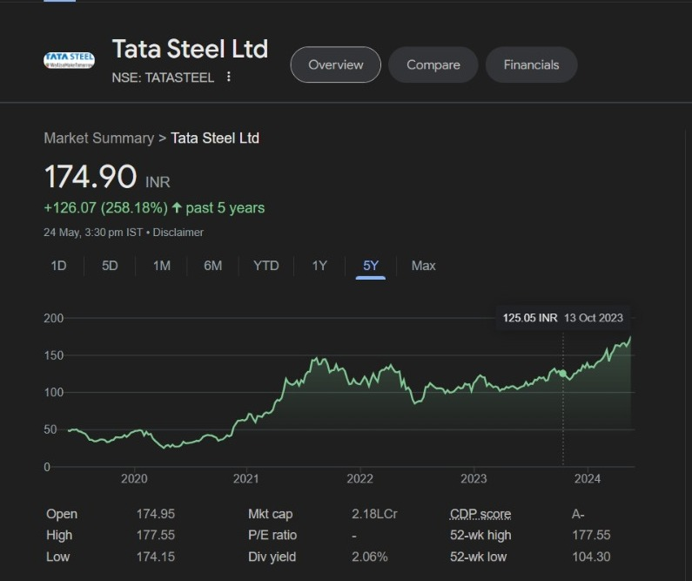

**4. MOIL (Manganese Ore India Limited) Sector: Mining (Manganese Ore) Market Position: Largest producer of manganese ore in India, supplying to major steel manufacturers.**

**MOIL (Manganese Ore India Limited) stock market performance in last 5 year.**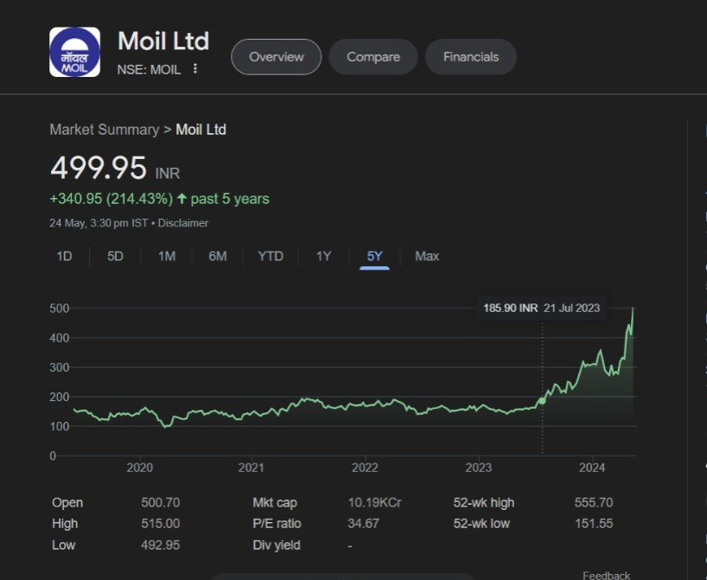

**Summary**

**• SBI: Positioned well for growth with strong fundamentals in the banking sector.**

**• Adani Enterprises: High growth potential, but with significant debt and regulatory risks.**

**• HUL: Consistent performer with strong market position and growth driven by consumer trends.**

**• Tata Steel: Benefiting from infrastructure**

**7. Are you familiar with web scraping techniques?**

**Yes, I'm familiar with web scraping techniques. Web scraping involves extracting data from websites, typically using Python libraries like BeautifulSoup or Scrapy to parse HTML and gather the desired information from web pages.**

***1. Understanding the Website Structure***

* **HTML Elements: Websites are structured using HTML. Understanding the HTML tags and elements (like <div>, <span>, <table>, etc.) is crucial.**
* **Inspecting Elements: Use browser developer tools (right-click on a webpage and select "Inspect") to examine the structure of the webpage and identify the data you want to extract.**

***2. Choosing the Right Tools and Libraries***

* **Python Libraries: Common libraries for web scraping in Python include:**
  + **BeautifulSoup: For parsing HTML and XML documents.**
  + **Requests: For making HTTP requests to fetch the webpage content.**
  + **Selenium: For scraping dynamic websites that require JavaScript execution.**
  + **Scrapy: A powerful and flexible web scraping framework.**

***5. Storing the Extracted Data***

* **CSV/Excel Files: Use libraries like pandas to store data in CSV or Excel format.**
* **Databases: Store data in databases like SQLite, MySQL, for more complex applications.**
* **By following these steps, you can efficiently scrape data from websites and handle various complexities such as dynamic content and anti-scraping measures.**

**8. Extracting NRI Data from SEBI Reports To extract the number of NRIs across PMSs from SEBI's monthly reports:**

**Process: Identify Data Source: Locate the URLs for the SEBI reports. Scrape Data: Use BeautifulSoup/Scrapy to scrape the relevant tables.**

**Data Processing: Extract and clean the data. Save Data: Store the data in a structured format like CSV or Excel. Time: This task could take a few hours to a day, depending on the complexity and number of reports.**

**Output File: A CSV or Excel file with columns for date, number of NRIs, and other relevant details.**

**Data Accuracy: Ensure data accuracy by validating scraped data against the source, handling missing values, and cross-checking totals.**

**9. Necessary Device Configuration**

**To perform these tasks daily, you would need:**

***Hardware Requirements***

* **Computer: Intel i5/i7 or AMD Ryzen, 8GB RAM (16GB recommended), 256GB SSD (512GB recommended)**
* **Internet: Reliable broadband, 25 Mbps minimum**
* **Monitors: Dual monitors (optional but recommended)**

***Software Requirements***

* **OS: Windows 10/11, macOS, or Linux (Ubuntu)**
* **Financial Analysis Tools:**
  + **Microsoft Excel or LibreOffice Calc**
  + **Python/R Programming (Jupyter Notebook for Python, RStudio for R)**

***Python Libraries***

* **Pandas, NumPy: Data manipulation and numerical computations**
* **Matplotlib/Seaborn: Data visualization**
* **Scikit-learn: Machine learning for financial modeling**

***Data Sources***

* **APIs: Yahoo Finance, Alpha Vantage**
* **Financial Databases: Moneycontrol, Screener.in, NSE/BSE websites**
* **Financial News: Reuters, Bloomberg, Economic Times**