**Lawrence’s Pack**

**No. 1**

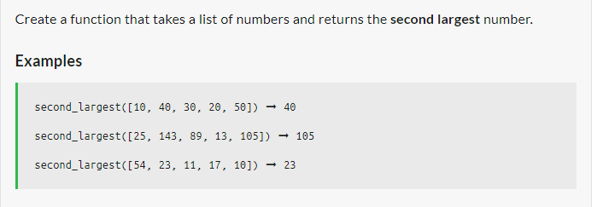

**No. 2**

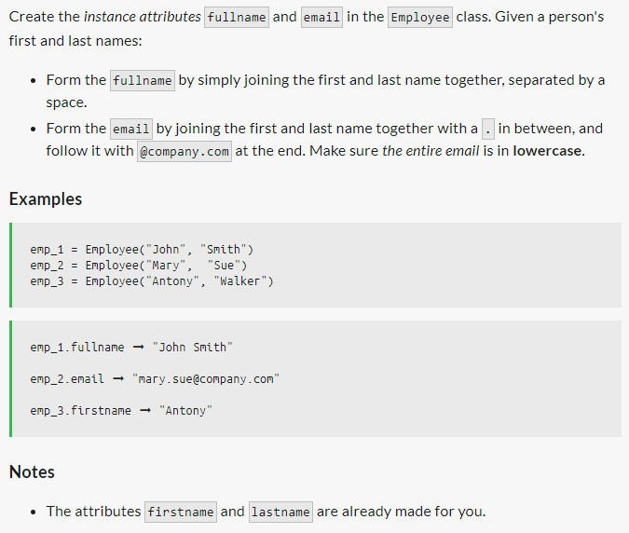

**No. 3**

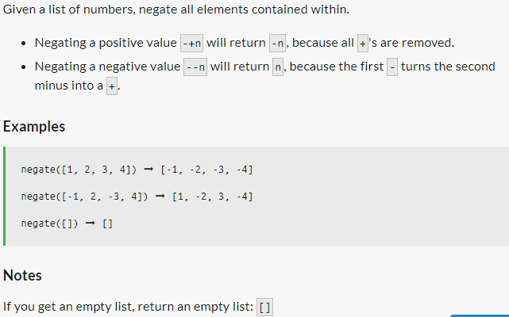

**No. 4**

Create a function that takes a list of words and transforms it into a list of each word's length.

**Examples**

word_lengths(["hello", "world"]) ➞ [5, 5]

word_lengths(["Halloween", "Thanksgiving", "Christmas"]) ➞ [9, 12, 9]

word_lengths(["She", "sells", "seashells", "down", "by", "the", "seashore"]) ➞ [3, 5, 9, 4, 2, 3, 8]

### Notes

* No test case will contain punctuation.
* Lists can be of various lengths.

**No. 5**

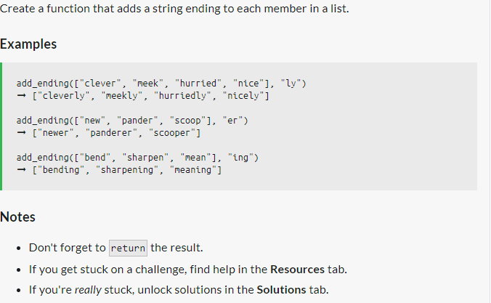

**No. 6**

