**Olu’s Pack**

**No. 1**

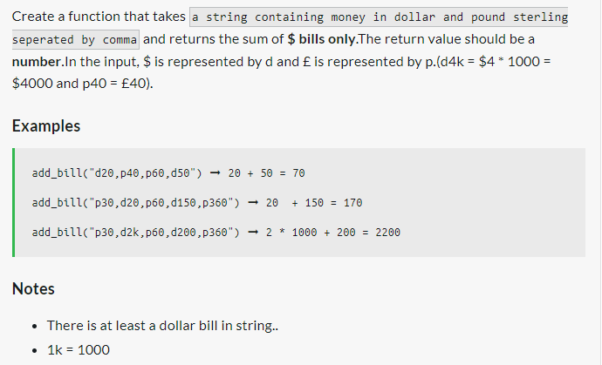

**No. 2**

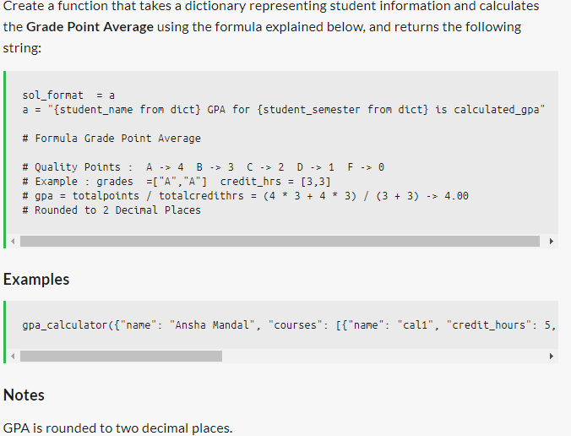

***Examples:***

gpa_calculator({"name": "Ansha Mandal", "courses": [{"name": "cal1", "credit_hours": 5, "grade": "A"}, {"name": "kin1", "credit_hours": 3, "grade": "A"}], "semester": "Spring 2018"}) ➞ "**Ansha Mandal GPA for Spring 2018 is 4.00**"

**No. 3**

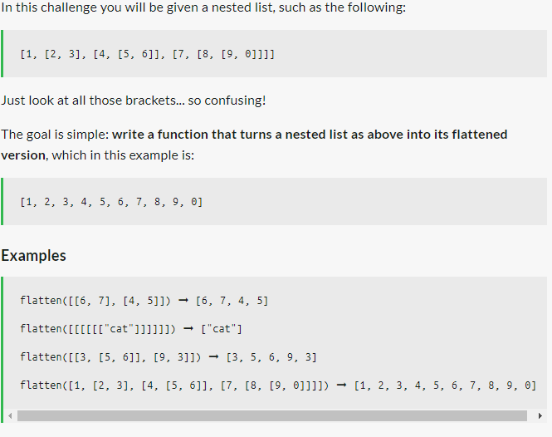

**No. 4**

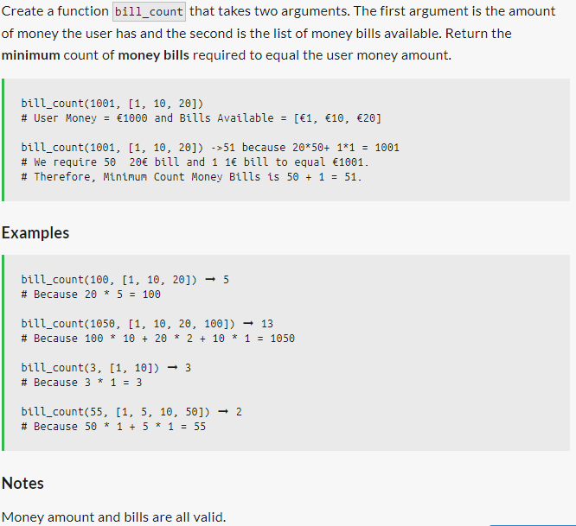

**No. 5**

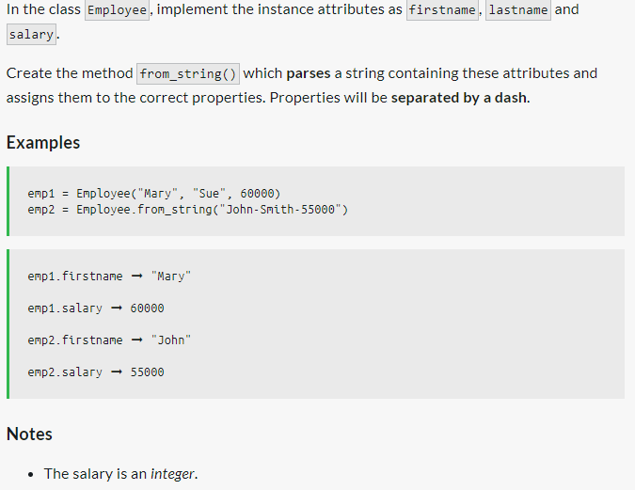

**No. 6**

