# Робот/бинанс LTCBTC 2022-09-28

|  |  |
| --- | --- |
|  |  |
|  |  |

|  |  |  |  |  |
| --- | --- | --- | --- | --- |
| **Номер** | **Название** | **Курс** | **свободные BTC** | **свободные** |
| 0 | ETHBTC | 0.06838300 | 0.00133637 | 0.01506500 |
| 1 | LTCBTC | 0.00276800 | 0.00133637 | 0.00013181 |
| 2 | BNBBTC | 0.01440500 | 0.00133637 | 6.74094000 |
| 3 | NEOBTC | 0.00044900 | 0.00133637 | 6.74094000 |
| 666 | BTCRUB | 1114816.00000000 | 0.00133637 | 6.74094000 |

# Close Date 2017-11-10 0.045217 2017-11-11 0.049497 2017-11-12 0.051749 2017-11-13 0.048284 2017-11-14 0.050881 ... ... 2022-09-23 0.068830 2022-09-24 0.069599 2022-09-25 0.068834 2022-09-26 0.069466 2022-09-27 0.069602 [1781 rows x 1 columns]

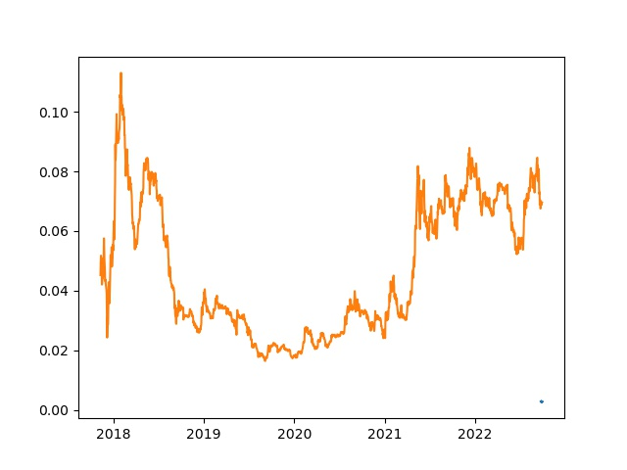

# Close Datetime 2022-09-21 19:00:00+00:00 0.002810 2022-09-21 19:01:00+00:00 0.002809 2022-09-21 19:02:00+00:00 0.002813 2022-09-21 19:03:00+00:00 0.002817 2022-09-21 19:04:00+00:00 0.002814 ... ... 2022-09-27 18:56:00+00:00 0.002748 2022-09-27 18:57:00+00:00 0.002751 2022-09-27 18:58:00+00:00 0.002751 2022-09-27 18:59:00+00:00 0.002750 2022-09-27 19:00:00+00:00 0.002749 [8556 rows x 1 columns]

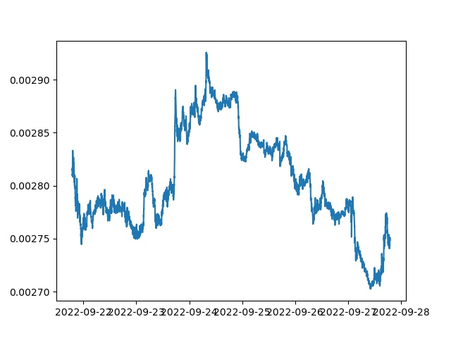

# Close Date 2017-11-10 0.045217 2017-11-11 0.049497 2017-11-12 0.051749 2017-11-13 0.048284 2017-11-14 0.050881 ... ... 2022-09-23 0.068830 2022-09-24 0.069599 2022-09-25 0.068834 2022-09-26 0.069466 2022-09-27 0.069602 [1781 rows x 1 columns]

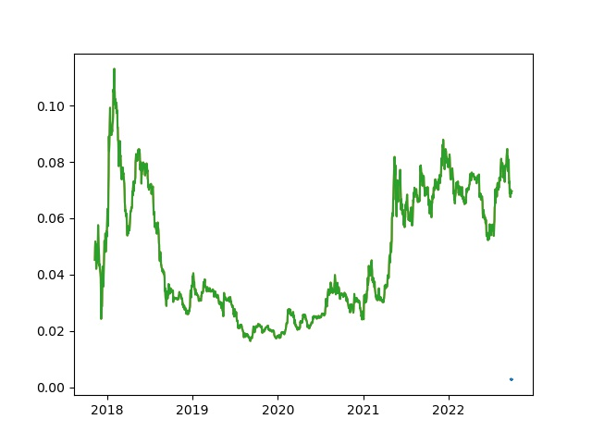

# Close Date 2017-11-10 0.004258 2017-11-11 0.004487 2017-11-12 0.004531 2017-11-13 0.004330 2017-11-14 0.004480 ... ... 2022-09-23 0.000444 2022-09-24 0.000444 2022-09-25 0.000441 2022-09-26 0.000436 2022-09-27 0.000466 [1781 rows x 1 columns]

