Complexities:

1. We don't know total number of results displayed, results increases as we scroll down, so not sure how much scrolling is to be done.

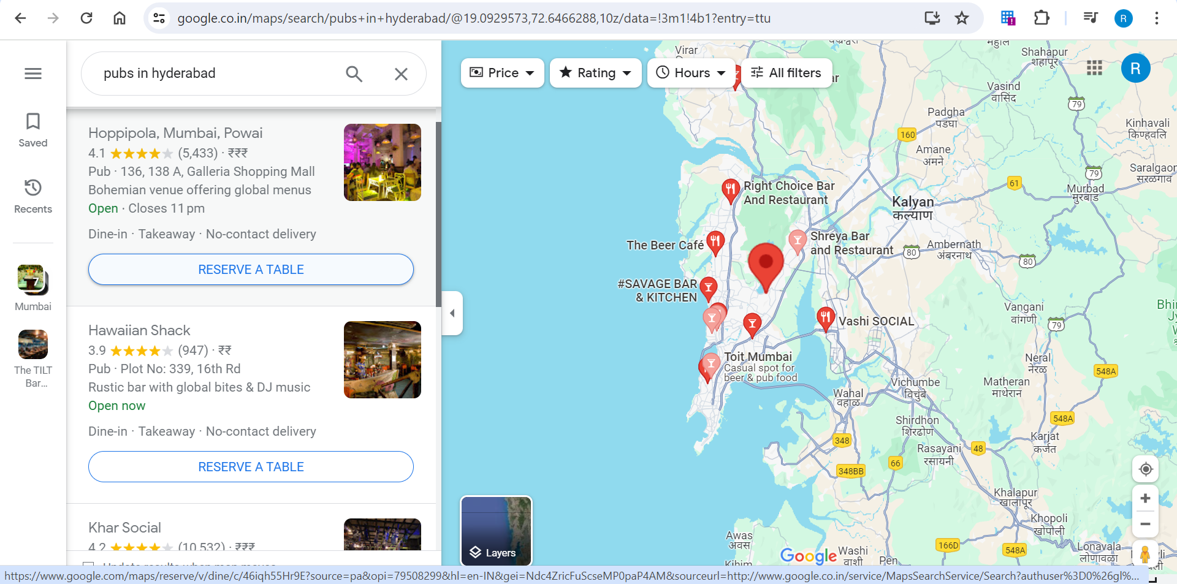

1. The extraction is done through Automated Browser through Selenium hence will be very slow.
2. We need further details/parameters for extraction like City name and data points to be extracted. For now, I have scraped Name of Restaurant/Pub, Address, Contact and URL.