FACTORY SIMULATION — PROGRESS REPORT
OOP with C++ GIST EECS

1. Team Information
Team name | JP
Factory domain | Energy Drink
GitHub repository | https://github.com/python-programmer1512/Gactorio

Member | Student ID | Primary responsibility
고원규 | 20265010 | FE, BE, PM
조용빈 | 20265260 | BE

2. Class Inventory
List every class you have defined or plan to define. Mark its layer and whether it is abstract or concrete.

Class name | Layer (Model/View/Controller) | Abstract / Concrete | Inherits from | Status (Planned/In progress / Done)
Machine | Model | Abstract | — | Done
MixingStation | Model | Concrete | Machine | Done
QualityStation | Model | Concrete | Machine | Done
BottlingStation | Model | Concrete | Machine | Done
PackagingStation | Model | Concrete | Machine | Done
MachineState | Model | Abstract | — | Done
IdleState / WorkingState / BrokenState / MaintenanceState | Model | Concrete | MachineState | Done
Observer | Model | Abstract | — | Done
EventLogObserver | Model | Concrete | Observer | Done
StatisticsObserver | Model | Concrete | Observer | Done
EventBus | Model | Concrete | — | Done
Event | Model | Concrete | — | Done
Item | Model | Abstract | — | Done
Ingredient / Water / EmptyBottle / Label / Package | Model | Concrete | Item | Done
Product | Model | Abstract | — | Done
VoltzClassic | Model | Concrete | Product | Done
HyperBolt | Model | Concrete | Product | Done
AuroraZero | Model | Concrete | Product | Done
Recipe | Model | Concrete | — | Done
Inventory | Model | Concrete | — | Done
ProductionLine | Model | Concrete | — | Done
ProductionTask | Model | Concrete | — | Done
SimClock | Model | Concrete | — | Done
Factory | Model | Concrete | — | Done
CarbonationFactory | Model | Concrete | Factory | Done
FactoryController | Controller | Concrete | — | Done
FactorySnapshot / MachineSnapshot / ProductionLineSnapshot / InventorySnapshot / EventSnapshot / StatisticsSnapshot | Controller (DTO) | Concrete | — | Done
UIComponent | View | Abstract | — | Done
AppUI | View | Concrete | — | Done
FactoryPanel | View | Concrete | UIComponent | Done
Application | View | Concrete | — | Done

Layer: Model/View/Controller Status: Planned / In progress / Done

3. Class Diagram (first version)
Attach or paste your current UML class diagram below. Hand-drawn is fine at this stage. Must show: class names, inheritance arrows, and key methods.

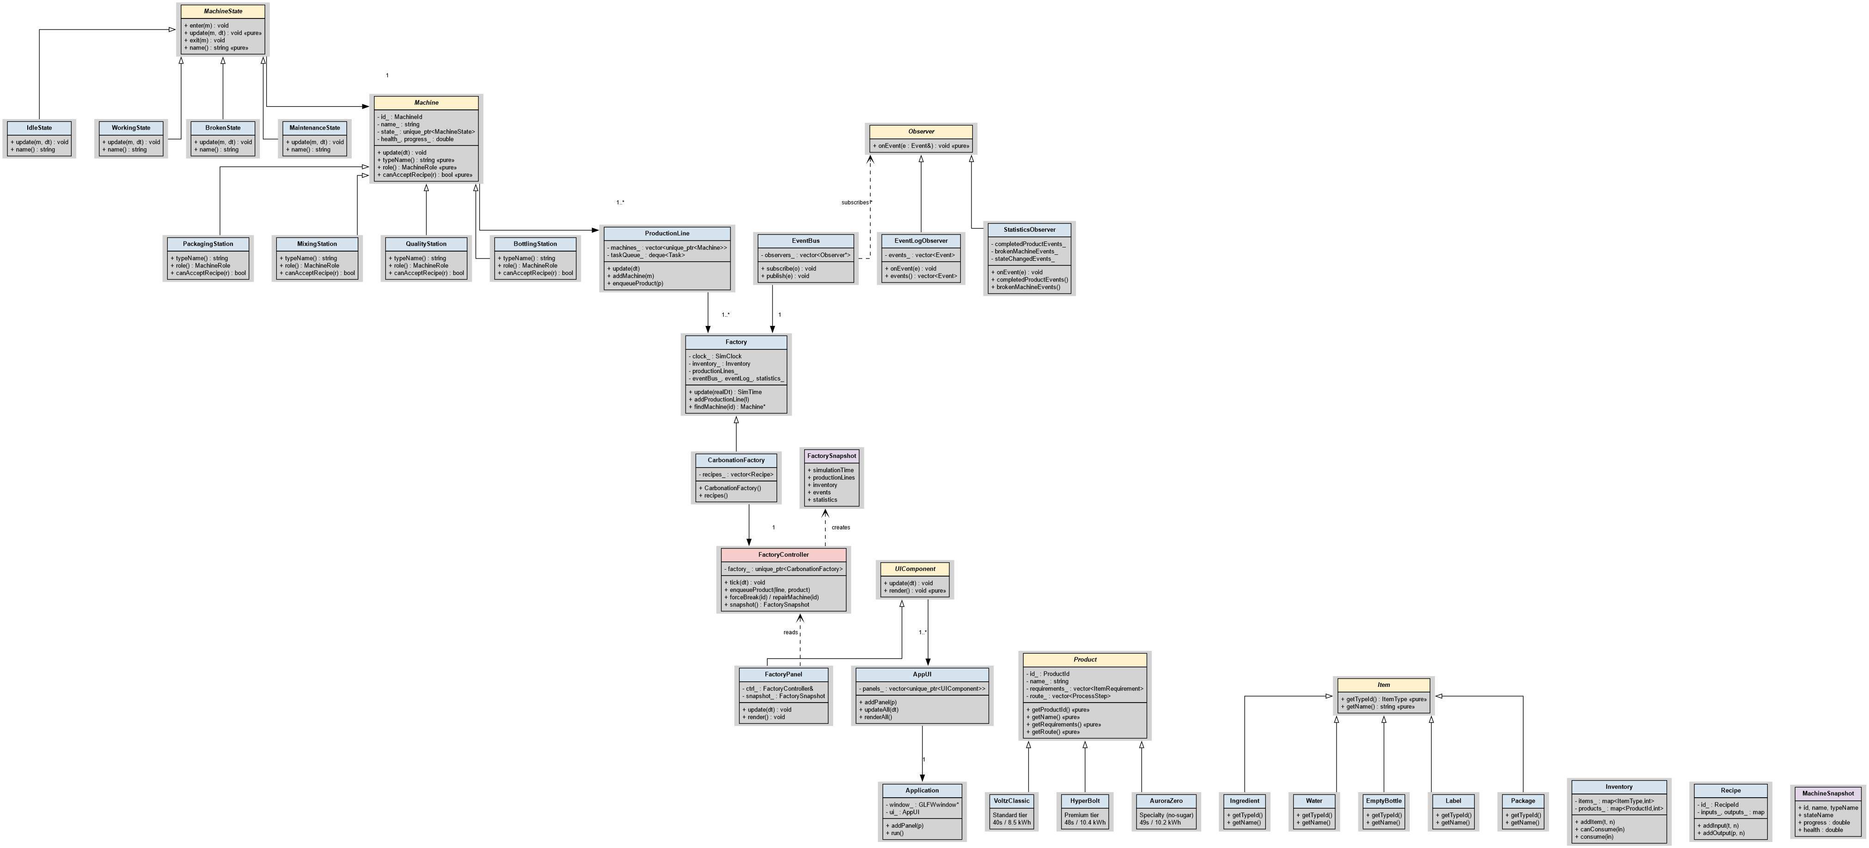

4. UI Screenshots
Paste 1–3 screenshots of your current UI. Add a one-line caption below each one explaining what it shows.

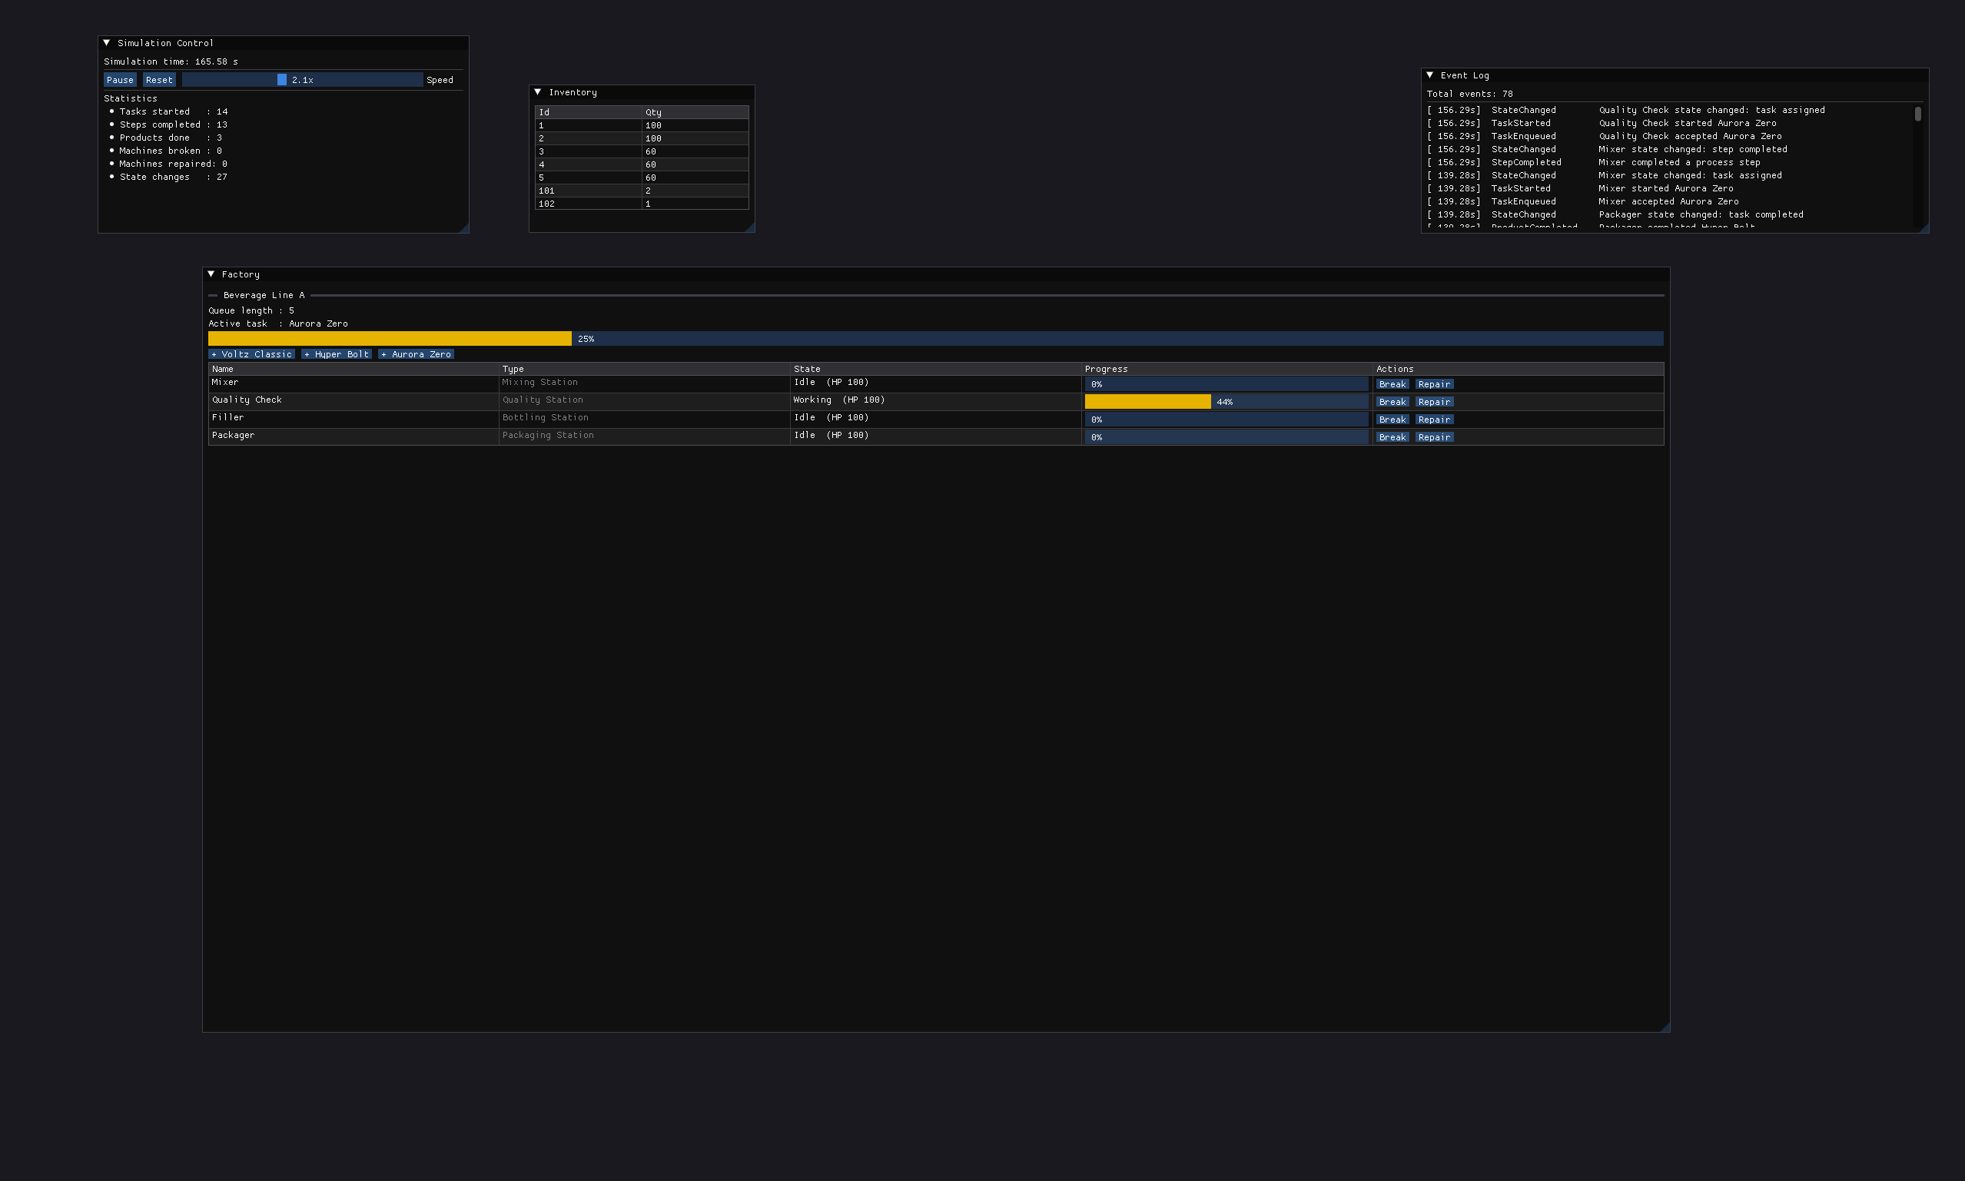
Caption: an Aurora Zero on the Quality Station, four panels updating from a single FactorySnapshot per frame

5. Project Completion Roadmap
List your remaining tasks with target dates. Be specific — one task per row.

# | Task | Owner | Target date | Done?
1 | 프로젝트 컨셉 확정 + 에너지 드링크 도메인 설계 (3종 음료, 4 스테이션, factory_config.json) | 고원규 | 2026-05-06 | ✓
2 | BE 핵심 모델 구현 — Item / Product / Recipe / Inventory / Machine + State Pattern | 조용빈 | 2026-05-15 | ✓
3 | Observer Pattern (EventBus + EventLogObserver + StatisticsObserver) + 11개 smoke 테스트 | 조용빈 | 2026-05-18 | ✓
4 | FE View 레이어 (Application, AppUI 컴포지터, FactoryPanel) + ImGui + GLFW 부트스트랩 | 고원규 | 2026-05-21 | ✓
5 | main 브랜치에 FE+BE 통합 (CMakeLists 통합, FactoryController/Snapshot 연동) | 고원규 | 2026-05-23 | ✓
6 | Energy-drink 도메인 리팩토링 (Voltz/Hyper/Aurora + 4 Station 적용) + UML + 진행 보고서 | 공동 | 2026-05-24 | ✓
7 | data/factory_config.json 파싱해 머신 스펙/레시피 동적 로딩 | 조용빈 | 2026-05-28 | □
8 | Memento Pattern 적용 (시뮬레이션 상태 undo/redo, 히스토리 스택) | 조용빈 | 2026-06-01 | □
9 | FE 다중 라인 지원 (음료별 전용 라인 + 시각화 개선, 라인 추가/삭제 UI) | 고원규 | 2026-06-04 | □
10 | 통합 시연 시나리오 + 데모 영상 + 최종 발표자료 + 코드 정리/제출 | 공동 | 2026-06-08 | □

6. Instructor Feedback
(This section is for instructor use only.)
Progress rating | □ On track □ Minor delays □ At risk □ Needs discussion
Architecture check | □ Frontend / backend correctly separated □ Needs revision
UML quality | □ Satisfactory □ Incomplete □ Incorrect — resubmit
Comments
Date reviewed

