Neo4j

What is Neo4j?

What is a graph
Neo4j is a graph database that stores data in a graph. Data is stored as nodes and relationships instead of tables or documents.
Graph databases are particularly useful when the connections between data are as important as the data itself.
In this lesson, you will learn about graphs and the elements that make up a Neo4j graph database.
A graph shows how objects are related to each other.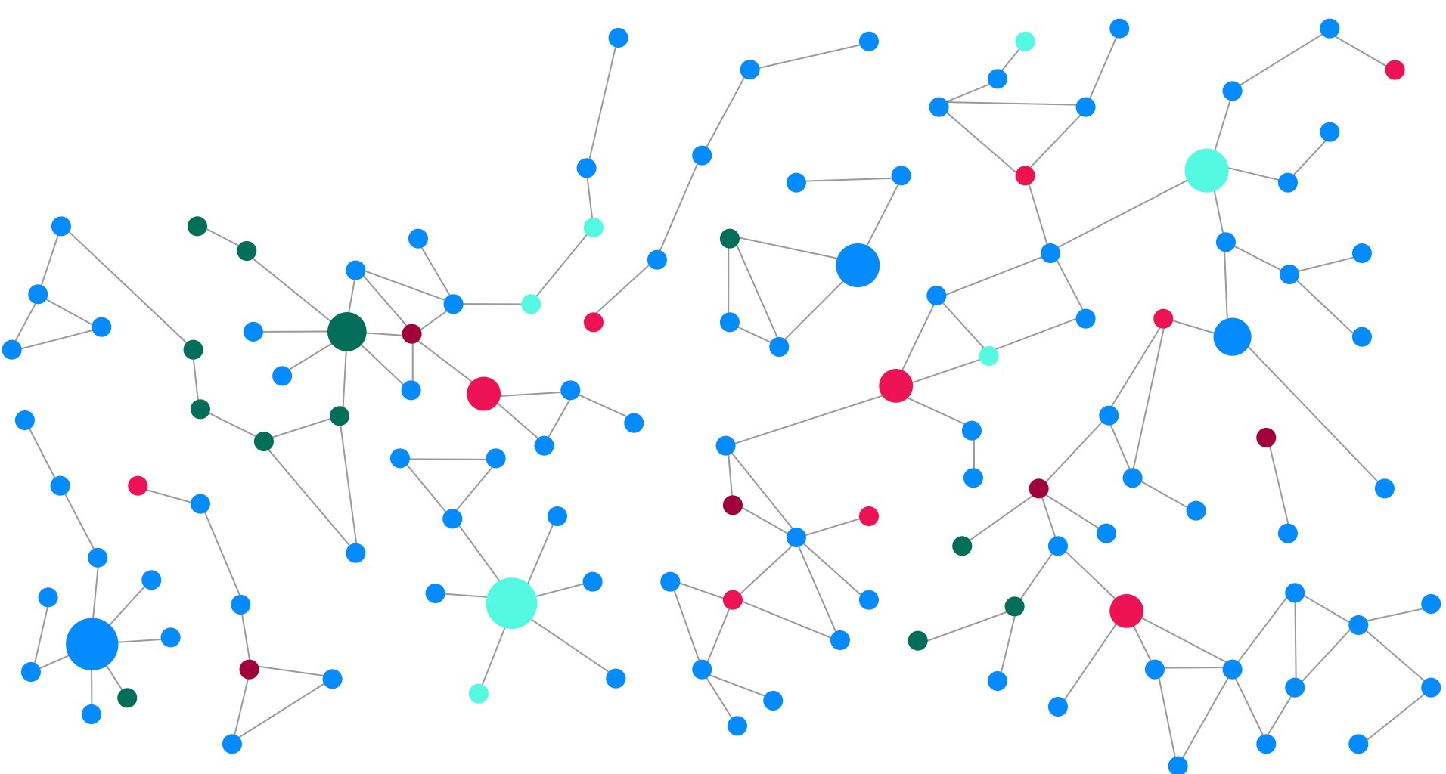
The objects are referred to as nodes (vertices) connected by relationships (edges).
Neo4j uses the graph structure to store data and is known as a labeled property graph.

Nodes, Relationships, Labels, and Properties
Data within Neo4j is stored and organized using:
- Nodes
- Relationships
- Labels
- Properties

Nodes
Nodes are the circles in a graph. Nodes typically represent objects or entities.
Imagine a social network, the entities (e.g. people, locations, companies) would be represented by nodes.
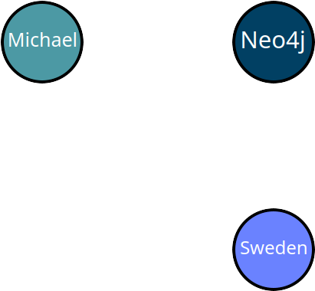
Each entity would be stored as a separate node in the graph.

Labels
Nodes are grouped by or categorized using labels. Labels describe what the nodes are, for example, Person, Company, Location.
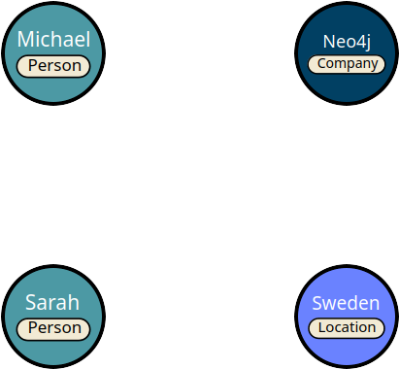
Nodes of the same type would have the same label.
Labels allow you to distinguish between different types of nodes and filter the graph.
Nodes can have multiple labels, for example, Michael is a Person and could also be an Employee.
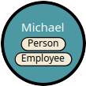
Use nouns for labels
Nodes typically represent things, and should be given a singular noun label. For example, Product, Event, Account.

Relationships
Relationships are the lines in the graph. Relationships describe how nodes within the graph are connected to each other.
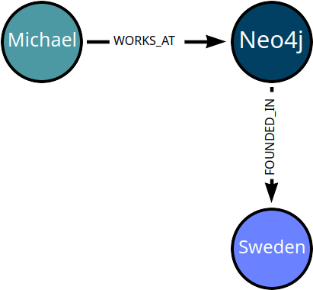
A relationship in Neo4j connects two nodes, referred to as the start and end nodes.
All relationships have:
- a type - WORKS_AT, FOUNDED_IN.
- a direction - Michael WORKS_AT Neo4j, Neo4j doesn’t work at Michael.
Nodes can have multiple relationships to other nodes.
Multiple relationships can be used to describe bi-directional relationships.
In this example, two LOVES relationships are used to describe the status between Michael and Sarah.
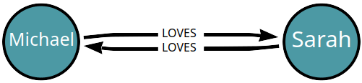
You cannot assume that just because Michael loves Sarah, Sarah loves Michael back!
Use verbs for relationship types
You can use a relationship to represent:
- A personal connection - Person KNOWS Person, Person MARRIED_TO Person.
- A fact - Person LIVES_IN Location, Person OWNS Car, Person RATED Movie.
- A hierarchy - Parent PARENT_OF Child, Software DEPENDS_ON Library.
- Any type of connection between 2 entities - Entity CONNECTED_TO Entity.

Properties
You can store data against nodes and relationships as properties.
Properties are named key, value pairs; for example firstName, lastName, and position.
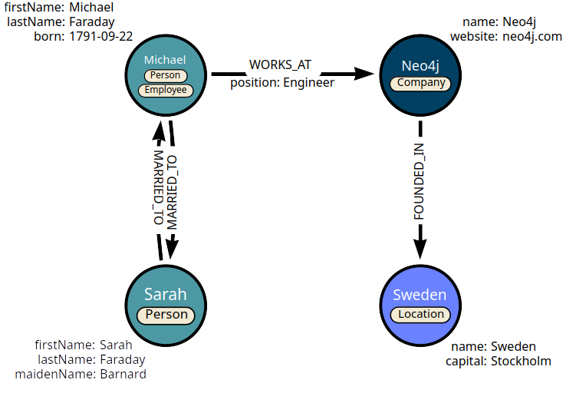
Nodes and relationships can have any number of properties, and those of the same type do not have to have the same properties (i.e. Neo4j is schemaless).
Properties have a type (integer, boolean, string, list, etc) and can be unique identifiers (keys) for specific node labels.

Check your understanding Data in Neo4j

Data within Neo4j is stored and organized using which of the following? (Select all that apply)
- Nodes
- Relationships
- Labels
- Properties

Check answer
Solution
Data within Neo4j is stored and organized using nodes, relationships, labels, and properties.

Thinking in Graphs
You have learned that Graph databases store data in a structure of nodes and relationships.
In this lesson, you will learn why a graph database can be the right solution.

Why Graph Databases?
Relationships in a graph are treated with the same importance as nodes that connect them.
This is not the same as other database technologies, as a result you may have experienced issues such as:
- Poorly performing queries when traversing complex schema of foreign keys and many-to-many relationships.
- Dealing with hierarchical data or trees, where the answer may lie at an unknown or varying depth.
- Finding a path through an ever-changing dataset with complex requirements.
- Simply finding it difficult to express what you are looking for.
These issues are often as a result of storing data in tables when the requirement is to understand relationships not rows.

The O(n) problem
Storing data in rows and columns is one of the oldest storage mechanisms and existed long before the computer.
Tabular data is a tried-and-tested methodology that works well for many use cases and an ecosystem of tooling exists to help you work efficiently.
However, as the amount of data grows or the application or use case becomes more complex, you may encounter challenges dealing with relationships.
When querying across tables, the joins are computed at read-time, using an index to find the corresponding rows in the target table. The more data added to the database, the larger the index grows, the slower the response time.

This problem is known as the “Big O” or O(n) notation.

NoSQL Databases
Over the years, many No-SQL databases have sprung up to handle different scenarios, for example:
- Document stores offer flexibility.
- Wide-column stores offer scalability for large datasets.
- Key-value stores provide simplicity and high performance.
- Graph databases enable efficient modeling and querying of complex relationships.
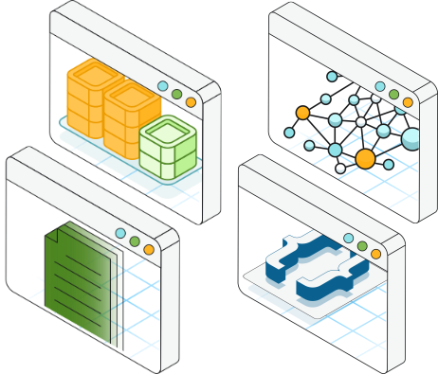

Graphs
When you create a relationship between two nodes, the database stores a pointer to the relationship with each node. When reading data, the database will follow pointers in memory rather than relying on an underlying index.
This means that the query time remains constant to the size of the relationships expanded regardless of the overall size of the data.
A graph database yields much faster results for queries across entities and is a great fit when you need to:
- Understand the relationships between entities - how two people are connected
- Self referenced data of the same type - a hierarchy of employees within a company
- Explore relationships of varying or unknown depth - the use of parts within a factory
- Calculate a route between two points in a network - finding the most efficient route on public transport
Graph databases are a great fit for scenarios when you need to handle relationships efficiently.

Check your understanding

The O(n) notation problem
Related to relational databases - what is the O(n) problem?

- Increasing response times as database indexes grow larger due to more data.

Solution
The answer is "Increasing response times as database indexes grow larger due to more data".
Graph databases negate this issue by as the database stores a pointer to the relationship with each node. So when the time comes to read the data, the database will follow pointers in memory rather than relying on an underlying index.

Graphs Are Everywhere

1736 to the Present Day
Graph databases originate from graph theory, a concept created in 1730’s Prussia.
The Seven Bridges of Königsberg problem asked whether it was possible to walk through the city, crossing each of its seven bridges exactly once without retracing steps.

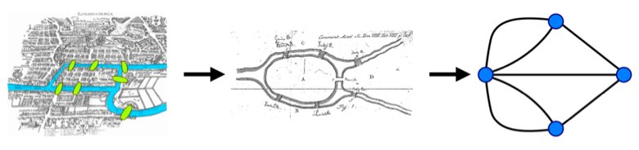
Euler solved this by representing the landmasses as vertices (nodes) and the bridges as edges (relationships), forming a graph.
He proved that such a path was impossible because the graph required all nodes to have an even number of edges, which was not the case, thus laying the foundation for graph theory.
Graphs allow you to find new information and prove hypothesis.

Uncover Patterns in your Data
Graphs allow you to uncover patterns in your data, whether that be:
- Customer: using customer data for recommendations, churn prevention, tailored offers, and targeted ads, enhancing customer retention and revenue growth.
- Network & Security: analyzing IT asset data to support comprehensive security monitoring and proactive threat response.
- Employee: storing employee data to support talent development, career management, and resource allocation, helping align workforce capabilities with business needs.
- Transactions: capturing transactional data to detect illegal activities, supporting anti-money laundering, fraud detection, credit risk assessment, and credit fraud detection by revealing hidden patterns, anomalies, and connections.
- Product: centralizing product data to support personalized recommendations, optimize new product launches, enhance customization, manage inventory, and refine pricing strategies.
- Suppliers: storing data on supplier performance, inventory, costs, logistics, and compliance to optimize supply chain management, supporting programs like route planning, real-time visibility, inventory planning, and risk analysis.
- Process: creating a graph of process-related data can identify bottlenecks, improve efficiency, automate tasks, and monitor performance by analyzing operational, resource, quality, and cost data.
You can read more Neo4j industry and customer uses cases at neo4j.com/use-cases.

Knowledge Graphs & Generative AI
Graphs have become an important part in developing Generative AI (GenAI) applications. GenAI applications need access to the meaning in data, and knowledge graphs can provide this context.
Knowledge graphs provide a structured way to represent entities, their attributes, and their relationships, allowing for a comprehensive and interconnected understanding of the information.
Knowledge graphs can break down sources of information and integrate them, allowing you to see the relationships between the data.
You may not be familiar with the term knowledge graph, but you have probably used one. Search engines typically use knowledge graphs to provide information about people, places, and things.
The following knowledge graph could represent Neo4j:
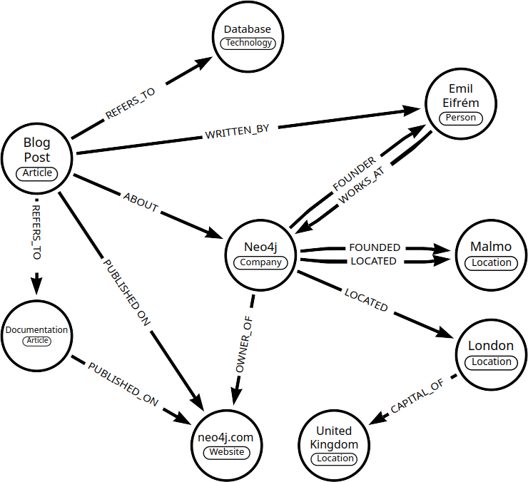
There are many use cases for Neo4j and GenAI including vector search, knowledge graph, and data science.

Routing
Graphs are easy to visualize in route planning and transportation.
When navigating a public transport network, you are using concepts from graph theory, treating stations or stops as nodes and routes or connections as edges.
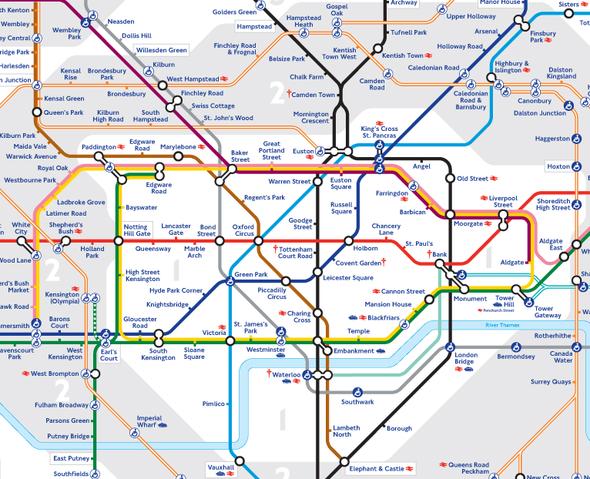
By finding the shortest or most efficient paths through this network, you are engaging in problem-solving similar to graph traversal, optimizing your route to reach your destination efficiently.
A higher level graph may contain weighted relationships between stops to represent the lines, while a lower level graph may model platforms within stations and services as nodes in the graph.
Transport for London (TfL) use Neo4j to store a digital representation of their transport network, allowing them to identify bottlenecks and cut congestion in the network.
Lesson Completed

Summary
In this lesson, you learned about some common use cases for graphs.
In the next module, you will learn how to query a graph database using Cypher.

