
Confirmed
You are booked with Hannah Guo

Interview with Per Scholas Los Angeles
Tuesday, September 2, 2025, 9:00 - 9:45 AM
(GMT-07:00) Pacific Time - Los Angeles
Zoom Meeting

Gain the skills needed to secure opportunities at top tech companies. In just a few weeks, this hands-on course equips you with essential knowledge and practical experience for in-demand IT Support roles, including:

- Fundamentals of IT Support – Analyze various IT systems and configurations
- Computer Hardware and Operating Systems – Install and configure enterprise-grade servers, networking equipment, and peripheral devices
- Security Practices and Technologies – Apply security best practices by configuring and securing workstations, networks, and mobile devices
- Industry Certifications – Earn the credentials that enhance employability
We know life continues while you’re enrolled at Per Scholas. Learners enrolled in a full-time IT Support course at Per Scholas Los Angeles can apply for a Zero Percent Loan from Ascent to pay for personal expenses while training with Per Scholas. Learn more in the FAQs.
*Open to learners within Los Angeles County.
Course level
Suitable for all levels ?

Get certified in
- CompTIA A+ ?
- Google IT Support Professional Certificate ?

Schedule
- 9AM - 4PM
Monday through Friday
13-15 weeks
- *Start and end times may vary based on time zone (under 9-4pm)
- LIVE & INSTRUCTOR LED

Upcoming course dates
- November 10th, 2025
Application Due October 27th, 2025
- November 10th, 2025 | Boyle Heights Technology Youth Center
Application Due October 27th, 2025
- November 10th, 2025
Application Due October 27th, 2025

Tuition-Free IT Support CompTIA and Google Training in Los Angeles
Launch your tech career learning the fundamentals through hands-on, live instructor-led instruction covering core concepts and technologies.

Free Technical Training in a Few Weeks
Learn 2 years of IT Support topics such as troubleshooting, hard drive technologies, and system administration in a fraction of the time. Our training is tuition-free to learners thanks to generous donors and partners.

Industry Recognized Certifications At No Cost
Unlock your career potential and showcase your job readiness to employers by earning the CompTIA A+ certification and the Google IT Support Professional Certificate for free.

Professional Development & Growth Opportunities in Los Angeles
Before connecting you with employer partners for job opportunities post-training, our Career Coaches prepare you with the tools to secure a role in the tech sector.

To engage with introductory topics that ensure you are prepared for day 1 of technical training, many of Per Scholas curriculums require learners to complete Self-Study Tech Prep Work due to the fast-paced, rigorous nature of our bootcamp-style training.

Required Tech Prep Work:
Required Courses:
- Computer Hardware Basics Course (6 hours)
- Operating Systems Basics Course (12 hours)
Submission Portal:
- Tech Prep Work Submission Portal
Help Resources:
- Instructions for Completing and Submitting Tech Prep Work
- CISCO NetAcad FAQs
- Email admissionsadmins@perscholas.org if you need any help troubleshooting

Tech Prep Work Deadline
Tech Prep Work is due prior to Seat Offers. Applicants are encouraged to have their Tech Prep Work completed before they interview.

Additional Optional Tech Prep Work:
Optional Tech Prep Work Upload
Most Recommended:
- GCF Computer Basics Course (4 hours) This prework tutorial will help you understand how computers work and how to use them. You will learn how to set up a computer, the difference between hardware and software, and the types of computers you can use. You will also explore operating systems, applications, the cloud, and much more.
  - Instructions
Additional:
- General Technology Training If you are new to computers, haven’t used them for a while, are a little unsure and uncomfortable, or just need a bit of a refresher, we have the tools to help you tackle technology at your own pace and gain the confidence you need to succeed. The course is self-paced and offered at no cost.
- Basic Computer Skills Course The Basic Computer Skills Course is available to provide training in common computer skills that can be used in your everyday lives. Each chapter contains online modules featuring learning activities followed by a knowledge check. The course is self-paced and offered at no cost.
- LinkedIn Learning: Working with Computers and Devices Learn about the different hardware parts that make up a computer. Explore the fundamentals of working with operating systems and applications and how to keep your computer secure. Plus, learn to work with essential productivity programs like word processors and spreadsheet tools. Follow along and learn the technical skills you need to succeed in our digital world. The course is self-paced and offered at no cost.
Have questions? Click here to contact an admissions team member.

🔑 Advanced IT Support Career Path
(From Help Desk → SysAdmin/Cloud Engineer → Security/Automation)

1. Core IT Infrastructure (Level-Up from Help Desk)
- CompTIA Network+ (N10-009) → deep dive into networking protocols, routing, firewalls, and wireless.
- CompTIA Security+ (SY0-701) → industry-standard security foundation.
- Microsoft Certified: Windows Server Hybrid Administrator Associate → AD, Group Policy, M365 hybrid.
👉 These set you up for System Administrator or IT Specialist roles.

2. Cloud & Virtualization (In-Demand for 2025)
- AWS Certified SysOps Administrator OR Azure Administrator Associate
  - Cloud infrastructure, deployments, monitoring, automation.
- VMware Certified Professional (VCP-DCV) → virtualization (still valuable in enterprise).
- Linux Foundation Certified System Administrator (LFCS) → critical if you want Linux support roles.
👉 Moves you toward Cloud/Systems Engineer jobs.

3. Automation & Scripting (Advanced Support → Engineering)
- Python for IT Automation (Google, Coursera)
- Microsoft PowerShell Advanced Scripting
- Terraform Associate → Infrastructure as Code.
👉 Gives you a competitive edge — companies want IT support pros who can automate repetitive tasks.

4. Cybersecurity (High-Growth Path)
- CompTIA CySA+ (Cybersecurity Analyst)
- Certified Ethical Hacker (CEH) or PenTest+ (if you want to pivot to security).
- Splunk Core Certified Power User → log analysis, SIEM support.
👉 These open doors to IT Security Analyst or SOC Support Engineer roles.

5. ITIL & Service Management (Leadership Path)
- ITIL 4 Foundation / Managing Professional
- Certified in IT Service Management (ISO/IEC 20000)
👉 Helpful if you want to move toward IT Support Manager roles.

📌 Recommended Order (Practical Path)
- Security+ + Network+ → solid advanced foundation.
- Cloud cert (AWS SysOps / Azure Admin) → cloud is mandatory now.
- Automation (Python + PowerShell) → makes you stand out.
- Then specialize → either Security path OR SysAdmin/Cloud path depending on your career interests.

⭐ Bonus:
Many companies now prefer Google IT Support Professional Certificate (Coursera) as a foundation — but since you’re aiming for advanced, stack it with Cloud + Security.

👉 Do you want me to create a 12-month step-by-step learning roadmap (with free + paid course links, projects, and cert milestones) so you can systematically level up into Cloud/Automation/Security IT Engineer?

You said:
yes

ChatGPT said:
Great! 🚀 Let’s build your 12-month Advanced IT Support → Cloud/Security Engineer roadmap.
I’ll break it into 4 quarters (3 months each) with certifications, skills, and hands-on projects so you’ll have a clear career path.

🗓️ 12-Month IT Support Career Roadmap

Quarter 1 (Months 1–3): Strengthen Foundation & Security
🎯 Goal: Move from basic IT support → advanced technician with security awareness.
- Certifications:
  - ✅ CompTIA Network+ (Networking fundamentals, routing, TCP/IP, VPNs)
  - ✅ CompTIA Security+ (Industry-standard entry security cert)
- Skills:
  - Networking: Subnetting, firewalls, VLANs.
  - Security basics: Threats, risk management, encryption.
  - Windows & Linux admin (practice in virtual machines).
- Projects to Do:
  - Build a home lab (VirtualBox/VMware) with 2–3 VMs (Windows + Linux).
  - Configure a firewall + VPN.
  - Document troubleshooting steps (showcase on GitHub/portfolio).

Quarter 2 (Months 4–6): Cloud Skills
🎯 Goal: Transition from on-prem IT → Cloud systems admin.
- Certifications:
  - ✅ AWS Certified SysOps Administrator OR Azure Administrator Associate.
- Skills:
  - Cloud deployments (VMs, storage, networking).
  - Identity & Access Management (IAM).
  - Monitoring & scaling apps.
- Projects to Do:
  - Deploy a 3-tier web app in AWS/Azure.
  - Configure auto-scaling & monitoring.
  - Compare cloud costs between AWS & Azure (mini report).

Quarter 3 (Months 7–9): Automation & Scripting
🎯 Goal: Become the IT person who automates everything.
- Certifications:
  - ✅ Google IT Automation with Python (Coursera).
  - ✅ Terraform Associate (Infrastructure as Code).
- Skills:
  - Python scripting for IT tasks.
  - PowerShell advanced scripting.
  - Automating deployments (Terraform + Cloud).
- Projects to Do:
  - Write a Python script that parses system logs and emails reports.
  - Automate user account creation in Active Directory.
  - Use Terraform to provision a VM + network in AWS/Azure.

Quarter 4 (Months 10–12): Specialize (Security or Cloud Ops)
🎯 Goal: Choose your long-term IT path → Security Analyst OR Cloud Engineer.

If Security Path:
- Certifications:
  - ✅ CompTIA CySA+ (Cybersecurity Analyst).
  - Optional: Certified Ethical Hacker (CEH).
- Projects:
  - Set up a SIEM with Splunk/ELK.
  - Run vulnerability scans with Nmap & Nessus.

If Cloud/DevOps Path:
- Certifications:
  - ✅ AWS Solutions Architect Associate OR Azure Solutions Architect Expert.
  - ✅ Docker + Kubernetes (CKA – Certified Kubernetes Administrator if possible).
- Projects:
  - Deploy a containerized app with Docker.
  - Orchestrate apps with Kubernetes cluster.

📌 By the End of 12 Months:
✅ Network+ & Security+ (advanced IT support baseline)
✅ Cloud certification (AWS/Azure Admin)
✅ Automation (Python + Terraform)
✅ Specialization (Security or Cloud Engineer)
📂 Portfolio with 6+ projects to showcase to recruiters

🗓️ 12-Month IT Support → Cloud/Security Career Path (with Courses)

Quarter 1 (Months 1–3): Networking + Security Foundations
🎯 Goal: Become advanced IT Support with strong networking & security skills.
- Certifications:
  - CompTIA Network+
📌 Course: CompTIA Network+ (Udemy – Mike Meyers)
  - CompTIA Security+
📌 Course: CompTIA Security+ (Udemy – Jason Dion)
- Free Resources:
  - Cisco Packet Tracer (networking simulator – free).
  - TryHackMe (free beginner labs for cybersecurity).
- Projects:
  - Build a home lab (VMs on VirtualBox).
  - Configure a firewall + VPN + test attacks in TryHackMe.

Quarter 2 (Months 4–6): Cloud Skills (AWS/Azure)
🎯 Goal: Transition to Cloud System Admin.
- Certifications (pick one track):
  - AWS Certified SysOps Administrator – Associate
📌 Course: AWS SysOps Administrator (Udemy)
  - OR Azure Administrator Associate (AZ-104)
📌 Course: AZ-104 Microsoft Azure Administrator (Udemy)
- Free Resources:
  - AWS Free Tier or Azure Free Account.
- Projects:
  - Deploy a 3-tier web app (frontend + backend + database).
  - Configure IAM roles + monitoring (CloudWatch/Azure Monitor).

Quarter 3 (Months 7–9): Automation & Scripting
🎯 Goal: Learn to automate IT tasks with scripting & IaC.
- Certifications:
  - Google IT Automation with Python (Coursera – Google Career Cert) → Link
  - Terraform Associate
📌 Course: HashiCorp Certified: Terraform Associate (Udemy)
- Free Resources:
  - Python practice on HackerRank.
  - Terraform official docs (hashicorp.com).
- Projects:
  - Python script that parses logs + sends email alerts.
  - Automate Active Directory user creation with PowerShell.
  - Use Terraform to provision AWS/Azure infra.

Quarter 4 (Months 10–12): Specialization (Choose Security OR Cloud/DevOps)
🎯 Goal: Pick your long-term IT career.

🔐 Security Path
- Certifications:
  - CompTIA CySA+ (Cybersecurity Analyst) → Udemy Course
  - CEH (Certified Ethical Hacker – optional).
- Projects:
  - Deploy SIEM with Splunk or ELK.
  - Run scans with Nmap, Nessus, OpenVAS.
  - Document vulnerabilities + mitigation steps.

☁️ Cloud/DevOps Path
- Certifications:
  - AWS Solutions Architect Associate OR Azure Solutions Architect Expert.
  - Kubernetes (CKA – Certified Kubernetes Administrator).
- Courses:
  - AWS Solutions Architect (Udemy)
  - Kubernetes CKA (Udemy)
- Projects:
  - Deploy Dockerized app.
  - Orchestrate with Kubernetes cluster.
  - Automate CI/CD pipeline (GitHub Actions or Jenkins).

✅ By end of this roadmap:
- You’ll have 4–6 industry certifications.
- A portfolio of 6–8 projects (GitHub/portfolio website).
- Experience in IT support, networking, cloud, automation, and either Security or DevOps.

Required Tech Prep Work:
Required Courses:
- Computer Hardware Basics Course (6 hours)
- Operating Systems Basics Course (12 hours)
Submission Portal:
- Tech Prep Work Submission Portal
Help Resources:
- Instructions for Completing and Submitting Tech Prep Work
- CISCO NetAcad FAQs
- Email admissionsadmins@perscholas.org if you need any help troubleshooting

Tech Prep Work Deadline
Tech Prep Work is due prior to Seat Offers. Applicants are encouraged to have their Tech Prep Work completed before they interview.
Computer Hardware Basics Course (6 hours)
https://www.netacad.com/launch?id=3252ef96-6b9c-4347-9f4e-c2e01ff79704&tab=curriculum&view=0d0ecad0-602e-5111-9ad8-4056c9950728
Per Scholas Tech Prep Work Computer Hardware Basics

1.0 Introduction
1.0.1 Why Should I Take This Module?
People prepare for work in the information technology fields by earning certifications, seeking formal education, and experiencing internships and jobs. In this module, you will learn about all the components that make up a PC, starting with the case that houses all of the internal components. Computers, components, and peripherals all contain hazards that can cause severe injury. Therefore, this module begins with safety guidelines that you should follow to prevent electrical fires, injuries, and fatalities while working inside a computer. You will also learn about Electrostatic Discharge (ESD) and how it can damage computer equipment if not discharged properly
In this module, you will watch a demonstration of a computer disassembly so that you can become more familiar with all of the components and how they are connected. We also provide instructions if you would like to disassemble a computer of your own.
Additionally, you will watch detailed demonstrations of assembling a computer, from installing the power supply, CPU, RAM, motherboard, adapter cards, cables, and external connectors. We also provide instructions if you would like to assemble a computer of your own.

1.0.2 What Will I Learn in This Module?
Module Title: Personal Computers
Module Objective: Install components to safely build, repair, or upgrade personal computers.
Topic Title | Topic Objective
General and Fire Safety | Define general and fire safety standards.
Personal Computers and Safety | Explain how to keep personal computer components safe.
Computer Disassembly | Disassemble a PC.
Open the Case and Connect the Power Supply | Connect the power supply.
Install Motherboard Components | Install the motherboard components.
Install Drives and Adapter Cards | Install the internal drives and adapter cards.
Install Cables and Complete Assembly | Connect the computer components with appropriate cables.

1.1.2 Practice Item - General and Fire Safety
What are two personal safety actions that should be performed when working on computer equipment? (Choose two.)
Turn off and disconnect the power from the computer.

Wear safety googles.

1.1.2 Practice Item - General and Fire Safety

General safety and fire actions you should perform when working on computer equipment include turning off and disconnecting the power to the equipment; wearing safety googles; bending your knees when lifting heavy equipment; taping over sharp corners; not wearing watches and jewelry or loose clothing; and knowing the location of, and be able to use, a fire extinguisher.

1.2.2 Electrical Safety
Follow electrical safety guidelines to prevent electrical fires, injuries, and fatalities.
⁠⁠⁠⁠⁠⁠⁠Some parts, such as power supplies, contain high voltage. It is essential to check the printer manual for the location of high-voltage components. Some components retain a high voltage even after being turned off.
Electrical devices have specific power requirements—for example, AC adapters manufactured for particular laptops.
Exchanging AC adapters with different types of devices may cause damage to both the AC adapter and the device.
Electric equipment must be grounded. If a fault causes metal parts of the equipment to become live with electrical current, the ground will provide a path of least resistance for the current to flow harmlessly away. Typically computer products connect to the ground via the power plug—large equipment such as server racks that house network devices must also be grounded.

1.2.3 ESD
Electrostatic discharge (ESD) can occur when a buildup of an electric charge (static electricity) exists on a surface that comes into contact with another, differently charged surface. ESD can cause damage to computer equipment if not discharged properly. To prevent equipment damage and data loss, follow proper handling guidelines, be aware of environmental issues, and use equipment that stabilizes power.
At least 3,000 volts of static electricity must build up before a person can feel ESD. For example, static electricity can build up as you walk across a carpeted floor. When you touch another person, you both receive a shock. If the discharge causes pain or makes a noise, the charge is probably above 10,000 volts. Less than 30 volts of static electricity can damage a computer component. Static buildup discharges by touching a grounded object before touching any electronic equipment, also known as self-grounding.
ESD can cause permanent damage to electrical components. Follow these recommendations to help prevent ESD damage:
- Keep all components in antistatic bags until you are ready to install them.
- Use grounded mats on workbenches.
- Use grounded floor mats in work areas.
- Apply antistatic wrist straps when working inside computers.

1.2.4 Practice Item - ESD Characteristics
If at least 3,000 volts of static electricity must build up before a person can feel electrostatic discharge (ESD) why should an antistatic wrist strap be worn at all times when working on a computer?
Electronic components can be damaged by voltages as low as 30 volts.

1.2.4 Practice Item - ESD Characteristics

Voltage as low as 30 volts can damage electronic components, so wear an antistatic wrist strap when working on a computer.

1.3.2 Practice Item - Technician's Toolkit
Which three tools would be most likely to be in the toolkit of a PC technician? (Choose three.)
screwdriver with a magnetic tip

extraction tool

can of compressed air

1.3.2 Practice Item - Technician's Toolkit

Tools most likely to be in the toolkit of a PC technician include screwdrivers with magnetic tip, an extraction tool, a can of compressed air, screwdrivers for different screw types, a cable crimping tool, and a cable tester.

Lab - Disassemble a Computer

Introduction
In this lab, you will disassemble a desktop computer using safe lab procedures and the proper tools. Use extreme care and follow all safety procedures. Familiarize yourself with the tools you will be using inthis lab.
The goal of this lab is to separate the components and practice using tools properly. The separated components can be used in a later lab for assembly.
This lab does not include removing the motherboard, CPU, and cooling device from the computer due to the replacement cost of these items. If possible, allow learners to remove these components from spare or broken computers that are kept in the classroom for part identification and demonstration.
Part 1: Preparation
Part 2: Parts Removal

Recommended Tools
Safety glasses  Antistatic wrist strap  Antistatic mat  Flat head screwdrivers  Phillips head screwdrivers  Torx screwdrivers  Hex driver | Part retriever  Thermal compound  Can of compressed air  Cable ties  Parts organizer  Containers for storing computer parts  Antistatic bags for electronic parts

Instructions

Part 1: Preparation
Step 1: Power off the Computer and remove peripheral items.
- Turn off the power to the computer and disconnect the power cable from the wall and the power supply.
- Remove all external peripheral items, such as Ethernet cables, monitors, keyboards.
Step 2: Open the Computer Case.
Generally, computer cases are held in place using one or a combination of these three ways below:
Screwless
These cases are held together using metal or plastic clips. To open the case, the clips are released by pressing buttons or switches to remove the side panel.
Screw
Locate all the screws that secure the side panels to the back of the computer. These screws are located at the edge of the case. Use the proper size and type of screwdriver to remove the side panel screws. Do not remove the screws that secure the power supply to the case. Put all the screws in one place, such as a compartment in the parts organizer or small cup. Label the compartment or cup with a piece of masking tape on which you have written side panel screws. Remove the side panels from the case.
Thumbscrew
These cases come with screws that can be tightened or loosened with your fingers. Loosen the thumbscrews to remove the side panel. The thumbscrews are located on the edge of the computer case.
If you have a camera or smartphone, take a picture of the inside of the computer case to be used as a reference when reassembling the computer.
1. What type of screwdriver did you use to remove the screws?
Phillips head screw and hex screwdrivers
A Phillips screwdriver and hex drivers are the most commonly used screwdrivers to remove case panels.

2. How many screws secured the side panels?
2 screws
Answers may vary. Normally there are two screws for each panel on a mid-tower case.

Step 3: Antistatic Wrist Strap.
Put on an antistatic wrist strap. Connect one end of the conductor to the wrist strap. Clip the other end of the conductor to an unpainted, metal part of the case.
If you have an antistatic mat, place it on the work surface and put the computer case on top of it. Ground the antistatic mat to an unpainted, metal part of the case.

Part 2: Parts Removal
In this part, you will remove the internal drives and data cables, adapter cards, memory modules, and power supply.
Note: Some manufacturers do not use screws to fasten components inside of the computer case. Some may use plastic or metal clips that fasten components to the computer chassis. When in doubt, perform a web search for the computer case manufacturer or computer system.
Note: Be careful to remove only screws holding components in place, and not the screws that hold components together.
Step 1: Remove the Hard Drive.
- Locate the hard drive. Carefully disconnect the power and data cables from the back of the hard drive.
Which type of data cable did you disconnect?
SATA Power Connector, SATA Data Connector.
Answers may vary. SATA is an example of data cables.
- Locate all the screws that secure the hard drive in place. Use the proper size and type of screwdriver to remove the hard drive screws. Put all the screws in one place and label them.
What type of screws secured the hard drive to the case?
crosshead screws
Answers may vary. Normally, crosshead screws secure hard drives in place.
How many screws secured the hard drive to the case?
4 screws
Answers may vary. Most cases allow for up to four screws per hard drive.
Is the hard drive connected to a mounting bracket? If so, what type of screws secure the hard drive to the mounting bracket?
Flush screw and crosshead screw
Answers may vary. Most hard drive manufacturers use a flush, crosshead screw.

Caution: Do NOT remove the screws that hold the hard drive together.
- Gently remove the hard drive from the case. Look for a jumper reference chart on the hard drive. If there is a jumper installed on the hard drive, use the jumper reference chart to see if the hard drive is set for a Master, Slave, or Cable Select (CS) drive. Place the hard drive in an antistatic bag.
What is the jumper setting of the hard drive?
Master, Slave, or Cable Select(CS) drive
Master, Slave, or Cable Select (CS)
Step 2: Remove Optical Drive.
- Locate the optical drive (Blu-ray, DVD, etc.). Carefully disconnect the power and data cables from the optical drive. Remove the audio cable from the optical drive if there is one connected.
What kind of data cable did you disconnect?
SATA Data Cable.
Answers may vary. For example, SATA cable connects the optical drive to the motherboard.
Is there a jumper on the optical drive? What is the jumper setting?
Master, Slave, or Cable Select(CS) drive
Master, Slave, or Cable Select (CS) drive.
- Locate and remove all the screws that secure the optical drive to the case. Put all the screws in one place and label them. Place the optical drive in an antistatic bag.
How many screws secured the optical drive to the case?
4 screws
Answers may vary. There are usually four screws.
Step 3: Remove the Power Supply.
- Locate the power supply. Find the power connection(s) to the motherboard.
- Gently remove the power connection(s) from the motherboard.
How many pins are there in the motherboard connector?
14 pin connector
- Disconnect the power cables from any case fans.
- Disconnect the power cable from the video card if it requires one.
- Disconnect any other power supply cables from where they were connected.
If there were additional cables disconnected, to what were they connected?
Audio on the front power, Front Pannel, USB Connector. Power LED, Reset switch, Speaker BIOS
- Locate and remove all the screws that secure the power supply to the case. Put all the screws in one place and label them.
How many screws secure the power supply to the case?
4 screws
- Carefully remove the power supply from the case. Place the power supply with the other computer components.
Step 4: Remove Adapter Cards.
- Locate any adapter cards that are installed in the computer, such as a video, NIC, or sound card.
- Locate and remove the screw that secures the adapter card to the case. Put the adapter card screws in one place and label them.
- Carefully remove the adapter card from the slot. Be sure to hold the adapter card by the mounting bracket or by the edges. Place the adapter card in an antistatic bag. Repeat this process for all the adapter cards.
Note: Be very careful when removing video adapters. There is often a locking tab on the slot that must be released before the card can be removed.
- List the adapter cards and the slot types below.
🔹 Adapter Cards (a.k.a. Expansion Cards)
- Graphics Card (GPU / Video Adapter) – used for rendering images, video, and 3D graphics.
- Sound Card (Audio Adapter) – enhances audio input/output quality.
- Network Interface Card (NIC) – provides wired Ethernet connectivity.
- Wireless Network Card (Wi-Fi Adapter) – provides wireless (Wi-Fi) connectivity.
- Storage Controller Cards – e.g., RAID controller, SATA / NVMe expansion.
- Capture Card – video capture/streaming input device.
- TV Tuner Card – allows viewing/recording of television signals.
- Modem Card (legacy) – dial-up connectivity.
- I/O Expansion Cards – add more USB, FireWire, or serial/parallel ports.

🔹 Slot Types (where adapter cards are installed)
- PCI (Peripheral Component Interconnect) – older standard, still found in legacy systems.
- PCI-X (Extended PCI) – improved version of PCI, used mainly in servers.
- PCIe (PCI Express) – modern standard, different sizes:
  - PCIe x1
  - PCIe x4
  - PCIe x8
  - PCIe x16 (common for GPUs)
- AGP (Accelerated Graphics Port) – legacy slot for older graphics cards (pre-PCIe).
- ISA (Industry Standard Architecture) – very old, now obsolete.
- M.2 Slot – for modern SSDs and sometimes Wi-Fi/Bluetooth cards.
- Mini PCI / Mini PCIe – used in laptops for Wi-Fi/network adapters.
- CNR / AMR / ACR (Communication/Audio Riser slots) – legacy, rarely used today.

✅ So for a typical modern PC:
- GPU → PCIe x16
- NIC / Wi-Fi → PCIe x1 (or M.2 in laptops)
- Sound Card → PCIe x1
- Storage Expansion → PCIe x4 / x8 / M.2
Step 5: Remove Memory Modules.
- Locate the memory modules on the motherboard.
What type of memory modules are installed on the motherboard?
How many memory modules are installed on the motherboard?
DDR3 and DDR4
Answers may vary. Some of the examples are DDR3 and DDR4.
- Remove the memory modules from the motherboard. Be sure to release any locking tabs that may be securing the memory module. Hold the memory module by the edges and gently lift it out of the slot. Put the memory modules in an antistatic bag.
Step 6: Remove Data Cables.
- Remove all data cables from the motherboard. Make sure to note the connection location of any cable you disconnect.
What types of cables were disconnected?
SATA Cables
- You have completed this lab. The computer case should contain the motherboard, the CPU, and any cooling devices. Do not remove any additional components.

1.4.2 Practice Item - Install the Power Supply
Why is it important to install a power supply with the correct wattage into a computer?
to ensure that the power supply has sufficient power to run the installed components such as CPU and graphics card
1.4.2 Practice Item - Install the Power Supply

It is essential to install a power supply with the correct wattage to ensure that it has sufficient power to run the installed components, such as the CPU and graphics card. The power supply wattage does not determine the location of physical features such as mounting screw holes.

1.5.2 Practice Item - Install the CPU

Place the options in the following order:
Orient the CPU to the CPU socket. | Step 1
Place the CPU into the CPU socket. | Step 2
Lock the CPU in place. | Step 3
Apply thermal paste to the CPU. | Step 4
Install the heatsink. | Step 5
Secure the heatsink. | Step 6

1.5.4 Practice Item - Install the RAM

1.5.4 Practice Item - Install the RAM

Place the options in the following order:
Open the RAM slot levers. | Step 1
Orient the RAM stick to the motherboard slot. | Step 2
Lower the RAM stick into the slot. | Step 3
Press down firmly to lock in the RAM stick. | Step 4

1.5.6 Practice Item - Install the Motherboard
When installing the motherboard into the computer case what is the next step after installing and locating the standoffs?
Align the I/O plate to the back of the case.

1.5.6 Practice Item - Install the Motherboard

The steps to be carried out when installing the motherboard into the computer case are:
1. Align the motherboard in the correct direction
2. Install and locate the standoffs.
3. Align the I/O plate to the back of the case.
4. Lower the motherboard into place.
5. Install the screws into the standoffs.

1.6.2 Practice Item - Install the Drives
When installing internal drives in a computer case which two statements are correct? (Choose two.)
The front panel of the computer case is usually removed to install optical drives.

HDDs, SSDs, and optical drives should be secured in the case with mounting screws.

1.6.2 Practice Item - Install the Drives
The front panel of the computer case is usually removed to install optical drives, and HDDs, SSDs, and optical drives should be secured in the case with mounting screws. HDD and SSD connectors do not have to face the front of the computer case. Two and a half inch SSDs usually require an adapter to be mounted in a computer case. Optical drives must be mounted on the correct side up.

1.6.4 Practice Item - Install the Adapter Cards
Place the options in the following order:
Find an empty slot on the motherboard and remove the case rear metal cover. | Step 1
Align the adapter card to the appropriate expansion slot on the motherboard. | Step 2
Press down gently on the adapter card until the card is fully seated. | Step 3
Secure the adapter card-mounting bracket to the case with the appropriate screw. | Step 4

1.7.5 Practice Item - Identify the Front Panel Cables
What are three examples of front panel connectors and cabling? (Choose three.)
SATA 15-pin power cable

HD audio connector

HDD activity LED cable

power supply 24-pin connector

USB connector cable
3-pin CPU fan cable

1.7.7 Practice Item - Identify the External Connectors

Identify the three external connections of a computer. (Choose three.)
USB

DVI

network

SATA

IDE

drive activity LED

1.7.2 Practice Item - Identify the Power Connectors

e Item - Identify the Power Connectors

Place the options in the following order:
15-pin connector | SATA drive power
24-pin connector | Motherboard power supply
3-pin connector | Case fan

1.7.5 Practice Item - Identify the Front Panel Cables

The HD audio connector, HDD activity LED cable, and USB cable connect these functions on the front panel to the motherboard. The SATA 15-pin power cable, power supply 24-pin connector, and 3-pin CPU fan cable connect those devices internally to the motherboard.

2
2.0.1 Why Should I Take This Module?.0.1 Why Should I Take This Module?
The first laptops were used primarily by business professionals who needed to access and enter data while away from the office. Laptops have been limited compared to less expensive desktops due to expense, weight, and limited capabilities. Improvements in technology have allowed the laptop to become lightweight, powerful, and much more affordable. Because of this, laptops are found in just about every setting today. Laptops run on the same operating systems as desktop computers and come with built-in Wi-Fi, a webcam, a microphone, speakers, and ports to attach external components.
In this module, you will learn about laptops' internal and external features, how to configure them for wireless connectivity, and standard preventive maintenance techniques.
2.0.2 What Will I Learn in This Module?
Module Title: Laptops
Module Objective: Explain the features and functions of laptops.
Topic Title | Topic Objective
Laptop Components | Describe the features of laptop components.
Laptop Wireless Configuration | Explain how to configure wireless communication on laptops.
Preventive Maintenance for Laptops | Explain common preventive maintenance techniques for laptops.

2.1.3 Practice Item - External Features Unique to Laptops

USB stands for Universal Serial Bus. It is a plug and play interface that allows a computer to communicate with peripheral and other devices. The five overall main speeds of the USB standards are as follows:
- USB 1.0: 1.5 Mbps.
- USB 1.1: 12 Mbps.
- USB 2.0: 480 Mbps.
- USB 3.0 and USB 3.1: 5 Gbps.
- USB 3.2 gen 2: 10 Gbps.

2.1.1 Laptops
Laptops are portable computers. They usually run full versions of operating systems such as Microsoft Windows, MacOS or Linux.
Laptops can have the same computing power and memory resources as desktop computers. As shown in the figure, laptops integrate a screen, keyboard, and a pointing device, such as a touchpad, in one portable device. Laptops can be run from an internal battery or from an electrical outlet. They offer connectivity options such as wired or wireless Ethernet networking and Bluetooth.
Laptops offer device connection options such as USB and HDMI. Laptops frequently have speaker and microphone connections as well. Some laptops offer graphic connectivity using different types of graphics standards, similar to desktops. However, in order to make laptops more portable, some peripheral connection options may require additional hardware, such as a dock or port replicator.
In order to increase portability, laptops may sacrifice some of the advantages that are offered by desktop computers. For example, laptops may not use the fastest processors available due to cooling concerns and high power consumption. Laptop memory upgrades may be limited, and some types of laptop memory are more expensive than comparable desktop memory. Laptops lack the expansion capability of desktops as well. Special-purpose expansion cards and large volume storage often cannot be installed in laptops. For example, upgrading the graphics subsystem in a laptop is likely to be impossible.
Refer to the exhibit. Which laptop component port is circled?
USB

Refer to the exhibit. A laptop user realizes that the key that is shown in the exhibit is used when connecting a laptop to an external projector. What additional key on the laptop keyboard is normally required to make the image on the laptop screen display on the projector?
Fn

2.1.5 Practice Item - Common Input devices and LEDs in Laptops

The Function (Fn) key when used with the F keys across the top of the keyboard, provides short cuts to performing actions, such as controlling the brightness of the screen, turning Bluetooth on/off, turning WI-Fi on/off. The Fn key enables the secondary purpose of other keys on the keyboard, such as the function keys (F1 - F12).

2.1.6 Motherboards
The compact nature of laptops requires a number of internal components to fit in a small amount of space. The size restrictions result in a variety of form factors for a number of laptop components, such as the motherboard, RAM, CPU, and storage devices. Some laptop components, such as the CPU, may be designed to use less power to ensure that the system can operate for a longer period of time when using a battery source.
Desktop motherboards have standard form factors. The standard size and shape allow motherboards from different manufacturers to fit into common desktop cases. In comparison, laptop motherboards vary by manufacturer and are proprietary.
Desktop Motherboard
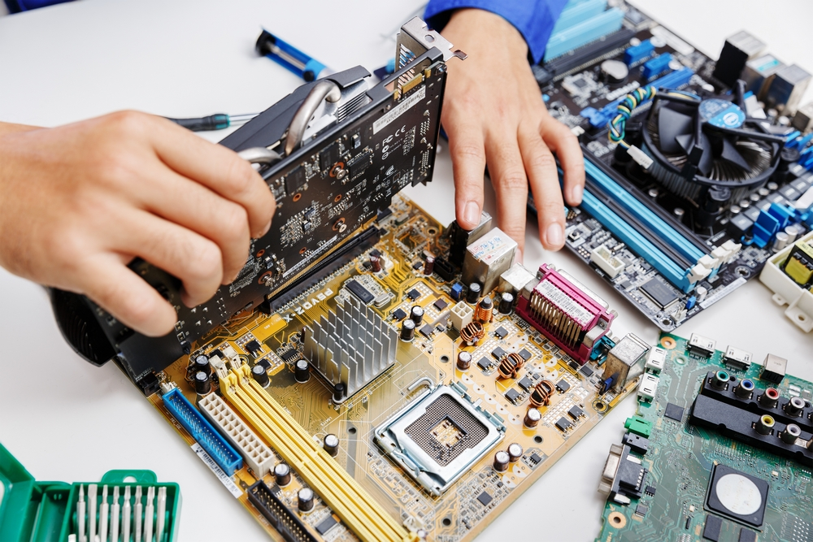
Laptop Motherboard
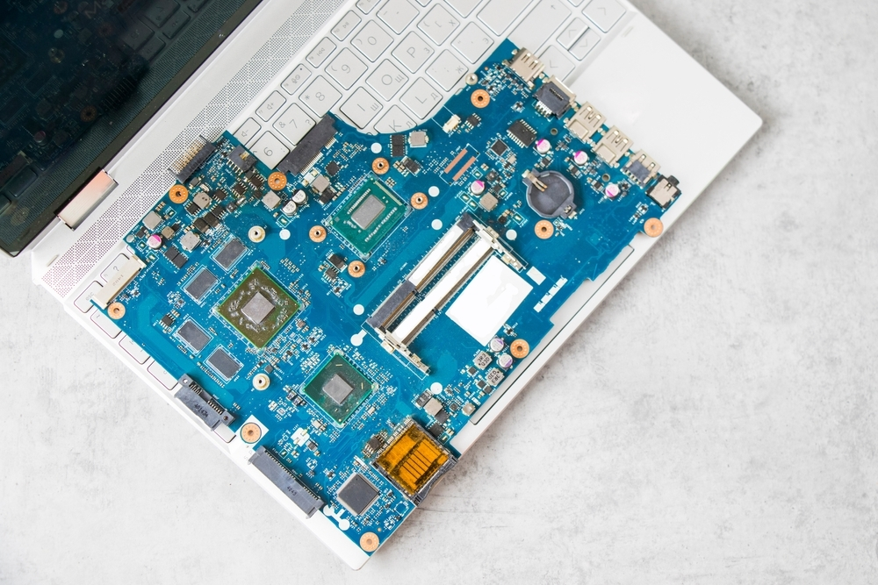
When you repair a laptop, you must often obtain a replacement motherboard from the laptop manufacturer. The figure shows a comparison between a desktop motherboard and a laptop motherboard.
Because laptop motherboards and desktop motherboards are designed differently, components designed for a laptop generally cannot be used in a desktop. Laptop and desktop designs are compared in the table.
Component | Desktop | Laptop
Motherboard form factor | ATX, Micro-ATX, Mini-ITX, ITX | Proprietary
Expansion Slot | PCI, PCI-X, PCIe, miniPCI | Mini-PCI
RAM slot type | DIMM | SODIMM

2.1.7 Internal components
Laptop internal components are designed to fit into the confined spaces of the laptop form factor.
- RAM
- CPUs
- SATA drives
- Solid-state drives
Click each laptop internal component for more information.
RAM
Because of the limited amount of space within laptops, memory modules are much smaller than those used in desktops. Laptops use Small Outline Dual In-line Memory Modules (SODIMMs), as shown.

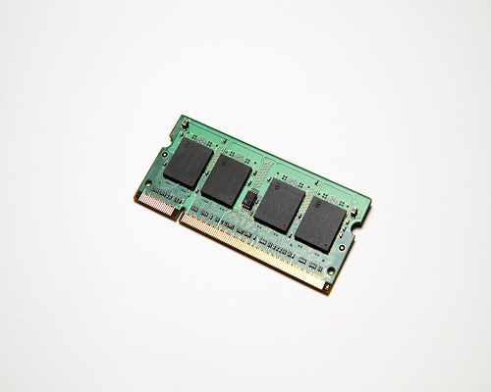

RAM
CPUs
Laptop processors are designed to use less power and create less heat than desktop processors. As a result, laptop processors do not require cooling devices that are as large as those found in desktops. Laptop processors also use CPU throttling to modify the clock speed as needed to reduce power consumption and heat. This results in a slight decrease in performance. These specially designed processors allow laptops to operate for a longer period of time when using a battery.
Note: Refer to the laptop manual for compatible processors and for replacement instructions.
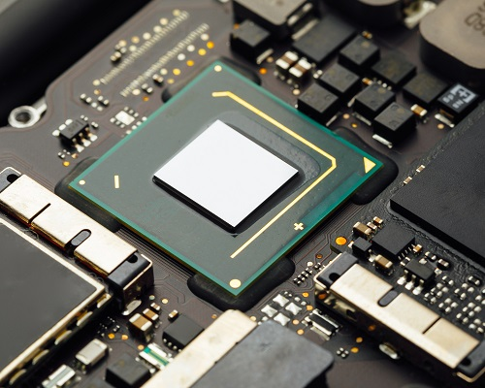

CPUs
SATA Drives
Laptop storage devices are 1.8 in. (4.57 cm.) or 2.5 in. (6.35 cm.) in width, while desktop storage devices are typically 3.5 in. (8.9 cm.). The 1.8 in. drives are mostly found in ultraportable laptops because they are smaller, lighter, and consume less power. However, their spin rate is usually slower than that of 2.5 in. drives which have spin rates of up to 10000 RPMs.
There are several storage drive form factors and technologies used in laptops due to their compact size. SATA 2.5 is a specification of SATA hard drive with a compact casing that enclosed 2.5 in. drive platter.
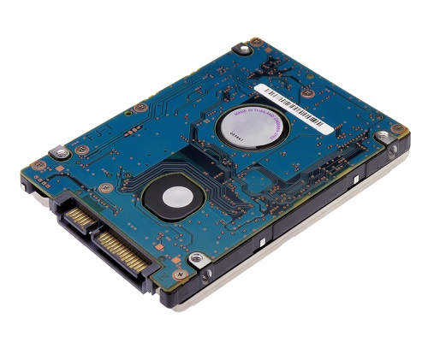

SATA Drives
Solid-State Drives
An M.2 drive, shown in the figure, is a very small form factor of solid-state drive about the size of a stick of gum. It is very fast and designed for high performance in small, power-constrained devices. Another very fast and compact solid-state drive standard is NVMe which has read and write speeds many times faster than SATA drives.
2.2.1 Bluetooth
The Bluetooth technical specification is described by the Institute of Electrical and Electronics Engineers (IEEE) 802.15.1 standard. Bluetooth devices are capable of handling voice, music, videos, and data.
The distance of a Bluetooth personal area network (PAN) is limited by the amount of power used by the devices in the PAN. Bluetooth devices are broken into three classifications, as shown in the table below. The most common Bluetooth network is Class 2, which has a range of approximately 33 ft (10 m).
Bluetooth Classifications
Class | Maximum Permitted Power mW | Approximate Distance
Class 1 | 100 mW | ~330 feet (100m)
Class 2 | 2.5 mW | ~33 feet (10m)
Class 3 | 1 mW | ~3 feet (1m)
Five specifications of Bluetooth technology are capable of different transfer rates, ranges, and power consumption, as shown in the table below.
Bluetooth Specifications
Specification | Version | Data Transfer Rate
1.0 | v1.2 | 1 Mb/s
2.0 | v2.0 + EDR | 3 Mb/s
3.0 | v3.0 + HS | 24 Mb/s
4.0 | v4.0 + LE | 1 Mb/s
5.0 | v5.0 + LE | 125 Kb/s, 500 Kb/s, 1 Mb/s, 2 Mb/s

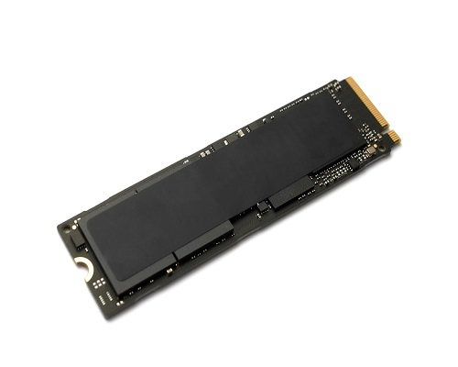

Solid-State Drives

3.0.1 Why Should I Take This Module?
A mobile device is any device that is hand-held, lightweight, and typically has a touchscreen for input. Like a desktop or laptop computer, mobile devices use an operating system to run applications (apps) and games and play movies and music. Mobile devices also have a different CPU architecture, designed to have a reduced instruction set compared to laptop and desktop processors. With the increase in demand for mobility, the popularity of laptops and other mobile devices continues to grow. This module focuses on many features of mobile devices and their capabilities and preventive maintenance.

3.0.2 What Will I Learn in This Module?
Module Title: Other Mobile Devices
Module Objective: Explain the features and functions of other mobile devices.
Topic Title | Topic Objective
Mobile Device Overview | Describe the features of mobile devices.
Other Mobile Device Hardware | Describe common mobile device hardware and preventive maintenance.

3.1.1 What Do You Already Know? - Mobile Devices
What Do You Already Know? is a type of activity in which we ask you to simply take a guess! It is not meant to evaluate your knowledge. You will receive additional information for the answers that you choose, so these activities also help you learn.
For each scenario, select the device that provides the best solution.
You are offline, but need to work with full copies of a spreadsheet and word processor program.
Laptop
done
A woman is hiking in the park and does not have a smartwatch but wants to upload data from her fitness tracker to the Internet.
Smartphone
done
A mother wants to keep her child entertained with a game while she talks to a friend on her smartphone.
Tablet
done
You want to read a book while you are at the beach but don't want to bring your more expensive computing devices.
E-reader
done
A sports fan leaves his smartphone at home but still wants to be alerted to the scores of some football games while he is out jogging.
Smartwatch
done
done

3.1.2 Mobility
Mobility in information technology means accessing information electronically from different locations outside the home or office. Mobile connectivity is limited only by the availability of cellular or data networks. Mobile devices have self-contained power in rechargeable batteries, are generally small and lightweight, and do not rely on other connected peripheral devices, such as a mouse and keyboard, to operate.
Examples of mobile devices are laptops (covered in the previous module), tablets, smartphones, smartwatches, and wearables.


3.1.3 Smartphone Characteristics
Smartphones differ from laptops because they run unique operating systems designed for mobile devices. Examples of these operating systems are Google's Android and Apple's iOS. Smartphones may have limited OS upgradeability, so they can become out-of-date and require a purchase of a new phone to take advantage of new features of the OS and apps that need a higher OS version. Smartphone software is usually limited to apps that can download from stores such as Google Play or the Apple App Store.
Smartphones are very compact and powerful, with small touch keyboards on the screen. Smartphones are limited to only one or two physical connection types, such as USB and headphones, and use cellular connectivity options for voice, text, and data services. Other data connections include Bluetooth and Wi-Fi.


3.1.4 Smartphone Features
An additional feature of smartphones is location services. Most phones include global positioning system (GPS) functionality. A GPS receiver in the phone uses satellites to determine the device's geographic location. The GPS allows apps to use the device location for various purposes, such as social media updates or receiving offers from nearby businesses. Some apps will enable a smartphone to act as a navigational GPS that guides driving, biking, or walking. If the GPS is off, most smartphones can still determine the location, in a less precise way, by using information from nearby mobile service antennas or nearby Wi-Fi access points.
Another feature of some smartphones is the ability to "tether," or share, the cellular data connection with other devices. The smartphone becomes a modem when other devices are configured to its cellular data network over USB, Bluetooth, or Wi-Fi. Not all smartphone carriers permit tethering.


3.1.5 Practice Item - Smartphones
Mobile devices have become an integral part of many processes of business organizations. IT professionals need to know the types of mobile devices available, how they can be adopted in the workplace, and the consequences of this choice for business. The main types of mobile devices employees use to conduct business fall into two categories: smartphones and tablets. What are three characteristics of smartphones? (Choose three.)
Smartphones have larger touch-screen displays than tablets.

done

Smartphones battery life is longer than tablets.
signal_cellular_4_bar

Smartphones offer more processing power and memory than tablets.
done

Smartphones can share cellular data connection with other devices.
signal_cellular_4_bar

done
Smartphones can access cellular networks.
signal_cellular_4_bar

Smartphones have more physical connections than tablets.
done

3.1.6 Tablets and E-Readers
Tablets are similar to smartphones in that they use special mobile operating systems like Android or iOS. However, most tablets do not have the ability to access cellular networks. Some higher-end models do allow access to cellular services.
Unlike smartphones, tablets normally have larger touch-screen displays. The displays are often quite vivid in their graphic rendering. Tablets usually offer Wi-Fi and Bluetooth connectivity and most have USB and audio ports. In addition, some tablets include GPS receivers that can be activated to provide location services, similar to smartphones. Most of the apps that work on phones are also available for tablets.
E-readers, such as the Amazon Kindle, are special purpose devices with black and white displays that have been optimized for reading text. Although they resemble tablets, they lack many of the features and functions that tablets provide. Web access is limited to eBook stores that may be operated by the e-reader manufacturer. Many have touch displays that make it easy to turn pages, change settings, and access eBooks online. Many E-readers can store 1,000 or more books. For connectivity, some offer free cellular data connections for downloading books from a specific store, but most rely on Wi-Fi. Bluetooth is also available and supports headphones for audio books. E-reader battery life is usually longer than tablets, at up 15 -20 hours of reading time or more.


3.1.7 Practice Item - Tablets and E-Readers
A parent decides to buy a mobile device to encourage a child to read books. When arriving at a specialized store, the parent asks the salesperson which device would be the most suitable to accomplish this. Two options are offered by the salesperson: tablet and e-reader. Which three options present the characteristics of these devices so the parent can choose wisely? (Choose three.)
Tablets have black and white displays that have been optimized for reading text.

done

The e-reader screen has e-ink technology that does not emit light, allowing the user to read for long periods without straining the eyes.
signal_cellular_4_bar

The tablet battery life is usually longer than that of the e-reader, at up 15 -20 hours of reading time or more.
done

On the e-reader, all features are geared towards the reading experience, not allowing the user to access applications from different segments.
signal_cellular_4_bar

done
The tablet can be used to read books, but also to browse the internet, play games, take pictures, providing a distraction to put reading aside.
signal_cellular_4_bar

E-readers and tablets are much alike, but e-reader can store more books.
done

3.1.8 Wearables: Smartwatches and Fitness Trackers
Wearables are smart devices that are meant to be worn on the body or attached to clothing. Two popular wearables are smartwatches and fitness trackers.
Smartwatches
Smartwatches are a type of wearable that includes a microprocessor, a special operating systems, and apps. Sensors in the smartwatch can gather data about various aspects of the body, such as heart rate, and use Bluetooth to report this information back to another device, such as a smartphone. The smartphone then forwards the information to an application over the internet for storage and analysis. Some smartwatches can also connect directly to a cellular network, serve as convenient displays for notifications from apps, can include GPS location services, and the ability to store and play music and playlists.
Fitness Trackers
Fitness trackers are similar to smartwatches but are limited to monitoring the body such as physical activity, sleep, and exercise. FitBit is a popular example that monitors heart rate and the number of steps taken. Similar to fitness trackers are more sophisticated health monitoring devices that can detect heart attacks, monitor air quality, and detect oxygen levels in the blood. These devices can deliver hospital-quality data to healthcare practitioners.


3.1.9 Wearables: Augmented and Virtual Realities
In Augmented Reality (AR), computer graphics are integrated with what is seen in the real world, usually through the device camera, as shown for the figure. The graphics overlays can range from cartoon characters in a game application to information for emergency management training for first responders. There are many potential uses for AR and it is one of the most promising areas for future product development.
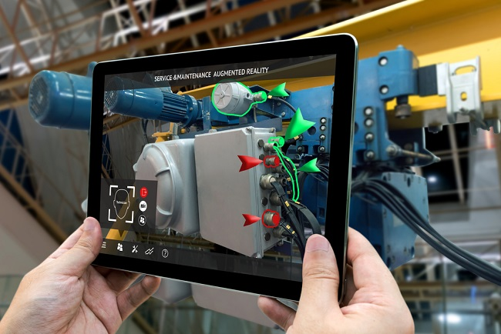
Related to AR is virtual reality (VR). In VR a user wears a special headset which displays graphics from a separate computer, as shown in the figure. The graphics are immersive 3D and create very realistic worlds. The VR user's motions are detected by sensors which allow the user to interact with and move around in the virtual environment. VR is very popular in games but has applications in other fields such as education and training.


3.1.10 Practice Item - Wearables
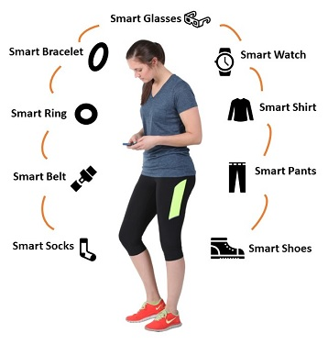
Refer to the exhibit. These are examples of some wearable technologies already available on the market. These devices are creating a series of challenges and marketing opportunities. What is one consequence of widespread adoption of wearable devices?
done

Data collected by wearable devices being used inappropriately.
signal_cellular_4_bar

People becoming healthier with the use of wearables devices.
The increasing number of manufacturers, causing the wearable devices to be more expensive.

Wearable devices being regulated by manufacturers with the same operating system and hardware to provide usage compatibility.

done

Lab - Mobile Device Information

Introduction
In this activity, you will use the internet, a technical journal, or a local store to gather information about an Android and an iOS device. You will document the specifications of each Android and iOS device on this worksheet. Be prepared to discuss your decisions regarding the devices you would purchase as your next mobile device.

Recommended Equipment
- Device with internet connection

Instructions
In this activity, you will perform research on an Android and iOS device in your decision for the next mobile device purchase.
- Choose an Android device and an iOS device for research.
- Record the hardware specifications for each type of mobile devices below.
Specifications | Android Device | iOS Device
Model
Manufacturer
Operating System
Available Memory
Camera
Wi-Fi Connectivity
Cellular Network Connectivity
Battery Information
Screen Size and Resolution
Size and Weight
Based on your research, which mobile device would you select? Be prepared to discuss your decisions regarding the mobile device you select. What are other factors that affect your selection?

📱 Device Comparison: Samsung Galaxy S23 vs. Apple iPhone 15

Samsung Galaxy S23
- Display: 6.1-inch Dynamic AMOLED 2X, 2340 x 1080 resolution, 120Hz refresh rate
- Processor: Qualcomm Snapdragon 8 Gen 2 for Galaxy
- RAM: 8 GB
- Storage Options: 128 GB, 256 GB, 512 GB (non-expandable)
- Rear Cameras: 50 MP (wide), 12 MP (ultrawide), 10 MP (telephoto)
- Front Camera: 12 MP
- Battery: 3,900 mAh
- Charging: 25W wired, 15W wireless, 4.5W reverse wireless charging
- Operating System: Android 15 with One UI 7
- Build: Armor Aluminum frame, Gorilla Glass Victus 2, IP68 water and dust resistance
- Weight: 168 g
- Price Range: Approximately $799 USDApple Support+9Samsung Mobile Press+9Shidirect Public Sector+9Samsung+3Wikipedia+3TechRadar+3Shidirect Public Sector+2The Sun+2WIREDColumbia University IT+8The Sun+8Samsung+8Samsung+1Mint Mobile+2WIRED+2

Apple iPhone 15
- Display: 6.1-inch Super Retina XDR OLED, 2532 x 1170 resolution, 60Hz refresh rate
- Processor: A16 Bionic chip
- RAM: 6 GB
- Storage Options: 128 GB, 256 GB, 512 GB (non-expandable)
- Rear Cameras: 48 MP (wide), 12 MP (ultrawide)
- Front Camera: 12 MP
- Battery: Not officially disclosed, but optimized for all-day use
- Charging: USB-C with USB 2.0 transfer speeds
- Operating System: iOS 18
- Build: Aluminum frame, Ceramic Shield front, IP68 water and dust resistance
- Weight: 171 g
- Price Range: Approximately $799 USDPhonetradrWIRED+2Wikipedia+2Wikipedia

🧠 Decision Factors
When choosing between the Samsung Galaxy S23 and the Apple iPhone 15, consider the following:
- Operating System Preference: If you prefer Android's customization and flexibility, the Galaxy S23 is a strong choice. For those invested in the Apple ecosystem, the iPhone 15 offers seamless integration with other Apple devices.
- Camera Capabilities: The Galaxy S23's triple-camera setup provides versatile photography options, including telephoto zoom. The iPhone 15's 48 MP main sensor delivers high-quality images with excellent color accuracy.
- Display Quality: The Galaxy S23 boasts a higher refresh rate (120Hz) for smoother visuals, while the iPhone 15 offers a brighter display with better outdoor visibility.
- Ecosystem Integration: Consider which ecosystem aligns better with your other devices. Apple's ecosystem offers tight integration across its products, while Samsung provides features like Samsung DeX and broader hardware compatibility.
- Budget and Value: Both devices are priced similarly, but promotions and trade-in deals can affect the final cost.tomsguide.com

✅ Recommendation
- Choose the Samsung Galaxy S23 if you value a higher refresh rate display, versatile camera system, and prefer Android's customization options.
- Choose the Apple iPhone 15 if you're already within the Apple ecosystem, prioritize a brighter display for outdoor use, and appreciate iOS's user experience.

Wi-Fi Connectivity
- Supports Wi-Fi 6E (802.11 a/b/g/n/ac/ax), offering access to the 6 GHz band for lower congestion and faster speeds. Also includes tri-band support and Wi-Fi Direct. SamsungQuantaDose

Cellular Network Connectivity
- 5G: Supports both Sub-6 GHz and mmWave, in both Standalone (SA) and Non-Standalone (NSA) modes, with advanced features such as 4×4 MIMO and up to 6-carrier aggregation (6CA). Google Fi
- Performance: Offers up to around 2.0 Gbps download and 150 Mbps upload on LTE. Google Fi
- Bluetooth: Version 5.3. SamsungVodafone Australia
- Other: Includes NFC, GPS/GLONASS/Galileo, VoLTE, and Wi-Fi calling. Vodafone Australia

iPhone 15 (iOS)

Wi-Fi Connectivity
- Supports Wi-Fi 6 (802.11ax) with 2×2 MIMO. AppleWikipediaAT&T
- No Wi-Fi 6E support in the standard iPhone 15 (only Wi-Fi 6). AppleWikipedia

Cellular Network Connectivity
- 5G: Compatible with Sub-6 GHz and mmWave (in U.S. models), along with Gigabit-class LTE and 4×4 MIMO support. AppleWikipedia
- Wireless Tech: Includes Bluetooth 5.3, NFC (with Reader Mode), Ultra Wideband (UWB), VoLTE, Wi-Fi Calling, and support for FaceTime over both cellular and Wi-Fi. AppleWikipediaAT&T

Summary Table
Feature Category | Samsung Galaxy S23 | iPhone 15
Wi-Fi Standard | Wi-Fi 6E (802.11 a/b/g/n/ac/ax) + 6 GHz band | Wi-Fi 6 (802.11ax) only, 2×2 MIMO
5G Support | Sub-6 GHz + mmWave, SA & NSA, 4×4 MIMO, 6CA | Sub-6 GHz + mmWave (US), Gigabit LTE, 4×4 MIMO
Bluetooth | Version 5.3 | Version 5.3
NFC | Yes | Yes (with Reader Mode)
VoLTE / Wi-Fi Call | Yes | Yes
Other Wireless | GPS + GLONASS + Galileo; Wi-Fi Direct | UWB; FaceTime over Wi-Fi/cellular

Which Stands Out?
- Wi-Fi Advantage: The Samsung Galaxy S23 offers Wi-Fi 6E, giving it potential for faster and less-congested Wi-Fi performance (especially in 6 GHz bands), which is an edge over the iPhone 15's Wi-Fi 6. SamsungQuantaDose
- Equal Cellular Features: Both phones are on par in terms of 5G support (including mmWave in applicable regions), Bluetooth, NFC, and calling features.

Samsung Galaxy S23
- Dimensions: 146.3 × 70.9 × 7.6 mm (height × width × depth)
- Weight: 168 g (approximately 5.93 ounces) Samsung Mobile PressDevice GuidesPhoneArena

Apple iPhone 15 (Base Model, Not Plus)
- Dimensions: 147.6 × 71.6 × 7.8 mm
- Weight: 171 g (approximately 6.02 ounces) AppleWikipediaPhoneArenaDeviceSpecificationsTechRadar

Quick Comparison Table
Device | Height (mm) | Width (mm) | Thickness (mm) | Weight (g)
Samsung Galaxy S23 | 146.3 | 70.9 | 7.6 | 168 g
Apple iPhone 15 | 147.6 | 71.6 | 7.8 | 171 g

Based on your research, which mobile device would you select? Be prepared to discuss your decisions regarding the mobile device you select. What are other factors that affect your selection?

ChatGPT said:
Here’s a well-rounded response you can use for your worksheet discussion:

📱 My Selection and Rationale
Based on my research, I would select the Samsung Galaxy S23 as my next mobile device.

✅ Reasons for Choosing Galaxy S23:
- Display Advantage:
The Galaxy S23 offers a 120Hz refresh rate Dynamic AMOLED display, which makes scrolling, gaming, and video playback smoother compared to the iPhone 15’s 60Hz OLED panel.
- Connectivity:
It supports Wi-Fi 6E (vs. iPhone 15’s Wi-Fi 6), which means faster and more reliable connections on compatible networks.
- Camera Flexibility:
The Galaxy S23 has a triple-camera system (wide, ultrawide, telephoto), while the iPhone 15 only has a dual setup. The extra telephoto lens provides better zoom capabilities for photography.
- Portability:
It’s slightly lighter and thinner (168 g vs. 171 g) and feels more compact in the hand, which improves comfort for long use.
- Customization:
Android allows greater flexibility in personalization (home screens, default apps, themes), which fits my preference for tailoring a phone to my workflow.

🔎 Other Factors Affecting My Selection
- Ecosystem Compatibility:
If I already owned a MacBook, iPad, or Apple Watch, the iPhone 15 might make more sense because of Apple’s tight ecosystem integration.
- Software Longevity:
Apple devices usually receive longer iOS updates (5+ years), while Samsung typically guarantees 4–5 years of Android updates. Longevity could play a big role in the final choice.
- Battery Life & Charging:
Both devices offer fast charging, but Samsung supports reverse wireless charging, which can power accessories like earbuds. That’s a practical feature.
- Price & Deals:
Both start around $799, but trade-in promotions, carrier discounts, and bundled accessories can make one option more cost-effective.
- User Experience Preference:
iOS is known for its simplicity and stability, while Android appeals more to users who want customization and advanced features.

👉 Final Thought: While both the iPhone 15 and Galaxy S23 are excellent devices, my preference leans toward the Samsung Galaxy S23 due to its superior display, Wi-Fi 6E support, telephoto camera, and slightly more compact build.

