1.0.1 Why Should I Take this Module?

From its humble beginnings over 35 years ago in 1985, the Windows operating system has seen many iterations; from Windows 1.0 to today's current desktop version, Windows 10, and server version, Windows Server 2019.
This module covers some of the basic concepts of Windows, including how the operating system works and the tools used to secure Windows endpoints.
1.0.2 What Will I Learn in this Module?
This module contains the following:
- 5 Labs
- 2 Check Your Understanding activities
- 1 Module Quiz
Module Title: The Windows Operating System
Module Objective: Use Windows administrative tools.
Topic Title | Topic Objective
Windows History | Describe the history of the Windows Operating System.
Windows Architecture and Operations | Explain the architecture of Windows and its operation.
Windows Configuration and Monitoring | Use Windows administrative tools to configure, monitor, and manage system resources.
Windows Security | Explain how Windows can be kept secure.

1.1.1 Disk Operating System
The first computers did not have modern storage devices such as hard drives, optical drives, or flash storage. The first storage methods used punch cards, paper tape, magnetic tape, and even audio cassettes.
Floppy disk and hard disk storage require software to read from, write to, and manage the data that they store. The Disk Operating System (DOS) is an operating system that the computer uses to enable these data storage devices to read and write files. DOS provides a file system which organizes the files in a specific way on the disk. Microsoft bought DOS and developed MS-DOS.
MS-DOS used a command line as the interface for people to create programs and manipulate data files, as shown in the command output. DOS commands are shown in bold text.
Starting MS-DOS...
HIMEM is testing extended memory... done.
C:∖> C:∖DOS∖SMARTDRV.EXE /X
C:∖> dir
Volume in drive C is MS-DOS_6
Volume Serial Number is 4006-6939
Directory of C:∖
DOS <DIR> 05-06-17 1:09p
COMMAND COM 54,645 05-31-94 6:22a
WINA20 386 9,349 05-31-94 6:22a
CONFIG SYS 71 05-06-17 1:10p
AUTOEXEC BAT 78 05-06-17 1:10p
5 file(s) 64,143 bytes
517,021,696 bytes free
C:∖>
With MS-DOS, the computer had a basic working knowledge of how to access the disk drive and load the operating system files directly from disk as part of the boot process. When it was loaded, MS-DOS could easily access the disk because it was built into the operating system.
Early versions of Windows consisted of a Graphical User Interface (GUI) that ran over MS-DOS, starting with Windows 1.0 in 1985. The disk operating system still controlled the computer and its hardware. A modern operating system like Windows 10 is not considered a disk operating system. It is built on Windows NT, which stands for “New Technologies”. The operating system itself is in direct control of the computer and its hardware. NT is an OS with support for multiple user processes. This is much different than the single-process, single-user MS-DOS.
Today, many things that used to be accomplished through the command line interface of MS-DOS can be accomplished in the Windows GUI. You can still experience what it was like to use MS-DOS by opening a command window, but what you see is no longer MS-DOS, it is a function of Windows. To experience a little of what it was like to work in MS-DOS, open a command window by typing cmd in Windows Search and pressing Enter. The table lists some commands that you can use. Enter help followed by the command to learn more about the command.
MS-DOS Command | Description
dir | Shows a listing of all the files in the current directory (folder)
cd directory | Changes the directory to the indicated directory
cd .. | Changes the directory to the directory above the current directory
cd∖ | Changes the directory to the root directory (often C:)
copy source destination | Copies files to another location
del filename | Deletes one or more files
find | Searches for text in files
mkdir directory | Creates a new directory
ren oldname newname | Renames a file
help | Displays all the commands that can be used, with a brief description
help command | Displays extensive help for the indicated command

1.1.2 Windows Versions
Since 1993, there have been more than 20 releases of Windows that are based on the NT operating system. Most of these versions were for use by the general public and businesses because of the file security offered by the file system that was used by the NT OS. Businesses also adopted NT OS-based Windows operating systems. This is because many editions were built specifically for workstation, professional, server, advanced server, and datacenter server, to name just a few of the many purpose-built versions.
Beginning with Windows XP, a 64-bit edition was available. The 64-bit operating system was an entirely new architecture. It had a 64-bit address space instead of a 32-bit address space. This is not simply twice the amount of space because these bits are binary numbers. While 32-bit Windows can address a little less than 4 GB of RAM, 64-bit Windows can theoretically address 16.8 million terabytes. When the OS and the hardware all support 64-bit operation, extremely large data sets can be used. These large data sets include very large databases, scientific computing, and manipulation of high definition digital video with special effects. In general, 64-bit computers and operating systems are backward-compatible with older, 32-bit programs, but 64-bit programs cannot be run on older, 32-bit hardware.
With each subsequent release of Windows, the operating system has become more refined by incorporating more features. Windows 7 was offered with six different editions, Windows 8 with as many as five, and Windows 10 with eight different editions! Each edition not only offers different capabilities, but also different price points. Microsoft has said that Windows 10 is the last version of Windows, and that Windows has become a service rather than just an OS. They say that rather than purchasing new operating systems, users will just update Windows 10 instead.
The table lists common Windows versions.
OS | Versions
Windows 7 | Starter, Home Basic, Home Premium, Professional, Enterprise, Ultimate
Windows Server 2008 R2 | Foundation, Standard, Enterprise, Datacenter, Web Server, HPC Server, Itanium-Based Systems
Windows Home Server 2011 | None
Windows 8 | Windows 8, Windows 8 Pro, Windows 8 Enterprise, Windows RT
Windows Server 2012 | Foundation, Essentials, Standard, Datacenter
Windows 8.1 | Windows 8.1, Windows 8.1 Pro, Windows 8.1 Enterprise, Windows RT 8.1
Windows Server 2012 R2 | Foundation, Essentials, Standard, Datacenter
Windows 10 | Home, Pro, Pro Education, Enterprise, Education, loT Core, Mobile, Mobile Enterprise
Windows Server 2016 | Essentials, Standard, Datacenter, Multipoint Premium Server, Storage Server, Hyper-V Server

1.1.3 Windows GUI
Windows has a graphical user interface (GUI) for users to work with data files and software. The GUI has a main area that is known as the Desktop, shown in the figure.
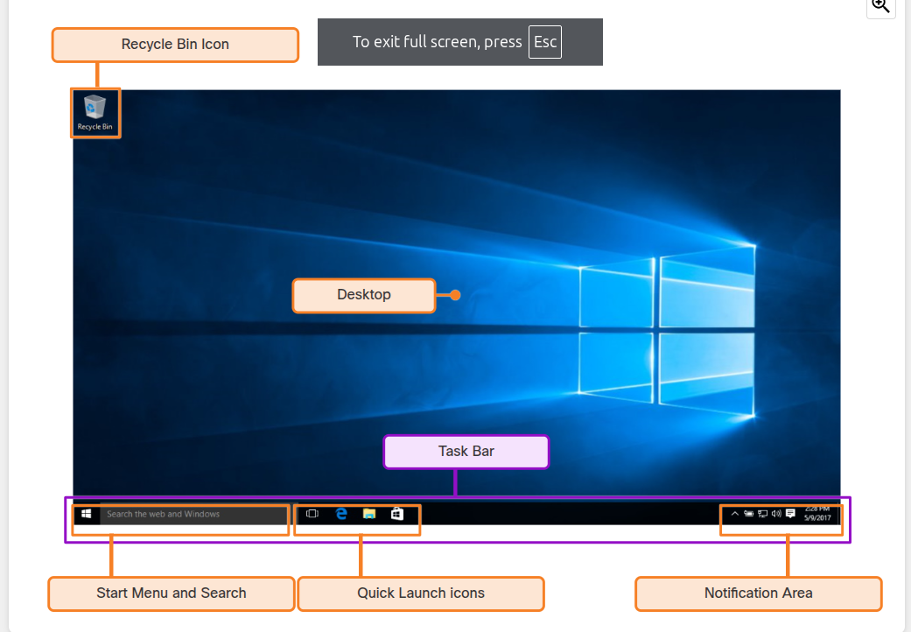

The Desktop can be customized with various colors and background images. Windows supports multiple users, so each user can customize the Desktop to their liking. The Desktop can store files, folders, shortcuts to locations and programs, and applications. The Desktop also has a recycle bin icon, where files are stored when the user deletes them. Files can be restored from the recycle bin or the recycle bin can be emptied of files, which truly deletes them.
At the bottom of the desktop is the Task Bar. The Task Bar has three areas that are used for different purposes. At the left is the Start menu. It is used to access all of the installed programs, configuration options, and the search feature. At the center of the Task Bar, users place quick launch icons that run specific programs or open specific folders when they are clicked. Finally, on the right of the Task Bar is the notification area. The notification area shows, at a glance, the functionality of many different programs and features. For example, a blinking envelope icon may indicate new email, or a network icon with a red “x” may indicate a problem with the network.
Often, right-clicking an icon will bring up additional functions that can be used. This list is known as a Context Menu, shown in the figure.
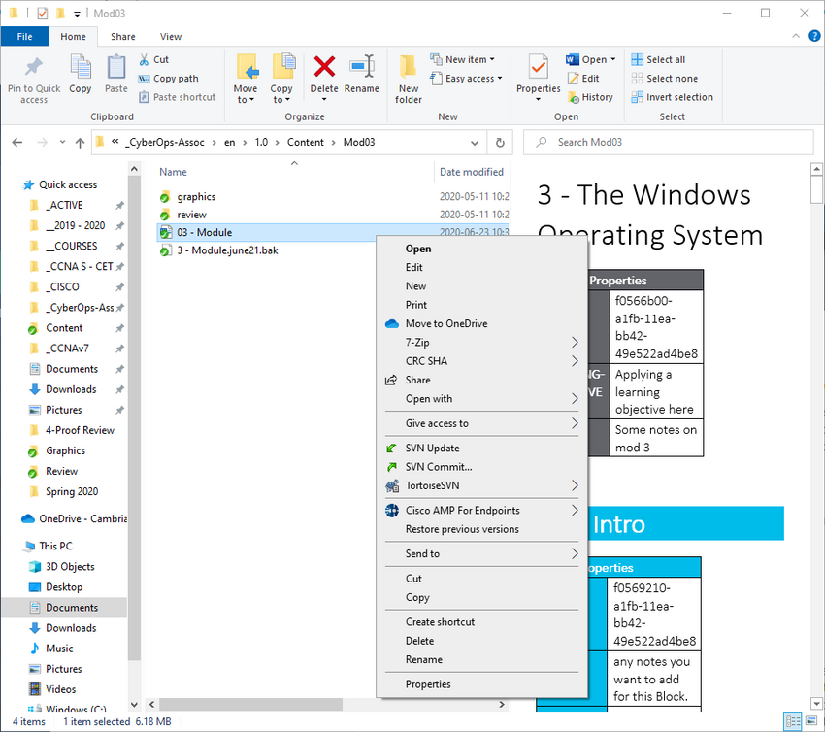
There are Context Menus for the icons in the notification area, for quick launch icons, system configuration icons, and for files and folders. The Context Menu provides many of the most commonly used functions by just clicking. For example, the Context Menu for a file will contain such items as copy, delete, share, and print. To open folders and manipulate files, Windows uses the Windows File Explorer.

1.1.4 Operating System Vulnerabilities
Operating systems consist of millions of lines of code. Installed software can also contain millions of lines of code. With all this code comes vulnerabilities. A vulnerability is some flaw or weakness that can be exploited by an attacker to reduce the viability of a computer’s information. To take advantage of an operating system vulnerability, the attacker must use a technique or a tool to exploit the vulnerability. The attacker can then use the vulnerability to get the computer to act in a fashion outside of its intended design. In general, the goal is to gain unauthorized control of the computer, change permissions, or to manipulate or steal data.
Click each of the headings below to see some common Windows OS security recommendations.
expand_less
Virus or malware protection

- By default, Windows uses Windows Defender for malware protection.
- Windows Defender provides a suite of protection tools built into the system.
- If Windows Defender is turned off, the system becomes more vulnerable to attacks and malware.

expand_less
Unknown or unmanaged services

- There are many services that run behind the scenes.
- It is important to make sure that each service is identifiable and safe.
- With an unknown service running in the background, the computer can be vulnerable to attack.

expand_less
Encryption

- When data is not encrypted, it can easily be gathered and exploited.
- This is not only important for desktop computers, but especially mobile devices.

expand_less
Security policy

- A good security policy must be configured and followed.
- Many settings in the Windows Security Policy control can prevent attacks.

expand_less
Firewall

- By default, Windows uses Windows Firewall to limit communication with devices on the network.
- Over time, rules may no longer apply.
- For example, a port may be left open that should no longer be readily available.
- It is important to review firewall settings periodically to ensure that the rules are still applicable and remove any that no longer apply

expand_less
File and share permissions

- These permissions must be set correctly.
- It is easy to just give the “Everyone” group Full Control, but this allows all people to do what they want to all files.
- It is best to provide each user or group with the minimum necessary permissions for all files and folders.

expand_less
Weak or no password

- Many people choose weak passwords or do not use a password at all.
- It is especially important to make sure that all accounts, especially the Administrator account, have a very strong password.

expand_less
Login as Administrator

- When a user logs in as an administrator, any program that they run will have the privileges of that account.
- It is best to log in as a Standard User and only use the administrator password to accomplish certain tasks.

1.2.1 Hardware Abstraction Layers
Windows computers use many different types of hardware. The operating system can be installed on a purchased computer or a on computer that is assembled by the user. When the operating system is installed, it must be isolated from differences in hardware. The basic Windows architecture is shown in the figure.

A hardware abstraction layer (HAL) is software that handles all of the communication between the hardware and the kernel. The kernel is the core of the operating system and has control over the entire computer. It handles all of the input and output requests, memory, and all of the peripherals connected to the computer.
The figure shows the basic windows architecture with the applications at the top, the User-Mode Drivers and Windows API below them, Other Kernel-Mode Drivers, Operating System Kernel, and File System Drivers below them, the Hardware Abstraction Layer below them, and at the bottom, the Hardware.
In some instances, the kernel still communicates with the hardware directly, so it is not completely independent of the HAL. The HAL also needs the kernel to perform some functions.

1.2.2 User Mode and Kernel Mode
As identified in the figure, there are two different modes in which a CPU operates when the computer has Windows installed: the user mode and the kernel mode.

Installed applications run in user mode, and operating system code runs in kernel mode. Code that is executing in kernel mode has unrestricted access to the underlying hardware and is capable of executing any CPU instruction. Kernel mode code also can reference any memory address directly. Generally reserved for the most trusted functions of the OS, crashes in code running in kernel mode stop the operation of the entire computer. Conversely, programs such as user applications, run in user mode and have no direct access to hardware or memory locations. User mode code must go through the operating system to access hardware resources. Because of the isolation provided by user mode, crashes in user mode are restricted to the application only and are recoverable. Most of the programs in Windows run in user mode. Device drivers, pieces of software that allow the operating system and a device to communicate, may run in either kernel or user mode, depending on the driver.
This figure is the same as the previous page, but shows that the Applications, User-Mode Drivers and Windows API make up the User Mode while the Other Kernel-Mode Drivers, Operating System Kernel, and File System Drivers, the Hardware Abstraction Layer, and the Hardware make up the Kernel Mode.
All of the code that runs in kernel mode uses the same address space. Kernel-mode drivers have no isolation from the operating system. If an error occurs with the driver running in kernel mode, and it writes to the wrong address space, the operating system or another kernel-mode driver could be adversely affected. In this respect, the driver might crash, causing the entire operating system to crash.
When user mode code runs, it is granted its own restricted address space by the kernel, along with a process created specifically for the application. The reason for this functionality is mainly to prevent applications from changing operating system code that is running at the same time. By having its own process, that application has its own private address space, rendering other applications unable to modify the data in it. This also helps to prevent the operating system and other applications from crashing if that application crashes.

1.2.3 Windows File Systems
Click each heading to learn more about Windows file systems.
expand_less
exFAT

- This is a simple file system supported by many different operating systems.
- FAT has limitations to the number of partitions, partition sizes, and file sizes that it can address, so it is not usually used for hard drives (HDs) or solid-state drives (SSDs) anymore.
- Both FAT16 and FAT32 are available to use, with FAT32 being the most common because it has many fewer restrictions than FAT16.

expand_less
Hierarchical File System Plus (HFS+)

- This file system is used on MAC OS X computers and allows much longer filenames, file sizes, and partition sizes than previous file systems.
- Although it is not supported by Windows without special software, Windows is able to read data from HFS+ partitions.

expand_less
Extended File System (EXT)

- This file system is used with Linux-based computers.
- Although it is not supported by Windows, Windows is able to read data from EXT partitions with special software.

expand_less
New Technology File System (NTFS)

- This is the most commonly used file system when installing Windows. All versions of Windows and Linux support NTFS.
- Mac-OS X computers can only read an NTFS partition. They are able to write to an NTFS partition after installing special drivers.

NTFS is the most widely used file system for Windows for many reasons. NTFS supports very large files and partitions and it is very compatible with other operating systems. NTFS is also very reliable and supports recovery features. Most importantly, it supports many security features. Data access control is achieved through security descriptors. These security descriptors contain file ownership and permissions all the way down to the file level. NTFS also tracks many time stamps to track file activity. Sometimes referred to as MACE, the timestamps Modify, Access, Create, and Entry Modified are often used in forensic investigations to determine the history of a file or folder. NTFS also supports file system encryption to secure the entire storage media.
Before a storage device such as a disk can be used, it must be formatted with a file system. In turn, before a file system can be put into place on a storage device, the device needs to be partitioned. A hard drive is divided into areas called partitions. Each partition is a logical storage unit that can be formatted to store information, such as data files or applications. During the installation process, most operating systems automatically partition and format the available drive space with a file system such as NTFS.
NTFS formatting creates important structures on the disk for file storage, and tables for recording the locations of files:
- Partition Boot Sector - This is the first 16 sectors of the drive. It contains the location of the Master File Table (MFT). The last 16 sectors contain a copy of the boot sector.
- Master File Table (MFT) - This table contains the locations of all the files and directories on the partition, including file attributes such as security information and timestamps.
- System Files - These are hidden files that store information about other volumes and file attributes.
- File Area - The main area of the partition where files and directories are stored.
Note: When formatting a partition, the previous data may still be recoverable because not all the data is completely removed. The free space can be examined, and files can be retrieved which can compromise security. It is recommended to perform a secure wipe on a drive that is being reused. The secure wipe will write data to the entire drive multiple times to ensure there is no remaining data.

1.2.4 Alternate Data Streams
NTFS stores files as a series of attributes, such as the name of the file, or a timestamp. The data which the file contains is stored in the attribute $DATA, and is known as a data stream. By using NTFS, you can connect Alternate Data Streams (ADSs) to the file. This is sometimes used by applications that are storing additional information about the file. The ADS is an important factor when discussing malware. This is because it is easy to hide data in an ADS. An attacker could store malicious code within an ADS that can then be called from a different file.
In the NTFS file system, a file with an ADS is identified after the filename and a colon, for example, Testfile.txt:ADS. This filename indicates an ADS called ADS is associated with the file called Testfile.txt. An example of ADS is shown in the command output.
C:∖ADS> echo "Alternate Data Here" > Testfile.txt:ADS
C:∖ADS> dir
Volume in drive C is Windows
Volume Serial Number is A606-CB1B
Directory of C:∖ADS
2020-04-28 04:01 PM <DIR> .
2020-04-28 04:01 PM <DIR> ..
2020-04-28 04:01 PM 0 Testfile.txt
1 File(s) 0 bytes
2 Dir(s) 43,509,571,584 bytes free
C:∖ADS> more < Testfile.txt:ADS
"Alternate Data Here"
C:∖ADS> dir /r
Volume in drive C is Windows
Volume Serial Number is A606-CB1B
Directory of C:∖ADS
2020-04-28 04:01 PM <DIR>
2020-04-28 04:01 PM <DIR>
2020-04-28 04:01 PM 0 Testfile.txt
24 Testfile.txt:ADS:$DATA
1 File(s) 0 bytes
2 Dir(s) 43,509,624,832 bytes free
C:∖ADS>
In the output:
- The first command places the text “Alternate Data Here” into an ADS of the file Testfile.txt called “ADS”.
- After that, dir, shows that the file was created, but the ADS is not visible.
- The next command shows that there is data in the Testfile.txt:ADS data stream.
- The last command shows the ADS of the Testfile.txt file because the r switch was used with the dir command.

1.2.5 Windows Boot Process
Many actions occur between the time that the computer power button is pressed and Windows is fully loaded, as shown in the figure. This is known as the Windows Boot process.

Two types of computer firmware exist:
The figure shows a flowchart of the windows boot process. The process starts with either BIOS initialization or UEFI Initialization. In the case of BIOS initialization, the next step is the POST, followed by the MBR. In the case of UEFI initialization, the next step is the EFI Files. The next steps for both paths are the Boot m g r dot e x e, followed by the B C D. If the computer is resuming from hibernation, the next step is the win resume dot e x e, followed by hiberfil dot s y s, and then to the logon. From a cold boot, after B C D, the next steps are win load dot e x e, K M C S, n t o s k r n l dot e x e, H A L, S M S S, and finally, logon.
expand_less
Basic Input-Output System (BIOS)

BIOS firmware was created in the early 1980s and works in the same way it did when it was created. As computers evolved, it became difficult for BIOS firmware to support all the new features requested by users.

expand_less
Unified Extensible Firmware Interface (UEFI)

UEFI was designed to replace BIOS and support the new features.

In BIOS firmware, the process begins with the BIOS initialization phase. This is when hardware devices are initialized and a power on self-test (POST) is performed to make sure all of these devices are communicating. When the system disk is discovered, the POST ends. The last instruction in the POST is to look for the master boot record (MBR).
The MBR contains a small program that is responsible for locating and loading the operating system. The BIOS executes this code and the operating system starts to load.
In contrast to BIOS firmware, UEFI firmware has a lot of visibility into the boot process. UEFI boots by loading EFI program files, stored as .efi files in a special disk partition, known as the EFI System Partition (ESP).
Note: A computer that uses UEFI stores boot code in the firmware. This helps to increase the security of the computer at boot time because the computer goes directly into protected mode.
Whether the firmware is BIOS or UEFI, after a valid Windows installation is located, the Bootmgr.exe file is run. Bootmgr.exe switches the system from real mode to protected mode so that all of the system memory can be used.
Bootmgr.exe reads the Boot Configuration Database (BCD). The BCD contains any additional code needed to start the computer, along with an indication of whether the computer is coming out of hibernation, or if this is a cold start. If the computer is coming out of hibernation, the boot process continues with Winresume.exe. This allows the computer to read the Hiberfil.sys file which contains the state of the computer when it was put into hibernation.
If the computer is being booted from a cold start, then the Winload.exe file is loaded. The Winload.exe file creates a record of the hardware configuration in the registry. The registry is a record of all of the settings, options, hardware, and software the computer has. The registry will be explored in depth later in this chapter. Winload.exe also uses Kernel Mode Code Signing (KMCS) to make sure that all drivers are digitally signed. This ensures that the drivers are safe to load as the computer starts.
After the drivers have been examined, Winload.exe runs Ntoskrnl.exe which starts the Windows kernel and sets up the HAL. Finally, the Session Manager Subsystem (SMSS) reads the registry to create the user environment, start the Winlogon service, and prepare each user’s desktop as they log on.

1.2.6 Windows Startup
There are two important registry items that are used to automatically start applications and services:
- HKEY_LOCAL_MACHINE - Several aspects of Windows configuration are stored in this key, including information about services that start with each boot.
- HKEY_CURRENT_USER - Several aspects related to the logged in user are stored in this key, including information about services that start only when the user logs on to the computer.
The registry will be discussed later in this topic.
Different entries in these registry locations define which services and applications will start, as indicated by their entry type. These types include Run, RunOnce, RunServices, RunServicesOnce, and Userinit. These entries can be manually entered into the registry, but it is much safer to use the Msconfig.exe tool. This tool is used to view and change all of the start-up options for the computer. Use the search box to find and open the Msconfig tool.
The Msconfig tool opens the System Configuration window. There are five tabs which contain the configuration options.
expand_less
General

Three different startup types can be chosen here. Normal loads all drivers and services. Diagnostic loads only basic drivers and services. Selective allows the user to choose what to load on startup.

expand_less
Boot

Any installed operating system can be chosen here to start. There are also options for Safe boot, which is used to troubleshoot startup.

expand_less
Services

All the installed services are listed here so that they can be chosen to start at startup.

expand_less
Startup

All the applications and services that are configured to automatically begin at startup can be enabled or disabled by opening the task manager from this tab.

expand_less
Tools

Many common operating system tools can be launched directly from this tab.

1.2.7 Windows Shutdown
It is always best to perform a proper shutdown to turn off the computer. Files that are left open, services that are closed out of order, and applications that hang can all be damaged if the power is turned off without first informing the operating system. The computer needs time to close each application, shut down each service, and record any configuration changes before power is lost.
During shutdown, the computer will close user mode applications first, followed by kernel mode processes. If a user mode process does not respond within a certain amount of time, the OS will display notification and allow the user to wait for the application to respond, or forcibly end the process. If a kernel mode process does not respond, the shutdown will appear to hang, and it may be necessary to shut down the computer with the power button.
There are several ways to shut down a Windows computer: Start menu power options, the command line command shutdown, and using Ctrl+Alt+Delete and clicking the power icon. There are three different options from which to choose when shutting down the computer:
- Shutdown - Turns the computer off (power off).
- Restart - Re-boots the computer (power off and power on).
- Hibernate - Records the current state of the computer and user environment and stores it in a file. Hibernation allows users to pick up right where they left off very quickly with all their files and programs still open.

1.2.8 Processes, Threads, and Services
A Windows application is made up of processes. The application can have one or many processes dedicated to it. A process is any program that is currently executing. Each process that runs is made up of at least one thread. A thread is a part of the process that can be executed. The processor performs calculations on the thread. To configure Windows processes, search for Task Manager. The Processes tab of the Task Manager is shown in the figure.

All of the threads dedicated to a process are contained within the same address space. This means that these threads may not access the address space of any other process. This prevents corruption of other processes. Because Windows multitasks, multiple threads can be executed at the same time. The amount of threads that can be executed at the same time is dependent on the number of the computer’s processors.
Some of the processes that Windows runs are services. These are programs that run in the background to support the operating system and applications. They can be set to start automatically when Windows boots or they can be started manually. They can also be stopped, restarted, or disabled.
Services provide long-running functionality, such as wireless or access to an FTP server. To configure Windows Services, search for services. The Windows Services control panel applet is shown in the figure.

Be very careful when manipulating the settings of these services. Some programs rely on one or more services to operate properly. Shutting down a service may adversely affect applications or other services.

1.2.9 Memory Allocation and Handles
A computer works by storing instructions in RAM until the CPU processes them. The virtual address space for a process is the set of virtual addresses that the process can use. The virtual address is not the actual physical location in memory, but an entry in a page table that is used to translate the virtual address into the physical address.
Each process in a 32-bit Windows computer supports a virtual address space that enables addressing up to 4 gigabytes. Each process in a 64-bit Windows computer supports a virtual address space of 8 terabytes.
Each user space process runs in a private address space, separate from other user space processes. When the user space process needs to access kernel resources, it must use a process handle. This is because the user space process is not allowed to directly access these kernel resources. The process handle provides the access needed by the user space process without a direct connection to it.
A powerful tool for viewing memory allocation is RAMMap, which is shown in the figure. RAMMap is part of the Windows Sysinternals Suite of tools. It can be downloaded from Microsoft. RAMMap provides a wealth of information regarding how Windows has allocated system memory to the kernel, processes, drivers, and applications.

1.2.10 The Windows Registry
Windows stores all of the information about hardware, applications, users, and system settings in a large database known as the registry. The ways that these objects interact are also recorded, such as what files an application opens and all of the property details of folders and applications. The registry is a hierarchical database where the highest level is known as a hive, below that there are keys, followed by subkeys. Values store data and are stored in the keys and subkeys. A registry key can be up to 512 levels deep.
Select the headings to find out more about five hives of the Windows registry.
expand_less
HKEY_CURRENT_USER (HKCU)

Holds information concerning the currently logged in user.

expand_less
HKEY_USERS (HKU)

Holds information concerning all the user accounts on the host.

expand_less
HKEY_CLASSES_ROOT (HKCR)

Holds information about object linking and embedding (OLE) registrations. OLE allows users to embed objects from other applications (like a spreadsheet) into a single document (like a Word document).

expand_less
HKEY_LOCAL_MACHINE (HKLM)

Holds system-related information.

expand_less
HKEY_CURRENT_CONFIG (HKCC)

Holds information about the current hardware profile.

New hives cannot be created. The registry keys and values in the hives can be created, modified, or deleted by an account with administrative privileges. As shown in the figure, the tool regedit.exe is used to modify the registry. Be very careful when using this tool. Minor changes to the registry can have massive or even catastrophic effects.

Navigation in the registry is very similar to Windows file explorer. Use the left panel to navigate the hives and the structure below it and use the right panel to see the contents of the highlighted item in the left panel. With so many keys and subkeys, the key path can become very long. The path is displayed at the bottom of the window for reference. Because each key and subkey is essentially a container, the path is represented much like a folder in a file system. The backslash (∖) is used to differentiate the hierarchy of the database.
Registry keys can contain either a subkey or a value. The different values that keys can contain are as follows:
- REG_BINARY - Numbers or Boolean values
- REG_DWORD - Numbers greater than 32 bits or raw data
- REG_SZ - String values
Because the registry holds almost all the operating system and user information, it is critical to make sure that it does not become compromised. Potentially malicious applications can add registry keys so that they start when the computer is started. During a normal boot, the user will not see the program start because the entry is in the registry and the application displays no windows or indication of starting when the computer boots. A keylogger, for example, would be devastating to the security of a computer if it were to start at boot without the user’s knowledge or consent. When performing normal security audits, or remediating an infected system, review the application startup locations within the registry to ensure that each item is known and safe to run.
The registry also contains the activity that a user performs during normal day-to-day computer use. This includes the history of hardware devices, including all devices that have been connected to the computer including the name, manufacturer and serial number. Other information, such as what documents a user and program have opened, where they are located, and when they were accessed is stored in the registry. This is all very useful information when a forensics investigation needs to be performed.

1.2.11 Lab - Exploring Processes, Threads, Handles, and Windows Registry
In this lab, you will explore the processes, threads, and handles using Process Explorer in the SysInternals Suite. You will also use the Windows Registry to change a setting.
- Part 1: Exploring Processes
- Part 2: Exploring Threads and Handles
- Part 3: Exploring Windows Registry
descriptionLab - Exploring Processes, Threads, Handles, and Windows Registry

1.2.12 Check Your Understanding - Identify the Windows Registry Hive

Question 1
Which Windows registry hive stores information about object linking and embedding (OLE) registrations?
radio_button_unchecked

HKEY_CURRENT_USER (HKCU)

radio_button_unchecked

HKEY_CURRENT_CONFIG (HKCC)

radio_button_unchecked

HKEY_USERS (HKU)

radio_button_unchecked

HKEY_LOCAL_MACHINE (HKLM)

radio_button_unchecked

HKEY_CLASSES_ROOT (HKCR)

Question 2

Which Windows registry hive stores information about the current hardware profile?
radio_button_unchecked

HKEY_USERS (HKU)

radio_button_unchecked

HKEY_LOCAL_MACHINE (HKLM)

radio_button_unchecked

HKEY_CLASSES_ROOT (HKCR)

radio_button_unchecked

HKEY_CURRENT_USER (HKCU)

radio_button_unchecked

HKEY_CURRENT_CONFIG (HKCC)

Question 3

Which Windows registry hive stores information concerning all the user accounts on the host?
radio_button_unchecked

HKEY_CURRENT_CONFIG (HKCC)

radio_button_unchecked

HKEY_CLASSES_ROOT (HKCR)

radio_button_unchecked

HKEY_CURRENT_USER (HKCU)

radio_button_unchecked

HKEY_USERS (HKU)

radio_button_unchecked

HKEY_LOCAL_MACHINE (HKLM)

Question 4

Which Windows registry hive stores information concerning the currently logged in user?
radio_button_unchecked

HKEY_USERS (HKU)

radio_button_unchecked

HKEY_CLASSES_ROOT (HKCR)

radio_button_unchecked

HKEY_CURRENT_CONFIG (HKCC)

radio_button_unchecked

HKEY_LOCAL_MACHINE (HKLM)

radio_button_unchecked

HKEY_CURRENT_USER (HKCU)

Question 5

Which Windows registry hive stores system-related information?
radio_button_unchecked

HKEY_CLASSES_ROOT (HKCR)

radio_button_unchecked

HKEY_USERS (HKU)

radio_button_unchecked

HKEY_LOCAL_MACHINE (HKLM)

radio_button_unchecked

HKEY_CURRENT_USER (HKCU)

radio_button_unchecked

HKEY_CURRENT_CONFIG (HKCC)

