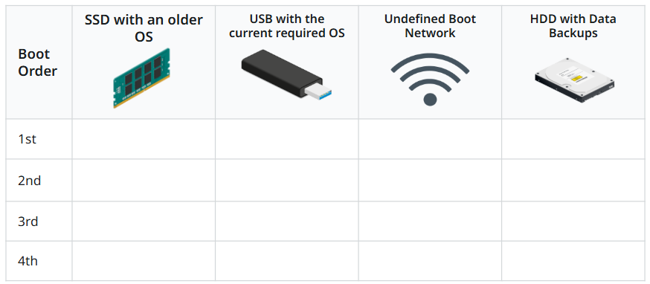
Lesson 4
2
1
3
4

