Book keeping

1.1 Accounting Equation:
What will I do as a book keeper?
Everyone has different reasons for becoming a bookkeeper, but what you all share are the foundational principles of accounting. Helping businesses grow.
Accounts Payable:
Money a business owes to others for goods or services.
Accounts Receivable:
Money that is owed to a business for providing a goods or services.

General bookkeeping responsibilities
As a bookkeeper, you will be expected to fulfill the following responsibilities.
Recording financial transactions:
Recording financial transactions involves systematically documenting financial events in a business's accounting system.
Reconciling bank accounts:
Reconciling bank accounts requires comparing and matching transactions in a business's accounting records with those in the bank statement to ensure accuracy and to identify any discrepancies.
Managing accounts receivable and accounts payable:
Managing accounts receivable and accounts payable entails efficiently tracking and handling the money owed to the business by customers and the money owed by the business to suppliers and creditors.

Working with tax preparers and assisting with tax compliance :
Working with tax preparers and assisting with tax compliance includes collaborating with professionals, such as CPAs and tax advisors, to ensure accurate tax reporting and adherence to tax regulations for the business.
Generating financial statements:
Generating financial statements involves preparing core financial documents that summarize a business's financial activities, performance, and position, providing valuable insights for decision-making and financial analysis.
All of these functions allow you to help businesses, particularly small to medium sized businesses, thrive—giving a financial compass to help owners make their dreams a reality.

1.2 categorized transactions

Why categorized transaction?
Understanding how to categorize transactions accurately allows businesses to track their income, expenses, and assets, providing valuable insights for decision-making and financial reporting.
Let's look at the core components of categorizing transaction: revenue and expenses.

Revenue
Revenue represents the income your client earns through their business operations. It's their gross proceeds from sales, whether that's products, services, rentals, or anything else that bring money into the business.

Expenses
Expenses represent the costs of doing business, such as labor costs like salaries and employee benefits, operating costs like utilities, rent and insurance, and other essential expenses like taxes and advertising, or anything else that keeps their business moving.

Revenue and expenses come together on the income statement, a document that summarizes a client's financial performance through the calculation of revenue minus expenses.
This calculation helps you determine your client's net income or net loss for specified time periods, providing a clear view of their financial journey so they can make informed decisions and track the health of their business.
Note: In accounting you will often find negative values noted by being shown in parenthesis, for example: ($6,000).
Your client owns a business mowing lawns. They completed a mow service for a mini mall and billed the property manager for the service. Which balances will change?
Liabilities and Expenses

Liabilities and Owner's Equity

Assets and Revenue
(The assets will increase because of the accounts receivable and revenue will increase as a result of the service income. )

Debits and credits
Debits and credits are the choreography of your client's financial performance. Understanding their movements helps you keep track of your client's assets, expenses, liabilities, owner's equity, and revenue.
Debits
Debits represent an increase in assets or expenses, or a decrease in liabilities, owner’s equity, or revenue.
Credits
Credits represent a decrease in assets, or expenses, or an increase in liabilities, owner's equity, or revenue.
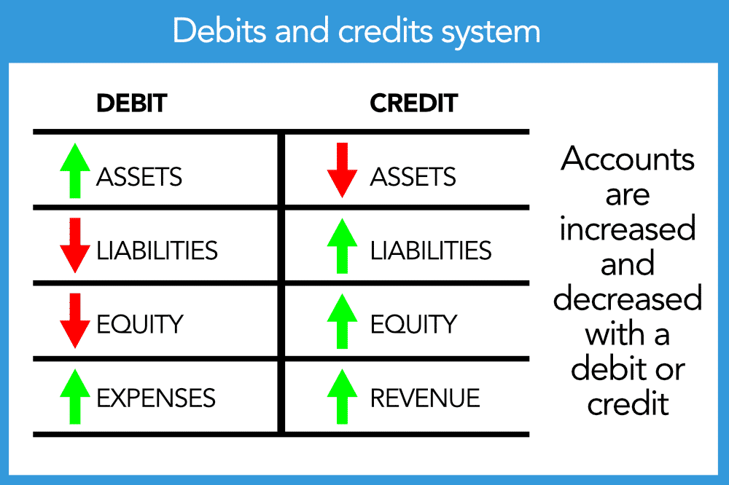

When recording the purchase of office supplies purchased on account, which side of the ledger should the accounts payable be recorded on?
Credit
Debit

( You should credit the accounts payable ( liability) when recording the purchase of office supplies on account.)

When recording the payment of salaries to employees, which side of the salary expense ledger should the transaction be recorded?
Credit

Debit
( You should debit the salary expense (expense) and credit the cash (asset) when recording the payment of salaries to employees.)

1.3 Accounting Principals:

What is the role of accounting principals?
Accounting principles play an important role in maintaining financial integrity and ensuring accurate reporting in business.
Accounting principles also provide a standardized framework that guides financial information recording, analysis, and communication.
By adhering to these principles, businesses can:
Make informed decisions
Build trust with stakeholders
Maintain transparency in their financial operations
Let's explore the first four accounting principles to see how they will guide the integrity of your bookkeeping practices.

Components of ethics
There are four key components of ethics in bookkeeping: honesty, objectivity, professionalism, and confidentiality. Let's review each component.
Honesty
As a bookkeeper, you must act with integrity and honesty. Here's what that looks like in practice:

- Report financial data in an accurate and timely manner.
- Own any mistakes and do everything you can do fix them.
- Be open and transparent with your client about the state of their finances.
•

•

•

Objectivity
Having accurate financial records is vital to the success of any business. To achieve accuracy, bookkeepers must act objectively at all times.
To maintain objectivity, here are things you should never do as a bookkeeper:
- Never take a job that might pose a conflict of interest (when a person's individual interests raise a question about their ability to act or make decisions or judgments objectively).
- Never allow another party to influence your findings.
- Never let personal bias get in the way of performing your duties.
•

•

•

Professionalism
Business owners expect you to act professionally at all times. Acting professionally includes:
- Being courteous and considerate of the business owner’s needs.
- Avoiding any activity, personal or professional, that could bring shame to the profession or business.
- Maintaining proper credentials and keep up skills through continuing education.
Confidentiality
•

•

•

Clients entrust bookkeepers with very sensitive financial information, and a business owner must be able to trust that you will treat their data with the utmost care. This means:

- Never discussing anything with a client outside of the job.
- Never using inside information of a client for personal gain.

What is your ethical responsibility?
•

•

With your ethical responsibilities in mind, how would you handle the following scenario?
scene -1
Setting the scene: Your client, Maxine, owns two thriving coffee shops. She has plans to open a third shop sometime in the next year. You've met and are friendly with her whole family. You run into her brother, Marty, and he casually brings up the third shop.
Marty says,
“I'm so proud of Max. I can't believe how well her shops are doing. Is she really able to fund a new shop so soon?"
Ans:
"She's a great boss, but you understand that I can't divulge any information about the business."

scene -2
Take a moment to consider how you would respond in this scenario:
The dentist you work for had a busier than normal month. He asks you to keep some of the payments received off the books and to not show the bump in income.
What would you do?
This type of request can be tough to navigate. You want to make your client happy, but you don't want to do anything illegal or unethical. It's best to be honest with the dentist and explain that your oath as a bookkeeper prohibits you from accommodating the request. If your client pushes back, chances are it's not the last time he will make a request like this. You have to ask yourself if this is the type of client you want to have. He
1. Which of the following tasks fall under a bookkeeper's role? Select all that apply.
- Handle bank feeds and reconcile bank accounts

- Manage accounts receivable/payable

- Record financial transactions

- Work with tax preparers and assist with tax compliance

ks and to not show the bump in income.
2. You are a bookkeeper for a music venue. The owner's son contacts you privately, asking for financial information. How should you respond?
You should not share any information, and inform the owner of the request.

3. You are the bookkeeper for a chiropractor's office. You notice that you recorded duplicate income from several invoices last month, making it seem like more funds were available. You fix the issue and disclose the mistake to the owner.
In which of the four key bookkeeping ethics elements does this scenario fall?
Honesty

4. Your client's account's receivable is $6,750. What does that mean?
Your client is owed $6,750 for services or goods they provided.

5. Never using inside information of a client for personal gain is part of which ethical principle?
Confidentiality

You'll review the accounting equation, which shows how assets, liabilities, and equity all come together on the balance sheet. You'll decide whether to record transactions as revenue or expenses, helping you confidently navigate the financial landscape. Lastly, you'll explore the assumptions and principles that underpin the financial integrity and accuracy of your client's books.

What is the accounting equation?
The accounting equation is a simple, yet powerful, concept that helps us understand how a business's resources are financed.
Select the plus icons to open and learn more.
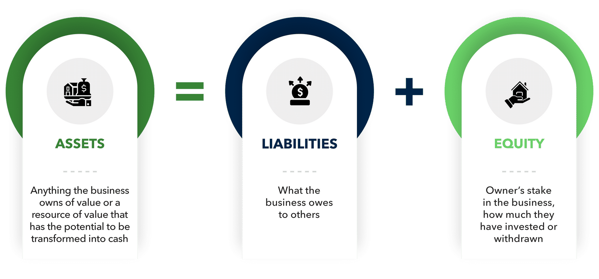
The accounting equation is the foundation of the balance sheet. A balance sheet is the accounting equation displayed as a financial statement. It is a core financial document for businesses.
As you scrutinize the balance sheet for an important client, you notice that the total assets of the business don't match up with the combined value of liabilities and equity. The accounting equation, which should always be in balance, seems incorrect.
What's the correct accounting equation?
Assets = Liabilities + Equity

Parts of the accounting equation
Let's review the dynamic trio of a balance sheet: assets, liabilities, and equity. They play a key role in painting the financial picture of a business.
Assets:
Assets are the valuable resources a business owns. Cash, accounts receivable, inventory, investments in other businesses, equipment, intellectual property (such as a patent), you name it! They're the business's superpowers, ready to be used to generate profits and fuel growth.
Liabilities:
Liabilities are the obligations the business owes to others. Liabilities can be loans to support the business, mortgage, payroll, sales tax owed to the government, credit cards, or any other debts that need to be repaid. They represent the business's promises to others.
Equity :
Equity represents the owner's stake in the business. Equity is the result of one or more owner investments and the accumulated profits or losses over time. It's the business's net worth, the shield protecting it from financial turmoil.

The balance sheet:
The balance sheet is where everything comes together. It's the document where the accounting equation is found displaying assets, liabilities, and the business’s equity.
When you look at a balance sheet, you see how the business's assets are financed. Liabilities and equity provide the fuel to acquire those assets. The balance sheet shows the relationship between what the business owns, what it owes, and how much the owners have invested.

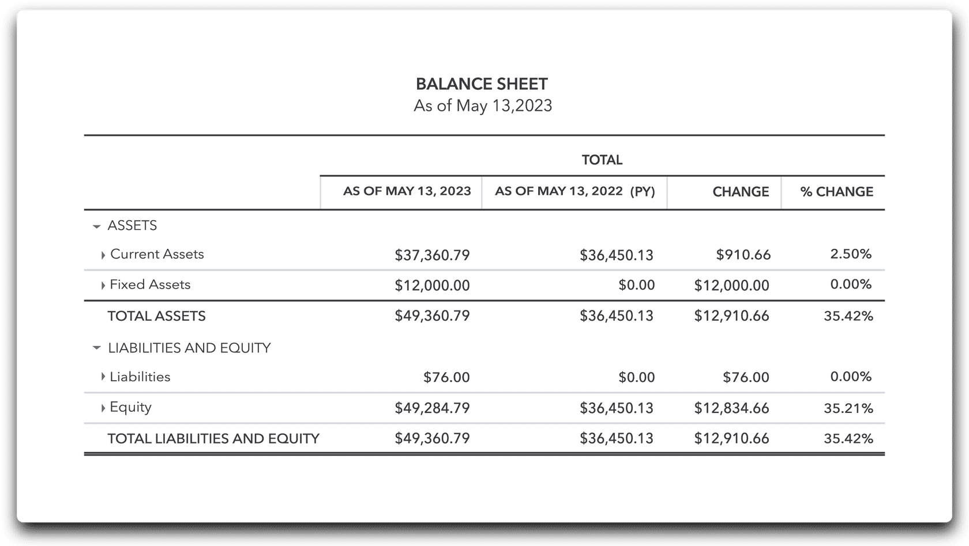
You are reviewing your client's balance sheet. Which of the following items represent assets?
Buildings and equipment

You know how important it is to understand the accounting equation. Which items represent equity in the accounting equation?
Investments made by the owners and retained earnings

Understanding how to categorize transactions accurately allows businesses to track their income, expenses, and assets, providing valuable insights for decision-making and financial reporting.
Revenue:
Revenue represents the income your client earns through their business operations. It's their gross proceeds from sales, whether that's products, services, rentals, or anything else that bring money into the business.
Expenses:
Expenses represent the costs of doing business, such as labor costs like salaries and employee benefits, operating costs like utilities, rent and insurance, and other essential expenses like taxes and advertising, or anything else that keeps their business moving.
Revenue and expenses come together on the income statement, a document that summarizes a client's financial performance through the calculation of revenue minus expenses.
This calculation helps you determine your client's net income or net loss for specified time periods, providing a clear view of their financial journey so they can make informed decisions and track the health of their business.
In accounting you will often find negative values noted by being shown in parenthesis, for example: ($6,000).
Your client owns a business mowing lawns. They completed a mow service for a mini mall and billed the property manager for the service. Which balances will change?
Assets and Revenue

Debits and credits
Debits and credits are the choreography of your client's financial performance. Understanding their movements helps you keep track of your client's assets, expenses, liabilities, owner's equity, and revenue.
Debits
Debits represent an increase in assets or expenses, or a decrease in liabilities, owner’s equity, or revenue.
Credits
Credits represent a decrease in assets, or expenses, or an increase in liabilities, owner's equity, or revenue.
The cardinal rule of bookkeeping: debits and credits need to be equal. It's like a balancing act where the numbers on both sides of the stage should always match up.
When recording the purchase of office supplies purchased on account, which side of the ledger should the accounts payable be recorded on?
Credit
When recording the payment of salaries to employees, which side of the salary expense ledger should the transaction be recorded?
Debit
Accounting principles play an important role in maintaining financial integrity and ensuring accurate reporting in business.
Accounting principles also provide a standardized framework that guides financial information recording, analysis, and communication.
By adhering to these principles, businesses can:
- Make informed decisions
- Build trust with stakeholders
- Maintain transparency in their financial operations
•

•

•

Let's explore the first four accounting principles to see how they will guide the integrity of your bookkeeping practices.
Economic Entity assumption:
This assumption means that the business is its own separate entity, distinct from its owners. It reminds us that we must keep the business's financial activities completely separate from any personal finances.
Business and personal expenses are like oil and water—they should never mix!
Reliability assumption:

This principle ensures that the information you record in your client's financial documents is verifiable and backed by proper documentation. If your client can't provide an invoice, receipt, or bank statement to support a transaction, it is not a reliable transaction and can't be recorded.
Full disclosure principle:
This principle states that any information lenders or investors might need to make informed decisions should be disclosed in the financial statements or accompanying notes.
For example, if a worker files a worker's compensation claim, it's essential to include that information in the notes of the financial statements.
Conservatism assumption:
When you are not sure if or how to record an item, this principle guides us to err on the side of caution. It means we choose options that show less income or asset benefit. Potential losses can be recorded, while potential gains cannot.
For instance, if your client is facing a potential lawsuit, you can consider it a loss and note it. But, if your client is expecting increased foot traffic to their business due to a new business opening nearby, you can't record a potential gain until it actually happens. Better to be cautious than overly optimistic.

You're the bookkeeper for a small coffee shop. You found out your client does not have a separate business account for the coffee shop. You inform them it's a best practice to separate business and personal accounts. Which accounting principle are you using?
Economic entity assumption

Your client has bought a new coffee machine for the shop. They paid cash and cannot locate the receipt and have no record of the purchase. You inform them that since there's no supporting documentation for the purchase, it can't be recorded. Which accounting principle are you using?
Reliability assumption

You're the bookkeeper for a small construction business. The business has bid on a large contract, but the results from the bid are still a month away. This is the largest contract with potential gains. Which accounting principle should be used?
Conservatism assumption

You're a bookkeeper for a technology startup, and the CEO informs you that the business is in advanced negotiations to secure a significant investment from a venture capital firm. This investment will have a substantial impact on the business's financial position and future prospects. There is lawsuit pending that hasn’t been settled. Which of the following should be used?
Full disclosure principle

You're a bookkeeper for a retail store, and your task is to record daily sales transactions. The store accepts currency payments, including USD, EUR, and GBP. However, the financial records are only showing USD. Which of the following is being used?
Monetary unit assumption

The business's quarterly financial reports consistently meet or surpass the previous year's sales performance. This consistent and strong sales performance shows the business has maintained its operations and financial stability at the same level as the last year. Which of the following is this an example of?
Going concern assumption

As the bookkeeper for a small manufacturing business, you encounter a minor discrepancy in the inventory records. Upon investigation, you discover that the difference amounts to less than $50, immaterial in the business's overall financial statements. You decide not to make an adjusting entry for this minor discrepancy, as it does not significantly impact the financial position or decision-making of the stakeholders. Which of the following are you using?
Materiality principle
As the bookkeeper for a local bakery, you discover that different branches within the bakery chain are using different methods to record inventory. Recognizing the importance of consistency, you implement a standardized inventory valuation method across all branches, ensuring uniformity in reporting. Which of the following are you using?
Consistency principle

Setting the scene
As a bookkeeper, you're working with a new client and need to better understand their business, goals, and transactions.
Let's say your client owns a small business and contacts you with a series of questions. Let's take them one at a time.
First client question
"I recently started a photo booth business. I bought $15,000 worth of equipment with cash to get started. I am confused on how to log it into the books. What should I do?"
What do you say?
The photo booth would be categorized as an asset and would be logged as debit to assets in the books because purchasing equipment increases your business's assets overall.

Second client question
"I'm thinking about purchasing another photo booth using my supplier's financing services. Would a second photo booth also be considered an asset? It will also be used to generate revenue."
What do you say?
While the photo booth is an asset, this transaction will add a liability, since you will be financing the photo booth.
Third client question
"I provided photo booth services for a party and received a payment. Can I deposit the payment into my personal account, to recuperate some of the initial investment?"
What do you say?
It is understandable you want to recuperate start up costs, but it is important to separate business from your personal accounts.
Fourth client question
"What information do I need to disclose to a lender when requesting a loan for my business?"
What do you say?
It is important to provide the lender with all relative information.
Remember ✓
Categorizing transactions and applying accounting principles helps you in two ways.
First, of course, by managing your client's books. Second, by providing them with the information they need to make informed decisions in the future.
Which of the following is an example of a liability?
Outstanding debt to suppliers

Cecilia sells 1980s themed enamel pins. She has a huge inventory she purchased in 1994 at $0.20 each. They are now worth $1 each. According to the monetary unit assumption, you:
Keep the value of the pins at $0.20 each
Accounts receivable would be an example of what kind of account?
An asset account.
The owner’s stake in the business is defined as:
Equity

You're the bookkeeper for a plant nursery, a newly formed corporation. The plant nursery had the following transactions for their business:
- Four shareholders contributed $60,000 ($15,000 each) in exchange for the plant nursery's common stock.
- The plant nursery purchases inventory for $10,000. The plant nursery paid cash for the invoice.

What are the effects on the plant nursery's accounting equation?
Based on the two transactions, assets increased by $60,000, and shareholder equity increased by $60,000.
The plant nursery opens a line of credit at a wholesale specialty nursery and uses it to purchase $600 in inventory, how do you categorize the $600 borrowed from the wholesale store?
Liability

If the plant nursery purchases increase liabilities by $600, what also needs to happen for the accounting equation to be in balance?
Add $600 to assets
The plant nursery borrows $150,000 from a local bank. The plant nursery uses the loan to buy a warehouse building.

What is the effect on the plant nursery's accounting equation?
The assets and liabilities of the accounting equation both increase by $150,000.

The accounting cycle is a reliable process to make sure financial statements are accurate and consistent. It begins with analyzing the accounting events of a business and ends with producing financial reports for a given period. By using this process, you'll make sure you stay organized and don't miss any important details.
