# Linux encode

## Set encode to utf-8

Configuration of encode stores in /etc/sysconfig/i18n , so open this file to edit encode. 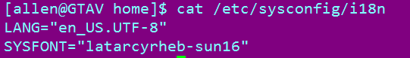

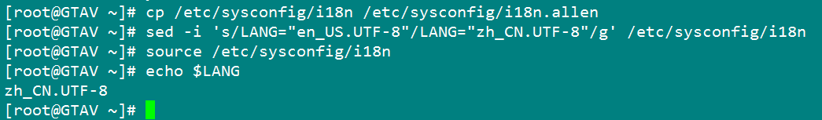

First, need a backup ; then , exchange the encode to your encode , and use “source” command to make it alive ;

## Source command

Source filename : execute commands from filename in the current shell, so it means the “filename” will be initialized again. You could use “. Filename ” that is same function as “source filename”. 

This command is a built-in command