# What is the port?

### Logic port

this kind of port is used to perform service, range from 0~65535,

### Well-known port

0~1023 are used to common service, you can’t use port within this range, these ports are called “well-known port”, you could find this map in “/etc/services”

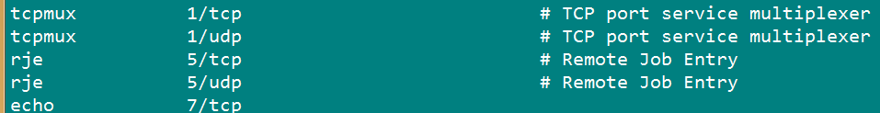

### Registered port

1024~49151, they registered some services, and those ports are used for other service

### Dynamic port or private ports

Those ports are used for software to connection with another software service. The range from 49152~65535, e.g.: tcp ports is limited as following pic: 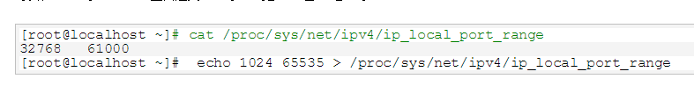

# Scan port commands

## NMAP: scan port and network exploration tool