# change default-ssh

## 1.change ssh service configuration

Linux stores the “sshd” service in the /etc/init.d/sshd

,and you could use commands to show process of sshd

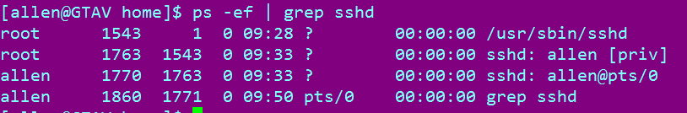

The “sshd configuration” stores under the /etc/ssh/ dir. Checking out it and make a modifycation what you need.

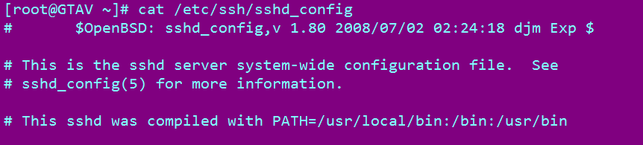

It’s similar with “/etc/ssh/ssh_config”,actually they are different, the “ssh_config” is serverice for client, the “sshd_config” is the service for server. The first one is likely “CRT” in locale of linux and don’t care about it. we need to modify the last one, it’s a server service for linux.

### modification

1. first
   1. backup with the “/etc/ssh/sshd_config”(backup first) 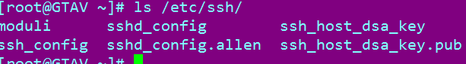
2. second
   1. change port num to a stanger number;
   2. change no to “Use DNS”(we use normally ip address to connect server, so shut it down to speed it up );
   3. not permit root login with ssh way(the root users only login by “su – root /sudo root”);
   4. modify ip address to server address(so only this ip is permitted to login in server);
   5. change “GSSAPIAuthentication ” yes to no(handle this of two more machines slowly connection ) ;(five modifies)
3. third
   1. collect all modificationes and put these together like this

|  |
| --- |
| Port 52113  PermitRootLogin no  UseDNS no  GSSAPIAuthentication no  ListenAddress 192.168.184.165 |

1. forth
   1. restart “ssh service ” to make it useful .
   2. 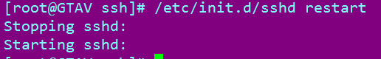
   3. Or restart in this way: 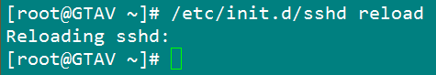,

This way is recommanded to use, because it’s solid way to restart, not affect other users.

Note:

If not connection on new port , because the firewall is opened. So please close firewall in following way 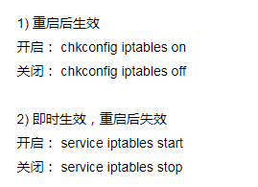

## 2.What is the port?

### Logic port

this kind of port is used to perform service, range from 0~65535,

### Well-known port

0~1023 are used to common service, you can’t use port within this range,these ports are called “well-known port”,you could find this map in “/etc/services”

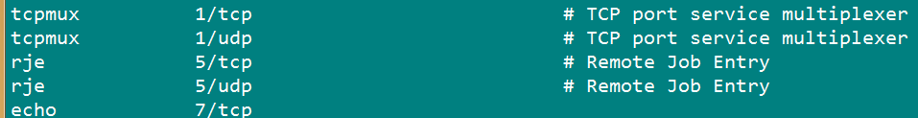

### Registered port

1024~49151 ,they registered some services, and those ports are used for other service

### Dynamic port or private ports

Those ports are used for software to connnection with another software service. The range from 49152~65535, eg: tcp ports is limited as following pic: 