# 两种方法修改内核参数

把参数设置直接复制到/etc/systcl.conf中，执行sysctl –p 来使参数生效，是永久生效

## Systcl 命令

这个命令用来配置和显示在/proc/sys目录下的内核参数，如果要使参数一直有效，通过编辑/etc/sysctl.conf文件来实现；

-w 临时改变某个参数的值



使用这个参数可以禁止ping命令连接自己的机器



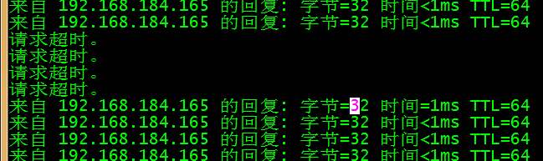

-a 显示所有系统参数

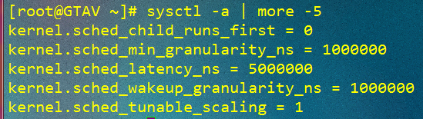

-p 从指定的文件加载系统参数，默认从/etc/sysctl.conf文件中加载

# 生产环境内核参数修改

net.ipv4.tcp_syn_retries = 1

net.ipv4.tcp_synack_retries = 1

net.ipv4.tcp_keepalive_time = 600

net.ipv4.tcp_keepalive_probes = 3

net.ipv4.tcp_keepalive_intvl =15

net.ipv4.tcp_retries2 = 5

net.ipv4.tcp_fin_timeout = 2

net.ipv4.tcp_max_tw_buckets = 36000

net.ipv4.tcp_tw_recycle = 1

net.ipv4.tcp_tw_reuse = 1

net.ipv4.tcp_max_orphans = 32768

net.ipv4.tcp_syncookies = 1

net.ipv4.tcp_max_syn_backlog = 16384

net.ipv4.tcp_wmem = 8192 131072 16777216

net.ipv4.tcp_rmem = 32768 131072 16777216

net.ipv4.tcp_mem = 786432 1048576 1572864

net.ipv4.ip_local_port_range = 1024 65000

net.ipv4.ip_conntrack_max = 65536

net.ipv4.netfilter.ip_conntrack_max=65536

net.ipv4.netfilter.ip_conntrack_tcp_timeout_established=180

net.core.somaxconn = 16384

net.core.netdev_max_backlog = 16384