# Linux device information

## /dev/null

This device is named null device on Unix or Unix-like system. In programmers jargon, it would be called “black hole”,that means all the data written to it will be discarded, and return true for writeen operation.

This device in fact is a device file that writen to it which will be discards. So if any process want to read it , yield EOF immediately.

This file is used to handle unwannted output stream , it’s a empty file, and is used for input stream as a conventient file , that is uesed for redirection.

Note: this file is not a directory, so can not use “mv” command to move a file or directory to the file. But you could use “rm” command to handle properly.

e.g. operate stardard input and output by /dev/null

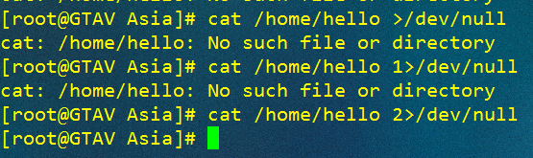

So we use 2 represent startard error, if this error is oup, redirect it to /dev/null

,the 0 and 1 are same from 2



We also could use these num together



The same function with last command

Sometimes we need to delete text, but not delete the file, so we could do like this:the command “cat /dev/null” will return null, and null will be passed to 1.txt, it will clear all text in this file

,the same thing is

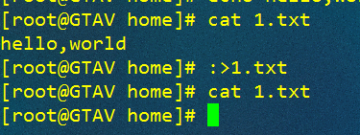

2>&1: redirect error info to output stream. 

Redirect 1 to null, and next redirect 2 to 1, so nothing will be printed.(can’t make order wrong, or it’s no effection.)

