Information Technology

21st century has come to be known as the era of Information Technology; it is the key driver of economic growth of not only a nation, but rather the whole world.
The growth and progress of every sector of the country today depends on the level of Information Technology.
Furthermore, technology is not important only at the work place, but also in our everyday life; whether it is working with the microwave oven which is a cooking appliance or a super computer, an appliance is based on information technology, technology helps everywhere.
From hi-tech industry to an education system, Information Technology footprints can be seen everywhere.
Likewise, Information Technology is one of the essential features for the overall development of a country.

Meaning of Information Technology
The technology, which is exclusively designed to store, process, and transmit information, is known as Information Technology.
The following diagram illustrates the basic features and applications of Information Technology −
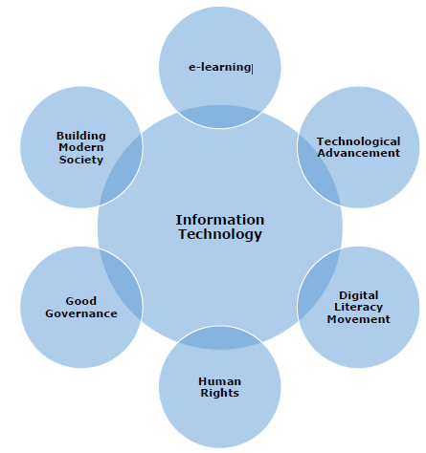
Information technology (IT) encompasses a broad range of technologies and practices that involve the use of computers, software, networks, and other electronic systems to store, process, transmit, and retrieve information. Here are some important features of information technology:
- Data Management: IT involves the collection, storage, and retrieval of data. This includes databases, file systems, and other data storage mechanisms.
- Software Development: IT plays a crucial role in the creation and maintenance of software applications. This includes programming languages, development frameworks, and software development methodologies.
- Hardware Infrastructure: IT involves the design, development, and maintenance of hardware components such as computers, servers, networking devices, and storage systems.
- Networks and Connectivity: IT facilitates communication and data exchange through networks. This includes local area networks (LANs), wide area networks (WANs), and the internet. Network security is also a critical aspect of IT.
- Cybersecurity: With the increasing digitization of information, IT is crucial for protecting data and systems from unauthorized access, cyberattacks, and other security threats.
- Cloud Computing: IT enables the use of cloud services, allowing users to access and use computing resources (such as storage, processing power, and applications) over the internet.

Fiber Optics: It is a technology that transmits signals on the principle of Total Internal Reflection (TIR) of light. The technology employs transmission of data in pulses of light form.

- Artificial Intelligence (AI) and Machine Learning (ML): IT is at the forefront of AI and ML development, enabling machines to learn from data and perform tasks that traditionally required human intelligence.
- Mobile Technology: IT includes the development of mobile devices, applications, and services, enabling users to access information and perform tasks on the go.
- Automation: IT facilitates the automation of various processes, improving efficiency and reducing the need for manual intervention in repetitive tasks.
- E-commerce: IT has transformed the way business is conducted, with online transactions, electronic payments, and digital marketplaces becoming integral parts of the global economy.
- Collaboration Tools: IT provides tools and platforms for communication and collaboration, including email, messaging apps, video conferencing, and project management software.
- Big Data: IT enables the handling and analysis of large volumes of data, helping organizations make informed decisions based on data-driven insights.
- Internet of Things (IoT): IT connects and integrates various physical devices and objects to the internet, allowing them to communicate and share data. This has applications in smart homes, healthcare, industrial processes, and more.
- User Interface (UI) and User Experience (UX): IT is involved in designing intuitive and user-friendly interfaces for software applications, websites, and other digital platforms.

