Sharks

Did you know that sharks can sense a fish 500 miles away?
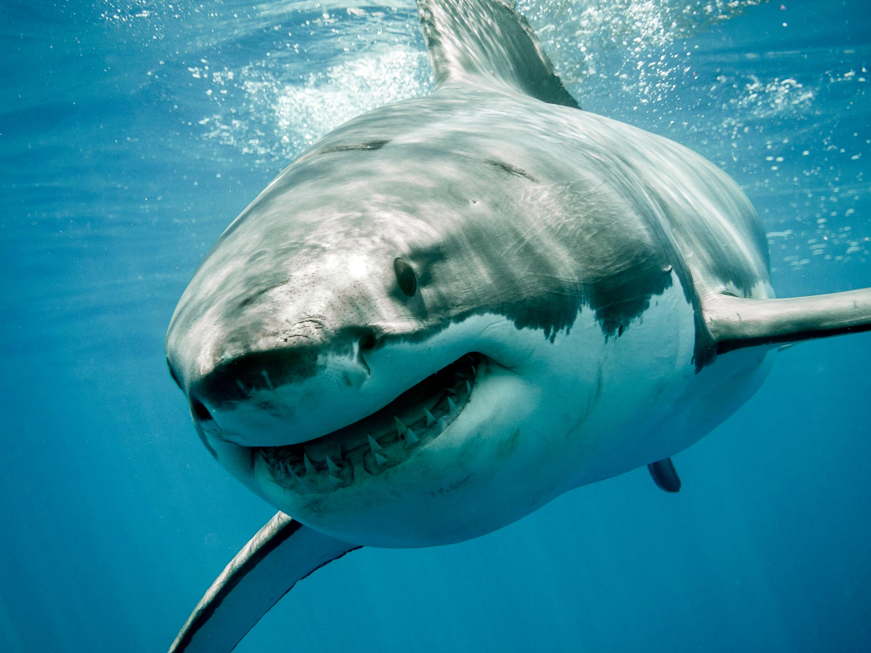
Sharks are very interesting, and fascinating creatures. Did you know that sharks eat meat? Some sharks eat anything one time scientists found a shoe, bucket, and even a suit of armor in a shark! sharks will only think you are food if you act like there favorite food witch is seals. A whale shark can filter water through their mouth capturing little fish to eat. There are more than 400 species of sharks. Sharks are a type of fish. Sharks don’t have bones they have a skeleton made of soft cartilage. Sharks can live up to 40 years! Some sharks like deep water while others like shallow. Sharks live in the ocean. Sharks have great talents. Sharks are very cool. I think sharks are amazing and cool! The end

