Coinage of the United States
The U.S. Mint was established in 1792-- all of the coins in this era had liberty on the front, and a bald eagle on the back
- half cent($.005)
- cent($.01)
- half dime($.05)
- dime($.10)
- quarter($.25)
- half dollar($.50)
- dollar($1)
- quarter eagle($2.50)
- half eagle($5)
- eagle ($10)
Seated Liberty Era (1836-1891)
- Seated Liberty dollar($1)-(1840-1873)
- Double Eagle($20)-(1849-1907)
- Flying Eagle cent($.01)-( )
- Indian Head cent($.01)-(1859-1909)
- nickel introduced-half dime obsolete($.05)-(1866)
- 2 cent piece($0.02)-(1864-1873) this was the first coin to say “In God We Trust”
- 3 cent pieces($0.03)-( )
- copper-nickel($0.05)-( )
- 20 cent pieces($0.20)-(1875-1878)
- 3 dollar Gold coin($3)-(1854-1889)
- Morgan dollar($1)-(1878-1904, 1921) This was the first U.S. coin to have “IN GOD WE TRUST” written on it.
Intro of paper money and end of gold coins(1892-1932)
- Liberty Head Nickel($0.05)-(1883-1913)
- “Barber” quarter, dime, and half dollar($0.25, $0.10, $0.50)-(1892-1932)
- Indian Head Eagle and fractions of eagle($10, $5, $2.50)-full eagle in 1907, fractions in 1908
- St. Gaudens double Eagle($20)-(1907)
- Wheat Penny($0.01)-(1909-1958)
- Peace dollar($1)-(1921-1935)
- Buffalo nickel($0.05)-(1913-1938)
- Mercury dime($0.10)-(1916-1945)
- Liberty Walking Half Dollar($0.50)-(1916-1947) This is the only U. S. Coin that shows the American Flag (draped over Liberty's robe)
Mid to Late 20th Century & end of silver coinage(1932-1999)

- Washington quarter($0.25)-(1932-1999)

- Jefferson nickel($0.05)-(1938-2004)

- Franklin half dollar($0.50)-(1948-1964)

- Roosevelt dime($0.10)-(1946-present)

- Lincoln Memorial penny($0.01)-(1959-2008)

- Kennedy half dollar($0.50)-(1964-present)

- Susan B Anthony dollar($1)-(1979-1981, 1999)

21st Century-(1999-present)

- State Quarters($0.25)-(1999-2008) design for each state

- Lewis & Clark Western Journey nickel series($0.05)-(2004-present) Shows Lewis & Clark's journey

- Lincoln Bicentennial pennies($0.01)-(2009) Shows Lincoln's life with 5 coins, the last one silver

- Shield Pennies($0.01)-(2010-present)

- Sacagawea Dollar($1)-(2000-present) The Sacagawea had the same design from 2000-2008 then now it changes every year

- Presidential Dollars($1)-(2007-present) design for each president who has been dead for 2 years
The Presidential Dollars will also come with $10 First Spouse coins. As each president's coin is released, so will the president's wife's coin.

- National Park Quarters(or America The Beautiful quarters)($0.25)-(2010-present) National park design for each state

Individual Coin History
Cent (1¢)
Fugio Cent (1787) Chain (1793) Wreath (1793) Liberty Cap (1793–96) Draped Bust (1796–1807) Classic Head (1808–14) Matron Head (1816–39) Large cent (Braided Hair) (1835–57; 1868) Flying Eagle cent (1856–58) Indian Head (1859–1909) Wheat penny (1909–) Lincoln Memorial Penny (1959-2008) Lincoln Bicentennial pennies (2009) Shield penny (2010-present)
Nickel or half dime(5¢)
Flowing Hair (1794–95) Draped Bust (1796–97, 1800–05) Capped Bust (1829–37) Seated Liberty (1837–73) Shield (1866–83) Liberty Head (1883–1913) Buffalo (1913–38) Jefferson (1938–2003) Western Journey Nickel Series (2004-present)

Dime (10¢)
Disme (1792) Draped Bust (1796–1807) Capped Bust (1809–37) Seated Liberty (1837–91) Barber (1892–1916) Mercury (1916–45) Roosevelt (1946–present)
Quarter dollar (25¢)
Draped Bust (1796–1807) Capped Bust (1815–39) Seated Liberty (1839–91) Barber (1892–1916) Standing Liberty (1916–30) Washington (1932–1998) 50 State Quarters (1999–2008) District of Columbia and United States Territories Quarters (2009) America the Beautiful Quarters (national parks) (2010–present)
Half dollar (50¢)
Flowing Hair (1794–95) Draped Bust (1796–1807) Capped Bust (1807–39) Seated Liberty (1839–91) Barber (1892–1915) Walking Liberty (1916–47) Franklin (1948–63) Kennedy (1964–present)
Dollar ($1)
Flowing Hair (1794–95) Draped Bust (1795–1804, 1804 ) (1834, c. 1858–60) Gobrecht (1836–39) Seated Liberty (1840–73) Gold (1849–89) Trade (1873–85) Morgan (1878–1904; 1921) Peace (1921–35) Eisenhower (1971–78) Susan B. Anthony (1979–81; 1999) Silver Eagle (1986–present) Sacagawea (2000–present) Presidential (2007–present)
Gold
Turban Head eagle (1795–1804) Half eagle (1795–1929) Eagle (1795–1933) Quarter eagle (1796–1929) Gold dollar (1849–89) Three-dollar piece (1854–89) Liberty Head double eagle (1849–1907) Double eagle (1849–1933) Saint-Gaudens double eagle (1907–33) Indian Head eagle (1907–33) Indian Head gold pieces (1908–29) Gold Eagle (1986–present) Gold Buffalo (2006–present) First Spouse gold bullion coins($10)-(2007–present)
Commemorative
Early
(1892–1954)
Columbian half dollar (1892–93) Isabella quarter (1893) Lafayette dollar (1900) Louisiana Purchase Exposition dollar (1903) Lewis and Clark Exposition dollar (1904–05) Panama–Pacific commemorative coins (1915) McKinley Birthplace Memorial dollar (1916–17) Illinois Centennial half dollar (1918) Maine Centennial half dollar (1920) Pilgrim Tercentenary half dollar (1920–21) Missouri Centennial half dollar (1921) Alabama Centennial half dollar (1921) Monroe Doctrine Centennial half dollar (1923) Huguenot-Walloon half dollar (1924) Stone Mountain Memorial half dollar (1925) Lexington-Concord Sesquicentennial half dollar (1925) California Diamond Jubilee half dollar (1925) Fort Vancouver Centennial half dollar (1925) United States Sesquicentennial coinage (1926) Oregon Trail Memorial half dollar (1926–39) Vermont Sesquicentennial half dollar (1927) Hawaii Sesquicentennial half dollar (1928) Texas Centennial half dollar (1934–38) Hudson Sesquicentennial half dollar (1935) Connecticut Tercentenary half dollar (1935) California Pacific International Exposition half dollar (1935–36) Rhode Island Tercentenary half dollar (1936) Cincinnati Musical Center half dollar (1936) Cleveland Centennial half dollar (1936) Bridgeport half dollar (1936) Elgin, Illinois, Centennial half dollar (1936)
Modern
(1982–present)
Los Angeles XXIII Olympiad dollar (1984) Eisenhower commemorative dollar (1990) Library of Congress ten dollar coin (2000) John Marshall commemorative dollar (2005) Marine Corps 230th Anniversary silver dollar (2005) Boy Scouts of America centennial silver dollar (2010)
Patterns
Two-cent billon (1836) Three-cent bronze (1863) Stella (1879–80) Half-union (1877)
Other
Half cent (1793–1857) Two-cent piece (1864–73) Three-cent silver (1851–73) Three-cent nickel (1865–89) Twenty-cent piece (1875–78) United States Bicentennial coinage (1975–76) Platinum Eagle (1997–present) Palladium Eagle (2017–present) America the Beautiful Silver Bullion Coins (2010–present) Norse-American medal (1925)
References

Special Coins to Collect
- Steel Pennies(1943) These coins are special because they are the only US Coins that will stick to a magnet. They were made because of World War 2, copper and zinc were scarce then, so they made the pennies out of a much cheaper metal, steel. If you get a 1943 penny that does not stick to a magnet, it is made of bronze. If you have one, then you are holding big buckos in your hand, more than a million dollars!
- 1970 S Washington Quarter This coin is very irregular. The US mint got tired of Canadian money being so close to theirs, so they decided to take the 1943 Canadian quarters and print their own 1970 S Washington Quarters on top! If you have a 1970 S Washington Quarter, that is a great start, but you still might not have this valuable coin. The way to tell is to flip the quarter onto its reverse side (the back, or tales) and turn it upside down. Under where it says “Quarter Dollar” you may see a slight marking of the year “1943” If you can see it, then you are holding a very valuable coin, ranging in worth from $80,000 to $1,000,000!
- Double-Died coins A coin is double-died when there is an error in the minting, or when the coin is stamped. The metal stamp that is putting the design on the coin may slide a little bit, or shake, but either way the coin is left different. If you look at the coin closely, then it will have an extra design right next to the first one, almost like the coin was stamped twice. Here is a picture of a double-died penny

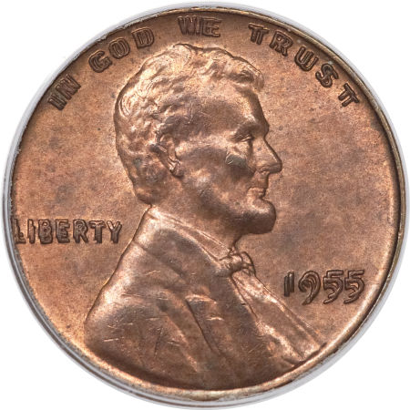

Depending on how much the coin is double-died, and how good of condition the coin is in, these coins can be worth quite a bit of money

- Bicentennial Coins(1976): Bicentennial coins are fun to collect because they commemorate the year America declared independence from Great Britain. In 1976, most of the main coins at that time were shortly changed to a different design. The Washington Quarter, which normally has an eagle on the back, was changed in 1976 to a picture of a drummer boy in the army. The ironic thing is, is that the drummer boy is actually George Washington himself in the British army. The Kennedy half dollar also changed to a new design, as well as the Eisenhower dollar. The few coins that did not have a bicentennial design were the penny, the nickel, and the dime. Just about all of the other coins that were being made in 1976 have a bicentennial design.
- Lincoln Bicentennial Pennies(2009): Lincoln Bicentennial Pennies commemorate the birth of Abraham Lincoln. The US mint made 4 of these coins to show Lincoln's life with the traditional copper and zinc, then made the 5th coin out of a silver metal.
- State, Territorial, and Washington D. C. Quarters(normally just called state quarters) (1999-2008) These are fun to collect because they have a design for each state or territory in the United States, even one for the capitol. Probably one of the most popular types of coins to collect.
- 3-legged Buffalo Nickel: This coin is a pretty awesome mint error. Some 1937 Buffalo Nickels(1913-1938) were minted missing one leg. This is easy to see, but these error coins are very rare, fetching a whopping price of over a million dollars!
- Wisconsin State Quarter with extra High Leaf: If you look closely at the two quarters below, you can see that the two quarters are different. The one with the extra high leaf is worth $300. If You don't know what you are looking for, then it's quite hard to notice, but it is a mint error worth quite a bit more than its face value.
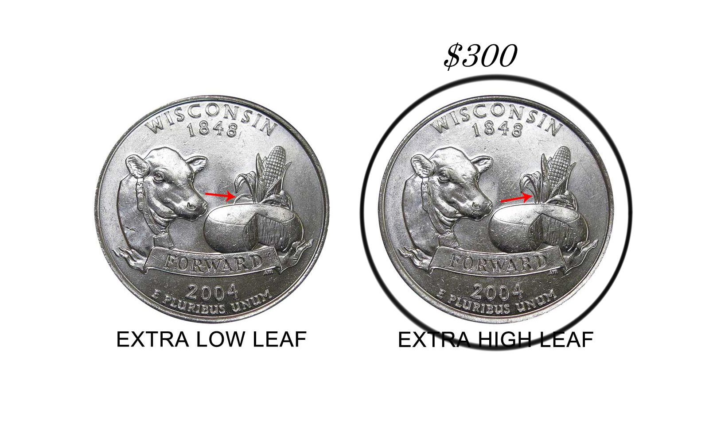
- Ben Franklin Half dollars are also worth a lot of money when they are in good condition, most selling for over 80 dollars, but getting to much more than that!
- Nickels made during World War II were made with different metals, and so are worth more than their face value, starting at around $25, but fetching much higher prices.
- Some Mercury dimes made in San Francisco have a large S mint mark, but the ones to look for are the ones with the micro s mint mark. If you are wondering about the different sizes of the mint mark, then look it up on Google. They should have something that shows what the sizes compare to each other like.
- The U.S. $20 coin: This coin is favored by many collectors to be the most beautiful of all of the U.S. coins. This would be a great addition to your collection.
There are many more coins that are worth much more than their face value to other collectors, but most people don't seem to realize they are worth much more when they spend them at the grocery store. Watch your coins, and watch for the next update of this document.
Happy Collecting!

