Experiment Title 2.1

# Student Name: Himanshu UID: 20BCS7944

# Branch: CSE Section/Group: 804-A

**Semester: 4th Subject Name: CN**

# Aim/Overview of the practical:

Create a network that shows the working of hub and also write the steps how to implement it.

# Task to be done/ Which logistics used:

To Create a network connection using cisco packet tracer

# Steps for experiment/practical/Code

* 1. Attach required devices (Hub/Switch/Router) in the packet tracer software.
  2. Assign IP address to devices.
  3. Select source and destination and drop packet from source to destination.
  4. Go to Simulation mode and click capture/Play.
  5. Simulation will start and packet will only be accepted by destination.

The step by step process is shown below in pictorial form.

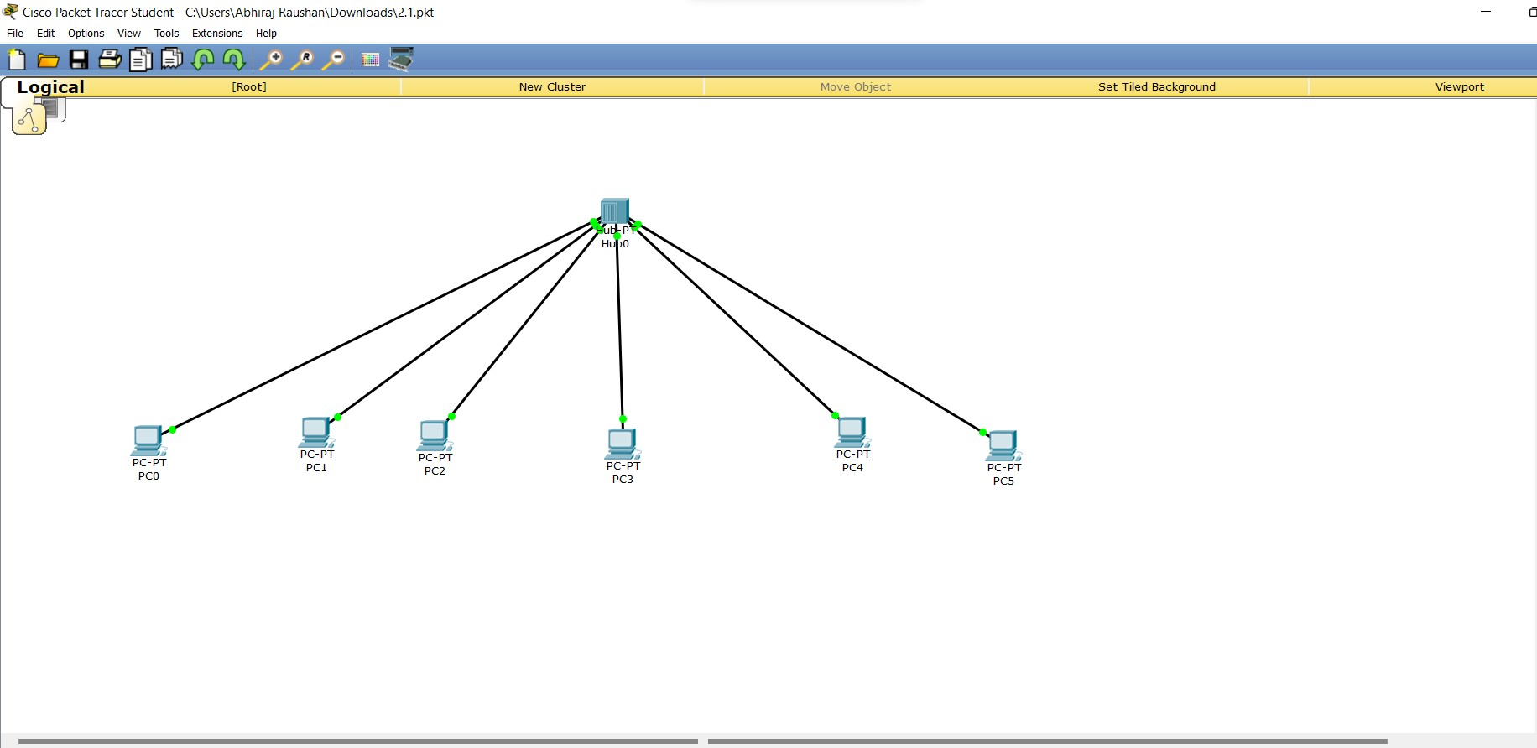

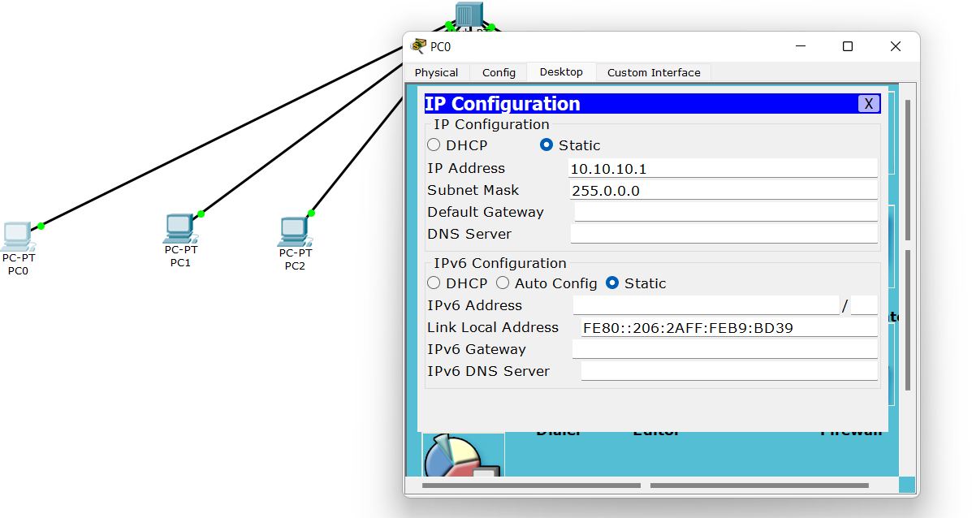

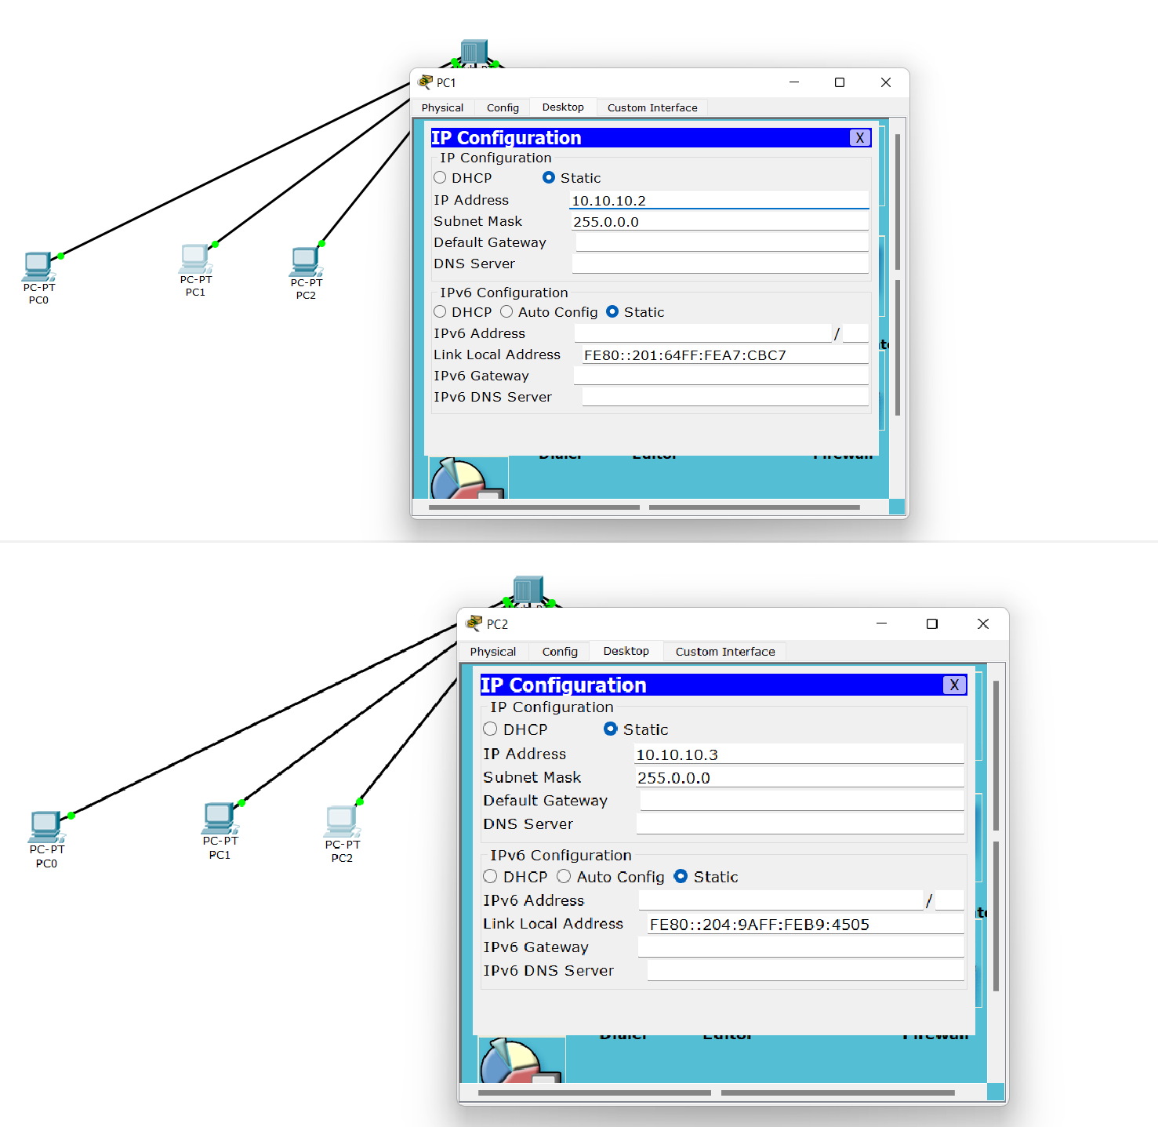

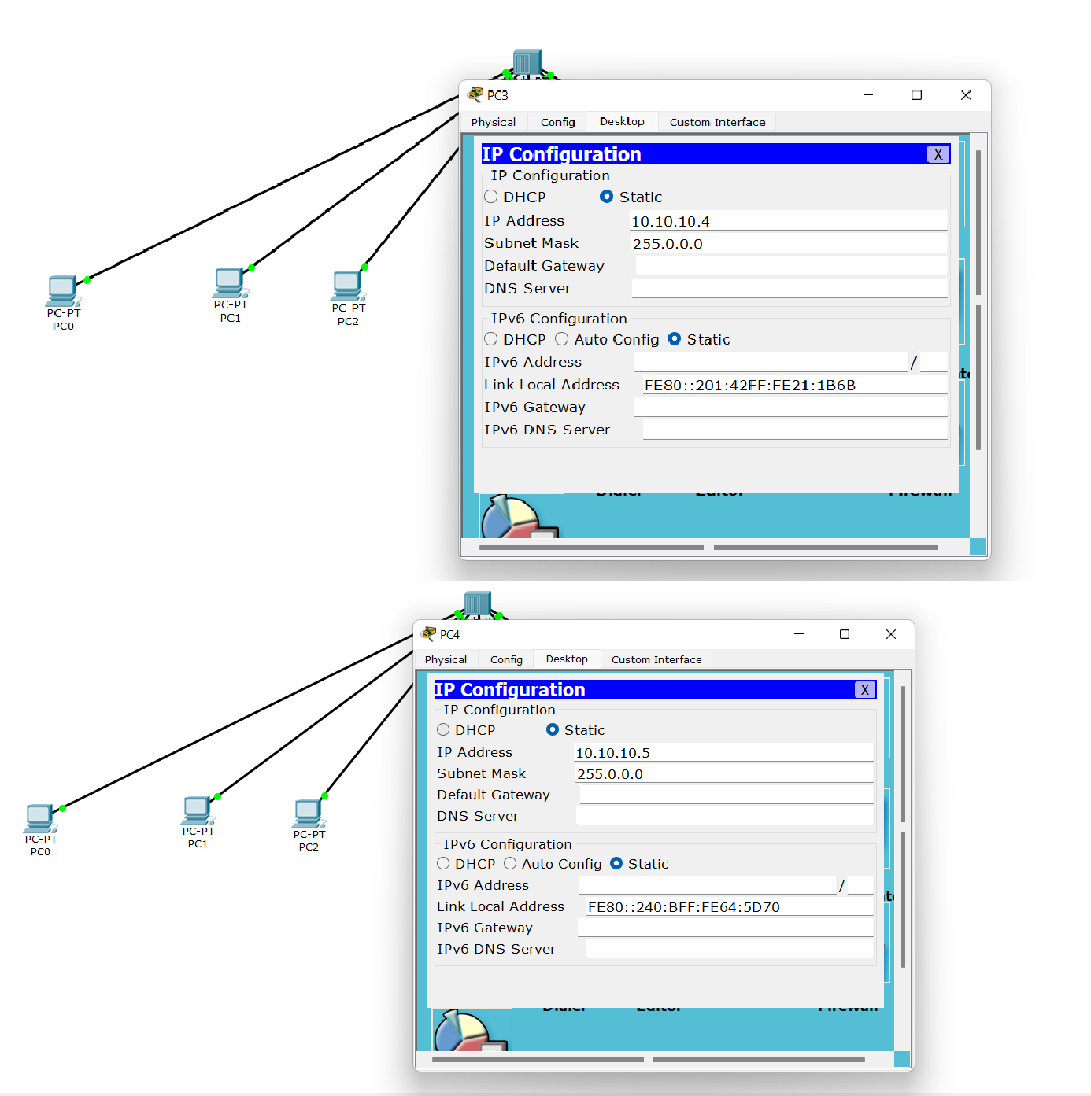

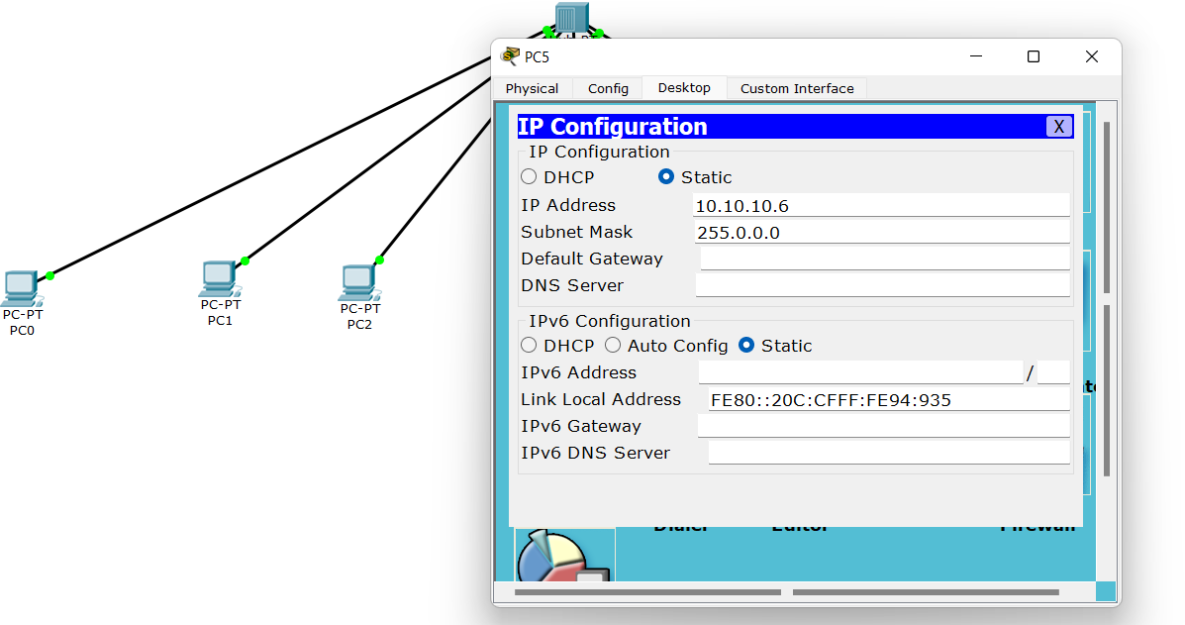

# Result/Output/Writing Summary:

Packet was sent from 0 and transferred to all 5 though hub

However only 5 accepted the packet because it was only intended to it. Rest rejected the packet

## Output

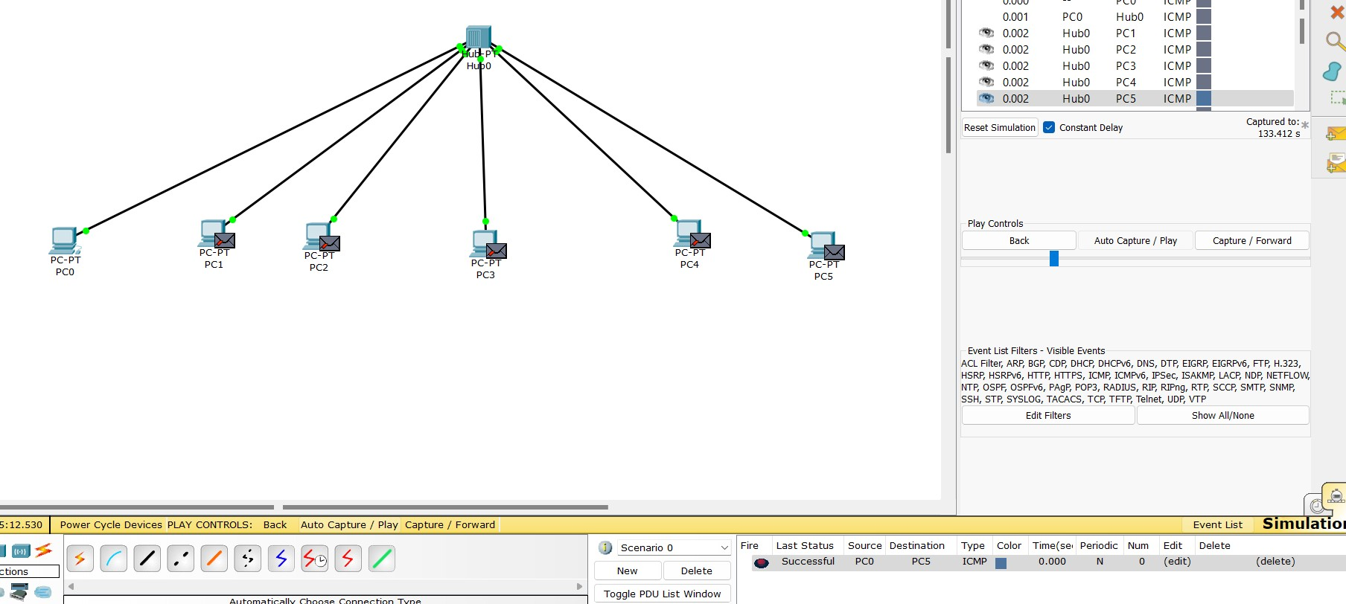

Then 5 sent an acknowledgement through the hub

It was only accepted by 0 and denied by all the other computers

# Output 2

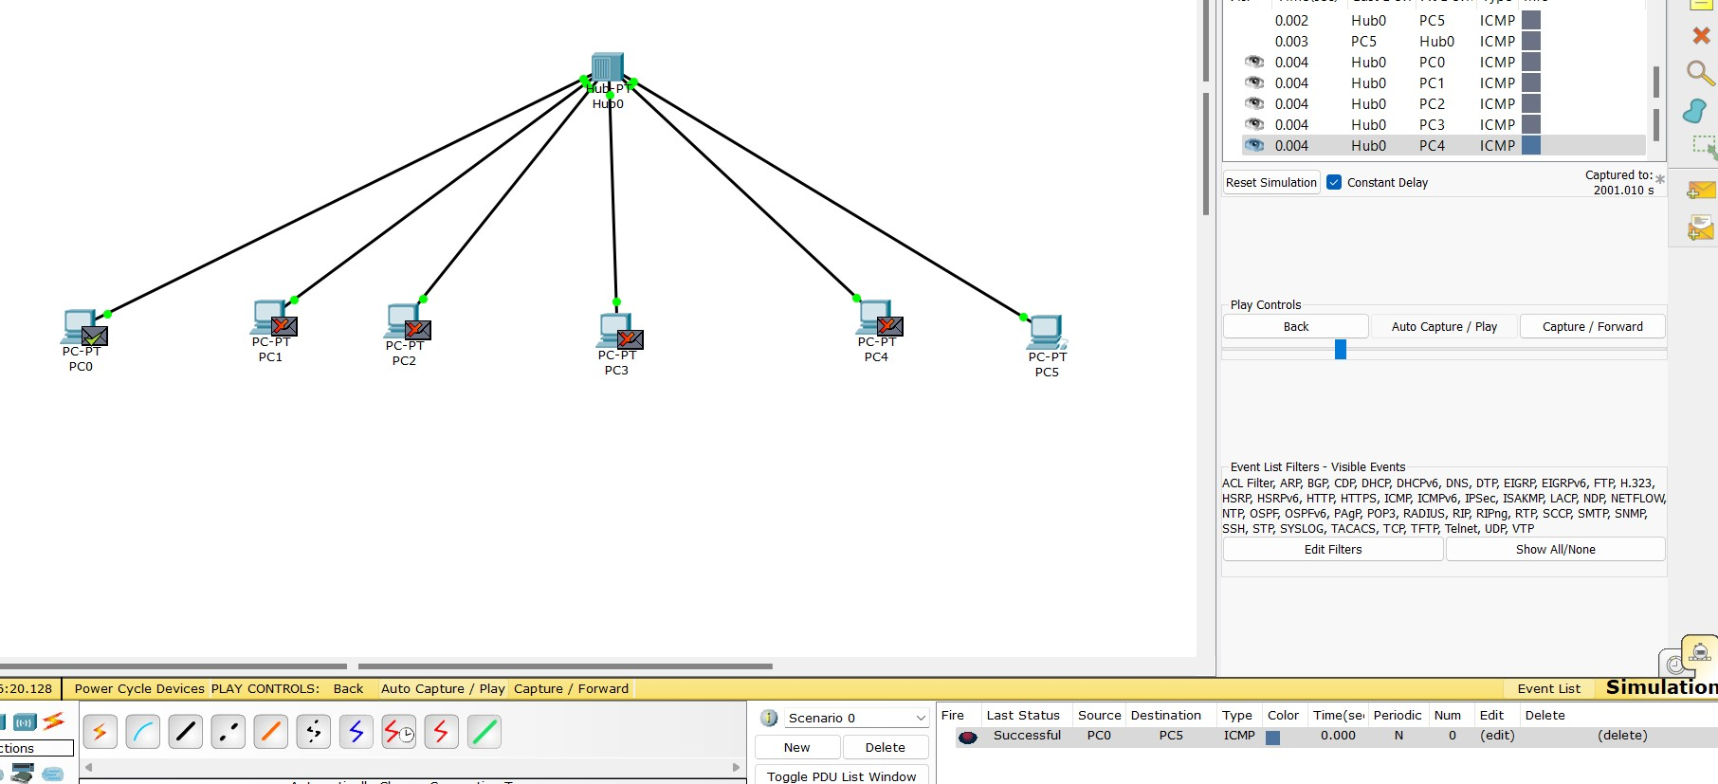

Working principle of hub was verified.

Communication was successful and a local area network using hub was established.

# Learning outcomes (What I have learnt):

1. Learn about hub.
2. Learn how to implement and configure hub.
3. Learn the working of hub.

## Evaluation Grid (To be created as per the SOP and Assessment guidelines by the faculty):

|  |  |  |  |
| --- | --- | --- | --- |
| Sr. No. | Parameters | Marks Obtained | Maximum Marks |
| 1. |  |  |  |
| 2. |  |  |  |
| 3. |  |  |  |

|  |  |  |  |
| --- | --- | --- | --- |
|  |  |  |  |