**EXPERIMENT 2.2**

**Student Name :Himanshu UID: 20BCS7944**

**Branch: CSE Section/Group:804A Subject Name: COMPUTER NETWORKING LAB**

**Q1.** **Create different network topologies like Star, Bus and Mesh Topology with the help of packet tracer and show the output.**

**1. Aim/Overview of the practical:**

Create a network that shows the working of ALL TOPOLOGY and also write the steps how to implement it.

**2. Task to be done/ Which logistics used:**

To Create a network connection using cisco packet tracer

**3. Steps for experiment/practical/Code**

1. Attach required devices (Hub/Switch/Router) in the packet tracer software.

2. Assign IP address to devices.

3. Select source and destination and drop packet from source to destination.

4. Go to Simulation mode and click capture/Play.

5. Simulation will start and packet will only be accepted by destination. The step by step process is shown below in pictorial form.

1.STAR TOPOLOGY

Star topology is a network topology in which each network component is physically connected to a central node such as a router, hub or switch.

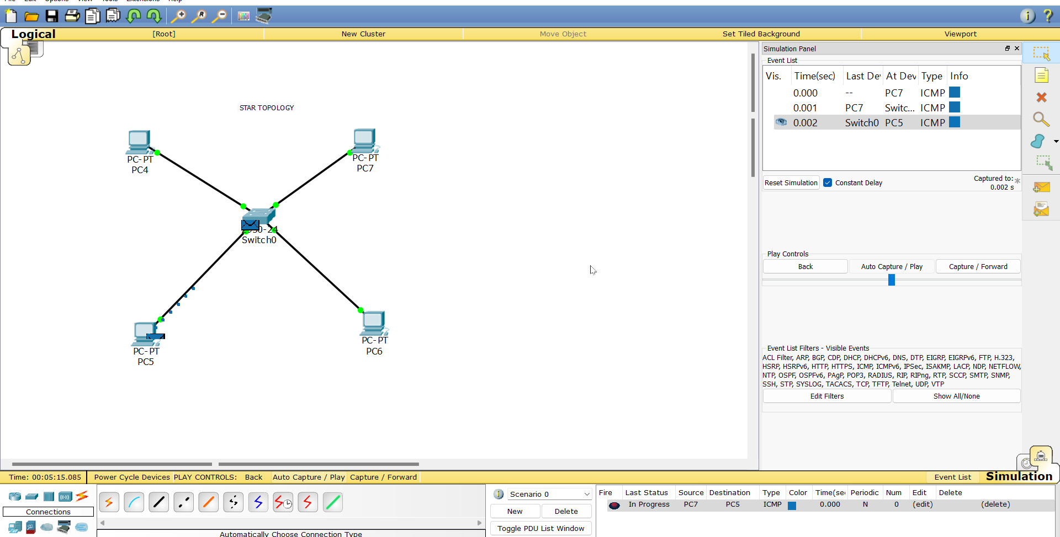

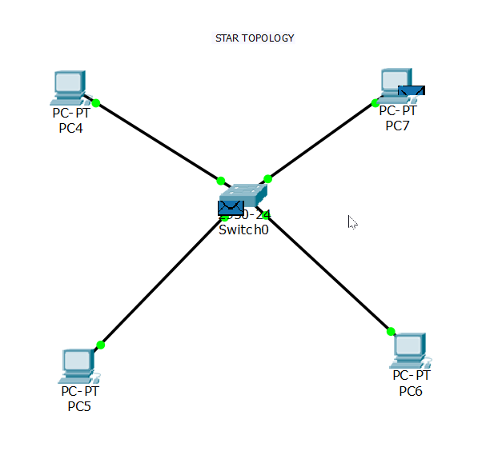

2.BUS TOPOLOGY

A bus network is a network topology in which nodes are directly connected to a common half-duplex link called a bus

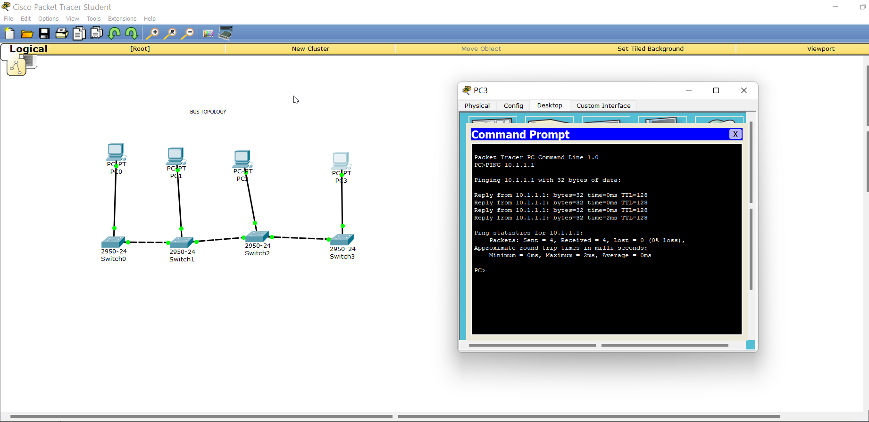

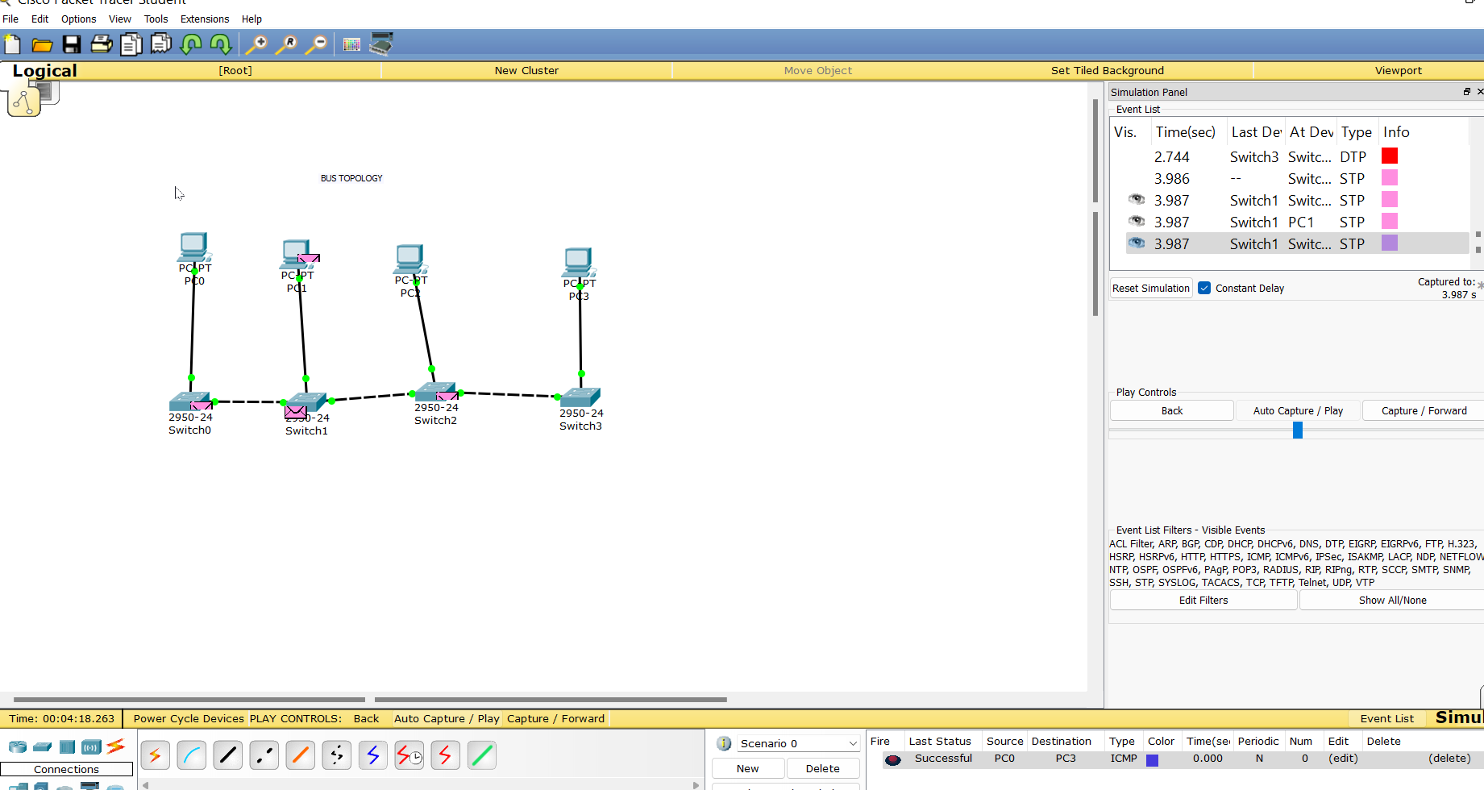

MESH TOPOLOGY

In a mesh topology there is no central connection point. Instead, each node is connected to at least one other node and usually to more than one

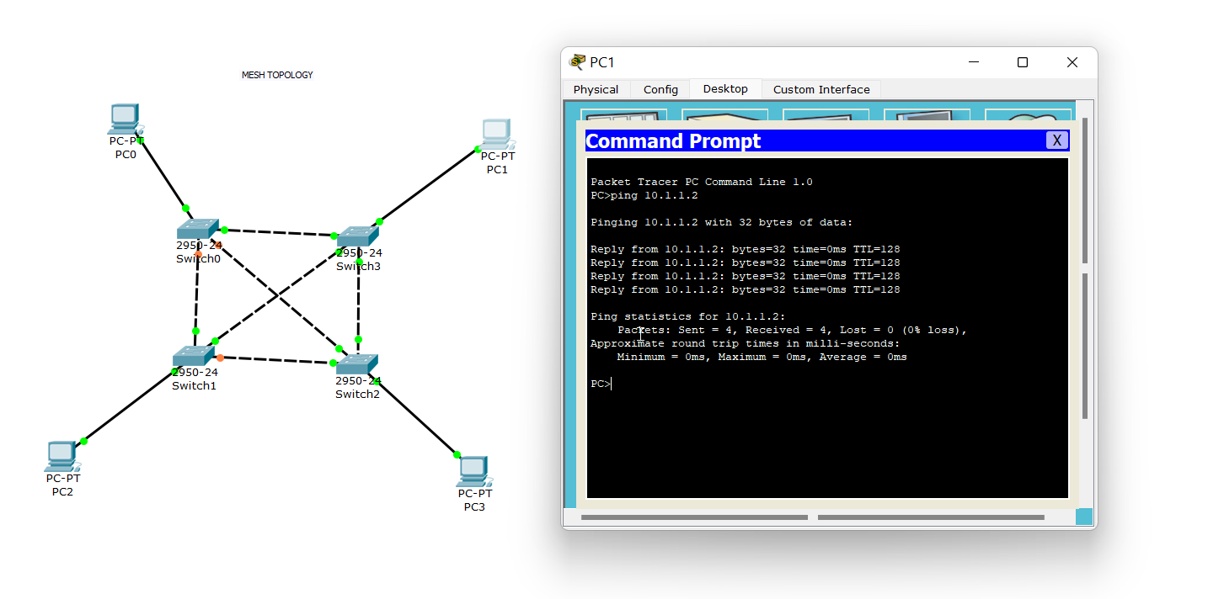

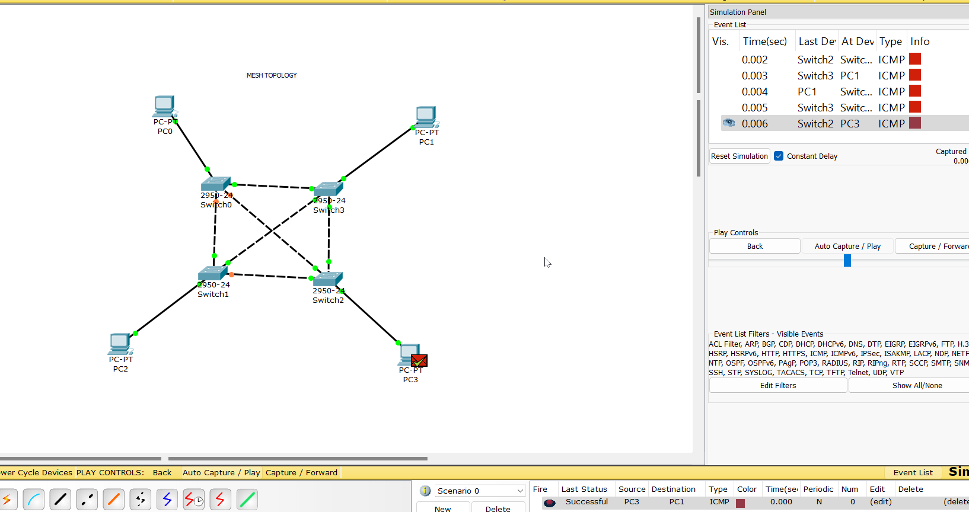

RING TOPOLOGY

A ring network is a network topology in which each node connects to exactly two other nodes, forming a single continuous pathway for signals through each node – a ring.

