LAB MST WORKSHEET

**STUDENT’S NAME –** HIMANSHU

**STUDENT’S UID –** 20BCS7944

**CLASS –** PH20BCS804

**Section –**  A

**SUBJECT NAME –** COMPUTER NETWORKS LAB

SUBJECT CODE – 20CSP – 257

SEMESTER – 04

**BRANCH –** CSE

**DATE OF PERFORMANCE –** March 17, 2021

**Task to be done:**

Implement all the networking commands and show their working as output.

**Result:**

Traceroute:

Traceroute tracks the route packets taken from an IP network on their way to a given host.

It utilizes the IP protocol's time to live (TTL) field and attempts to elicit an ICMP TIME_EXCEEDED response from each gateway along the path to the host.

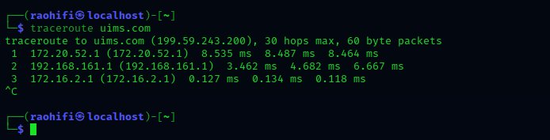

ifconfig:

Ifconfig is used to configure the kernel-resident network interfaces. It is used at boot time to set up interfaces as necessary. After that, it is usually only needed when debugging or when system tuning is needed.

If no arguments are given, ifconfig displays the status of the currently active interfaces. If a single interface argument is given, it displays the status of the given interface only; if a single -a argument is given, it displays the status of all interfaces, even those that are down. Otherwise, it configures an interface.

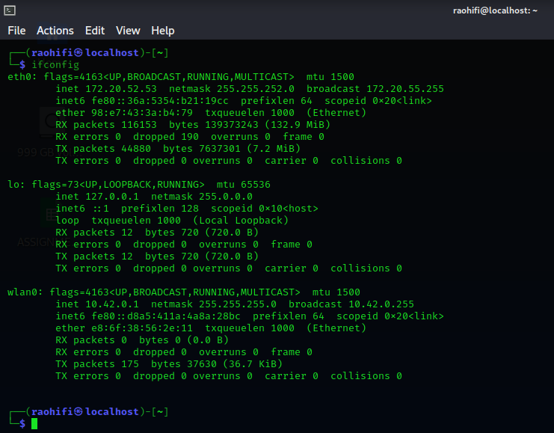

nslookup:

nslookup is a program to query Internet domain name servers. nslookup has two modes: interactive and non-interactive.

Interactive mode allows the user to query name servers for information about various hosts and domains or to print a list of hosts in a domain.

Non-interactive mode prints just the name and requested information for a host or domain.

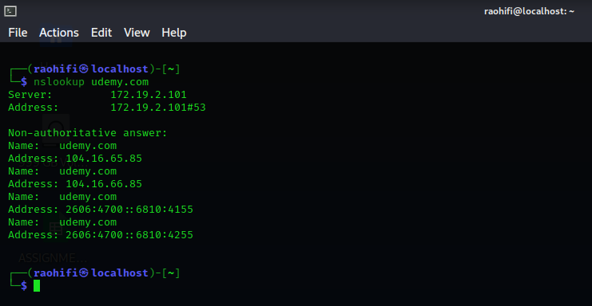

ping:

Ping uses the ICMP protocol's mandatory ECHO_REQUEST datagram to elicit an ICMP ECHO_RESPONSE from a host or gateway. ECHO_REQUEST datagrams (“pings”) have an IP and ICMP header, followed by a struct timeval and then an arbitrary number of “pad” bytes used to fill out the packet.

Ping works with both IPv4 and IPv6. Using only one of them explicitly can be enforced by specifying -4 or -6.

Ping can also send IPv6 Node Information Queries (RFC4620). Intermediate hops may not be allowed, because IPv6 source routing was deprecated (RFC5095).

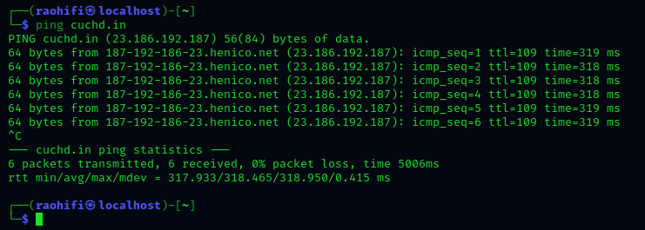

**hostname-**

Hostname is used to display the system's DNS name, and to display or set its hostname or NIS domain name.

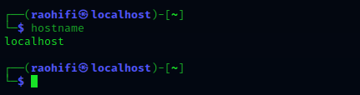

netstat:

Print network connections, routing tables, interface statistics, masquerade connections, and multicast memberships.

Netstat prints information about the Linux networking subsystem.

