WORKSHEET- 6

# NAME – Himanshu UID –20BCS7944

**CLASS – CSE -804/A SEMESTER –4th**

**SUBJECT- MPI Lab**

## AIM OF THE PRACTICAL

1. Shift Left 8-bit number by 1 bit.
2. Program to Shift Left 8-bit Number by 2 Bit

## APPARATUS REQUIRED

1. Jubin(8085 simulator)
2. Java

## CODE OF THE EXPERIMENT( 1-Bit left shift)

#BEGIN 0000H

LDA 2500H RAL

STA 2501H HLT

#ORG 2500H #DB 42H

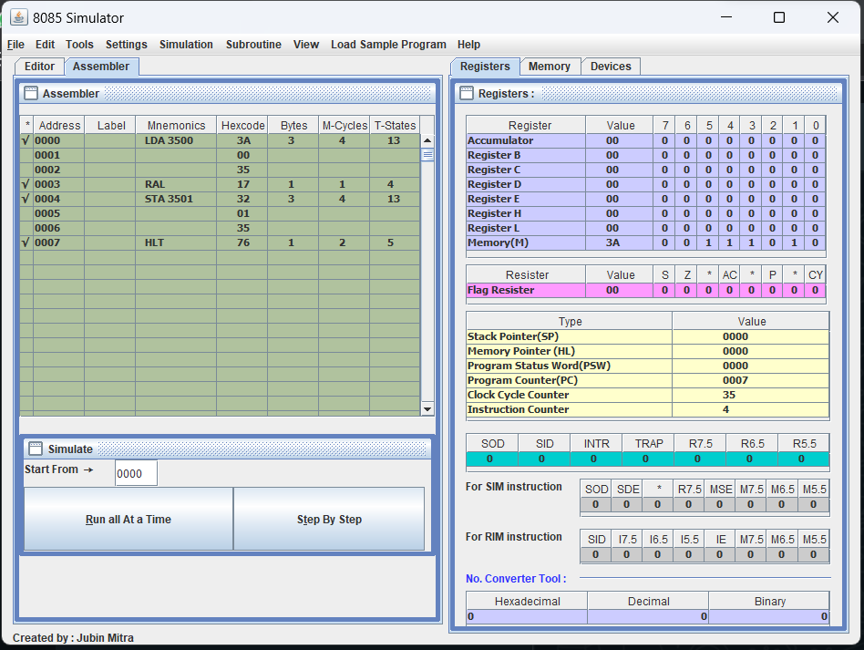SCHREENSHOT OF THE OUTPUT

Screenshot of Memory

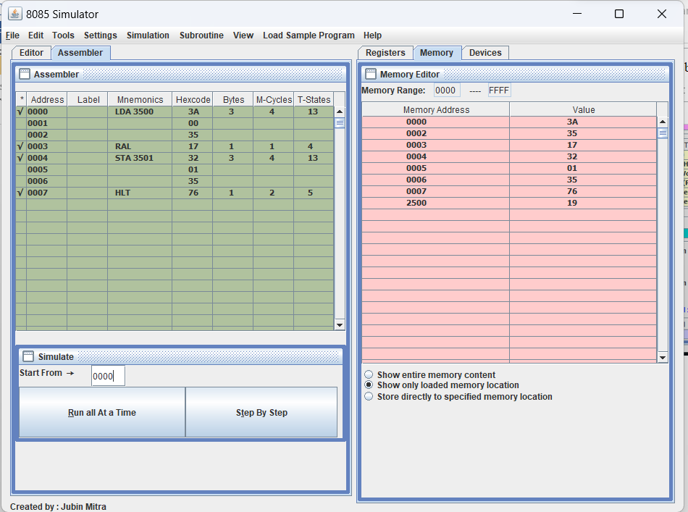

## CODE OF THE EXPERIMENT( 2-Bit left shift)

#BEGIN 0000H LDA 2500H RAL

RAL

STA 2501H HLT

#ORG 2500H #DB 42H

**SCHREENSHOT OF THE OUTPUT**

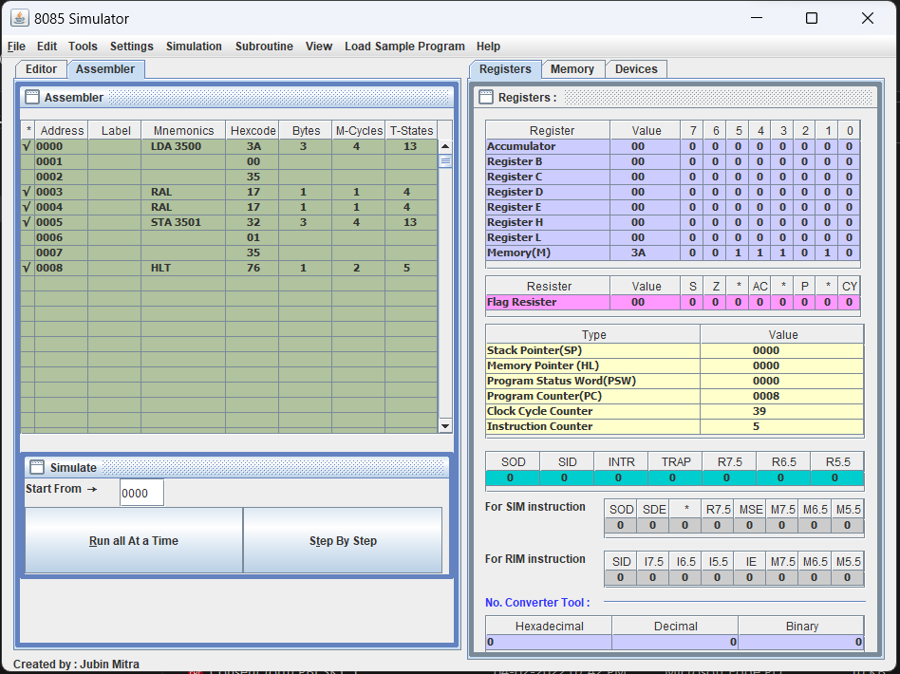

Screenshot of Memory

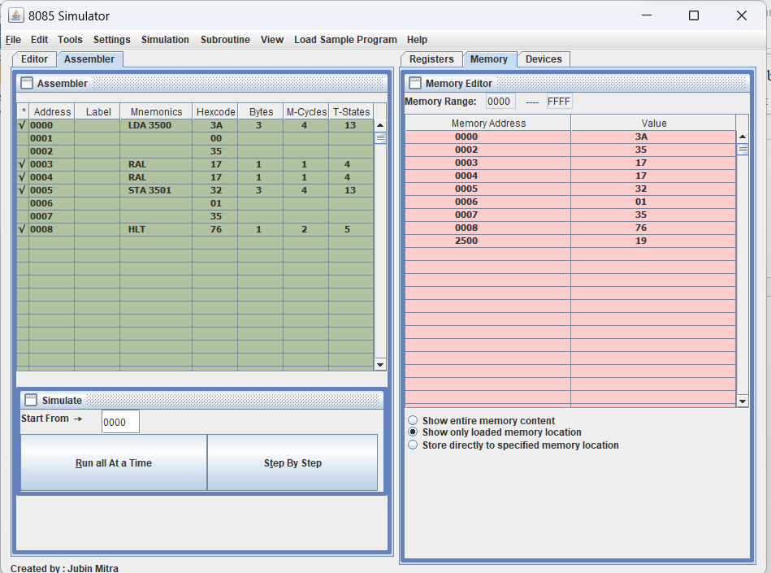

## LEARNING OUTCOMES

1. Learned about 8085 simulator.
2. Learned about left shift and right shift operators.