**Addition of two 8 bit numbers**

**Student Name:** Himanshu **UID:** 20BCS7944

**Branch:** CSE  **Section:** 20BCS802-A

**Semester:** 04 **Date of Performance:** 13/02/2022

**Subject Name:** Microprocessor and Interfacing Lab **Subject Code:** 20CSP-253

**1. Aim:**

Familiarization with basic assembly language programming.

**2. Task to be done:**

Addition of two 2 bit numbers.

**3. Simulator used:**

GNUSim8085 – 8085-Microprocessor Simulator.

**4. Algorithm:**

* Initialize the C register which contains 0.
* Load address H which contains 0026.
* Load number in register B which will contain an input number.
* Took input from input port in 01H.
* Then add B to A.
* If there is no carry then we will store A at address 0027H and store C at 0028H.
* If there is a carry then will increment in C and it will become 1 and after increment it will store in 0027H and 0028H.
* At last we will output the result in 05H and 06H( if there is a carry).

**5. Code:**

MVI C,00H

LXI H,0026H

MOV B, M

IN 01H

ADD B

JNC STORE

INR C

STORE: INX H

MOV M, A

INX H

MOV M, C

OUT 05H

MOV A, C

OUT 06H

HLT

**6. Result/Output/Writing Summary:**

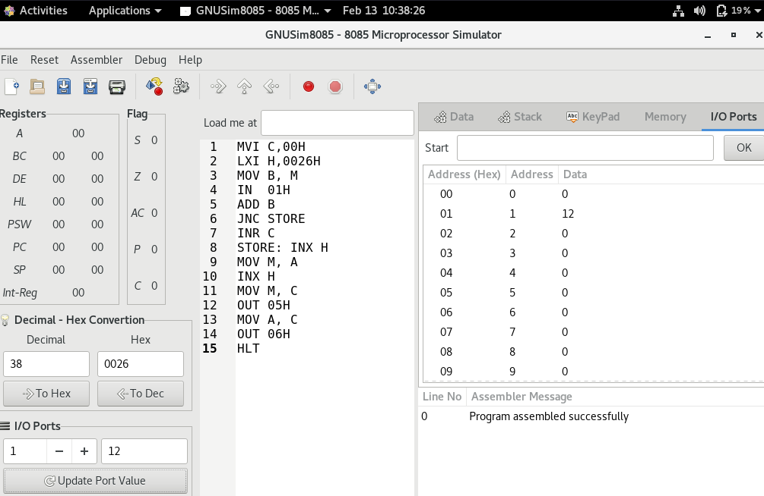

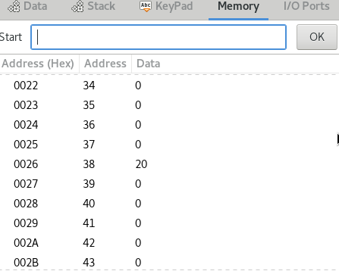

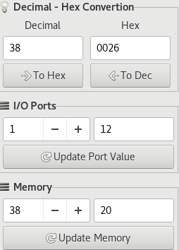

Save data in memory as 20 at 0026H which is 38 in decimal.

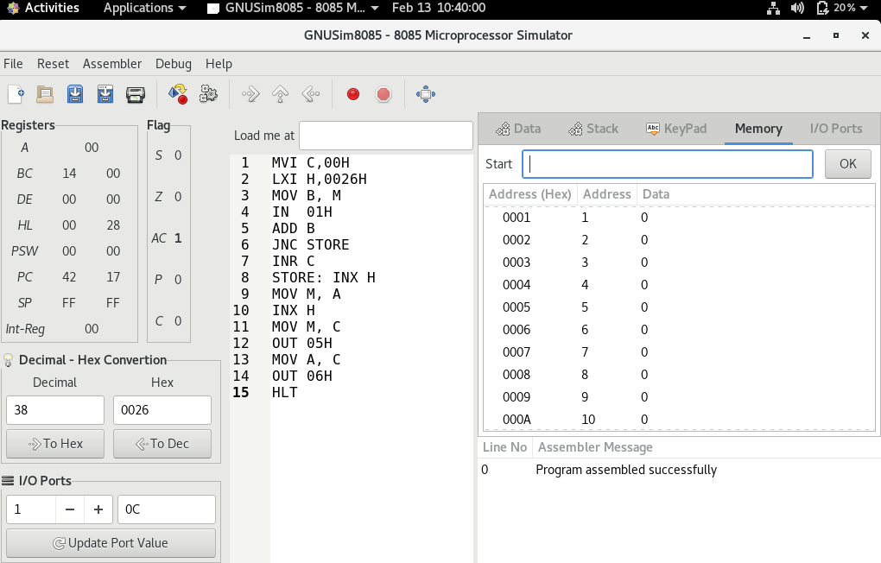

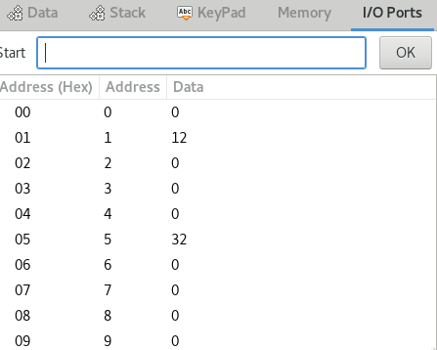

We got the output of addition of 20 and 12 on 05H is 32 as we can see from the above image.

**Learning outcomes (What I have learnt):**

**1.** Some basics of assembly language programming.

**2.** How to load registers and about memory addresses.

**3.** Working of microprocessor-8085 simulator.

**4.** Learnt about how to input value to memory and I/O port.

**5.** How to add two 8 bit numbers.

**Evaluation Grid (To be created as per the SOP and Assessment guidelines by the faculty):**

|  |  |  |  |
| --- | --- | --- | --- |
| Sr. No. | Parameters | Marks Obtained | Maximum Marks |
| 1. |  |  |  |
| 2. |  |  |  |
| 3. |  |  |  |
|  |  |  |  |