**Addition of two 16 bit numbers**

**Student Name:** Himanshu **UID:** 20BCS7944

**Branch:** CSE  **Section:** PH20BCS804-A

**Semester:** 04 **Date of Performance:** 05/03/2022

**Subject Name:** Microprocessor and Interfacing Lab **Subject Code:** 20CSP-253

**1. Aim:**

Familiarization with basic assembly language programming.

**2. Task to be done:**

Addition of two 16 bit numbers.

**3. Simulator used:**

GNUSim8085 – 8085-Microprocessor Simulator.

**4. Algorithm:**

* Initialize the input numbers in the memory.
* LHLD 0000 loads the value at 0000 in L register and that in 0001 in H register.
* Copy the first number to another register pair.
* XCHG change the content of HL register with DE register.
* Then move the content of register E to accumulator.
* Add the value A7 of register L to accumulator.
* Now we storing the result in variable, so we move the content of accumulator to L.
* Store the content of D to accumulator.
* Add with carry the data of H in register HL.
* Move the result from accumulator to H.
* At last store the result of HL to another memory location which is 004H and because there is a carry in this addition it will store in 005H.

**5. Code:**

LHLD 0000H

XCHG

LHLD 0002H

MOV A, E

ADD L

MOV L, A

MOV A, D

ADC H

MOV H, A

SHLD 004H

HLT

**6. Result/Output/Writing Summary:**

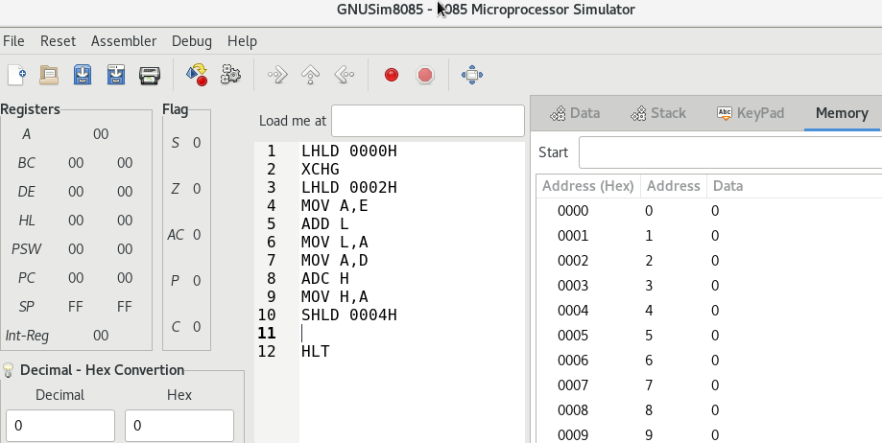

As we can see here A9 is the result which is stored in register HL.

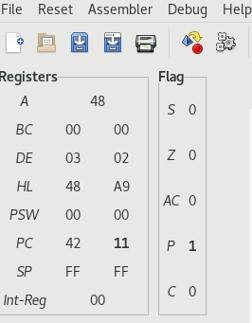

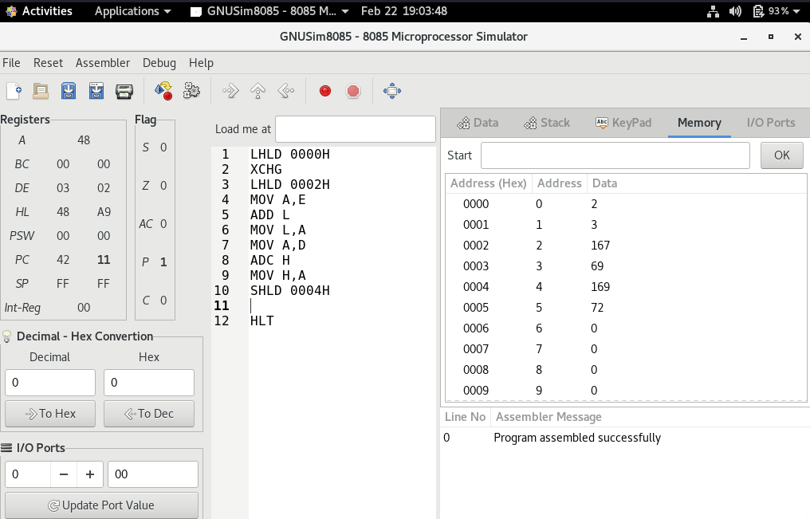

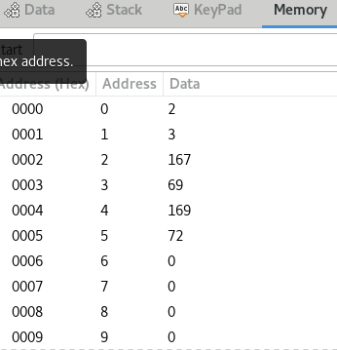

We got the output of addition on 0004H is 169 which is equivalent to A9 in hexadecimal and the carry on 0005H is 72 which is equivalent to 48 in hexadecimal.

**Learning outcomes (What I have learnt):**

**1.** Learn the basics of assembly language programming.

**2.** Working of different type of register.

**3.** Working of microprocessor-8085 simulator.

**4.** Learnt about how to input value to memory and I/O port.

**5.** How to add two 16 bit numbers.

**Evaluation Grid (To be created as per the SOP and Assessment guidelines by the faculty):**

|  |  |  |  |
| --- | --- | --- | --- |
| Sr. No. | Parameters | Marks Obtained | Maximum Marks |
| 1. |  |  |  |
| 2. |  |  |  |
| 3. |  |  |  |
|  |  |  |  |