**Subtraction of two 8 and16 bit numbers**

**Student Name:** Himanshu **UID:** 20BCS7944

**Branch:** CSE  **Section:** PH0BCS804-A

**Semester:** 04 **Date of Performance:** 30/03/2022

**Subject Name:** Microprocessor and Interfacing Lab **Subject Code:** 20CSP-253

**1. Aim:**

Familiarization with basic assembly language programming.

**2. Task to be done:**

* Subtraction of two 8 bit numbers along with borrow.
* Subtraction of two 16 bit numbers along with borrow.

**3. Simulator used:**

Jubin – 8085-Microprocessor Simulator.

**4. Algorithm1:**

* Loads the content of B050 into H register.
* Move the content of memory to accumulator.
* Increment the H register.
* Subtract the content of H register from the content of accumulator.
* Increment the H register again.
* Move the content from accumulator into the memory location B052.
* Stop.

**5. Code1:**

#BEGIN 0000H

LXI H,B050

MOV A,M

INX H

SUB M

INX H

MOV M,A

HLT

#ORG B050

#DB 75H,30H

**6. Result/Output/Writing Summary:**

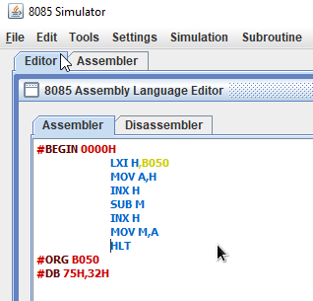

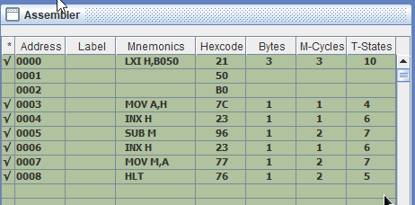

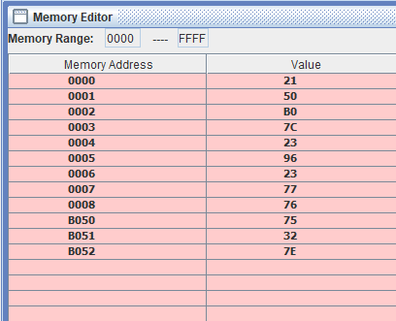

**7. Algorithm2:**

* Loads the content of 2050 into HL pair.
* Exchange the content of HL with DE pair.
* Load content of 2052 into HL pair.
* Move the content of 00H to C register.
* Move the content of register E to accumulator.
* Subtract the content of L register from the content of accumulator.
* Store the result of accumulator into 2054 location.
* Move the content of register D to accumulator.
* Subtract the content of register H from accumulator.
* Store the result of accumulator into 2055 memory location.

**8. Code2:**

#BEGIN 0000H

LHLD 2050

XCHG

LHLD 2052

MVI C,00

MOVE A,E

SUB L

STA 2054

MOV A,D

SBB H

STA 2055

#ORG 2050

#DB 19H,6AH,15H,14H

**9. Result/Output/Writing Summary:**

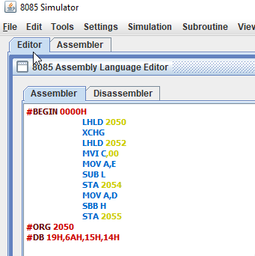

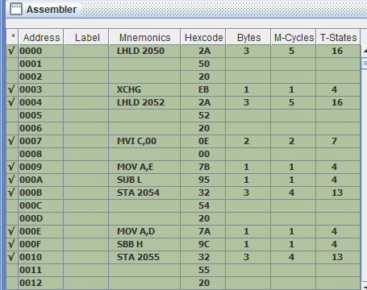

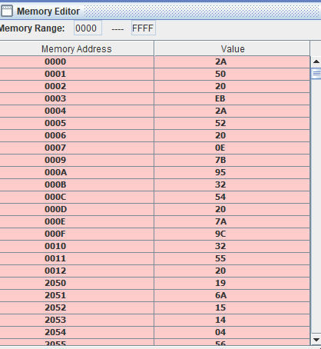

**Learning outcomes (What I have learnt):**

**1.** Learn the basics of assembly language programming.

**2.** Working of different type of register.

**3.** Working of microprocessor-8085 simulator.

**4.** Learnt about different terms like sub sbb etc.

**5.** How to subtract two 8 and 16 bits number with and without borrow.

**Evaluation Grid (To be created as per the SOP and Assessment guidelines by the faculty):**

|  |  |  |  |
| --- | --- | --- | --- |
| Sr. No. | Parameters | Marks Obtained | Maximum Marks |
| 1. |  |  |  |
| 2. |  |  |  |
| 3. |  |  |  |
|  |  |  |  |