**Complement of 8 bit numbers**

**Student Name:** Himanshu **UID:** 20BCS7944

**Branch:** CSE  **Section:** PH0BCS804-A

**Semester:** 04 **Date of Performance:** 24/03/2022

**Subject Name:** Microprocessor and Interfacing Lab **Subject Code:** 20CSP-253

**1. Aim:**

Complement of 8 bit number data.

**2. Task to be done:**

* 1’s Complement of 8 bit number data.
* 2’s Complement of 8 bit number data.

**3. Simulator used:**

Jubin – 8085-Microprocessor Simulator.

**4. Algorithm1:**

* Load H – L pair with address 1000H.
* Complement Accumulator.
* Store the result at memory location 1050H.
* Terminate the program.

**5. Code1:**

* LDA 1000H
* CMA
* STA 1050H
* HLT

**6. Result/Output/Writing Summary:**

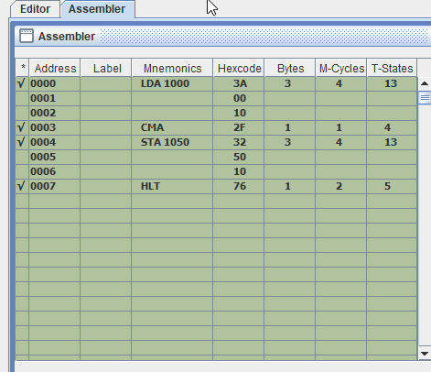

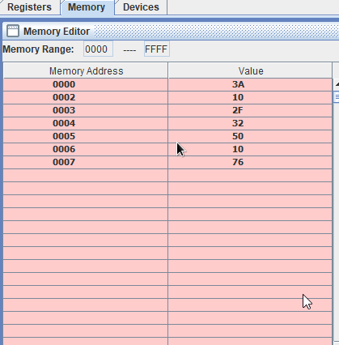

**7. Algorithm2:**

* Load H – L pair with address 1000H.
* Complement Accumulator.
* Store the result at memory location 1050H.
* Increase Accumulator by 1.
* Store the memory location 1051H.
* Terminate the program.

**8. Code2:**

* LDA 1000H
* CMA
* STA 1050H
* INR A
* STA 1051H
* HLT

**9. Result/Output/Writing Summary:**

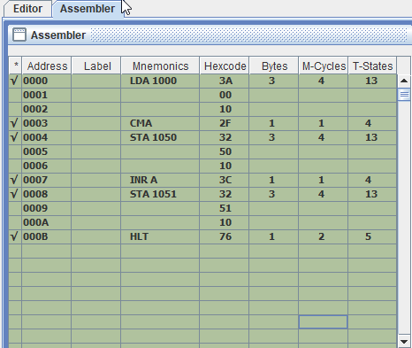

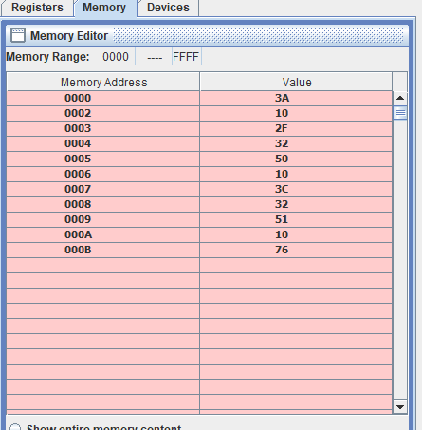

**Learning outcomes (What I have learnt):**

**1.** Learn the basics of assembly language programming.

**2.** Working of microprocessor-8085 simulator.

**4.** Learnt how to do 1’s and 2’s complement of 8 bit number data.

**Evaluation Grid (To be created as per the SOP and Assessment guidelines by the faculty):**

|  |  |  |  |
| --- | --- | --- | --- |
| Sr. No. | Parameters | Marks Obtained | Maximum Marks |
| 1. |  |  |  |
| 2. |  |  |  |
| 3. |  |  |  |
|  |  |  |  |