**Addition of two 16 bit numbers**

**Student Name:** Himanshu **UID:** 20BCS7944

**Branch:** CSE  **Section:** 20BCS802-A

**Semester:** 04 **Date of Performance:** 23/02/2022

**Subject Name:** Microprocessor and Interfacing Lab **Subject Code:** 20CSP-253

**1. Aim:**

Familiarization with basic assembly language programming.

**2. Task to be done:**

Addition of two 16 bit numbers.

**3. Code:**

LHLD 0000H

XCHG

LHLD 0002H

MOV A, E

ADD L

MOV L, A

MOV A, D

ADC H

MOV H, A

SHLD 004H

HLT

**6. Result/Output/Writing Summary:**

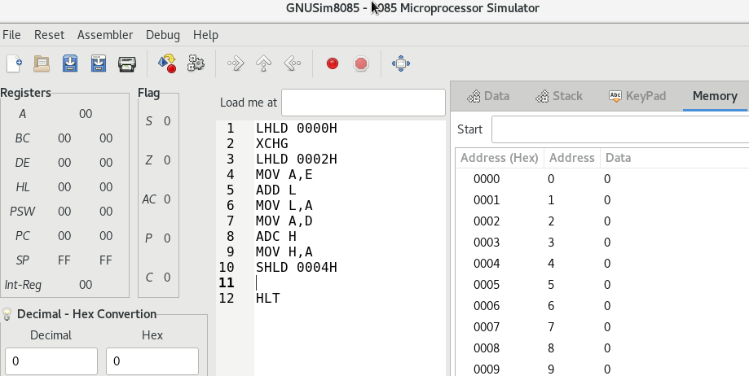

As we can see here A9 is the result which is stored in register HL.

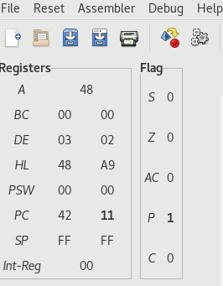

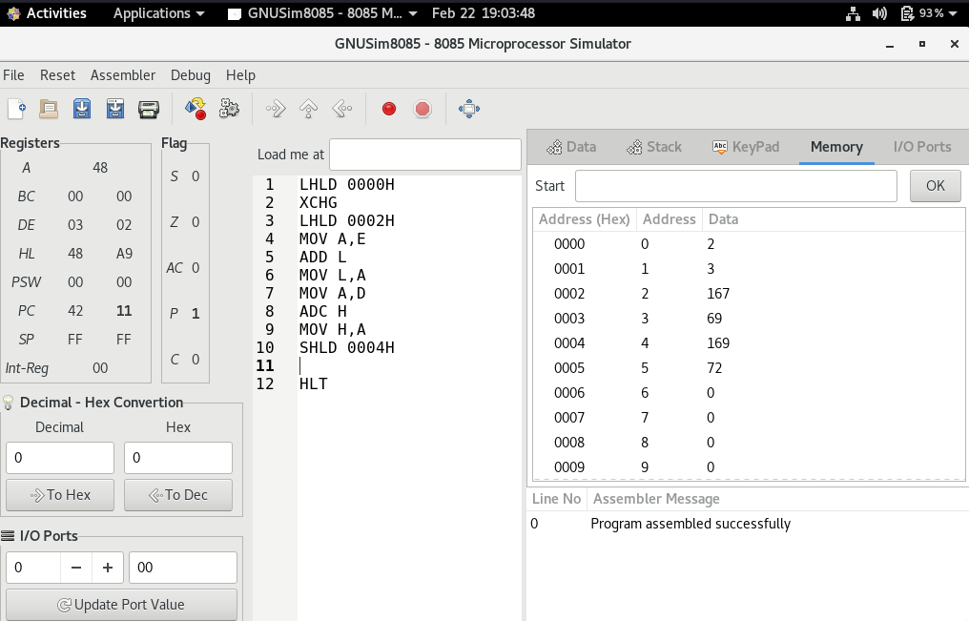

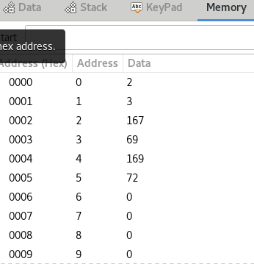

**Evaluation Grid (To be created as per the SOP and Assessment guidelines by the faculty):**

|  |  |  |  |
| --- | --- | --- | --- |
| Sr. No. | Parameters | Marks Obtained | Maximum Marks |
| 1. |  |  |  |
| 2. |  |  |  |
| 3. |  |  |  |
|  |  |  |  |