WORKSHEET **– 1.1**

**STUDENT’S NAME –** HIMANSHU

**STUDENT’S UID –** 20BCS7944

**CLASS –** 20BCS802

**Section –**  A

**SUBJECT NAME –** PROGRAMMING IN PYTHON LAB

SUBJECT CODE – 20CSP – 259

SEMESTER – 04

**BRANCH –** CSE

**DATE OF PERFORMANCE –** Feb 18, 2021

**Aim:**

Basic of Python, Operators, Expression and conditional statement.

**Task to be done:**

1. Write a program to enter two numbers and perform all arithmetic operations.
2. Write a program to enter marks of 5 subjects and calculate total, average marks and the percentage.
3. Write a program to enter length in centimeter and kilometer and also convert the same into equivalents.

**Algorithm:**

1. Enter two numbers from user using input method explicitly defined int.

**a = int(input())**

1. For average of marks, took input 5 number from user and divided sum of marks by total number of subjects and for percentage divide obtained marks by total marks multiply by 100.

1. For conversion of centimeter to kilometer we divide the centimeter unit by 100000 and 100 to meter.
2. Print method is used to write a statement to output.

Program code:

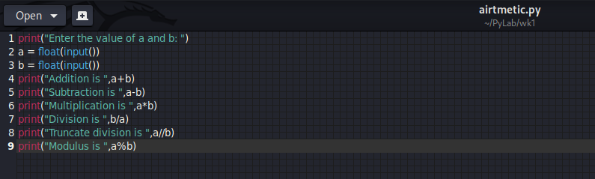

OUTPUT:

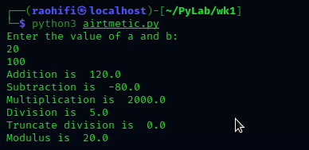

Program code:

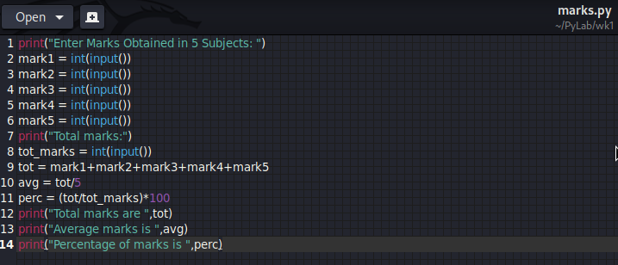

OUTPUT:

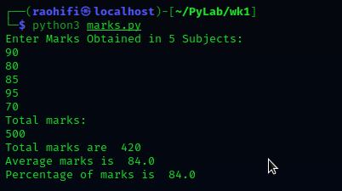

Program code:

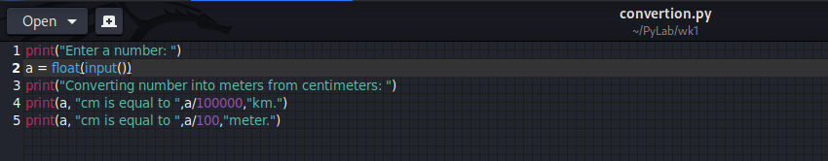

**OUTPUT:**

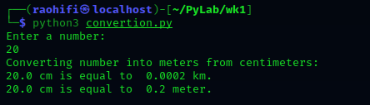

Observation:

* There is no error occur during the execution of program.

**Learning outcomes (what I had learnt):**

1. Learn how the different arithmetic operation work in python.
2. Learn the syntax of python and how to encounter the indentation error.

**Evaluation Grid (To be created as per the SOP and Assessment guidelines by the faculty):**

|  |  |  |  |
| --- | --- | --- | --- |
| Sr. No. | Parameters | Marks Obtained | Maximum Marks |
| 1. |  |  |  |
| 2. |  |  |  |
| 3. |  |  |  |
|  |  |  |  |