WORKSHEET **– 1.2**

**STUDENT’S NAME –** HIMANSHU

**STUDENT’S UID –** 20BCS7944

**CLASS –** 20BCS802

**Section –**  A

**SUBJECT NAME –** PROGRAMMING IN PYTHON LAB

SUBJECT CODE – 20CSP – 259

SEMESTER – 04

**BRANCH –** CSE

**DATE OF PERFORMANCE –** Feb 20, 2021

**Aim:**

Basic of Python, Operators, Expression and conditional statement.

**Task to be done:**

1. Write a program to check given number is palindrome or not.
2. Write a program to check given number is armstrong or not.
3. Write a program to find the largest number among three numbers.

**Algorithm:**

1. Enter a number from user and store its value into variable temp.
2. Find the reverse of number.
3. If reverse of number is equal to the number than the number is palindrome otherwise not.
4. For amstrong, set sum=0, assign number to variable temp and while temp less than zero:

digit = temp % 10

sum += digit ** 3

temp //= 10

1. If num equals to sum than the number is armstrong otherwise not.
2. To find lagrest number among three number we simply used nested if else and compare num1, num2 and num3 to each other respectively using less than and greater than operator.

Program code:

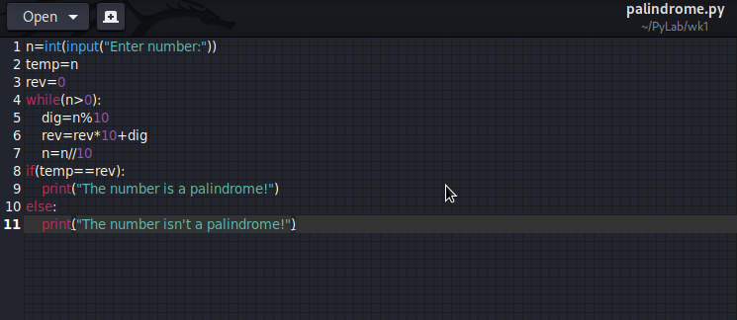

OUTPUT:

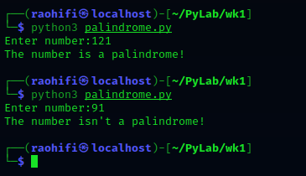

Program code:

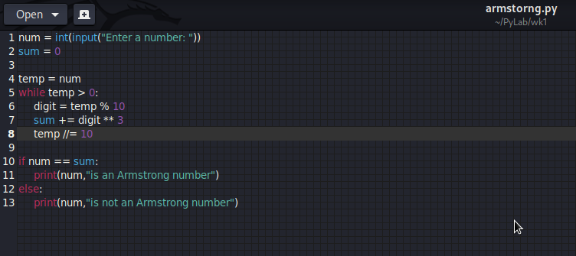

OUTPUT:

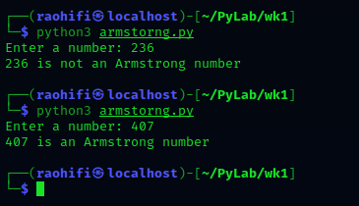

Program code:

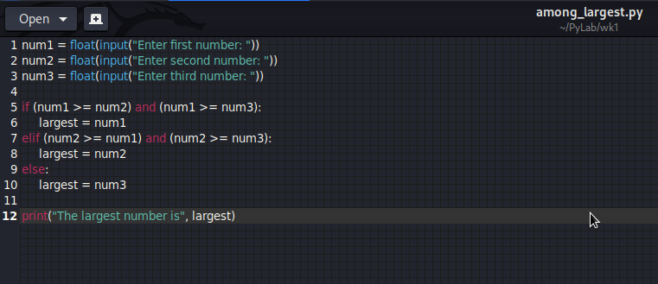

**OUTPUT:**

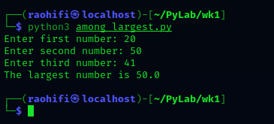

Observation:

* There is no error occur during the execution of program.

**Learning outcomes (what I had learnt):**

1. Learn about conditional statement like for and while loop.
2. Learn about nested if-else statements.

**Evaluation Grid (To be created as per the SOP and Assessment guidelines by the faculty):**

|  |  |  |  |
| --- | --- | --- | --- |
| Sr. No. | Parameters | Marks Obtained | Maximum Marks |
| 1. |  |  |  |
| 2. |  |  |  |
| 3. |  |  |  |
|  |  |  |  |