WORKSHEET **– 1.3**

**STUDENT’S NAME –** HIMANSHU

**STUDENT’S UID –** 20BCS7944

**CLASS –** 20BCS802

**Section –**  A

**SUBJECT NAME –** PROGRAMMING IN PYTHON LAB

SUBJECT CODE – 20CSP – 259

SEMESTER – 04

**BRANCH –** CSE

**DATE OF PERFORMANCE –** March 02, 2021

**Aim:**

Basic of Python, Operators, Expression and conditional statement.

**Task to be done:**

1. Write a python program to calculate area of 10 different circles. Given the pie = 22/7 and radius of the circles entered by user using simple function, parameterized function, Return type with function and return type with parameterized Functions.
2. Write a python program to print multiplication tables from 2 to 20 whether table values entered by user using simple function, parameterized function, Return type with function and return type with parameterized Functions.

**Algorithm:**

1. Declare a parameterized function area with keyword def.
2. Value of pie is given from question and put the value of variables in area of circle.
3. Taking r as the variable to input number from user and passing it to the function.
4. For multiplication table declare a function named table.
5. Use for loop to multiply the number from 2 to 20.
6. Take n as the variable from user and pass it to the function as parameter and print the table.

Program code:

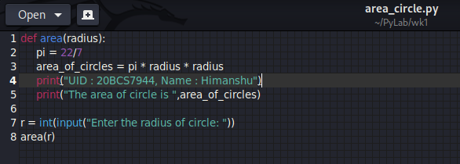

OUTPUT:

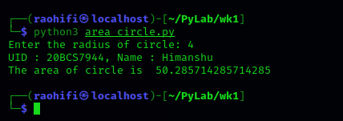

Program code:

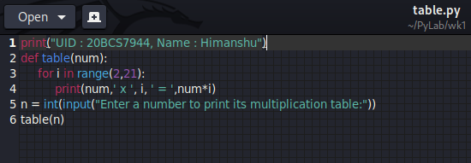

OUTPUT:

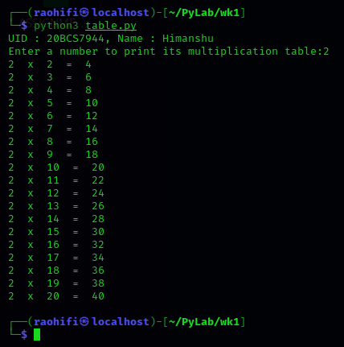

Class example code:

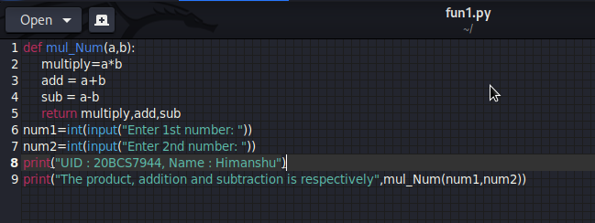

OUTPUT:

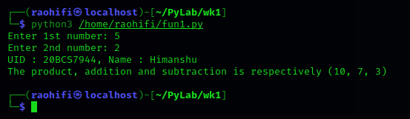

Observation:

* There is no error encounter during execution of program.

**Learning outcomes (what I had learnt):**

1. Learn how the function works in python.
2. Learn how to make function, pass arguments and many more.

**Evaluation Grid (To be created as per the SOP and Assessment guidelines by the faculty):**

|  |  |  |  |
| --- | --- | --- | --- |
| Sr. No. | Parameters | Marks Obtained | Maximum Marks |
| 1. |  |  |  |
| 2. |  |  |  |
| 3. |  |  |  |
|  |  |  |  |