WORKSHEET **– 1.3**

**STUDENT’S NAME –** HIMANSHU

**STUDENT’S UID –** 20BCS7944

**CLASS –** 20BCS802

**Section –**  A

**SUBJECT NAME –** PROGRAMMING IN PYTHON LAB

SUBJECT CODE – 20CSP – 259

SEMESTER – 04

**BRANCH –** CSE

**DATE OF PERFORMANCE –** March 20, 2021

**Aim:**

To study strings and its all related function.

**Task to be done:**

1. Write a python program to check whether the string is symmetrical or palindrome.
2. Write a python program to find uncommon words from two strings.
3. Write a python program to add ing to a given string. If the given string already ends with ing then add ly instead. If the word has less than 3 alphabets leave it changed.

Program code:

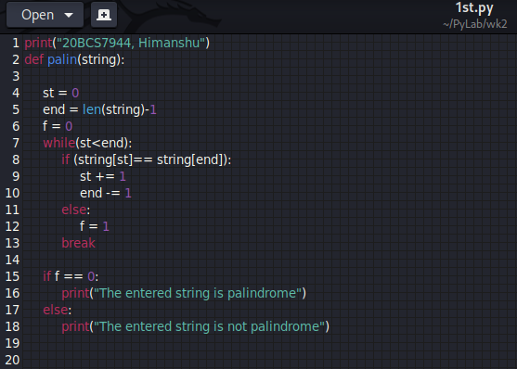

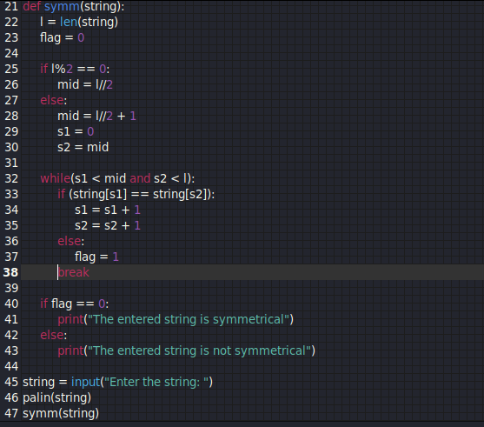

OUTPUT:

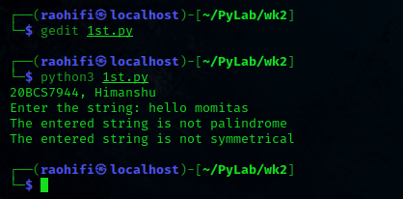

Program code:

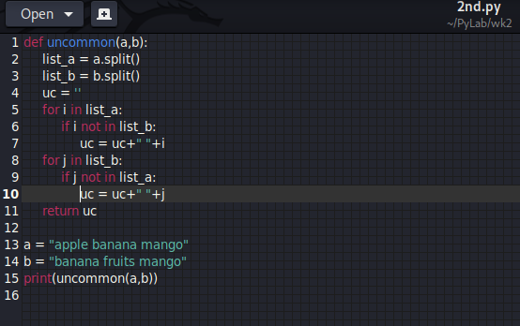

OUTPUT:

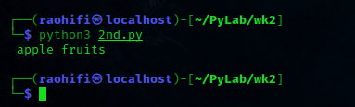

Program Code:

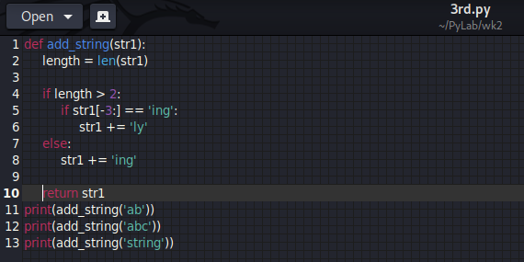

OUTPUT:

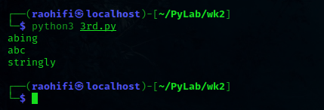

Observation:

* There is no error encounter during execution of program.

**Learning outcomes (what I had learnt):**

1. Learn how the string and its function works in python.
2. Also the slicing and indexing on strings.

**Evaluation Grid (To be created as per the SOP and Assessment guidelines by the faculty):**

|  |  |  |  |
| --- | --- | --- | --- |
| Sr. No. | Parameters | Marks Obtained | Maximum Marks |
| 1. |  |  |  |
| 2. |  |  |  |
| 3. |  |  |  |
|  |  |  |  |